Deep Learning as an Implementation of Mathematical Theory for Modeling Sentiment Dynamics: The Case of Pertamina’s “BBM Oplosan” Issue
Andy Hermawan¹, Adinda Prilly Cindana², Dian Margaretha Nainggolan³, Rizky Jemal Safryan⁴
¹Teknik Informatika, FTIK, Universitas Indraprasta PGRI, Jakarta, Indonesia, 12530
^{2,3,4}Purwadhika Digital Technology School, Jakarta, Indonesia, 12920
*Corresponding author: andyhermawan@unindra.ac.id, adindaprilly.work@gmail.com, dianmnainggolan22@gmail.com, rizkyjemal@gmail.com
Keywords:  Deep Learning; Mathematical Modeling; Sentiment Analysis; Public Opinion Dynamics; Lexicon-Based Analysis; CNN; LSTM; Optimization Theory; Pertamina; “BBM Oplosan”; Crisis Communication; Social Media Analytics; Indonesia. | ABSTRACT. Public sentiment dynamics provide a quantitative reflection of how societal trust and perception evolve during crises. This study implements mathematical theory through deep learning techniques to model changes in public sentiment surrounding Pertamina’s “BBM Oplosan” (fuel adulteration) issue, which went viral in Indonesia in early 2025. Twitter (X) data containing the keyword “Pertamina” were collected across two temporal windows—before and after the issue’s emergence. Sentiment was classified into positive, neutral, and negative categories using both lexicon-based analysis (InSet Lexicon) and deep learning architectures including Convolutional Neural Networks (CNN), Long Short-Term Memory (LSTM), and a hybrid CNN-LSTM model. From a mathematical standpoint, deep learning serves as a functional approximation framework that minimizes loss through gradient-based optimization—an implementation of multivariable calculus and linear algebra principles. Results show that negative sentiment increased from 23.5% to 48.2%, while positive sentiment declined from 44.6% to 26.2%, indicating a significant erosion of public trust. The CNN model achieved the highest validation accuracy (~63%), though it exhibited signs of overfitting. This research demonstrates how mathematical models underlying deep learning can be effectively applied to analyze real-world social phenomena, offering a robust quantitative framework for monitoring and interpreting public opinion dynamics during corporate crises.

INTRODUCTION
Pertamina, as a strategic state-owned enterprise, plays a crucial role in ensuring national energy security, making public trust in its quality and integrity critically important. At the end of February 2025, allegations of “Pertamina fuel blending” emerged and spread rapidly on social media, triggering a significant shift in public opinion. This situation highlights the importance of systematically monitoring public sentiment to support communication strategies and crisis mitigation.
Previous studies have shown that sentiment analysis is effective in identifying shifts in public opinion, but research specifically focused on national energy crisis issues remains limited. This research gap points to the need for more targeted analysis to understand the dynamics of public opinion during crises.
This study aims to measure changes in public sentiment before and after the issue surfaced, identify dominant narratives, and provide strategic recommendations for public communication and reputation management. The findings are expected to serve as a data-driven foundation for decision-making and strengthen public trust in the national energy sector.
METHODS
The methodological framework in this study integrates both theoretical and technical foundations that are commonly applied in modern sentiment analysis research. This section also incorporates the theoretical background to align with the journal template.
The study begins with data collection through web scraping to automatically gather large-scale public opinion data from the social media platform X (formerly Twitter), using the keyword “Pertamina.” This approach follows established text analysis methods that emphasize the importance of large and representative textual datasets [1], [5].
The theoretical foundation of this research is grounded in Natural Language Processing (NLP) and text mining. Sentiment analysis has been proven effective in identifying public opinion dynamics during crises [2], [18]. The preprocessing stage plays a crucial role in standardizing the textual data. It involves character normalization, removal of special characters and URLs, case folding, slang normalization, tokenization, stopword removal, and stemming using the Sastrawi Stemmer. These steps ensure that the text corpus is clean and consistent before further analysis [1], [2].
After preprocessing, vectorization is applied to transform text into numerical representations suitable for machine learning models. Techniques such as Bag-of-Words, TF-IDF, and word embeddings (Word2Vec, GloVe, FastText) provide structured representations that capture semantic and syntactic information from text [6], [8], [19].
Exploratory Data Analysis (EDA) is conducted to uncover patterns in the text corpus and to provide a descriptive overview of word distributions, sentiment proportions, and thematic trends. WordCloud visualization is employed to identify dominant themes and linguistic shifts in public discourse, which is particularly useful in crisis communication research [3], [16].
Sentiment classification is carried out using the InSet Lexicon (Indonesian Sentiment Lexicon), which includes 3,609 positive words and 6,609 negative words with sentiment scores ranging from −5 to +5. Tweets are categorized into positive, neutral, and negative sentiment classes based on their total lexicon scores.
In addition to the lexicon-based approach, this study evaluates three deep learning architectures: Convolutional Neural Network (CNN), Long Short-Term Memory (LSTM), and CNN–LSTM hybrids [7], [10], [14], [20]. CNN is effective in extracting local features, LSTM captures long-term dependencies, and their combination provides both local and contextual feature learning. The models are trained and evaluated using accuracy, precision, recall, and F1-score metrics [4], [9], [12], [15].
From a mathematical perspective, each deep learning model can be interpreted as a function approximation problem, where the goal is to find a mapping
$$f_{θ }: R^{n}→R^{k}$$
parameterized by weights $θ$, that minimizes the loss function
$$L\left(θ\right)=\frac{1}{N}\sum_{i=1}^{N}{l\left(f_{θ }\left(x_{i}\right),y_{i}\right),}$$
with $l$ representing the cross-entropy loss between predicted and true sentiment labels. Optimization is achieved through gradient descent, updating parameters according to
$$θ_{t+1}=θ_{t}-η∇_{θ} L\left(θ_{t}\right),$$
Where $η$ denotes the learning rate.
The CNN applies convolution operations
$$h_{j}=σ\left(w_{j}*x+b_{j}\right),$$
to extract local patterns, while the LSTM employs recurrent gates that compute hidden states using
$h_{t}=σ\left(W_{h}h_{t-1}+W_{x}x_{t}+b\right),$
capturing sequential dependencies in text data. These formulations represent direct implementations of linear algebra (matrix multiplications), calculus (gradient-based optimization), and functional analysis (non-linear activation functions).
To reduce overfitting and improve generalization, dropout regularization, early stopping, and limited epochs are applied. Despite these measures, short-text characteristics and class imbalance remained key challenges in model training.
By integrating mathematical theory with computational implementation, this methodology ensures a rigorous and structured approach to modeling public sentiment dynamics during a crisis event. The mathematical formulations behind deep learning emphasize that these models are not merely heuristic but are grounded in formal optimization and functional representation theory.

RESULTS AND DISCUSSION
- Sentiment Analysis Before and After the “BBM Oplosan” Issue
This sentiment analysis was conducted to examine how public perceptions of Pertamina shifted before and after the emergence of the “BBM oplosan” (fuel adulteration) issue. Sentiment was categorized into three types—positive, neutral, and negative—representing the public’s opinion trends toward the company.
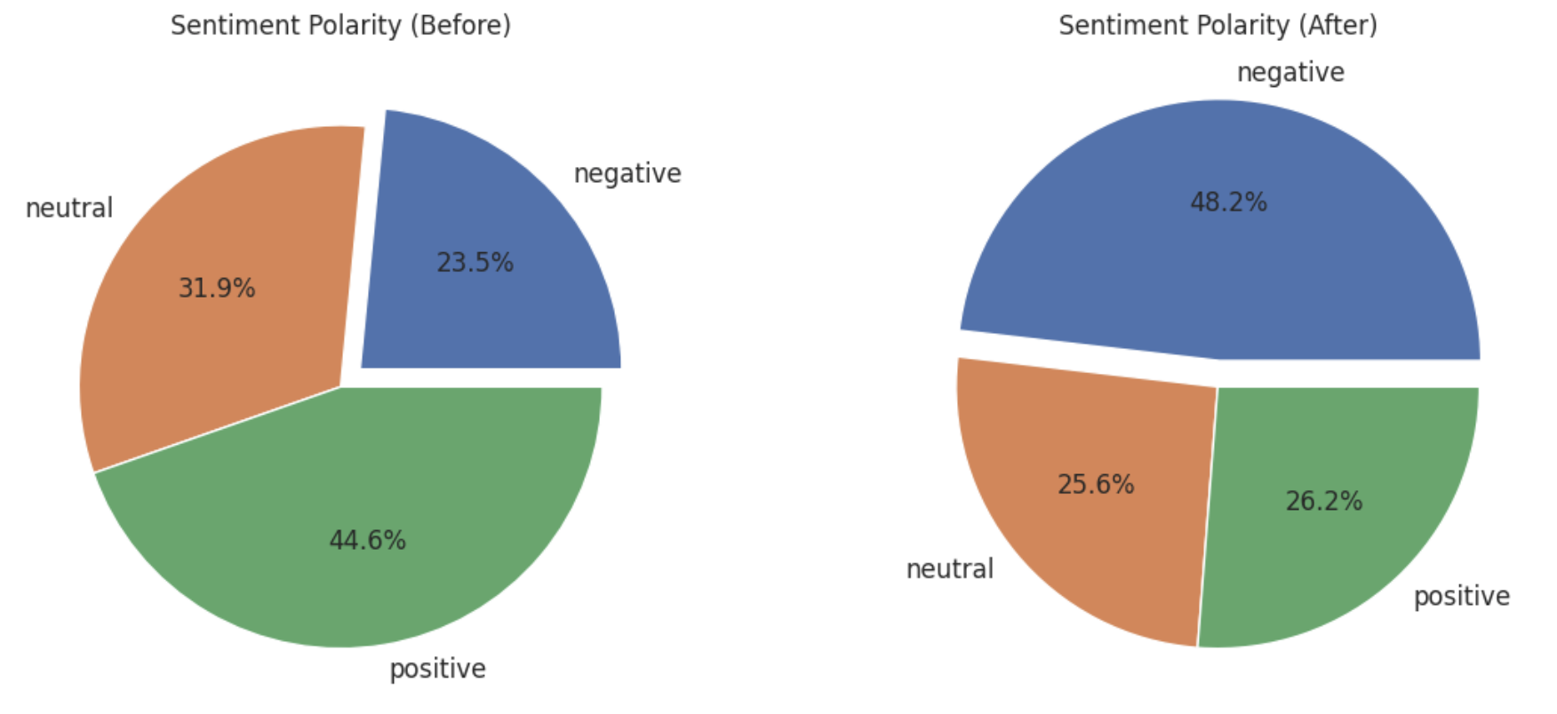
Figure 1. Sentiment Polarity Proportion Before and After the BBM Oplosan Issue
Before the issue emerged, positive sentiment dominated at 44.6%, followed by neutral at 31.9% and negative at 23.5%. After the issue surfaced, public perception changed dramatically: negative sentiment surged to 48.2%, positive sentiment dropped sharply to 26.2%, and neutral sentiment decreased slightly to 25.6%.
This comparison indicates a substantial shift in public opinion—from a predominance of positive sentiment to a dominance of negative sentiment. The spike in negative sentiment reflects the strong impact of the fuel adulteration issue on Pertamina’s image, signaling declining public trust and growing dissatisfaction after the scandal broke.
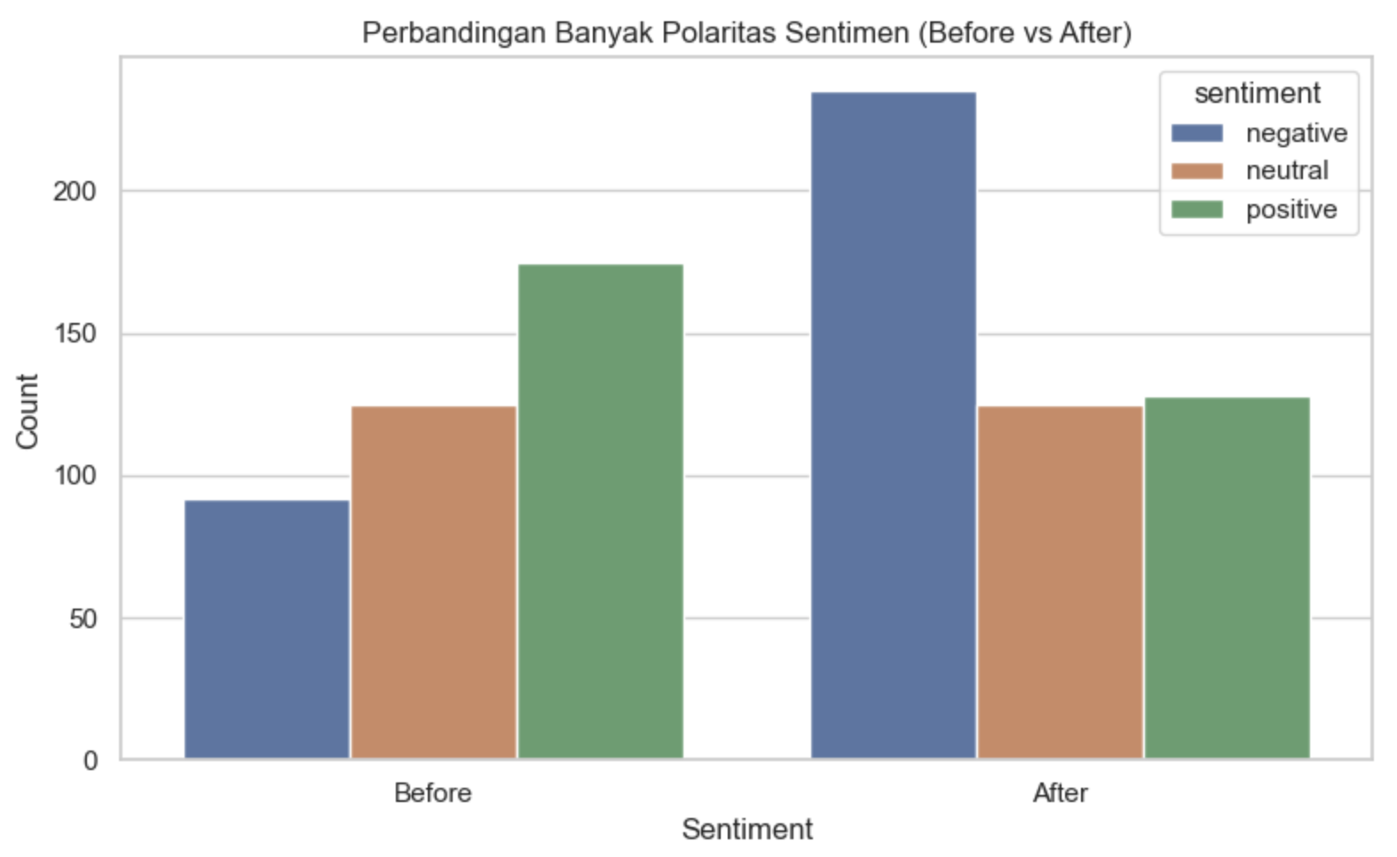
Figure 2. Sentiment Polarity Counts Before and After the BBM Oplosan Issue
Before the issue, positive sentiment dominated with around 180 tweets, while negative sentiment was only about 90 tweets. Afterward, negative sentiment spiked to over 200 tweets, becoming the largest category compared to positive and neutral sentiment.
This sharp rise in negative sentiment supports the earlier pie chart findings, where negative sentiment rose from 23.5% to 48.2%. It illustrates how the BBM oplosan issue significantly damaged Pertamina’s public image, reflected in a steep decline in positive opinions and the dominance of negative opinions.
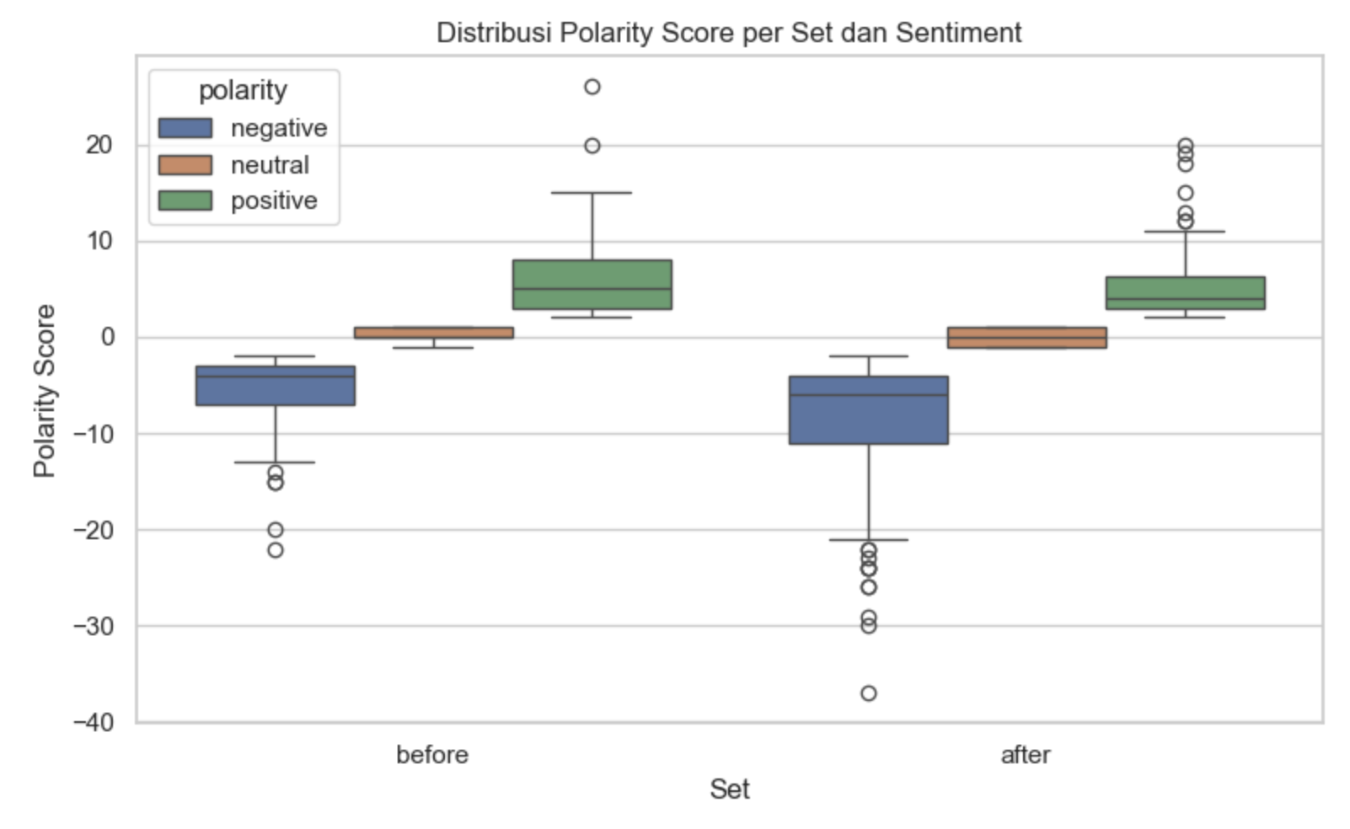
Figure 3. Sentiment Polarity Score Distribution
The box plot shows a clear downward shift in negative sentiment scores after the issue emerged. The post-issue negative median is lower than the pre-issue median, indicating more intense negative expressions. More outliers appear after the issue, some below -30, signaling extreme negative reactions.
For positive sentiment, the median remains relatively stable but slightly declines, meaning positive opinions persisted but weakened in intensity. Neutral sentiment shows narrow distribution with minimal variation, indicating stable neutral opinions.
The presence of extreme negative outliers reinforces the earlier findings: not only did negative sentiment increase, but its emotional intensity deepened, reflecting a surge of stronger public reactions after the scandal.

- Analysis of Words Before and After the Viral Oplosan Pertamax Case
- Unigram Frequency Analysis Before and After the Pertamax Adulteration Case Went Viral
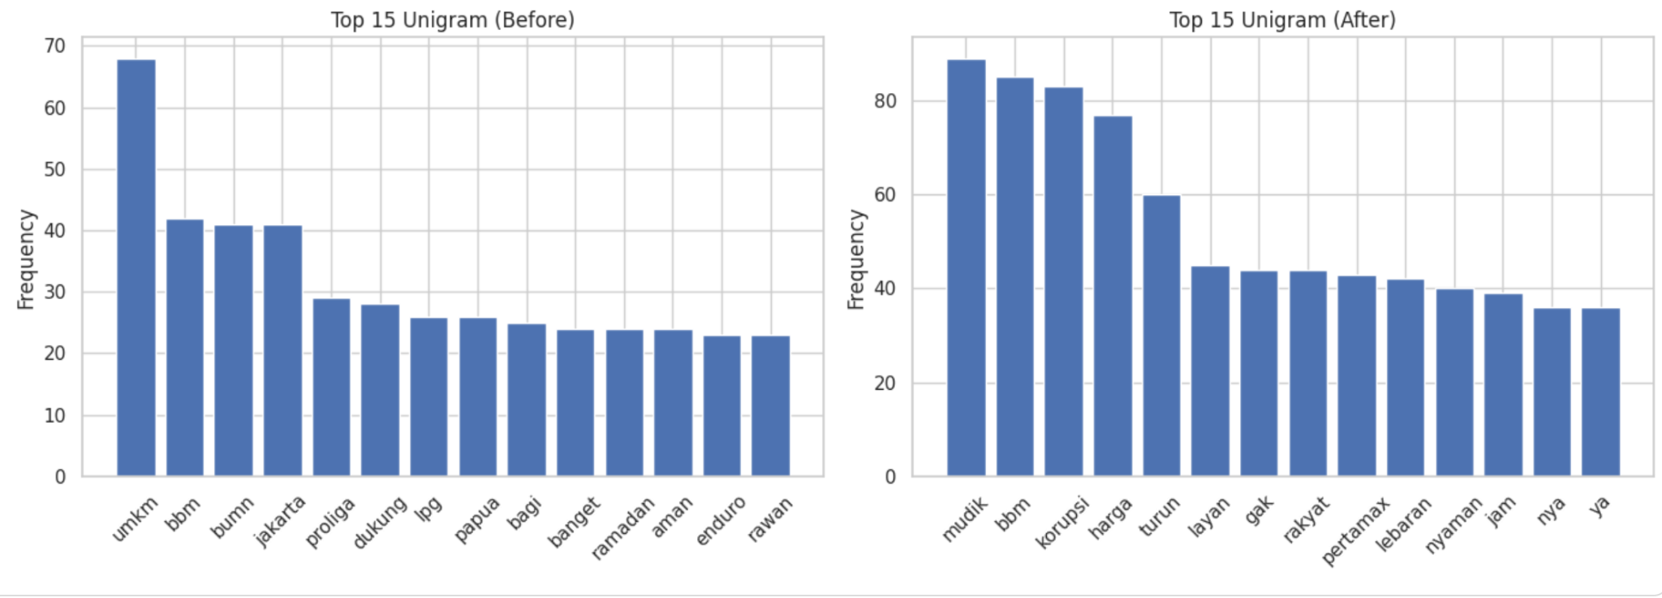
Figure 4. Top 15 Unigram Frequency Chart Before and After the Pertamax Adulteration Case
Before the issue, dominant words such as “umkm,” “bbm,” “bumn,” and “jakarta” indicate conversations focused on corporate policy support and social contributions, particularly tied to government programs and economic activities. Words like “ramadan” and “aman” suggest a neutral to positive context centered on seasonal activities and fuel services.
After the issue went viral, dominant words shifted dramatically to “korupsi,” “harga,” “turun,” and “rakyat,” indicating rising public criticism regarding trust, transparency, and fuel pricing. Words like “pertamax” and “gak” further reveal increased negative perceptions and skepticism. Some neutral words like “mudik,” “lebaran,” and “nyaman” remained, showing ongoing functional or informational discussions, especially around holiday fuel availability.
Overall, unigram analysis reveals a discursive shift from institutional and supportive topics to criticism and public dissatisfaction, aligning with the sentiment analysis results showing increased negative sentiment after the issue.

- Bigram Frequency Analysis Before and After the Pertamax Adulteration Case Went Viral
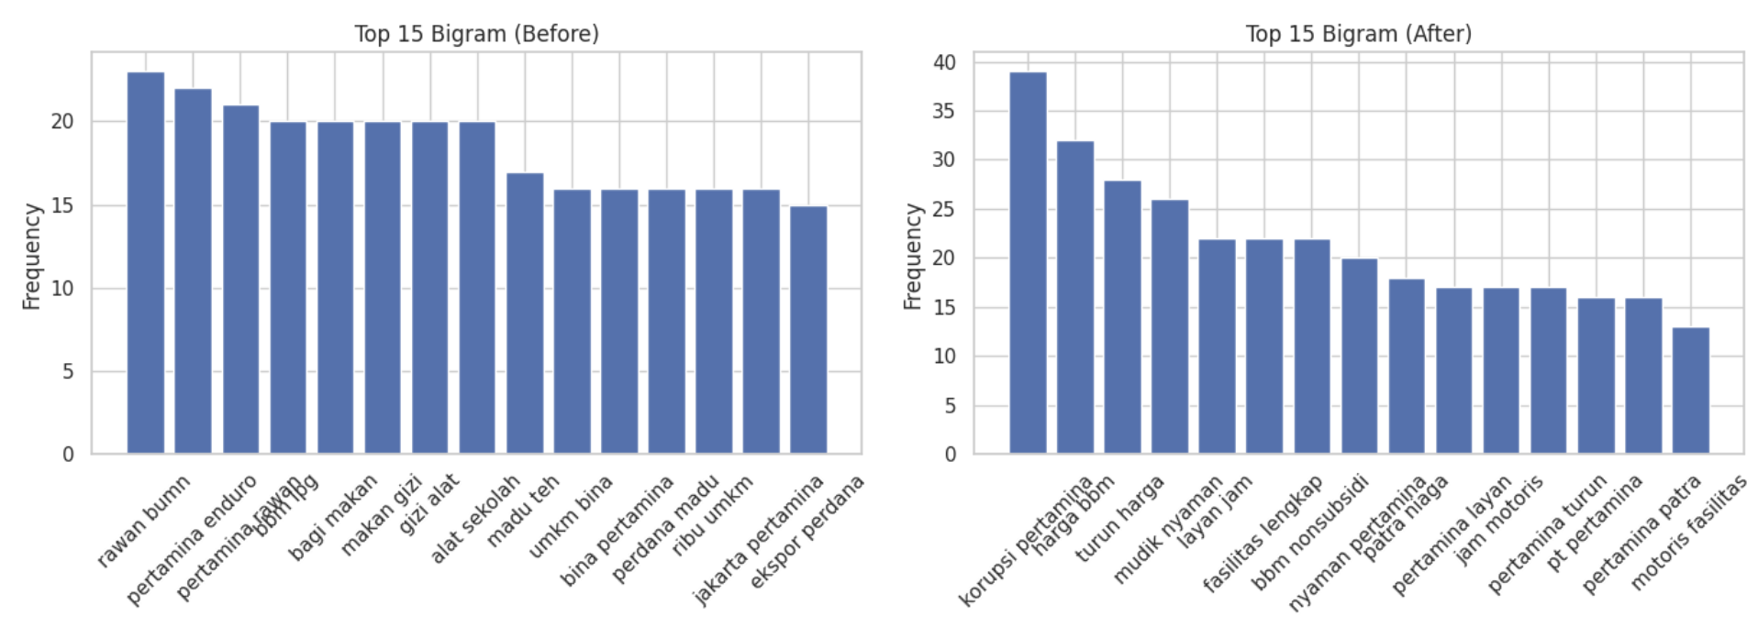
Figure 5. Top 15 Bigram Frequency Chart Before and After the Pertamax Adulteration Case
Before the issue, bigrams like “rawan bumn,” “pertamina enduro,” “pertamina bumn,” and “bmh lpg” reflect diverse, mostly positive or neutral conversations—covering product promotions, corporate activities, and social responsibility programs.
After the issue, dominant bigrams shifted clearly toward negative and critical narratives: “korupsi pertamina,” “harga bbm,” and “turun harga” reveal more emotionally charged discourse. Phrases like “pertamina turun” and “pt pertamina” show how the corporate name became central to criticism. Some neutral bigrams such as “mudik nyaman” and “fasilitas lengkap” persisted, indicating residual neutral or positive conversations about operational services.
This bigram analysis confirms the unigram findings, showing a clear thematic shift from corporate and social narratives to issues of pricing and trust.

- WordCloud Analysis of Negative Sentiment Before and After the Pertamax Adulteration Case Went Viral
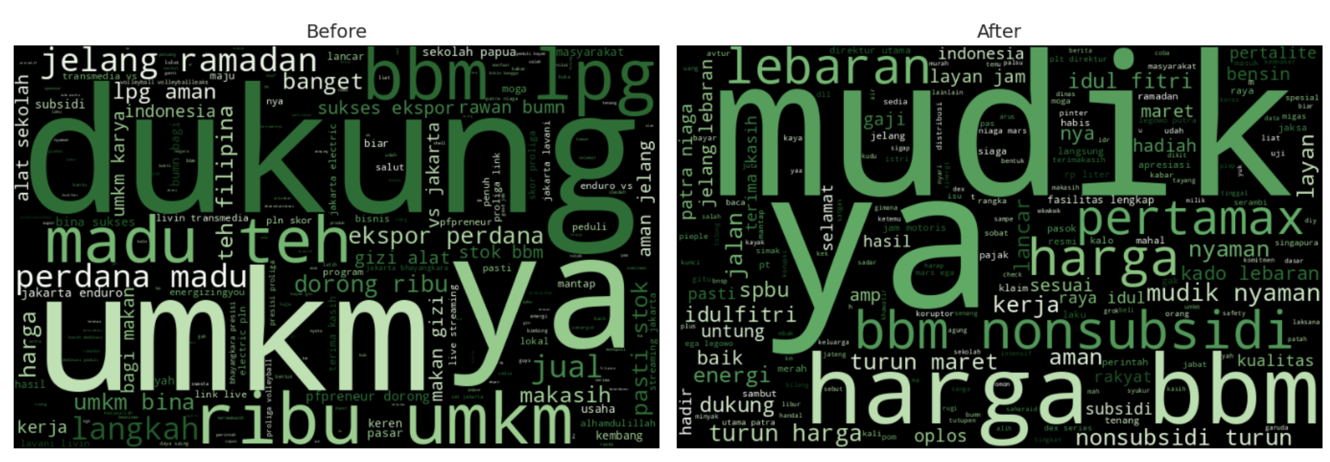
Figure 6. WordCloud of Negative Sentiment Toward Pertamina Before and After the Pertamax Adulteration Case
Before the issue, negative sentiment was weak and mostly associated with corporate activities like promotions or social programs. Words like “dukung,” “umkm,” “bbm,” and “lpg” dominated.
After the issue, negative word frequency and character changed drastically. Words like “harga,” “bbm,” “pertamax,” “nonsubsidi,” “turun,” and “oplos” became dominant, along with “rakyat,” “korupsi,” and “subsidi,” showing a shift toward structural distrust and moral outrage.
The WordCloud confirms the CNN, LSTM, and CNN-LSTM sentiment analysis results: negative sentiment not only increased in volume but also deepened in emotional and thematic intensity.

3. Sentiment Model Analysis
- CNN Model
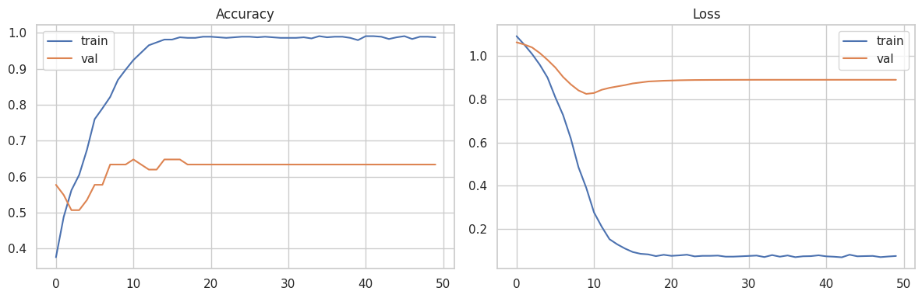
Figure 7. CNN Model Training and Validation Accuracy and Loss
Training accuracy rose quickly to near 100%, while validation accuracy plateaued around 63%. Training loss dropped sharply, but validation loss stagnated early, indicating overfitting.
Table 1. CNN Confusion Matrix
 | Pred | Negative | Neutral | Positive
Actual |  | Negative | Neutral | Positive
Negative |  | 40 | 21 | 4
Neutral |  | 12 | 36 | 2
Positive |  | 10 | 16 | 35

The classification report shows high precision but low recall for positive sentiment, high recall but low precision for neutral, and moderate performance for negative. The main errors occur between neutral and positive. Overfitting likely results from class imbalance or insufficient regularization. Stronger dropout and early stopping could help.

- LSTM Model
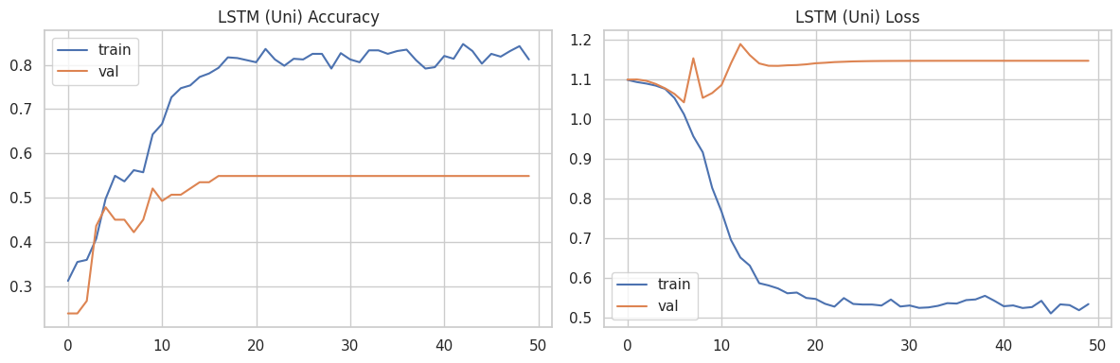
Figure 8. LSTM Model Training and Validation Accuracy and Loss
The LSTM model also overfits. Training accuracy rose steadily above 80%, while validation accuracy stalled at around 48%. Validation loss increased, indicating poor generalization.
Table 2. LSTM Confusion Matrix
 | Pred | Negative | Neutral | Positive
Actual |  | Negative | Neutral | Positive
Negative |  | 35 | 18 | 12
Neutral |  | 9 | 31 | 10
Positive |  | 10 | 32 | 19
LSTM struggles with short text sequences, limiting its advantage in long-term dependency modeling. Insufficient regularization likely contributed to overfitting.

- CNN–LSTM Model
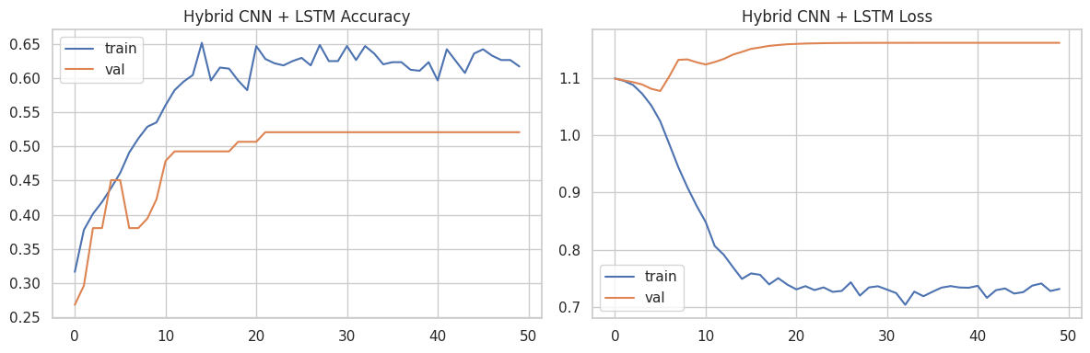
Figure 9. CNN–LSTM Model Training and Validation Accuracy and Loss
The hybrid CNN–LSTM model shows moderate overfitting, with training accuracy around 63% and validation accuracy stuck at 50%. Validation loss increased, indicating difficulty generalizing despite the more complex architecture.
Table 3. CNN–LSTM Confusion Matrix
 | Pred | Negative | Neutral | Positive
Actual |  | Negative | Neutral | Positive
Negative |  | 35 | 18 | 12
Neutral |  | 9 | 31 | 10
Positive |  | 10 | 32 | 19
The model frequently misclassified positive sentiment as negative or neutral, showing limited ability to distinguish positive emotions. CNN helped capture local patterns and LSTM added sequential context, but the combination wasn’t optimal for short-text data. Stronger regularization, dropout tuning, or pre-trained embeddings could improve results.
CONCLUSION
The viral Pertamax adulteration issue substantially reversed sentiment toward Pertamina: positive dominance gave way to negative sentiment with deeper intensity. Narratives shifted from institutional/operational topics toward price transparency, fairness, and governance. Among tested models, CNN was most stable yet still overfit on short texts with imbalanced labels. Future work should adopt pre-trained embeddings or Transformer architectures, expand data coverage, and balance classes to improve generalization.

REFERENCE
[1] H. D. Abubakar and M. Umar, “Sentiment Classification: Review of Text Vectorization Methods: Bag of Words, Tf-Idf, Word2Vec and Doc2Vec,” SLU Journal, 2022.
[2] M. S. Akhtar, D. Ghosal, A. Ekbal, P. Bhattacharyya, and S. Kurohashi, “A Multi-task Ensemble Framework for Emotion, Sentiment and Intensity Prediction,” arXiv, 2018.
[3] A. Alasmari, N. Farooqi, and Y. Alotaibi, “Sentiment analysis of pilgrims using CNN-LSTM deep learning approach,” PeerJ Computer Science, 2024.
[4] S. Al-Dhaqm, T. Ma, and W. Zhong, “Developing an Intelligent System with Deep Learning Algorithms for Sentiment,” PMC, 2021.
[5] J. Allen, “Exploratory Text Data Analysis,” Taylor & Francis, 2018.
[6] P. Bojanowski, E. Grave, A. Joulin, and T. Mikolov, “Enriching Word Vectors with Subword Information,” TACL, 2017.
[7] L. Deng, T. Yin, Z. Li, and Q. Ge, “Analysis of the Effectiveness of CNN-LSTM Models Incorporating BERT and Attention Mechanisms,” Atlantis Press, 2022.
[8] Y. Goldberg and O. Levy, “word2vec Explained: Deriving Mikolov et al.’s Negative-Sampling Word-Embedding Method,” arXiv, 2014.
[9] M. Islam and T. Anwar, “An efficient CNN-LSTM model for sentiment detection in Black Lives Matter,” ResearchGate, 2024.
[10] A. Jain and A. Singh, “Sentiment analysis from textual data using multiple channels deep learning,” JESIT, 2023.
[11] Y. Li and H. Zhu, “A Study of Text Vectorization Method Combining Topic Model and Transfer Learning,” MDPI Processes, 2023.
[12] X. Liu, J. Li, Z. Chen, and H. Wang, “Efficient Long Short-Term Memory-Based Sentiment Analysis of E-Commerce Reviews,” PMC, 2023.
[13] T. Mikolov, K. Chen, G. Corrado, and J. Dean, “Efficient Estimation of Word Representations in Vector Space,” arXiv, 2013.
[14] S. Minaee, E. Azimi, and A. Abdolrashidi, “Deep Sentiment: Sentiment Analysis Using Ensemble of CNN and Bi-LSTM Models,” arXiv, 2019.
[15] N. Sharma and A. Sharan, “A Hybrid CNN-LSTM Based Natural Language Processing Model for Sentiment Analysis of Customer Product Reviews,” JHUNS, 2024.
[16] F. B. Viégas and M. Wattenberg, “Word Cloud Explorer: Text Analytics Based on Word Clouds,” ResearchGate, 2015.
[17] H. Wu, Y. Gu, S. Sun, and X. Gu, “Aspect-based Opinion Summarization with Convolutional Neural Networks,” arXiv, 2015.
[18] S. Yadav and D. K. Vishwakarma, “Challenges and future in deep learning for sentiment analysis,” Springer, 2023.
[19] X. Zhang and L. Yang, “Systematic Comparison of Vectorization Methods in Classification Context,” MDPI Applied Sciences, 2023.
[20] C. Zhou, C. Sun, Z. Liu, and F. Lau, “A C-LSTM Neural Network for Text Classification,” arXiv, 2015.

