Diversity and Abundance of Local Butterflies (Order Lepidoptera) in Ternate Island
(Diversity and abundance of local butterflies (order lepidoptera) in ternate island)

Nelly Ardianiª, Abdu Mas’ud^{b}, Zulkifli Ahmad^{b} Sundari ^{b}

ªMahasiswa S1 Pendidikan Biologi, FKIP, Universitas Khairun, Ternate, Indonesia, 97735
^{b}Pendidikan Biologi, FKIP, Universitas Khairun, Ternate Indonesia, 97735

*Corresponding author: nellyardiani73@gmail.
Keywords: Butterflies, Lepidoptera, Diversity, Abundance, Ternate Island  not italic;  single spaced.  (break down, alphabetically, spasi 1, font size 8,5 , after 6 pt) | ABSTRACT. Ternate island has a forest ecosystem rich in biodiversity, including butterflies that play an important role as natural pollinators and biological indicators of Environmental Health. However, pressures from human activities such as deforestation, land conversion, and disposals of inorganic waste lead to habitat degradation, loss of host plants, and a decline in butterfly populations. This study aims to update the latest information on the diversity and abundance of local butterfly species on Ternate island for conservation efforts. Explorative descriptive research, time search method with wide and wide limits of 100 m in each research location. The research results found 351 individuals consisting of 18 types of local butterflies from 4 families, namely; 1) family Nymphalidae with 11 species including Cyrestis acilia, Danaus genutia, Ideopsis vulgaris, Elymnias hypermnestra, Mycalesis terminus, Parantica cleona, Pantopria hordonia, Danaus affinis, Hypolimnas bolina, Ideopsis vitrea, and Euploea tulliolus 2) the Pieridae family of 3 species includes Eurema hecabe, Catopsilia pyranthe, and Catopsilia scyll 3) the Lycaenidae family includes 1 species Lampides boeticus 4) Family Papilionidae with 3 species including Pachliopta polyphontes, Troides criton and Troides helena etc. The value of the local butterfly diversity index in Ternate island is H' = 2.32.32 which is categorized as moderate diversity. Furthermore, the abundance index analysis is 100% which is categorized as very high abundance.
INTRODUCTION
Ternate Island has a forest ecosystem that supports biodiversity, including various endemic species of flora and fauna. However, pressure on the environment continues to increase due to human activities such as illegal logging, forest conversion into agricultural land, and settlement expansion resulting in habitat fragmentation, decreased ecosystem quality, and reduced biodiversity. This deforestation is not only threats the preservation of forests, but also leads to the loss of natural habitat for local species. The need for agricultural land for food and industry contributes to accelerating land conversion, which often turns natural forests into monoculture farming systems. This change has an impact on the decline in butterfly populations caused by erosion, flooding, and disruption of the hydrological cycle research in habitat destruction and loss of host plant availability as a breeding [1].
The impact of environmental degradation due to deforestation also affects the existence of various types of insects, including butterflies belonging to the order Lepidoptera. Butterflies not only have an alluring visual beauty, but also play an important role in ecosystem [1]. Butterflies contribute as natural pollinators that help the reproductive process of various types of plants. In addition, butterflies also serve as biological indicators that are sensitive to environmental changes, so their presence and diversity reflect the level of stability and quality of an ecosystem. However, the rarity of butterfly species is highly dependent on the preservation of their natural habitat. Environmental damage, such as deforestation and pollution, can threaten butterfly populations and impact the overall ecosystem balance[2].
Damage to butterfly habitats is not only caused by massive landscape changes, but also the loss of certain types of plants due to illegal logging and environmental pollution [3]. Many butterfly species rely on host plants as a site for metamorphosis, especially in the larval stage. If the host plant is lost due to logging or damage caused by human activities such as dumping waste into forest areas, the life cycle of the butterfly will be significantly disrupted. Waste disposals in forest areas are one of the factors in reducing environmental quality. Inorganic wastes such as plastics not only pollute soil and water, but also interfere with the growth of wild plants that serve as a source of food for adult butterflies and larvae [4].
Butterflies are a group of insects with high species diversity and are closely related to environmental factors that affect their presence and abundance in a habitat [5]. The diversity of butterflies that inhabit an area or habitat is influenced by environmental conditions, such as the availability of plants as hosts and food sources, such as parks, forests or green open spaces. The high diversity of butterflies reflects ecosystem stability and can be used as a bioindicator of environmental health[6].
The abundance of Butterflies is an important indicator in evaluating the condition of an ecosystem. Abundance refers to the number of individuals of each species found in a region. Regions with high levels of abundance indicate that the ecosystem has adequate availability of resources, such as food, spawning grounds, and protection from predators or environmental disturbances. Conversely, a low abundance of butterflies may indicate the presence of ecological disturbances such as pollution, habitat destruction or pressure from human activities. Therefore, the observation of the abundance of butterflies not only reflects the dynamics of the population, but also acts as a biological indicator of the stability and quality of the environment [1]; [7]
Environmental factors have an important role in influencing the diversity and abundance of butterflies in a habitat. Abiotic factors such as temperature, light intensity, humidity, and water availability directly affect the daily activities and physical processes of butterflies, such as flight, mating, and laying eggs. Meanwhile, biotic factors such as the presence of vegetation, especially host plants and flowering plants, largely determine the life cycle of butterflies. Human activities such as tree felling, land clearing, and disposal of inorganic waste can also alter microclimate conditions and damage habitats, thus decreasing the environmental carrying capacity for butterfly survival[8];[4]
Butterfly Conservation is one of the important steps in maintaining the balance of the ecosystem and the sustainability of biological resources. This paper reports the results of research on the types of local butterflies on the island of North Ternate and South Ternate. The purpose of this study is to update the latest information on the diversity and abundance of local butterfly species on Ternate island for conservation efforts.
RESEARCH METHODS
This research was conducted in the forest areas of South Ternate and North Ternate with a research time of 16 days starting in July 2025.
Types Of Research
This research is one of non-experimental explorative descriptive research with quantitative approach with time search[9];[10]. The variables measured in this study were the diversity and abundance of local butterfly species on South Ternate Island and North Island. Tools used in this peneitian sweepnet (insect nets), stationery, cameras, oil paper/papilot, paper labels, identification books Bioecology butterflies Ternate island, GPS, thermometer, camphor, raffia dance, meter. Materials used Chlorophrome 500 ml objects in this study are all types of local butterflies in South Ternate island and North Ternate island.
Research Procedures
The research procedure is to first determine the location of observations based on the presence of vegetation and butterfly activity, then use the Time Search method with an area limitation of 100 m x 50 m, then observe and record the butterflies seen within a radius of 5 meters from the observation path, then capture the butterflies that can not be identified in the sweepnet, then identifies species based on wing morphology and color patterns with the help of identification books, then records the number of individuals of each species, environmental conditions (especially temperature), and location coordinates and then collects data from each location repeated during the observation period.
Data Analysis
Data analysis conducted in this study includes: species diversity index (H’), species funding Index (D), and environmental analysis with the following formula:
Diversity Index
Analysis of the diversity of butterfly species to determine H’ used Index Shannon Wienner with Mangurran furmulation[11]. This H’ furmulation Magurran analysis also considers the number of types and the number of each individual per type found calculated by equation 1..
H’ = Ʃpi In pi where’s Pi = ni/N dan N = Ʃni (1)

Species Abundance Index (D)
Species abundance index using Luwdig and Reynolds (1981) formulation.
D = $\frac{ni}{N }$ x 100%
Enviromental Analysis
Environmental analysis in this study was conduct to determine the influence of environmental factors on the level of diversity and abandonment of butterflies in Ternate island, using the Principal Component Analysis (PCA) analysis.
RESULTS AND DISCUSSIONS
Identification of local butterflies in North Ternate and South Ternate
Based on the research results, there are several types of butterflies found in both locations from 4 families, namely Nymphalidae with 11 types, namely Cyrestis acilia, Danaus genutia, Ideopsis vulgaris, Elymnias hypermnestra, Mycalesis terminus, Parantica cleona, Pantoporia hordonia, Danaus affinis, Hypolimnas bolina, Ideopsis vitrea, Euploea tulliolus. Then there are 3 types of the Pieridae family, namely Eurema hecabe, Catopsilia Scylla, Catopsilia pyranthe. Next is the Papilionidae family which consists of 3 types, namely Pachliopta polyphontes, Troides criton, Troides helena, and 1 type of Lycaenidae family, namely Lampides boeticus. The types of butterflies found in the two research sites will be shown in Figure 1.

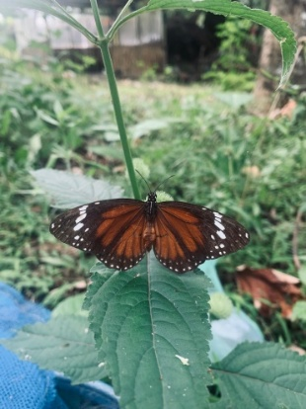
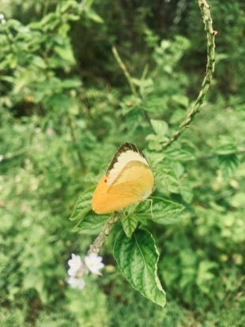
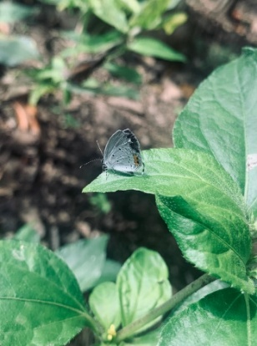
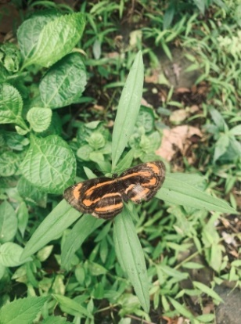

d
c
b
a

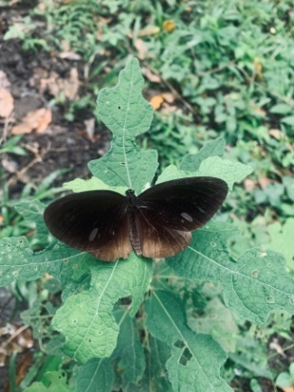
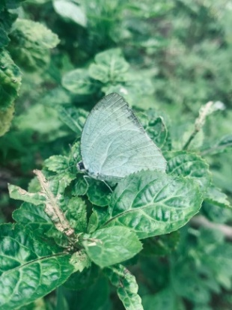
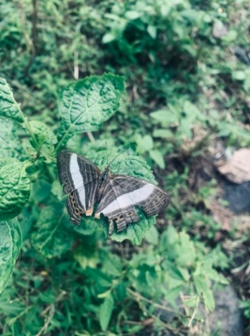
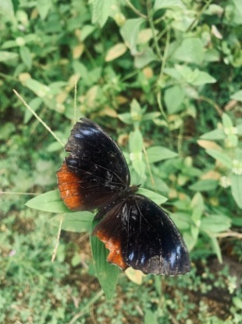

h
g
f
e

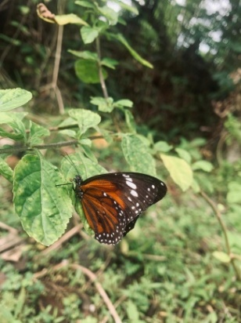
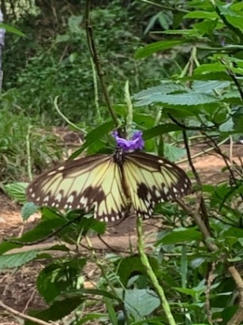
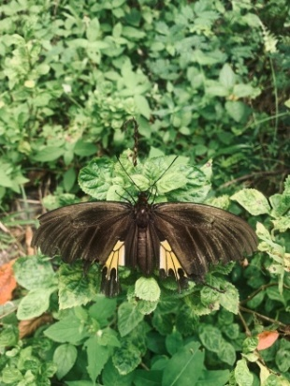
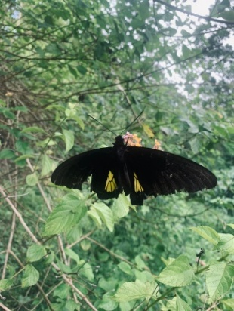

l
k
j
i

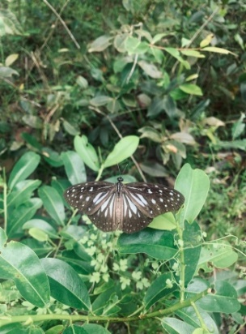
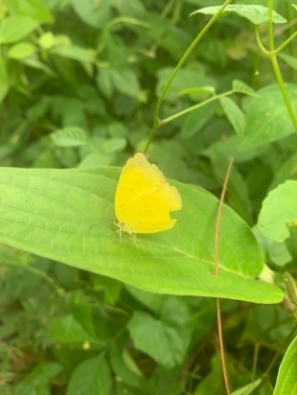
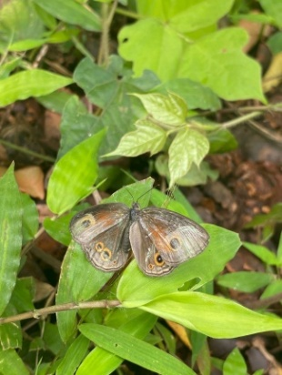
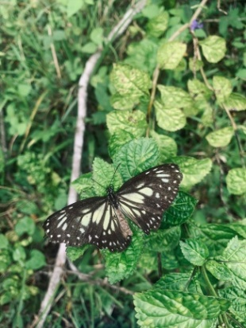

o
n
p
m

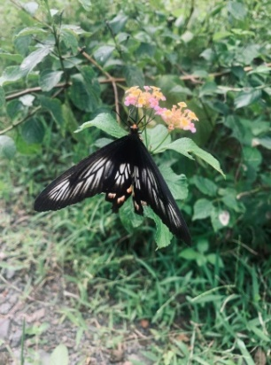
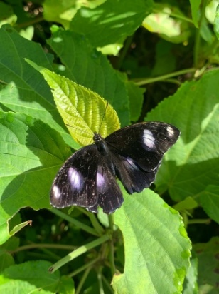

r
q

Figures 1. Types of butterflies in Tubo Village, North Ternate City and Sasa Village, South Ternate City
a. Danaus affinis  b. Catopsilia Scylla  c. Lampides boeticus  d. Pantopiria hordonia  e. Elymnias hypermnestra  f. Cyrestis acilia  g. Catopsilia pyranthe  h. euploea tulliolus  i. Troides criton | j. Troides helena  k. Ideopsis vitrea  l. Danaus genutia  m. Parantica cleona  n. Mycalesis terminus  o. Eurema hecabe  p. Ideopsis vulgaris  q. Hypolimnas bolina  r. Pachiopta polyphonte

Based on Figure 1, it is known that the dominant butterfly species at both research locations are; Tubo Village has 7 dominant types of butterflies, namely Ideopsis vulgaris, Danaus genutia, Eurema hecabe, Lampides boeticus, Pachliopta polyphontes, Catopsilia pyranthe and Mycalesis terminus. Sasa Village has 5 dominant types of butterflies, namely Eurema hecabe, Danaus genutia, Ideopsis vulgaris, Lampides boeticus and Catopsilia Scylla. The dominance of this type of butterfly is due to the high adaptability to various types of habitats, the availability of abundant host plants, as well as a source of feed in the form of nectar, which is easily found in gardens and shrubs. In addition, these species have relatively short life cycles and flexible foraging behavior so that their populations can grow faster than other species. The difference in the number of dominant species between the two locations shows that Tubo Sub-District has a more terrogenic habitat with extensive gardens and shrubs, thus supporting the existence of more dominant species, while in Sasa Sub-District the more open habitat conditions and higher environmental pressures cause only a few types of generalist butterflies to survive and dominate [12].
Diversity of local butterfly species in North Ternate and South Ternate
The results of research on the diversity of local butterfly species in North Ternate and South Ternate using time search method with an area limitation of 100 m x 50 m. The results of the study of species diversity of local butterflies in North Ternate and South Ternate have been shown in Table 1.

Tabel 1 Jumlah Individu Kupu-kupu di Ternate Utara dan Ternate Selatan
No | Species Name | Amount | H’ Value
1 | Eurema hecabe | 65 | -0,31
2 | Pachliopta polyphontes | 17 | -0,14
3 | Troides criton | 7 | -0,07
4 | Cyrestis acilia | 5 | -0,60
5 | Danaus genutia | 67 | -0,31
6 | Ideopsis vulgaris | 71 | -0,32
7 | Elymnias hypermnestra | 4 | -0,05
8 | Mycalesis terminus | 20 | -0,16
9 | Catopsilia pyranthe | 14 | -0,12
10 | Lampides boeticus | 32 | -0,21
11 | Troides Helena | 4 | -0,05
12 | Danaus affinis | 9 | -0,09
13 | Parantica cleona | 5 | -0,06
14 | Pantoporia hordonia | 11 | -0,10
15 | Catopsilia Scylla | 14 | -0,12
16 | Hympolimnas bolina | 2 | -0,02
17 | Ideopsis vitrea | 1 | -0,01
18 | Euploea tulliolus | 3 | -0,04
 | Amount | 351 | 2,32

Based on the results of the analysis of local butterfly diversity index in North Ternate and South Ternate obtained results of H ' = 2.32 which is categorized as medium butterfly diversity mediumbased on the criteria of diversity index value Shannon Wienner Mangurran [11]. This shows that the number of types of butterflies varies quite a lot, but the level of diversity is not very high.
The conditions can be caused by several factors. First, there is a predominance of certain types whose population is higher than other types so that the distribution of individuals between species is uneven. Second, environmental factors such as the availability of host plants and nectar sources have not varied optimally, so they only support the presence of certain species. In addition, the pressures of human activities such as land conversion, logging, or conservation of green areas can also affect the presence and spread of butterflies in a location.
This explanation is in line with opinion [13] which states that the level of butterfly diversity is influenced by the availability of vegetation as habitat, feed sources, and the level of human disturbance in the ecosystem. Similarly[14] adding that low butterfly diversity can occur due to the dominance of certain species as well as limited habitat resources (such as host vegetation and feed sources) that do not support all types equally.
Abundance of local butterfly species in North Ternate and South Ternate
The results of the study on the abandonment of local butterfly species in North Ternate and South Ternate using time search method with an area limitation of 100 m x 50 m. The results of the study abandonment of local butterfly species in North Ternate and South Ternate have been shown in Table 2.
Chart 2. The number of individual butterflies were observed at 2 observation sites and the results of analysis of the abandonment of butterflies in North Ternate and South Ternate.
No | Family | Amount | Relative Abundance (%)
1 | Nymphalidae | 198 | 56,41
2 | Pieridae | 93 | 26,49
3 | Lycaenidae | 32 | 9,11
4 | Papilionidae | 28 | 7,97
 | Amount | 351 | 100%

Based on the data of Table 2 of the analysis of the abandonment index of local butterflies in North Ternate and South Ternate obtained results spread 100%, then the category of abandonment is high in these two locations based on the criteria of abandonment index value Odum (1993) in [15] This is thought to be because environmental conditions at both locations are still able to provide abundant resources.
Environmental conditions that are able to provide the basic needs of butterflies, both in the form of host plants for larvae and food sources in the form of flower nectar for imago. The availability of sufficient and diverse feed resources allows butterflies to survive in a large number of populations. In addition, the butterflies found are dominated by species that have high adaptability to variations in habitat conditions, making it easier to breed and dominate the community.
This explanation is in line with opinion [15] which states that the high abundance of butterflies is influenced by certain dominance which is able to adapt well to local environmental conditions and utilize available feed plants. Meanwhile,[7] adding that butterfly families such as Nymphalidae tend to be abundant because they have a wide range and generalist characteristics in choosing host plants and feed sources, so their presence often dominates communities in various habitats.
Family Nymphalidae has the highest relative abundance of 56.41% with the number of individuals as many as 198 individuals, thus becoming the most dominant family in the study site. Family Pieridae ranks second with 93 individuals or 26.49.49%. Furthermore, family Lycaenidae recorded as many as 32 individuals 9.11% and family papilionidae has the lowest relative abundance of 7.97% with a total of 28 individuals. The dominance of Nymphalidae is suspected because this family has a high adaptability to environmental conditions, so it can be found in various types of habitats, both forests, gardens, and open areas. In addition, Nymphalidae utilize a variety of host plants and nectar sources, making it easier to obtain Oak than other families. Their relatively high reproductive ability also supports their abandonment in nature. These factors make Nymphalidae more common than Pieridae, Lycaenidae and Papilionidae[16];[17].
Family Papilionidae has the lowest relative abundance is thought to be because Papilionidae generally have a high specialization of certain host plants, so that the population is highly dependent on the availability of specific vegetation suitable for larval development. If the host plant is limited in number or not even distributed at the research site, then the number of Papilionidae is also low. In addition, this family generally requires relatively stable habitat conditions and minimal disturbance, so that in ecosystems that have undergone changes or fragmentation, their existence becomes less in the family of butterflies that are generational. These results are in accordance with the findings [16] which states that the low abundance of Papilionidae is closely related to limited feed sources, larval specialization, and sensitivity to habitat changes.
Environmental Data
Observation of environmental factors was conducted to determine abiotic conditions that can affect the presence of butterflies at the research site. Parameters measured include air temperature, light intensity, and relative humidity. The results of measurements at two research sites, namely North Ternate and South Ternate can be seen in Figure 2 below.

40
KT Moisture
30
20
Temperature
10

-40
10 20 30 40
-30
-20
-10
-10
-20
Light Intensity
KS
-30

-40

Figure 2. Data on environmental influences on the diversity and abundance of butterflies in Ternate Island.
Based on Figure 2, environmental factors such as temperature and humidity correlate positively, while light intensity correlates negatively to the diversity and abandonment of butterflies on Ternate island. This shows that in North Ternate and South Ternate, increasing temperature and humidity tend to support the diversity and abandonment of butterflies on Ternate island, while increasing light intensity has the potential to decrease. In addition to abiotic environmental factors, habitat types also play an important role in determining diversity and abundance.
Temperature and humidity are environmental factors that play an important role in supporting the existence of butterflies. Relatively warm temperatures help increase the physical activities of butterflies, such as flight, foraging, and reproduction. Meanwhile, the high humidity is able to maintain the balance of body fluids such as butterflies support the availability of green vegetation as a host plant larvae as well as a source of food in the form of nectar for imago.[18]
Conclusion
The diversity of local butterflies in Ternate island, especially in North Ternate and South Ternate is categorized as moderate diversity with high abundance. The results of butterfly collection and identification were obtained by 351 individuals consisting of 18 types of local butterflies from 4 Families Nymphalidae, Pieridae, Lycaenidae, and Papilionidae.
Advice
Habitat conservation needs to be improved, especially maintaining the availability of host plants and feed sources for butterflies, so that the more specific Papilionidae family remains sustainable. As well as environmental education to local communities about the importance of butterflies as pollinators need to be improved in order to support conservation efforts.
BIBLIOGRAPHY
[1] P. C. Latue, “Analisis Spasial Temporal Perubahan Tutupan Lahan di Pulau Ternate Provinsi Maluku Utara Citra Satelit Resolusi Tinggi,” Buana J. Geogr. Ekol. dan Kebencanaan, vol. 1, no. 1, pp. 31–38, 2023, doi: 10.56211/buana.v1i1.339.
[2] E. Tukuboya, A. Kurniawan, and A. Fatrawana, “Keanekaragaman Jenis Kupu-Kupu (Rhopalocera) Di Sungai Oba Kecamatan Oba Utara Kota Tidore KepulauanKeanekaragaman Jenis Kupu-Kupu (Rhopalocera) Di Sungai Oba Kecamatan Oba Utara Kota Tidore Kepulauan,” J. For. Isl., vol. 2, no. 2, pp. 6–13, 2024, doi: 10.33387/foris.v2i2.157.
[3] N. Jainuddin, “Dampak Deforestasi Terhadap Keanekaragaman Hayati Dan Ekosistem,” J. Humaniora, Sos. Dan Bisnis, vol. 1, no. 2, pp. 131–140, 2023.
[4] L. Muhelni, “Inventarisasi Kupu-Kupu (Rhopalocera) pada Kawasan Tempat Pembuangan Akhir (TPA) Air Dingin, Balai Gadang, Kota Padang,” Biosf. J. Biol. dan Pendidik. Biol., vol. 7, no. 2, 2022, doi: 10.23969/biosfer.v7i2.6884.
[5] H. Ruslan, A. Satiyo, and Y. Yenisbar, “Keanekaragaman kupu-kupu (Lepidoptera: Papilionoidea) di Kawasan Pusat Pendidikan Konservasi Alam Bodogol, Taman Nasional Gunung Gede Pangrango, Jawa Barat,” J. Entomol. Indones., vol. 20, no. 1, pp. 10–21, 2023, doi: 10.5994/jei.20.1.10.
[6] H. Raya, T. Provinsi, S. Tengah, N. M. Manopo, and A. Sudhartono, “KEANEKARAGAMAN JENIS KUPU-KUPU ( Lepidoptera ) DI KAWASAN TAMAN,” vol. 22, no. 4, pp. 365–371, 2024.
[7] S. Hengkengbala, R. Koneri, and D. Katili, “Keanekaragaman Kupu-Kupu di Bendungan Ulung Peliang Kecamatan Tamako Kepulauan Sangihe, Sulawesi Utara,” J. Bios Logos, vol. 10, no. 2, p. 63, 2020, doi: 10.35799/jbl.11.2.2020.28424.
[8] A. Walid, F. Turahmah, and P. Ismarliana, “Ekologia : Jurnal Ilmiah Ilmu Dasar dan Lingkungan Hidup,” Ekol. J. Ilm. Ilmu Dasar dan Lingkung. Hidup, vol. 20, no. 1, pp. 40–44, 2020, [Online]. Available: https://journal.unpak.ac.id/index.php/ekologia
[9] A. Mas’ud, A. D. Corebima, A. Haerullah, S. Hasan, and A. Alisi, “Jenis Kupu-Kupu Pengunjung Bunga Mussaenda Dan Asoka Di Kawasan Cagar Alam Gunung Sibela Pulau Bacan,” J. Biol. Trop., vol. 19, no. 2, pp. 189–196, 2019, doi: 10.29303/jbt.v19i2.1108.
[10] F. Anita, A.- Salatalohy, and A. K. Kamaluddin, “Keanekaragaman Jenis Kupu-Kupu Di Kawasan Air Terjun Tiga Bidadari Kecamatan Wasile Timur Kabupaten Halmahera Timur,” Makila, vol. 18, no. 1, pp. 103–114, 2024, doi: 10.30598/makila.v18i1.10634.
[11] A. Mas’ud, W. Hariswan, S. Sundari, and M. N. Tamalene, “New Record of Diversity and Distribution Pattern of Local Butterfly in Ternate Island,” J. Biol. Trop., vol. 22, no. 4, pp. 1328–1333, 2022, doi: 10.29303/jbt.v22i4.4354.
[12] H. Ruslan, A. Satiyo, and Y. Yenisbar, “Keanekaragaman kupu-kupu (Lepidoptera: Papilionoidea) di Kawasan Pusat Pendidikan Konservasi Alam Bodogol, Taman Nasional Gunung Gede Pangrango, Jawa Barat,” J. Entomol. Indones., vol. 20, no. 1, p. 10, 2023, doi: 10.5994/jei.20.1.10.
[13] R. Setiawan, A. M. Siddiq, S. Sudarmadji, and N. A. Wulansari, “Keanekaragaman Spesies Kupu-Kupu (Lepidoptera:Rhopalocera) Di Savana Pringtali Resort Bandealit Taman Nasional Meru Betiri,” BIOLINK (Jurnal Biol. Lingkung. Ind. Kesehatan), vol. 5, no. 2, pp. 81–87, 2019, doi: 10.31289/biolink.v5i2.1786.
[14] D. M. Sari and M. T. Harmoko, “Keanekaragaman Jenis Kupu-Kupu (Lepidoptera) Di Kawasan Curug Panjang Desa Durian Remuk Kecamatan Muara Beliti Kabupaten Musi Rawas,” Pros. Semin. Nas. Hayati, vol. 7, no. September, pp. 138–143, 2019, [Online]. Available: https://proceeding.unpkediri.ac.id/index.php/hayati/article/view/588
[15] D. R. Sari, M. Hadi, and R. Rahadian, “Kelimpahan dan Keanekaragaman Kupu-kupu di Kawasan Taman Nasional Gunung Merbabu, Jawa Tengah,” Bioma Berk. Ilm. Biol., vol. 18, no. 2, p. 173, 2016, doi: 10.14710/bioma.18.2.173-179.
[16] A. S. Modeong, R. Koneri, and F. D. J. Dapas, “Kelimpahan dan Keanekaragaman Kupu-Kupu Nymphalidae di Hutan Kota Kuwil Minahasa Utara Sulawesi Utara,” J. MIPA, vol. 9, no. 2, p. 70, 2020, doi: 10.35799/jmuo.9.2.2020.28893.
[17] D. Wakano and D. D. Moniharapon, “DIVERSITY OF BUTTERFLY Lepidoptera IN THE CAMPUS AREA OF PATTIMURA UNIVERSITY AMBON MALUKU,” RUMPHIUS Pattimura Biol. J., vol. 1, no. 2, pp. 058–062, 2019, doi: 10.30598/rumphiusv1i2p058-062.
[18] N. Millah, “Diversitas dan peranan ekologi kupu-kupu (Rhopalocera) di Area Blok Ireng-Ireng kawasan Taman Nasional Bromo Tengger Semeru,” 2020, [Online]. Available: http://digilib.uinsby.ac.id/id/eprint/42958

