**E-ISSN-2580-7129**

**Print- ISSN-1978-6107**

**TECHNO: JURNAL PENELITIAN**

**Journal homepage**: [**http://ejournal.unkhair.ac.id/index.php/Techno**](http://ejournal.unkhair.ac.id/index.php/Techno)

**Issue 09 Number 02 October 2020** DOI: http://dx.doi.org/10.33387/tk.v9i2



**Forecasting of Significant Wave Height and Period at Western Waters of Ternate Island, North Maluku**

**Mohammad Ridwan Lessy1, RommyM.Abdullah2**

*1 Marine Science Department, Fisheries and Marine Science Faculty, Universitas Khairun – Indonesia*

*Email:* [*mrlessy8375@gmail.com*](mailto:mrlessy8375@gmail.com)

*2 Marine Science Department, Fisheries and Marine Science Faculty, Universitas Khairun – Indonesia*

*Email:* [*ade.rommy2012@gmail.com*](mailto:ade.rommy2012@gmail.com)

*Received:*

*Accepted:*

*Available online:*

**ABSTRACT**

The water of West Ternate Island is open waters which are very dynamic oceanographic conditions. One of them is ocean waves that are strongly related to wind friction. This study aims to analyze the height and wave period that occurred in the western part waters of Ternate Island based on wind data for 10 years. It is expected that the results of this study will be useful for policymakers in the sustainable management of coastal areas in Ternate City. The data collected includes the maximum wind direction and speed during the period 2009-2018 obtained from the Meteorological and Geophysical Station of Baabullah Airport, Ternate City. The results showed that in The West Season and Transition Season 1 (TS 1), the wind direction is more dominant moving from the Northwest to the Southeast with an average maximum speed of 17.71 knots. During the observation year, significant wave height (Hs) formed in the Western Season period as high as 1.25 m – 2.75 m while in Transition Season 1 the wave height was between 1.0 m – 2.31m. While in the Eastern Season period the wave height that occurs ranges from 0.61 m – 1.55 m and in the MP2 period ranges from 0.67 m – 1.43 m. In the Western Season, the wave period ranges from 4.67 – 6.82 seconds, and in Transition Season 1 between 4.45 – 6.44 seconds. While in the eastern season the wave period ranges from 3.29 – 4.89 seconds and in Transition Season 2 (TS 2) ranges from 3.43 – 4.68 seconds.

**Keywords**: Significant Waves; Height and Length Waves; Ternate Island; Coastal Area

**ABSTRAK**

Perairan bagain Barat Pulau Ternate merupakan perairan terbuka dengan kondisi oseanografi yang sangat dinamis. Salah satunya adalah gelombang laut yang sangat berkaitan dengan gaya gesek angin. penelitian ini bertujuan untuk menganalisis tinggi dan periode gelombang yang terjadi di perairan bagian Barat Pulau Ternate berdasarkan data angin selama 10 tahun. Diharapkan hasil penelitian ini menjadi bahan masukan bagi pengambil kebijakan dalam pengelolaan wilah pesisir di Kota Ternate berkelanjutan. Data yang dikumpulkan meliputi arah dan kecepatan angin maksimum selama periode tahun 2009-2018 yang diperoleh dari Stasiun Meteorologi dan Geofisika Bandara Baabullah Kota Ternate. Hasil penelitian memperlihatkan bahwa pada Musim Barat dan Musim Peralihan 1 (MP1), arah angin lebih dominan bergerak dari arah Barat Laut menuju Tenggara dengan kecepatan maksimum rata-rata 17.71 knot. Selama tahun pengamatan, tinggi gelombang signifikan (*Hs*) yang terbentuk pada periode Musim Barat setinggi 1,25 m – 2,75 m sedangkan pada MP1 tinggi gelombang antara 1,0 m – 2,31m. Sementara pada periode Musim Timur tinggi gelombang yang terjadi berkisar antara 0,61 m – 1,55 m dan pada periode MP2 berkisar antara 0,67 m – 1,43 m. Pada Musim Barat, periode gelombang berkisar antara 4,67 – 6,82 detik dan pada MP1 antara 4,45 – 6,44 detik. Sedangkan pada Musim timur periode gelombang berkisar antara 3,29 – 4,89 detik dan pada MP2 berkisar antara 3,43 – 4,68 detik

**Kata Kunci:** Gelombang Signifikan; Tinggi dan Periode Gelombang; Pulau Ternate; Pesisir Pantai

**INTRODUCTION**

The phenomenon of highly dynamic oceanographic parameters has made the main object of research continuously carried out by many experts. Such phenomena are strongly related to each other e.g., wind and waves. Those are very related and contribute to the condition of the water. The wind itself with enough energy can generate waves in the waters. Consequently, the waves will move in the direction of movement of the wind by carrying a certain amount of water mass. And finally, it will arrive at the coastal direction in the form of surging waves. Waves that arrive on the beach can increase abrasion and sedimentation because they can generate longshore currents.

Generally, the movement of wind in Indonesia is strongly affected by the Munson wind cycle. According to Roem et al., (2013) Northwest monsoon winds in this region occur during December – February (Western Season) and Southeast monsoon winds during June – August (Eastern Season), while April – May and October – November is known as the early-year, and year-end Transition Seasons (TS). Therefore, the movement of wind direction is always changing and affecting the wave movement in the ocean every year.

The high and the period of ocean wave depends on the wind speed, the length of the wind blowing and the essential constant direction of wind blow (fetch length). According to Triatmojo, (1999) there is a strong relationship between the length and speed of the wind blowing and the waves generated in the waters, where the longer and stronger of wind blows, the greater the wave will be formed. In addition, Latimba et al., (2020), states that fetch also limits the formation of waves high because it affects the transfer of wind energy to waves. Therefore, wind data obtained can be used to analyze high and wave periods formed in the ocean. Several studies have been conducted to predict wave height using wind data such as Lubis & Khoirunnisa, (2016) on the dynamics of Praikalogu beach in West Nusa Tenggara Province; Purwono & Sismiani, (2018) on Forecasting the occurrence of coastal waves at Watunohu with an empirical approach of wind data analysis; and also Supiyati, (2008) with the title of analysis of sea wave height forecasting with a re-period using the Gumbel Fisher Tippet-type 1 method ; case study on Baai Island waters, Bengkulu.

Ternate Island is one of the islands in North Maluku Province which geographically has an area of 162.03 Km2 and is surrounded by the sea. As a small island, Ternate becomes a center of government of Ternate City so that all community activities and development are carried out on this island. Due to surrounded by the sea, the oceanographic phenomenon, especially the currents and waves greatly affect the coastal area of the Ternate island. But unfortunately, the lack of research on oceanographic conditions especially related to wave forecasting in this area makes the information about it was rare. Even though there are two research had conducted by Sofyan et al., (2010) and Angkotasan et al., (2017) about the wave in Ternate island but those studies focused on changing of Ternate coastal environment. Therefore, this study aims to analyze the height and wave period that occurred in the western part waters of Ternate Island based on wind data for 10 years. It is expected that the results of this study will be useful for policymakers in the sustainable management of coastal areas in Ternate City.

**MATERIALS AND METHOD**

This research was located in the western part waters of Ternate which is a part of the Maluku sea (Figure 1). The data collected includes the maximum wind direction and speed during the period 2009-2018 obtained from the Meteorological and Geophysical Station of Baabullah Airport, Ternate City. Then, the data will be sorted by Western Season (December–February), Transition Season 1 (March–May), Eastern Season (June–August), and Transition Season 2 (September–November) (Purwanto et al., 2020).



Figure 1. Study Location Map

Several calculations will be used to obtain wave height and period in this study. The first, Analyzing the wind data to obtain the dominant wind direction and fetch length using WRPLOT freeware 8.0.2. Then, both data are used to calculate wave height and period. Due to the wind data measurements are performed at an altitude of more than 10 meters, this data should be transformed into wind speed data at the sea surface. To transform the wind data is given by Supiyati, (2008); Wakkary et al., (2017) as:



Where: *U (10*) = Wind speed at an altitude of 10 m.

z = Wind measurement height

Furthermore, wind data transformation is then used to calculate stability correction value (*U*) and wind stress factor (*Ua*) based on formula: (Parauba et al., 2016); Satriadi, (2017);



Next, the calculation of fetch effective length by determining the effective distance of wind blow which is generates waves on the sea surface. The Sverdrup, Munk, and Bretschneider (SMB) methods were used to determine the fetch effective length where the dominant wind direction becomes the axis fetch line approximately 45o to the right and the left at intervals of 6o: (Satriadi, 2017).



Where:

*Feff*: Fetch effective

*F*: The length of the fetch segment measured from the wave observation point to the end of the fetch.

*α*: Deviation on both sides of the wind direction, using an increase of 6º to an angle of 42º on both sides of the wind direction

The next calculation is forecasting of wave height significant (Hs) and wave period (Ts) significant in shallow water. This calculation is based on the Wilson method; (Ukkas, 2009):



Where:

*Hs* = Significant wave height (m)

*Ts* = Significant wave period (sec)

*U* = Wind stress factor (m/ sec)

*F* = Fetch Effective (m)

*g* = Earth's gravity (m/det 2) = 9.8 m/sec 2

*π* = 3.14

**RESULTS AND DISCUSSION**

**Wind Directions and Speed**

To facilitate information on the direction of wind movement, eight directions of wind roses were used in this study. The interpretation results of wind direction movement as presented in figure 2. From this figure, The Western Season and Transition Season 1 (TS1), the wind direction is more dominant moving from Northwest to Southeast by 75% in the Western Season and 45% in TS1. While in the Eastern Season, the wind direction that occurs in the western waters of Ternate Island moves from the South to the North by 42% and in The Transition Season 2 (TS2) the dominant wind direction moves from the South by 21%, from the Southwest by 24% and from the North by 18%. According to Sofyan et al (2010) wind speeds in the coastal areas of Ternate city in the Northern Season vary where the wind moves from the Northwest towards the Southeast and in the South Season, the wind moves from the South to the North. While Angkotasan et al (2012) state the dominant wind speed in the waters of Ternate City moved from the Northwest by 23.64 %, the South direction by 20.42%, and the West by 15.77%.

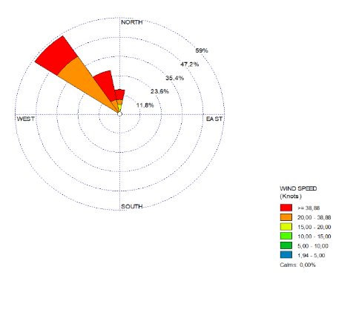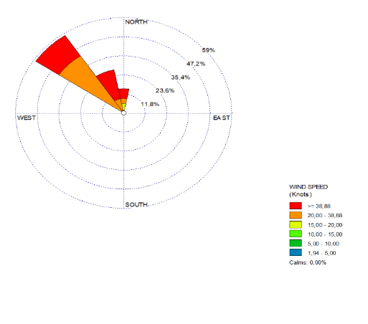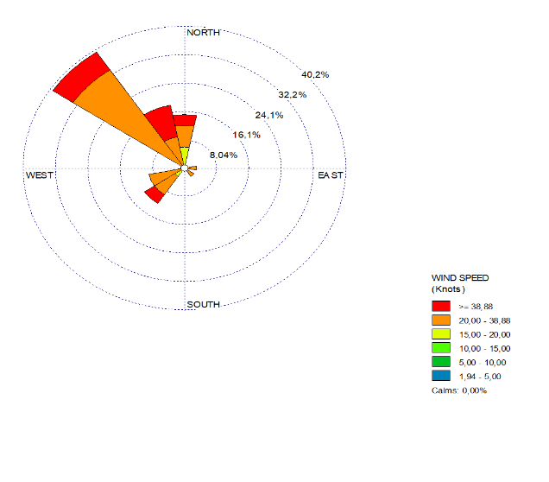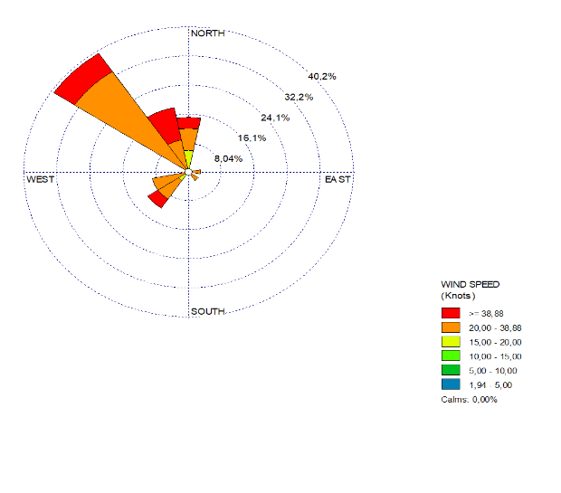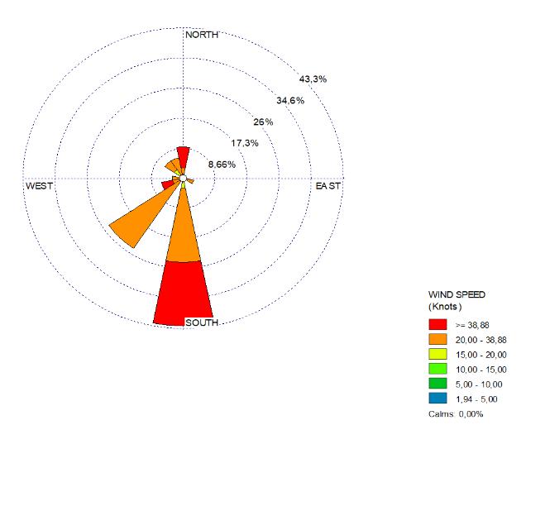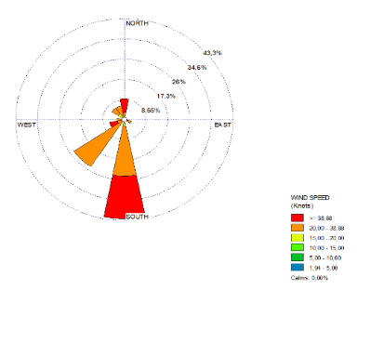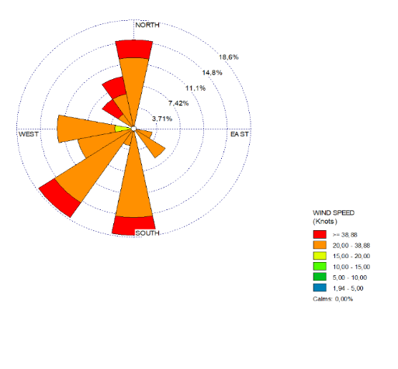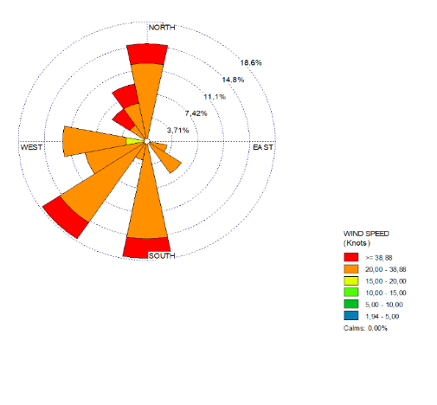

(a)

(b)

(c)

(d)

Figure 2. Wind Roses in (a) West Season; (b) TS1; (c) East Season; and (d) TS2

It can be stated that the movement of wind direction in the western part waters of Ternate Island is dominantly moving from the Northwest, South, and North while from the East the wind movement is very small. This is because of the geographical condition of Ternate Island where the distance of land that barriers wind blows quite large. On the other hand, in the eastern part of Ternate Island, fetch is blocked by Halmahera Island that extends to the South. Mentioned by Purwanto et al., (2020) that the geographical condition of the observation site and wind flow barriers (fetch) such as land or surrounding islands greatly affect the direction and speed of the wind moving.

The results of maximum wind speed analysis during 2009 – 2018 showed that along this period, the maximum wind speed ranged from 11 – 37 knots with an average maximum speed of 17.71 knots. The largest maximum wind speeds recorded in 2011 were 37 knots while the lowest occurred in 2012 and 2017 at 11 knots. While based on the distribution of maximum wind speed frequencies for each period of the season shows that in all four periods the season is dominated by a speed of 20 -38 knots with a percentage of 54.5% - 81.8% (figure 3). The distribution of wind speed events shown in figure 3 also informs that the Western Season has a high wind speed (>38 knots) with a frequency of 39.4% while in the Eastern Season the frequency of wind speed >38 knots was 27.3%. While in TS1 and TS2, wind speeds above 38 knots were only 21% and 15%.

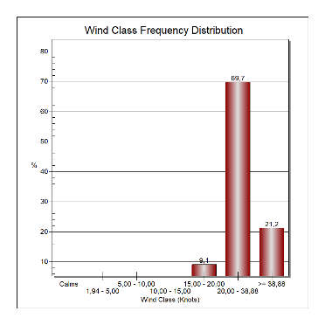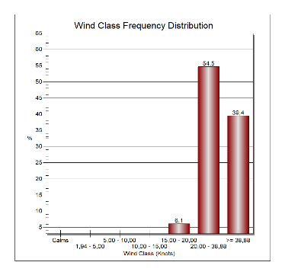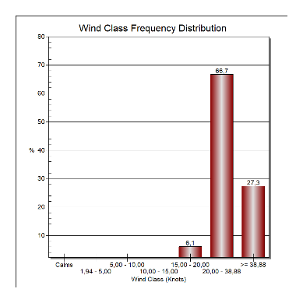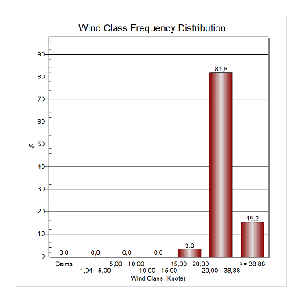

(a)

(b)

(c)

(d)

Figure 3. Distribution of maximum wind speed in (a) West Season; (b) TS1; (c) East Season; and (d) TS2

Next, the measured wind data is transformed to obtain wind speed on the sea surface. The results of the calculation of maximum wind speed transformation at the study site are presented in table 1. Based on the table it appears that the maximum wind speed at an altitude of 10 m (*U10*) throughout the Season ranges from 3.90 m/sec – 16.47 m/sec. While the corrected wind speed value (*U*) is between 4.29 m/sec – 18.12 m/sec and the wind voltage factor (*Ua*) ranges from 4.26 m/sec – 25.04 m/sec.

Table 1. Wind Speed Transformation in All Seasons at Study Site

|  |  |  |  |  |  |  |  |  |  |
| --- | --- | --- | --- | --- | --- | --- | --- | --- | --- |
| Seasons | *U10 (m/det)* | | | *U (m/det)* | | | *Ua (m/det)* | | |
| Min | Max | Average | Min | Max | Average | Min | Max | Average |
| West Season | 6,50 | 16,47 | 8,65 | 7,15 | 18,12 | 9,52 | 7,98 | 25,04 | 11,45 |
| TS1 | 4,33 | 13,00 | 7,41 | 4,77 | 14,30 | 8,15 | 4,85 | 18,72 | 9,45 |
| East Season | 3,90 | 13,44 | 7,48 | 4,29 | 14,78 | 8,23 | 4,26 | 19,49 | 9,63 |
| TS2 | 4,33 | 13,00 | 7,21 | 4,77 | 14,30 | 7,93 | 4,85 | 18,72 | 9,15 |

The analysis results of wind movement direction that has been shown on wind roses indicate the dominant wind direction on each Season could be used to determine the fetch effective. The calculation results show that in the Western Season and TS1 the fetch effective is 547.98 km while in the Eastern Season and TS2 is 122.06 km. The difference in the result due to the barriers in the Western part of Ternate Island facing the Maluku Sea and Sulawesi Island which is quite wide and a considerable distance. While in the Southern part there is numerous island that affects the fetch formed.

**Forecasting High and Periods of waves**

Based on the wind movement calculation, this study obtained high and period of waves in the Western part waters of Ternate Island in each season (Figures 4 and 5). In figure 4, indicates that the West Season has a significant wave height higher than other periods of seasons. This is related to the wind blows quite strongly from the Northwest that occurs in this season. This result is supported by Angkotasan et al (2012) that state the wave height in the West season is influenced by the large wind speed that blows from the Northwest to the Ternate island. During the observation year, significant wave height (*Hs*) formed in the West Season period as high as 1.25 m – 2.75 m and in TS1 between 1.0 m – 2.31m. While in the East Season period the wave height that occurs ranges from 0.61 m – 1.55 m and in the TS2 ranges from 0.67 m – 1.43 m (Figure 4). Kurniawan et al., (2011) mention that in the West Season, the waters bordering the Pacific Ocean, including the Maluku Sea, have a significant wave height between 1.5 – 2.5 m, while in TS1, the significant height waves in the Maluku Sea ranges from 1.25 – 2 m. Furthermore, in the East Season, the height of significant waves in this area is decreasing between 0.5 – 1.25 m and TS2 wave height between 0.5 – 0.75m.

Figure 4. The Significant Wave Height at Western Part Waters of Ternate Island during 2009-2018

According to the significant wave periods (*Ts*) result, shown in figure 5, that during the Western Season, the wave period ranged between 4.67 – 6.82 seconds and in TS1 between 4.45 – 6.44 seconds. While in the eastern season the wave period ranges from 3.29 – 4.89 seconds and in TS2 ranges from 3.43 – 4.68 seconds. This result implies that there is a correlation between wind speed, fetch effective, and significant wave height in the study location.

Figure 5. Significant Wave Periods at Western Part Waters of Ternate Island during 2009-2018

The wave forecasting model in the study used a wind data transformation based on the theory that wind blowing above the ocean would transfer its energy to the sea surface. This is because wind speed generates tension at the sea surface, so the previously calm will be disturbed and cause small ripples. Several studies have been conducted to analyze the height and period of significant waves in some regions in Indonesia provided in table 2.

From table 2, it can be seen that in the West Season, the wind blowing generates quite high waves in all the study locations. Then the height of the wave significantly decreased in the following season period (TS 1, East Season, and TS 2). The same result is also seen in wave periods where the largest wave periods are found in the West season and decrease in subsequent seasons. This condition according to Kurniawan et al., (2011) that in the West season, the consistent wind blows over Indonesia region causing heightened ocean waves in this area. On the contrary, in the transition season 1 and 2, wind speed is reduced. Consequently, the waves are also low compared to the Western and Eastern Seasons.

Table 2. Average Height and Wave Period in Each Season in Indonesia

|  |  |  |  |  |  |  |  |  |  |
| --- | --- | --- | --- | --- | --- | --- | --- | --- | --- |
| Wave Height (*Hs)* | | | | Wave Period *(Ts)* | | | | Study Location | Sources |
| West Season | TS1 | East Season | TS2 | West Season | TS1 | East Season | TS2 |  |  |
| 1,61 | 0,80 | 1,40 | 1,33 | 5,62 | 3,81 | 4,63 | 4,55 | Pulau Lirang, Kabupaten Maluku Barat Daya | Purwanto et al (2020) |
| 1,23 | 1,10 | 0,63 | 0,58 | 5,18 | 4,85 | 3,56 | 3,40 | Perairan Semarang | Satriadi (2017) |
| 0,15 | 0,11 | 0,11 | 0,12 | 1,61 | 1,37 | 1,39 | 1,59 | Tanjung Kalian, Kabupaten Bangka Barat | Azizi et al (2017) |
| 1,01 | 0,83 | 0,55 | 0,66 | 5,21 | 4,90 | 4,36 | 4,59 | Perairan Timbulsloko, Kabupaten Demak | Astuti et al (2016) |
| 1,80 | 1,38 | 1,06 | 0,99 | 5,77 | 5,11 | 4,08 | 4,01 | Perairan Barat Pulau Ternate | This Study |

**CONCLUSION**

The variety of waves formed in the western part waters of Ternate Island is strongly related to seasonal wind patterns occurring in this region. During the West Season and the Transition Season 1, the wind blows from the Northwest. While in the East Season, and the Transition Season 2, the wind blows more from the South. There is a significant relationship between the speed and duration of the wind blowing, effective fetch, height, and period of the wave. It is noticeable that the High and significant wave periods occur in the West season and Transition Season 1 where the maximum wind speed moves and the fetch distance formed is quite large compared to what happens in the East Season and Transition Season 2. The continue research should be conducted to improve and to analyze other problems due to ocean waves such as impact of the waves to the coastal area, tourism destination, and coastal abrasion.

**REFERENCES**

Angkotasan, A. M., Nurjaya, I. W., & Natih, N. M. N. (2017). Analisis Perubahan Garis Pantai Di Pantai Barat Daya Pulau Ternate, Provinsi Maluku Utara. *Jurnal Teknologi Perikanan Dan Kelautan*, *3*(2), 11–22. https://doi.org/10.24319/jtpk.3.11-22

Kurniawan, R., Habibie, M. N., & Suratno, S. (2011). Variasi Bulanan Gelombang Laut Di Indonesia. *Jurnal Meteorologi Dan Geofisika*, *12*(3), 221–232. https://doi.org/10.31172/jmg.v12i3.104

Latimba, Y., Sukri, A. S., & Putri, T. S. (2020). *Peramalan tinggi dan periode gelombang pada pantai tinobu lasolo konawe utara 1 1*. *8*, 59–70.

Lubis, M. Z., & Khoirunnisa, H. (2016). Dinamika Pantai Praikalogu Di Provinsi Nusa Tenggara Barat, Indonesia. *Jurnal Integrasi*, *8*(2), 125–133.

Parauba, R., Jasin, M. I., Jeffrey., & Mamoto, D. (2016). Analisis Karakteristik Gelombang Pecah di Pantai Niampak Utara. *Jurnal Sipil Statik*, *4*(10), 595–603.

Purwanto, RikiTristanto, Handoyo, G., Trenggono, M., & Suryoputro, A. A. D. (2020). *Analisis Peramalan dan Periode Ulang Gelombang di Perairan Bagian Timur*. *02*(1).

Purwono, N. A. S., & Sismiani, A. (2018). Peramalan Kejadian Gelombang Pantaiwatunohudengan Pendekatan Empiris Analisa Data Angin. *Jurnal ITeodolita*, *9*(2), 111–117.

Roem, M., Ibrahim, & Nur Alamsyah. (2013). Model Prediksi Gelombang Terbangkit Angin Di Perairan Sebelah Barat Kota Tarakan Berdasarkan Data Vektor Angin. *Jurnal Harpodon Borneo Vol.6. No.1. April. 2013 ISSN : 2087-121X*, *6*(1), 49–55.

Satriadi, A. (2017). Peramalan Tinggi dan Periode Gelombang Signifikan Di Perairan Dangkal (Studi Kasus Perairan Semarang). *Buletin Oseanografi Marina*, *6*(1), 17. https://doi.org/10.14710/buloma.v6i1.15737

Sofyan, A., Dudibiyakto, & Sahubawa, L. (2010). Kajian Erosi Marin Sebagai Penyebab Degradasi Kepesisiran Kota Ternate (The Study of Marine Erosion as A Coastal Degradation in Ternate City). *Jurnal Manusia Dan Lingkungan*, *17*(2), 89–97. https://doi.org/10.22146/jml.18707

Supiyati. (2008). Analisis Peramalan Ketinggian Gelombang Laut Dengan Periode Ulang Menggunakan Metode Gumbel Fisher Tippet-Tipe 1 Studi Kasus : Perairan Pulau Baai Bengkulu. *Jurnal Gradien*, *4*(2), 349–353.

Triatmojo, B. (1999). *Teknik Pantai* (2nd ed.). Beta Offset.

Ukkas, M. (2009). Studi Abrasi dan Sedimentasi di Perairan Bua-Passimarannu Kecamatan Sijai Timur Kabupaten Sinjai. *Akuatik*, *3*(1), 20–29. https://core.ac.uk/download/pdf/229877154.pdf

Wakkary, A. ., Jasin, M. . ., & Dundu, A. K. . (2017). Studi Karakteristik Gelombang Pada Daerah Pantai Desa Kalinaung Kab. Minahasa Utara. *Sipil Statik*, *5*(3), 167–174.