Attachment
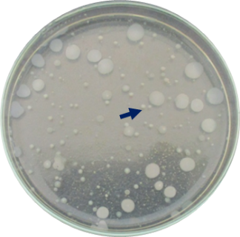
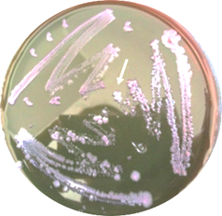

Figure 2. Colonies of E.coli bacteria on EMB-Agar medium
Figure 1. Colonies of bacteria on medium Nutrient Agar

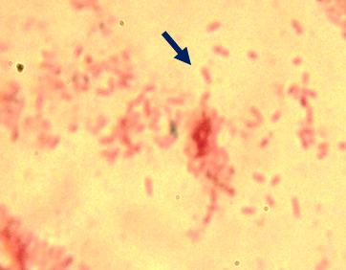
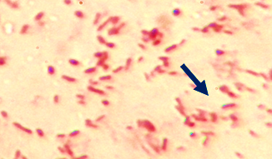

Figure 4 Proteus vulgaris Cells Gram staining results, the cell looks like a short red stem
Figure 3. Escherichia coli cells Gram staining results, the cell looks like a red stem

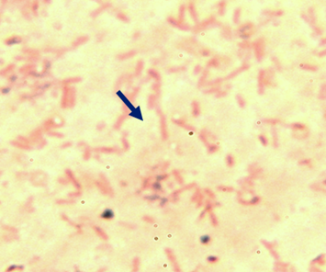
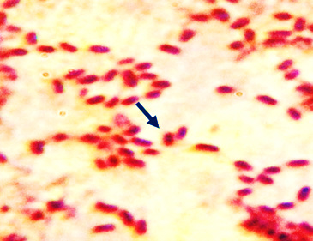

Figure 6. Cell Klebsiella pneumoniae, the cell looks like a red stem

Figure 5. Salmonella arizona bacteria cells, the cell looks like a red stem

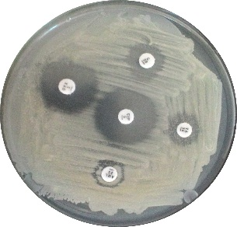
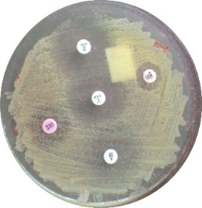

Figure 7. Antibiotic inhibition zone against Klebsiella pneumoniae
Figure 8. Antibiotic inhibition zone against Salmonella arizonae

Sample | Type of Bacteria | Validity Level (%)
A | Klebsiella pneumoniae | 79,33
B | Proteus vulgaris | 95,59
C | Escherichia coli | 82,86
D | Klebsiella pneumoniae | 97,74
E | Proteus vulgaris | 99,52
F | Escherichia coli | 82,84
G | Proteus mirabilis | 99,95
H | Salmonella arizonae | 87,74
Table 1. Microbact system biochemical test results

Validity Level results are the results of a microbat system software analysis to determine the type of bacteria that was isolated from Cockroach feet.
A to H bacterial sample code.

Table 2. The diameter of an inhibitory zone of antibiotic sensitivity test to bacteria

No |  | Type of bacteria |  | The diameter zone of antibiotic inhibition
 |  |  |  | A | B |  | C |  | D |  | E
1 | Escherichia coli |  | 12 (i) |  |  | 5 (r) |  | 0 (r) |  | 23 (s) |  | 18(s)
2 | Salmonella arizonae |  | 11 (i) |  |  | 5 (r) |  | 6 (r) |  | 20 (s) |  | 11(i)
3 | Proteus vulgaris |  | 10 (r) |  |  | 5 (r) |  | 0 (r) |  | 23 (s) |  | 20(s)
4 | Klebsiella pneunomiae |  | 9 (r) |  |  | 11(i) |  | 0 (r) |  | 22 (s) |  | 23(s)
5 | Proteus mirabilis |  | 20 (s) |  |  | 12(I) |  | 7 (r) |  | 25 (s) |  | 11(i)

The results of the measurement of bacterial sensitivity resulting from the isolation of Cockroach feet against some antibiotics, which is evidenced by the presence of bacteria that are Multi-Drug Resistant to some bacteria against antibiotics, which are commonly used in basic health services. A = Chloramphenicol, B = Amoxycillin, C = Vancomycin, D = Ciprofloxacin, E = Ofloxacin, r = resisten, i = intermediet, dan s = sensitive.

