Osmotik Word Level Teredo navalis Linnaeus 1758 in the Mangrove Root Habitat in East Halmahera, Indonesia
Yumima Sinyo¹, Asmar Hi. Daud², Kadri Daud³, Tamrin Robo⁴
1 Departement of Biology Education, Universitas Khairun, Indonesia. sinyoyumima@gmail.com
2 Departemen of Aquaculture, Universitas Khairun, Indonesia. asmarhidaud75@gmail.com
3 Departement of Mechanical Engineering, Universitas Khairun, Indonesia. kadridaud@gmail.com
4 Departemen of Geography Education, Universitas Khairun, Indonesia. Tamrinrobo.geoling18@gmail.com

ABSTRACT
This study aims to analyze the osmotic work level and pattern of osmoregulation at T. navalis in mangrove root habitats and with different salinities. This type of research is a case study using purposive sampling method. The research data were analyzed descriptively quantitatively. The sampling technique is based on tidal conditions of sea water. The research location consists of two stations, namely station I in the north and station II in the south. T. navalis samples were taken from 2 types of mangrove roots used as habitats. Analysis of the level of osmotic work using Automatic Micro Osmometer Roebling Type 13/13 DR. Salinity was measured using a refractometer. The results showed that the osmotic level of T. navalis in the root habitat of Rhizophora sp and Avicennia sp at high and low tide conditions varied, namely 523 mOsm/l H₂O, 123 mOsm/l H₂O, and 32 mOsm/l H₂O. This varying level of osmotic action results in three patterns of osmoregulation, namely hyperosmotic, hypoosmotic, and isosmotic. The results of the highest salinity analysis were found in Avicennia sp mangrove at station II, which was 31‰ and the lowest was in Rhizophora sp at low tide at station II, which was 10‰. Differences in salinity determine the osmoregulation pattern of T. navalis in different habitats.
Keywords: T. navalis, Osmotic work level, Root mangrove habitat, East Halmahera

ABSTRAK
Penelitian ini bertujuan untuk menganalisis tingkat kerja osmotik dan pola osmoregulasi pada T. navalis di habitat akar mangrove pada salinitas yang berbeda. Jenis penelitian ini adalah studi kasus dengan menggunakan metode purposive sampling. Data penelitian dianalisis secara deskriptif kuantitatif. Teknik pengambilan sampel didasarkan pada kondisi pasang surut air laut. Lokasi penelitian terdiri dari dua stasiun yaitu stasiun I di utara dan stasiun II di selatan. Sampel T. navalis diambil dari 2 jenis akar mangrove yang digunakan sebagai habitat. Analisis tingkat kerja osmotik menggunakan Automatic Micro Osmometer Roebling Type 13/13 DR. Salinitas diukur menggunakan refraktometer. Hasil penelitian menunjukkan bahwa tingkat kerja osmotik T. navalis di habitat akar Rhizophora sp dan Avicennia sp pada kondisi pasang dan surut bervariasi, yaitu 523 mOsm/l H₂O, 123 mOsm/l H₂O, dan 32 mOsm/l H₂O. Tingkat kerja osmotik yang bervariasi ini menghasilkan tiga pola osmoregulasi, yaitu hiperosmotik, hipoosmotik, dan isosmotik. Hasil analisis salinitas tertinggi terdapat pada mangrove Avicennia sp di stasiun II dengan nilai 31‰ dan terendah pada Rhizophora sp pada kondisi surut di stasiun II dengan nilai 10‰. Perbedaan salinitas tersebut menentukan pola osmoregulasi T. navalis di habitat yang berbeda.
Kata kunci: T. navalis, Tingkat kerja osmotik, Habitat akar mangrove, Halmahera Timur

INTRODUCTION
East Halmahera Regency is one of the districts in North Maluku Province which is located in the Eastern Region of Indonesia which has mangrove forests covering an area of ​​5.751.51 hectares and most of it is protected forest (Endah Widiyanti et al, 2018; Sinyo et al, 2019b). Mangrove forest is a natural resource that is unique and has a unique ecological role, and has a very high potential for nutrient storage (Sinyo et al, 2019a). Mangrove forests include natural resources that can be recovered so that they can ensure the preservation of organisms and are able to maintain the existence of habitats for sustainability in the future (Alwidakdo et al, 2014). The mangrove forest ecosystem is a plant community that grows on the coast and experiences a natural maturity phase. Mangroves grow and develop in tidal areas and are tolerant of salinity and time of inundation (Abubakar et al, 2021). The mangroves in this area are experiencing a phase of natural maturity and weathering. The productive mangrove forest area is one of the spawning grounds for aquatic biota and always gets a supply of salt and fresh water and receives and accommodates nutrients that are beneficial to aquatic organisms (Izzah & Roziaty, 2016; Swaim D, 2017).
Teredo navalis Linnaeus 1758 is an aquatic organism belonging to the Phylum Mollusca class Bivalvia Teredinidae which is also called the shipworm or mangrove worm because it lives in fragile mangrove roots (MacIntosh et al, 2014; Lippert et al, 2017). T. navalis is able to perforate fragile mangroves and make it a habitat (Appelqvist & Havenhand, 2016; Sinyo et al, 2019b) Morphologically, T. navalis .has a small shell on its head in the form of a drill that functions to make a hole, its body is naked while its head is covered with a shell, its body surface is smooth and soft like a worm and its body length reaches 30 to 70 centimeters (Voight, 2015; Eriksen et al, 2017). T. navalis can perform physiological adaptations by destroying and digesting wood assisted by cellulose and nitrogen binding bacteria and other morphological functions and utilizing wood as food (Evans et al, 2011; Appelqvist et al, 2015). T. navalis body contains protein (Setyabudi et al, 2020), and is a mangrove resource that humans need to meet the body's protein needs (Rosaini, Heni, 2015). T. navalis is highly dependent on salinity as an ecological component that plays an important role in the osmoregulation process (Appelqvist & Havenhand, 2016; Perez-alvaro, 2016), zoning factors, and tides (Yulianda et al, 2013). T. navalis maintains its osmolarity stability by carrying out an osmoregulation process that aims to increase salt ions and water media absorption, which is carried out through the gills (Weigelt et al, 2017). Salinity is an important ecological factor that affects the physiology of an organism's body (Anggoro, 2017). T. navalis osmoregulation is the main variable that affects the osmolarity of the media and the osmolarity of hemolime/body fluids (Yuliani et al, 2018).
Salinity that often changes causes differences in the pressure of the media and the body of the organism (Anggoro, 2017), so that if there is a difference in the pressure of the osmotic media, the organism's body undergoes a process of osmotic regulation, this process is called osmoregulation (Maulana et al, 2013). According to (Maulana et al, 2013) states that if the salinity level rises and is in the high range, the osmoregulation process of the organism's body will experience pressure and experience environmental osmotic stress and even cause death. Conversely, if the salinity decreases, the organism will again experience pressure to undergo the osmotic control process so that it has to expend large amounts of body energy (Pamungkas, 2012). Therefore, the osmolarity of body fluids (hemolime) and the osmolarity of the media must always be in normal conditions because changes in salinity levels cause T. navalis to experience environmental osmotic stress. T. navalis really needs osmoregulation to carry out physiological processes in the body (Romano & Zeng, 2012). Osmoregulation plays a role in the storage of substances that will be used by T. navalis and serves to balance the osmotic concentration of intracellular and extracellular fluids (Pati, 2014). The growth of T. navalis in mangrove habitats requires an osmotic work rate (OWL) by regulating the osmolarity and hemolime osmolarity media (Samudra & Anggoro, 2020).
The mangrove area in East Halmahera is dominated by mangrove species Rhizophora sp and Avicennia sp. Based on the survey results in water conditions during high tide and low tide, the researchers found that the mangrove roots of Rhizophora sp and Avicennia sp, which were already fragile, were inhabited by T. navalis in large numbers, as evidenced by the formation of many gaps in the mangrove roots. Based on the survey results, the researchers are interested in conducting research on T. navalis, which is inhabited by mangrove roots, the level of osmotic work and the effect of salinity because until now no research has been conducted on the osmotic work rate of T. navalis in the mangrove roots habitat of Rhizophora sp and Avicennia sp in Indonesia, especially in the mangrove area of ​​Wailukum East Halmahera. Based on this description, the purpose of this study was to analyze the osmotic work level and the effect of salinity on T. navalis in mangrove root habitat in Wailukum waters, East Halmahera.

METHODOLOGY
Time and Location
The research was conducted from September 2019 to June 2020 in the mangrove waters of Wailukum East Halmahera. A sampling of T. navalis, stem, and seawater samples was carried out in September, October, November 2019. Measurement of salinity and osmotic work level (OWL) and data testing was carried out from March to April 2020. This research is a type of case study research. by using the purposive sampling method. The sampling location consists of two stations as shown in Figure 1.
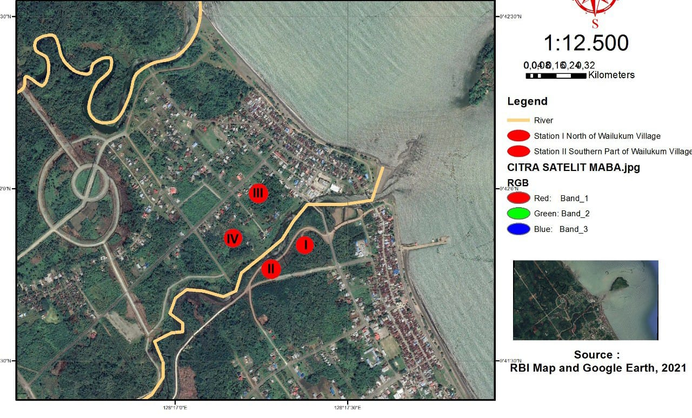
Figure 1. Sampling locations in the mangrove waters of East Halmahera
The location of the observation station consists of two stations starting from the northern part, namely station I, and the southern part designated as station II, which is a mangrove forest area that is always inundated by tidal water and becomes the center of community activities. The size of the beach at each location is 50 meters long and 50 meters wide. The tools used at the time of sampling were axes, swords to cut mangrove stalks, buckets to hold samples, tweezers to catch and clamp samples, coolboxes to accommodate cleaned samples, refractometers to measure salinity, plastic and duct tape to glue samples, scissors for cutting material. PE bottle container for storing water samples, syringe to collect body fluids T. navalis. Pipette is used to collect reagents.
Field Data Measurement and Sampling
The first stage of sampling was carried out at station I under high tide and low tide conditions. Samples of T. navalis were taken as many as 12 individuals for each type of mangrove root. Then proceed with the sampling of 12 pieces of mangrove stems measuring 8 cm and 2 bottles of water samples. The collected samples were cleaned with distilled water. The second stage of sampling was carried out at station II with the same number of samples, namely 12 samples of T. navalis, 12 pieces of 8 cm mangrove stalks, and 2 bottles of water sample then all samples were packed and put in a coolbox and brought to the laboratory, as shown in figure 2.
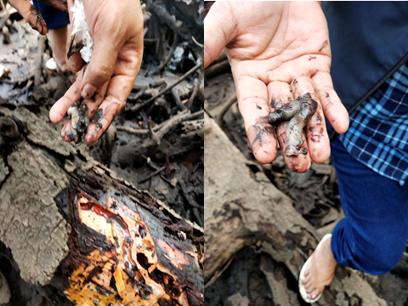
Figure 2. Sampling of T. navalis in mangrove root
Osmoregulation Analysis
Measurement of osmoregulation through the stem osmolarity and hemolymph (body fluid) test of T. navalis was carried out at the MSDP UNDIP Semarang laboratory using Roebling Type 13/13 DR Automatic Microsmometer based on the method (Anggoro, 2017). The liquid sample was taken using a 0.1 ml microtube then put into Roebling's Autocal Micro-osmometer and the tool would work and display the numbers on the glass screen as the measurement result. The results of the measurement of media osmolarity and hemolymph are presented in (Figure 3).

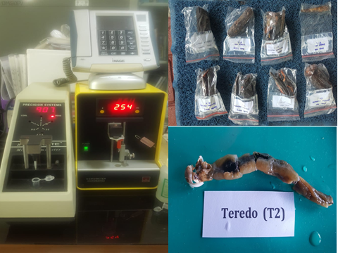
Figure 3. Sample hemolymph osmolarity and media osmolarity

Salinity Analysis

The ecological factors tested in this study were salinity levels in T. navalis biota and salinity in the mangrove root of Rhizophora sp and Avicennia sp. The samples were analyzed using a refractometer.

Data analysis

Osmoregulation is determined by analyzing the osmotic work level (OWL) which is calculated based on the difference between the osmolarity value of hemolymph T. navalis and the osmolarity of the media. The calculation of the osmotic work rate (OWL) uses the equation from (Samudra & Anggoro, 2020), as follows:

OWL = [P Osmo hemolymph-P Osmo media]

Information:

OWL: Osmotic working pressure (mOsm/l H₂O).

Osmo hemolymph: The osmotic pressure of body fluids (mOsm/l H₂O)

Ordinary media: Media osmolarity/osmolarity pressure.

RESULTS AND DISCUSSION

Osmotic Work Level and Osmoregulation Patern
The results of measurements of hemolymph osmolarity of T. navalis (H) and osmolarity of media (plasma cells/B) at tidal and low tide conditions at stations I and II for mangrove species Rhizophora sp and Avicennia sp obtained osmotic work level (OWL) namely Rhizophora sp ranged from 244 to 246 mOsm/l H₂O, and the osmoregulation pattern was hyperosmotic, while the osmotic work level value of Avicennia sp ranged from 282 to 285 mOsm/l H₂O with the same osmoregulation pattern. namely hyperosmotic. Furthermore, the osmotic work level of Rhizophora sp at station II ranged from 403 to 505 mOsm/l H₂O with a hyperosmotic osmoregulation pattern, while the osmotic work level value of Avicennia sp ranged from 521 ₂O to 523 mOsm/l H₂O with a pattern hyperosmotic osmoregulation. The osmotic work level at low tide at station I for mangroves Rhizophora sp ranged from 122 to 123 mOsm/ l H₂O and the osmoregulation pattern was hypoosmotic. The osmotic work level of Avecenia sp ranged from 36 to 58 mOsm/l H₂O, the osmoregulation pattern is isosmotic. Rhizophora sp osmotic work level values ​​for station II ranged from 32 to 34 mOsm/l H₂O with an Isosmotic osmoregulation pattern, while the osmotic work level values ​​for Avicennia sp ranging from 200 to 201 mOsm/l H₂O with a hyperosmotic osmoregulation pattern. Based on the value of the osmotic work level of the two types of mangroves above show that there are differences in osmoregulation patterns both in tide and low tide conditions. This can be expressed through the value of the osmotic work level which varies from each type of mangrove in each water condition. At high tide, the level of osmotic work is higher than at low tide, (Figure 4).
Figure 4. The results analysis of the osmotic work level (OWL) value of T. navalis in the root habitat
Based on the graph above, it is stated that the value of the osmotic work level (OWL) is categorized based on the habitat (media) of T. navalis, namely the root habitat of Rhizophora sp and Avicennia sp which is at high tide and low tide conditions. The results showed that the highest osmotic work level was seen in the water conditions at high tide at station II, namely 523 mOsm/l H₂O found in Avicennia sp with a hyperosmotic osmoregulation pattern. While the moderate osmotic work level value is found in the Rhizophora sp type at station I at low tide, namely 123 mOsm/l H₂O with a hypoosmotic osmotic pattern, then the lowest osmotic work level value is also found in the mangrove Rhizophora sp at low tide conditions at the station II, which is 32 mOsm/l H₂O with isoosmotic osmoregulation pattern. Based on these results it can be said that there are differences in the value of the osmotic workload and the osmoregulation pattern at each research station both at high tide and low tide conditions. These results also indicate that the osmolarity value of the hemolymph of T. navalis is higher than the osmolarity value of the media. This suggests that T. navalis has the ability to regulate the concentration of body fluids against the concentration of the medium (Sinyo et al, 2020). Each organism has the ability to undergo an osmoregulation mechanism to balance the osmotic pressure inside and outside the body. To maintain a relatively constant body fluid, aquatic animals must perform osmotic regulation which is called osmoregulation (Samudra et al, 2020). Based on the value of the osmotic work rate in Figure 2, this shows that T. navalis has an osmoregulatory pattern, because if the aquatic animal is said to have an osmoregulatory osmoregulation pattern if the OWL value is >500 m Osm/1 H₂O and is said to be an osmoconformer if the OWL value range is <500 mOsm/l H₂O , and If there is a high difference in the osmotic pressure of the body with the environment, the more energy required by aquatic animals to carry out the osmoregulation process until it reaches the tolerance limit.
The environmental osmotic pressure that is close to the osmotic pressure in the body will produce relative ions with a balanced concentration. The value of the osmotic work level serves to evaluate the osmotic response based on the need for osmoregulation in the ecophysiological mechanisms of aquatic animals (Anggoro, 2017). Osmoregulation is the regulation of fluid concentration in living things which plays an important role in the process of osmotic balance between intra-cell fluid (CIS) and extracellular fluid. Aquatic organisms really need an osmoregulation process, especially aquatic biota, especially Phylum Malusca type T. navalis which is permeable to the environment and salt solutions. The definition of osmoregulation for T. navalis is the regulation of the osmotic pressure of body fluids that is suitable for the life of T. navalis so that the body's physiological processes can function normally (Homeostatis) (Maulana et al, 2013; Anggoro, 2017). The value of the osmotic work rate (OWL) was obtained by reducing the osmolarity of the medium and the osmolarity of the hemolymph. T. navalis requires an isoosmotic environment to live a normal life. The pattern of osmoregulation is determined based on the value of the osmotic Work Level. the OWL value of 0 is isoosmotic, and the greater the OWL value, the osmoregulation pattern is hyperosmotic (Yuliani et al, 2018).
The varying workload values ​​for mangroves Rhizophora sp and Avicennia sp at the tide and low tide conditions both at stations I and II produce three patterns. osmoregulation namely hyperosmotic, hypoosmotic and isosmotic. It is said that the hyperosmotic osmoregulation pattern is if the media osmolarity and The increase in salinity affects the osmolarity of the medium. The higher the salinity value, the higher the osmolarity of the medium (Samudra et al, 2020).
Salinity
The salinity test (salt content) of the mangrove roots of Rhizophora sp and Avicennia sp using a refractometer was carried out at the MSDP Laboratory of Diponegoro University Semarang, and the results is stated of testing the salinity value (salt content) of mangrove roots Rhizophora sp and Avicennia sp obtained varying results in each water condition, both at high tide and at high tide. at low tide at stations I and II. The range of salinity values in Rhizophora sp at high tide is between 23 to 30 ‰, and at low tide is in the range of 10 to 15 permil (‰). While the salinity value of Avicennia sp mangroves at high tide ranges from 24 to 31 permil (‰) and at low tide it ranges from 15 to 22 permil (‰). At high tide, the highest salinity value was found in the Avicennia sp mangrove at station II, which was 31 permil (‰) and the lowest salinity value was found in the Rhizophora sp mangrove at low tide at station II with a salinity value of 10 permil. (‰). This value has a relationship with the osmotic work level of T. navalis (Figure 5).

Figure. 5. Media salinity and the osmotic work level T. navalis in the root habitat

Based on Figure 5 above, it can be said that the difference in the physical properties of the environment causes the osmoregulation process between T. navalis and its habitat. This can be seen through the osmosis process which shows that the salt content in the body is higher than the salt content of the root media (habitat) (Gito Hadiprayitno, dan M. Liwa Ilhamdi, 2014). However, when the salt level becomes normal, this process is said to be balanced (Maulana et al., 2013). In addition, the salinity of the root medium (Habitat) also affects the salinity balance process. The high and low salinity of the media greatly affects the osmotic workload. If the osmotic workload is high, the organism will absorb more energy to carry out the osmoregulation process (Pamungkas, 2012).
T. navalis performs an osmoregulation process to maintain its osmolarity stability by increasing the absorption of salt ions and water media through the gills. The hyperosmotic environment is a regulatory adaptation to avoid water loss from the body (Paalvast & Velde, 2013). Loss of water from the body occurs through the gills. When T. navalis absorbs large amounts of seawater, the salt content will also be absorbed and enter the body in large amounts, causing the body to experience excess salt (Wang et al., 2013). The excretion of large amounts of excess salt is also carried out through the gills because the gills contain specialized cells called chlorite cells. Chlorite cells are cells that function to remove NaCl from plasma into seawater. If T. navalis has a large osmotic workload, other physiological processes such as growth and reproduction will be disrupted (Gonz & Izquierdo, 2018).

CONCLUSION
The osmotic work level of T. navalis in the mangrove root habitats of Rhizophora sp and Avicennia sp in Wailukum, East Halmahera varied, namely 523 mOsm/l H₂O, 123 mOsm/l H₂O, and 32 mOsm/l H₂O. The varying workload values for mangroves Rhizophora sp and Avicennia sp at high tide and low tide both at stations I and II resulted in three osmoregulation patterns, namely hyperosmotic, hypoosmotic and isosmotic. The results of the salinity test (salt content) in the highest root habitat was found in mangrove Avicennia sp at station II, which was 31 per mil (‰) and the lowest salinity value was found in mangrove Rhizophora sp at low tide in station II with a salinity value of 10 per mil (‰). The difference in environmental physical properties (salinity) causes an osmoregulation process between T.navalis and its habitat so that the salt content in the body is higher than the salt content in the root medium (habitat).

REFERENCES
Abubakar, S., Subur, S.R., Kadir, M.A., Rina, R., Susanto, A.N., and Suriandjo, H.S. (2021). Vegetation Structure and Damage Level Mangrove Forest in Manomadehe Island, Subdistrict South Jailolo, North Maluku Province. Jurnal Biologi Tropis, 21(1), hlm. 222-230.
Alwidakdo, A., Azham, Z., and Kamarubayana, L. (2014). Studi Pertumbuhan Mangrove Pada Kegiatan Rehabilitasi Hutan Mangrove. Agrifor, 13(1), hlm.11–18.
Anggoro, S. (2017). Osmotic Perfomance Rate and Growth Rate of Green Mussel Perna viridis Cultivated in Tambak Lorok Semarang. hlm. 164–172.
Appelqvist, C., Al-hamdani, Z.K., and Jonsson, P.R. (2015). Teredo navalis (L), in the Baltic Sea. hlm. 1–17.
Appelqvist, C., and Havenhand, J.N. A phenological shift in the time of recruitment of the shipworm, Teredo navalis L., mirrors marine climate change. (2016). https://doi.org/10.1002/ece3.
Endah Widiyanti, S., Abubakar, dan M. Abd Murhum. (2018). Penentuan Kesesuaian Lahan Konservasi Hutan Mangrove Di Desa Gotowasi Kecamatan Maba Selatan Maluku Utara. JFMR-Journal of Fisheries and Marine Research, 2(3), hlm. 215–224.
Eriksen, A.M., Gregory, D.J., dan Matthiesen, H. (2017). The importance of cellulose content and wood density for attack of waterlogged archaeological wood by the shipworm, Teredo navalis. Journal of Cultural Heritage, 28, hlm. 75–81.
Evans., J.J.A. Borg, J. A., and Schembri, P.J. (2011). Distribution, habitat preferences and behaviour of the critically endangered Maltese top-shell Gibbula nivosa (Gastropoda: Trochidae). Marine Biology, 158(3), hlm. 603–611.
Hadiprayitno, G and Liwa Ilhamdi, M. (2014). Kekhasan Morfologi Spesies Mangrove di Gili Sulat. Jurnal Biologi Tropis, 14(2). hlm. 120-128.
Gonz,M.M., and Izquierdo, A. (2018). Estuarine , Coastal and Shelf Science Effects of substrata and environmental conditions on ecological succession on historic shipwrecks. https://doi.org/10.1016/j.ecss.2017.11.014.
N.A. Izzah, N.A., and Roziaty, E. (2016). Keanekaragaman Makrozoobentos Di Pesisir Pantai Desa Panggung Kecamatan Kedung Kabupaten Jepara. Bioeksperimen: Jurnal Penelitian Biologi, 2(2), 140–148.
Lippert, H., Weigelt, R., Glaser, K., Krauss, R., and Bastrop, R. Teredo navalis in the Baltic Sea : Larval Dynamics of an Invasive Wood-Boring Bivalve at the Edge of Its Distribution. (2017). 1–12.
MacIntosh, H., De Nys, R., and Whalan, S. Shipworms as a model for competition and coexistence in specialized habitats. Marine Ecology Progress Series, (2014). 461 Hlm. 95–105.
Maulana, R., Anggoro, S., and Rachmawati, D. (2013). Pola Osmoregulasi, Pertumbuhan dan Kelulushidupan Keong Macan (Babylonia spirata L) pada Media dengan Salinitas Berbeda. Management of Aquatic Resources Journal (MAQUARES), hlm. 233–242.
Paalvast, P., and Velde Van Der, G. (2013). What is the main food source of the shipworm (Teredo navalis )? A stable isotope approach. Journal of Sea Research, 80, hlm. 58–60.
Pamungkas, W. (2012). Aktivitas Osmoregulasi, Respons Pertumbuhan, Dan Energetic Cost Pada Ikan Yang Dipelihara Dalam Lingkungan Bersalinitas. Media Akuakultur, hlm.44.
Perez-alvaro, E. (2016). Climate change and underwater cultural heritage : Impacts and challenges. Journal of Cultural Heritage, 842–848.
Romano, N., and Zeng, C. (2012). Osmoregulation in decapod crustaceans: Implications to aquaculture productivity, methods for potential improvement and interactions with elevated ammonia exposure. Aquaculture, (2012). 334–337(October 2017), 12–23.
Rosaini, H.R. R. dan V. H. (2015). Penetapan Kadar Protein Secara Kjehdahl Beberapa Makanan Olahan Kerang Remis (Corbiculla moltkiana Prime) dari Danau Singkarak. Jurnal Farmasi Higea, (120–127.
Pati, S.K. (2014). Deterioration of Wood by Marine Borers in a Tropical Harbour: Influence of Environmental Parameters and Biotic Factors. International Journal of Marine Science, 119-133.
Samudra, N.R., and Anggoro, S. (2020). The effect of different salinity towards energy utilization levels and the effectiveness of bigfin reef squid egg hatching (Sepioteuthis lessoniana ). 450–455.
Setyabudi, I.S., Harpeni, E., and Wardiyanto, W. (2020). Improvement In The Growth Performance Of Tiger Grouper Epinephelus Fuscoguttatus (Forsskal, 1775) By Probiotic Microcapsules, Bacillus sp. D2.2. Aquasains, hlm. 853-860.
Sinyo, Y., Anggoro, S., dan Soeprobawati, T.R. (2019). Aktivitas Grazing Teredo Navalis L di Habitat Mangrove Menggunakan Metode Scan Sampling. Jurnal Pendidikan MIPA, (2019a). hlm. 2–7.
Sinyo, Y., Anggoro, S., and Soeprobawati, T.R. (2019). Morphologic characteristics and population density of Teredo navalis L in mangrove forest area, Wailukum East Halmahera Regency. Journal of Physics: Conference Series, (2019b). hlm.
Swaim D. (2017). Biodiversity of Shipworms (Mollusca : Bivalvia : Teredinidae ) in the Vicinity of a Tropical Mangrove Ecosystem along Bay of Bengal , Andhra Pradesh , India. hlm. 1–5. 26.
Voight, 2015 Aspek Biologi dan Dampak T. (n.d.).
Y.Wang, Y., Cheung, M. Hu., S.G.., Shin, P.K.S., Lu, W., and Li, J. (2013). Antipredatory responses of Perna viridis (Linnaeus, 1758) under acute hypoxia and low salinity. Journal of Molluscan Studies, hlm. 42–50.
Weigelt, R., Lippert, H., Karsten, U., and Bastrop, R. (2017). Genetic Population Structure and Demographic History of the Widespread Common Shipworm Teredo navalis Linnaeus 1758 (Mollusca : Bivalvia : Teredinidae) in European Waters Inferred from Mitochondrial COI Sequence Data. hlm.1–12.
Yulianda, F., Yusuf, M.S., and Prayogo, W. (2013). Zonasi dan Kepadatan Komunitas Intertidal di Daerah Pasang Surut, Pesisir Batuhijau, Sumbawa. Jurnal Ilmu Dan Teknologi Kelautan Tropis, hlm. 409–416.
Yuliani, T.A., Anggoro, S., dan Solichin, A. (2018). Pengaruh salinitas berbeda terhadap respon osmotik, regulasi ion dan pertumbuhan ikan sidat (anguilla sp.) Fase elver selama masa aklimasi dan kultivasi. Management of Aquatic Resources Journal (MAQUARES), hlm. 333–341.

