
E-ISSN-2580-7129
Print- ISSN-1978-6107

TECHNO: JURNAL PENELITIAN
Journal homepage: http://ejournal.unkhair.ac.id/index.php/Techno
Issue 09 Number 01 May 2020 DOI: http://dx.doi.org/10.33387/tk.v9i1

Analysis of Ca²⁺ and Fe³⁺ Ions in Ngade Water and Tolire Lake Water Ternate, North Maluku

^{1,a)}Fadlan Muin, ²Muhammad Amin, ³Saras Wati Banapon

^{1,a)} Chemistry Education Department, Universitas Khairun, Indonesia, fadlanmuin04@gmail.com (Corresponding author)
²Chemistry Education Department, Universitas Khairun, Indonesia, mmdamin@yahoo.com
³Chemistry Education Department, Universitas Khairun, Indonesia, saraswatybanapon@gmail.com

Received:
Accepted:
Available online:

ABSTRACT
This study aims to obtain optimal and valid conditions for the analysis of inorganic ions Ca²⁺ and heavy metal Fe³⁺ and the comparison between inorganic ions Ca²⁺ and heavy metal ions Fe³⁺ contained in the water of Lake Ngade and Lake Tolire, using ion chromatography and UV-Vis spectrophotometry. This type of research is experimental laboratory. Based on the results of the research, the concentrations obtained from Ca²⁺ ions and Ca²⁺ ions are for the highest concentration of Ca²⁺ ions in Lake Ngade water at 1.259 ppm, Big Tolire Lake water at 3.410 ppm and Small Tolire Lake water at 6.154 ppm. Meanwhile, the highest concentration of Fe³⁺ ions is in Lake Ngade water at 5.606 ppm, Big Tolire Lake water at 5.500 ppm, and Small Tolire Lake water at 5.379 ppm.
Keywords: Ca²⁺, Fe³⁺, Ion Chromatography, UV-Vis Spectrophotometry, Ngade Lake, Tolire Lake.
ABSTRAK
Penelitian ini bertujuan untuk mendapatkan kondisi yang optimal dan valid untuk analisis ion anorganik Ca²⁺ dan logam berat Fe³⁺ dan perbandingan antara ion anorganik Ca²⁺ dan ion logam berat Fe³⁺ yang terkandung dalam air Danau Ngade dan Danau Tolire, menggunakan kromatografi ion dan spektrofotometri UV-Vis. Jenis penelitian ini eksperimental laboratorium. Berdasarkan hasil penelitian konsentrasi yang didapatkan dari ion Ca²⁺ dan ion Fe³⁺ yaitu untuk konsentrasi ion Ca²⁺ tertinggi berada pada air Danau Ngade sebesar 1.259 ppm, air Danau Tolire Besar 3.410 ppm dan air Danau Tolire Kecil 6.154 ppm. Sedangkan untuk konsentrasi ion Fe³⁺ tertinggi berada pada air Danau Ngade sebesar 5.606 ppm, air Danau Tolire Besar 5.500 ppm, dan air Danau Tolire Kecil sebesar 5.379 ppm.
Kata Kunci: Ca²⁺, Fe³⁺, Kromatografi Ion, Spektrofotometri UV-Vis, Danau Ngade, Danau Tolire.

INTRODUCTION

Lakes are areas that are naturally formed, have surface water reservoirs and are also a source of fresh water that supports the life of all living things. A lake is a basin due to natural events or intentionally created by humans through springs or rivers. Lake water comes from rain that flows either through rivers or small ditches (Biggs et al., 2017) and (Dolph et al., 2017).

Lake Ngande is located in Ngade Village, Fitu Village, South Ternate District, North Maluku Province, which is about 18 KM from Ternate City, because the lake is located in Ngade Village so it is often referred to as Lake Ngade. In Ngade Village, an earthquake can cause the water conditions to become cloudy and turn black or yellow, and also kill all the fish in the lake. There is also plastic waste and household waste. Lake Tolire is located in Takome Village, Ternate Island District. Lake Tolire consists of two lakes, namely Big Tolire Lake and Small Tolire Lake.

Where the lake experiences a change in the color of the lake water to green due to conditions that usually occur during the transition from summer to rain and can also occur when the level of rainfall is high in the area. If the lake is in normal condition, the sulfur will settle to the bottom of the lake. This is because the temperature at the bottom of the lake is cooler at the surface. Then, when it rains it makes the surface water temperature cooler than the water temperature at the bottom of the lake. Thus, it allows a transition or water that is at the bottom to rise to the surface and vice versa. Because it contains sulfur and other substances, eventually changing the color of the lake water. The water of the small tolire lake is not suitable for direct consumption, if this happens it will result in the supply of oxygen at the surface being depleted. Thus, it will harm organisms or dead fish. However, usually this color change only occurs at certain points (Setiawan et al., 2014). which is dumped into the ditch, so that when it rains the garbage in the ditch will enter the lake area (Biruk, 2017).

Based on the point of view of toxicology, heavy metal iron is a metal that is needed by living organisms, but the metal in excess can cause toxic effects. This metal is one type of environmental pollutant that is usually found in waters. For the content of iron metal in the waters can be seen scientifically usually in less amounts. However, there is an increase in iron metal caused by community activities around the waters such as industry, domestic and others. While calcium is very important to neutralize acidic compounds. If the concentration is above the quality standard, this acid compound will have a negative effect on plants. The structure of calcium is very important in agricultural soil, because there is an adsorption complex of Ca²⁺ ions in groundwater which must be quite high (Amin, 2016).

Several methods that can be used to determine the concentration of ions to determine the analysis of metals in a sample are using tools such as ion chromatography and UV-Vis spectrophotometer. This ion chromatography method gives better results than other methods. The main principle in this method is based on the interaction of positive and negative charges between specific molecules and the matrix in the chromatographic column. An ion exchanger is a solid material that has an active part in the form of ions that can be exchanged (Simanjuntak, 2018). While the UV-Vis spectrophotometry tool has the advantage of being an instrument that can be used to analyze the amount of organic and inorganic substances that is carried out quickly and precisely. In addition, this UV-Vis spectrophotometer instrument also obtains very accurate results, where the numbers are read directly recorded by the detector and printed in the form of numbers and graphs that have been regressed (Rohmah et al., 2021). Based on the information above, the authors consider it necessary to conduct research on "Analysis of Ca²⁺ and Fe³⁺ Ions in Ngade Lake Water and Tolire Lake Water, Ternate, North Maluku".

RESEARCH METHOD
Methods Used
The research method used is laboratory experimental research. In this research, will be conducted to obtain the analysis of inorganic ions Ca²⁺ and heavy metal Fe³⁺ in Lake Ngade and Lake Tolire by Ion Chromatography and UV-Vis Spectrophotometry. This research took place in Ngade Lake, South Ternate District and Tolire Lake, both large and small, in Ternate Island District. Sample testing was carried out at the UPT Laboratory of Basic and Integrated Laboratories, Khairun University in June-August 2022.
Equipment Used
Compact 761 Metrohm Ion Chromatography (Switzerland) which is also equipped with a Metrosep C2-150 type cation separator column used for analysis, 50 ml beaker, 10 mL volumetric flask, 100 mL volumetric flask, watch glass, analytical balance, UV-Vis spectrophotometer, Spatula, sample bottle, funnel, dropper, 5 ml volume pipette and 10 ml volume pipette.
Materials Used
Cation resin, Ngade and Tolire Lake water, aquades, FeCl₂.6H₂O, CaCl₂.2H₂O, Na₂S₂O₃ (sodium thiosulfate), acetate buffer pH 4.5 (sodium acetate trihydrate and glacial acid), acetone and 1,10-phenanthroline.
Sample Preparation
Sample preparation was carried out from various types of lake water samples to be collected from various locations. There are 3 types of lake water collected: Ngade lake water, large tolire lake and small tolire lake. The three types of lake water are taken from the city of Ternate, North Maluku. Sampling was done randomly. The purpose of this sampling is to collect the volume of a body of water to be studied with the smallest possible amount (Flanagan et al., 2021). The sample was taken using a glass bottle that had been rinsed with distilled water and dried. The samples that have been taken are then stored in a refrigerator at 4ºC to avoid contamination.
RESULTS AND DISCUSSION
Based on the research that has been carried out to test the inorganic ions of calcium and iron heavy metal ions with samples of Lake Ngade Water, Big Tolire Lake and Small Tolire Lake on Ternate Island, the following results were obtained:

Calcium (Ca²⁺) Inorganic Ion Test

Below are tables and figures of the results of the inorganic calcium ion test as follows:

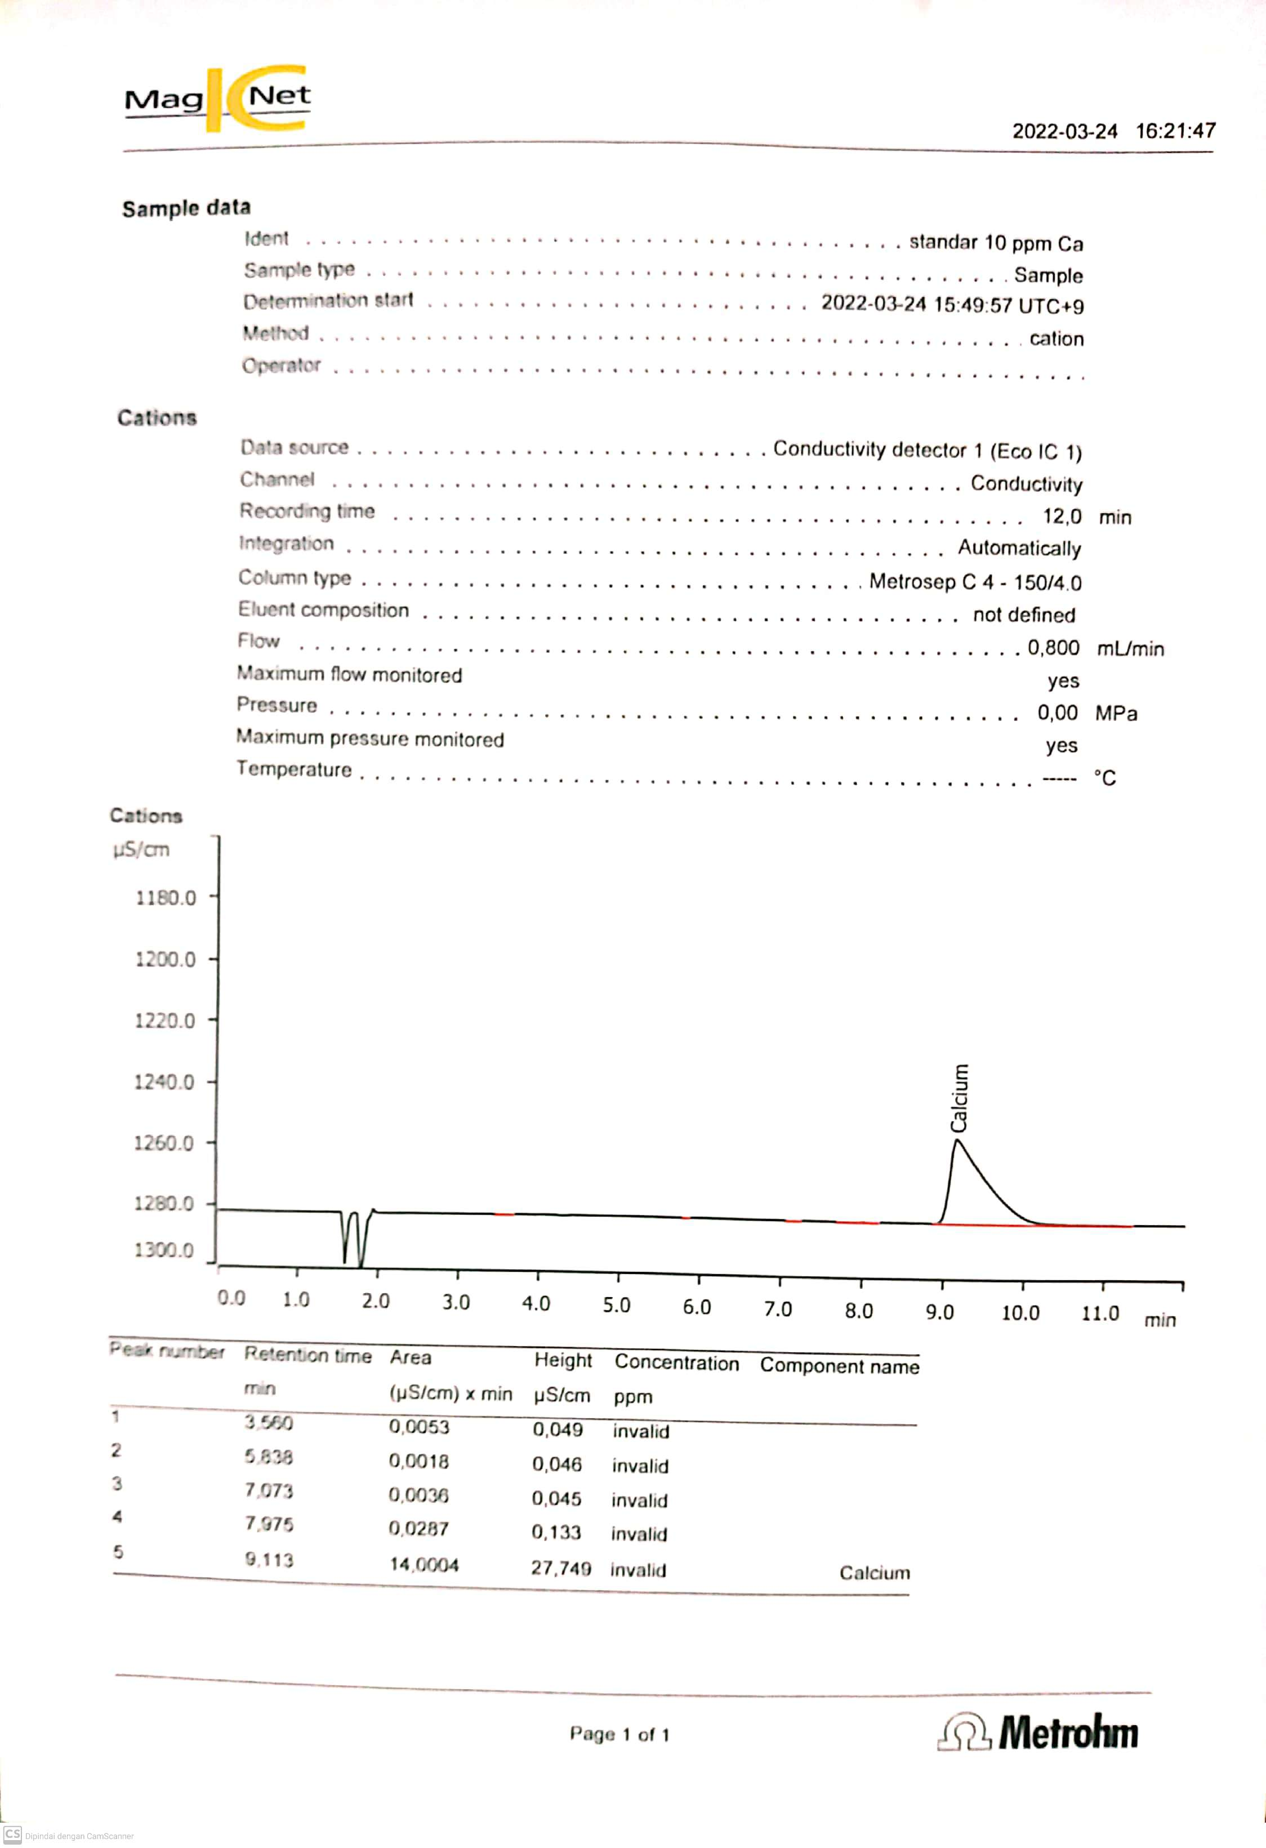
(a)
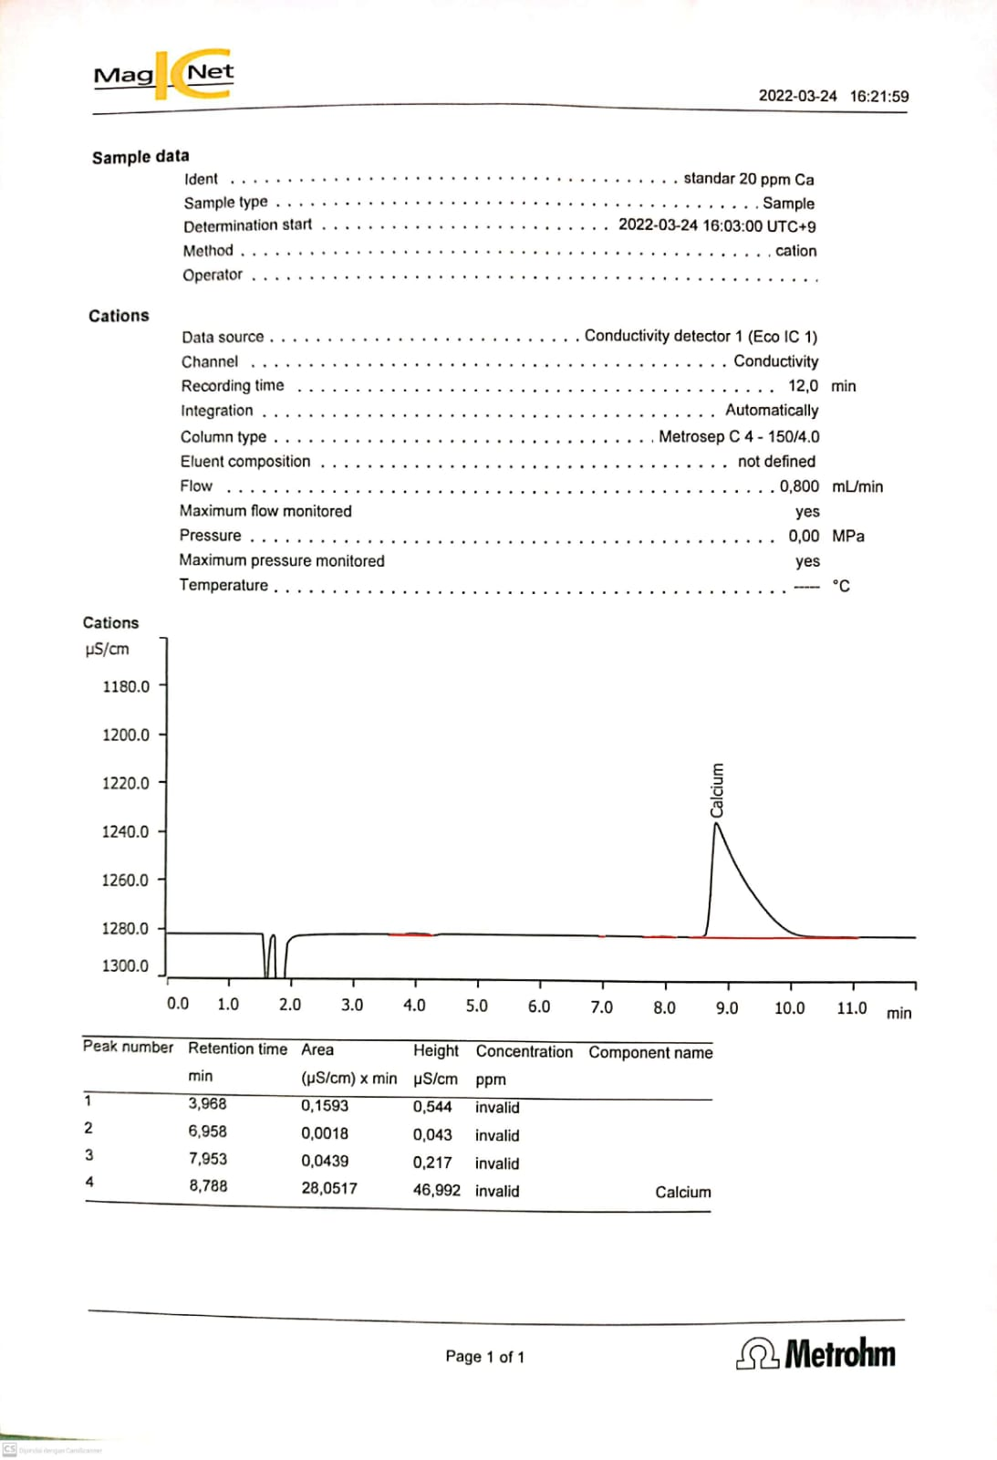
(b)
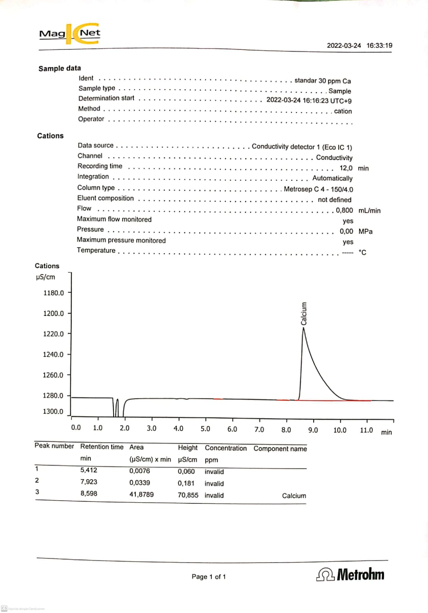
(c)
Figure 1. Standard solution chromatogram graph with: (a) concentration of 10 ppm,
(b) concentration of 20 ppm, and (c) concentration of 30 ppm.
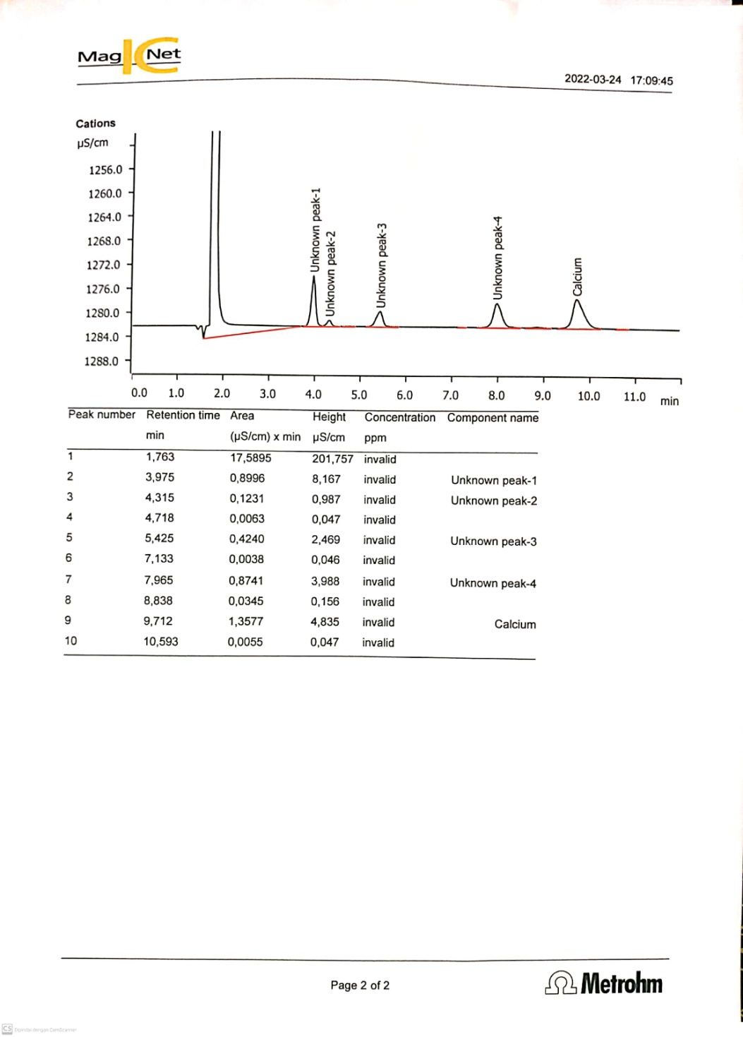
(a)
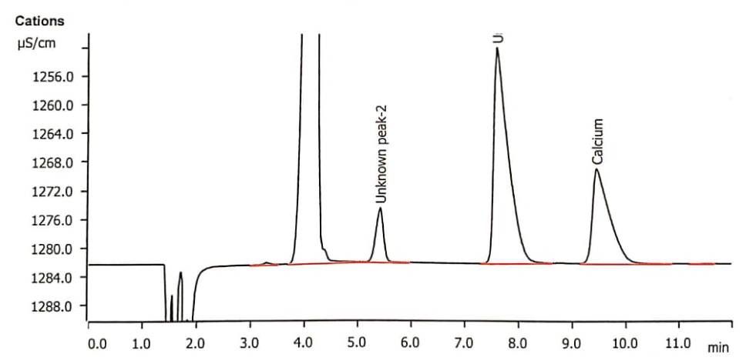
(b)
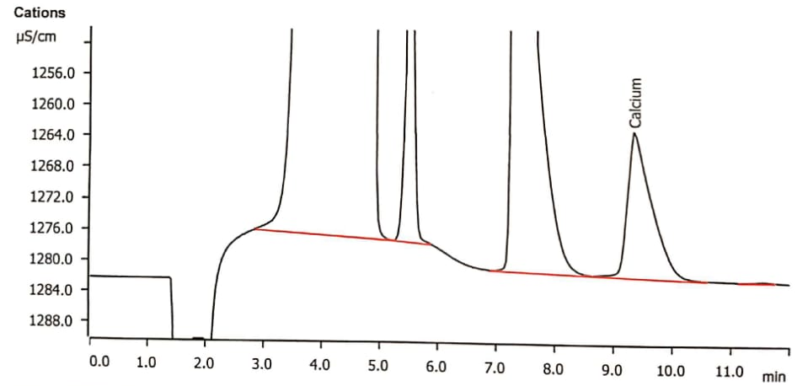
(c)
Figure 2. Sample Chromatogram (a) Lake Ngade Water, (b) Large Tolire Lake Water
and (c) Small Tolire Lake Water
Table 1. Recapitulation of Analysis Results of Ca²⁺ Ion Standard
Ion | Standard Solution (ppm) | Retention time (min) | Signal (µS/cm)
Ion | Standard Solution (ppm) | Retention time (min) | Peak area | Peak height
Ca²⁺ | 10 | 9.113 | 14.0004 | 27.749
Ca²⁺ | 20 | 8.788 | 28.0517 | 46.992
Ca²⁺ | 30 | 8.598 | 41.8789 | 70.855

Table 2. Recapitulation of Analysis Results of Ca²⁺ Ion Concentration in Samples
Sample | Signal (µS/cm)
Sample | Peak area | Peak height
Ngade Lake | 1.3577 | 4.835
Big Tolire Lake | 4.8489 | 13.239
Small Tolire Lake | 8.6701 | 18.636

Below is a graphic image of the concentration and sample chromatograms and a table of analytical conditions in determining cations using ion chromatography techniques.

(a)

(b)
Figure 3. Standard Calibration Curve of Ca²⁺ ion sample: (a) Peak Height and,
(b) Peak Area
Based on Figure 3 calibration curve, the standard Ca²⁺ ion sample above has a value (R²) = 0.999 for Peak Heigt, while for Peak Area the value (R²) = 1. Therefore, the researchers took the value (R²) of the peak area as the data to be used because when In research, researchers made a standard sample solution well and did not experience errors so that the results were good.
Below are the results of the calculation of the peak heagt and peak area values for each sample (Lake Ngade, Big Tolire Lake and Small Tolire Lake):
Table 3. Result of recapitulation of Ca²⁺ ion concentration in sample
based on peak height and peak area data
Sample | Ca²⁺ Ion Concentration (ppm)
1.259 | 1.259
3.410 | 3.410
6.154 | 6.154

Table 4. Analytical conditions in the determination of cations
using ion chromatography techniques.
Parameter | Analysis conditions
Eluent composition | 6MmHNO₃
Separation column | Metrocep C4-150
Detector type | conductivity
Eluent water velocity | 0.800 Ml/min
Injector volume | 10 $μ$L

Metal ion test Iron (Fe)
Calculation of the concentration of iron ion (Fe) 100 ppm using the graph of the results of UV-Vis spectrophotometry. The results of the 100 ppm Iron ion test using a standard solution can be seen in table 5.
Table 5. Absorbance value of standard solution
Concentration (ppm) | Absorbance (nm)
1 | 0.905
3 | 1.225
5 | 1.438
7 | 1.714

From table 5 above, the Fe³⁺ calibration curve is obtained as follows:

Figure 4. Fe Calibration Curve Fe³⁺

From the results of Figure 4 obtained the equation:
y = 0.132x + 0.792
The following are the measurement results for each sample (Ngade Lake, Bigi Tolire Lake and Small Tolire Lake):

Table 6. Concentration of Fe³⁺ ions in each sample (Lake Ngade,
Big Tolire Lake and Small Tolire Lake)
Sample | Absorbance (nm) |  |  | Fe³⁺ Ion Concentration (ppm)
Ngade Lake Water |  | 0.052 | 5.606
Big Tolire Lake Water |  | 0.066 | 5.500
Small Tolire Lake Water |  | 0.082 | 5.379
Sample preparation was carried out from various types of lake water samples to be collected from various locations. There are 3 types of lake water collected: Ngade lake, big tolire lake and small tolire lake. The three types of lake water are taken from the city of Ternate, North Maluku. Sampling was done randomly. The purpose of this sampling is to collect the volume of a body of water to be studied with the smallest possible amount (Ma et al., 2022). The sample was taken using a glass bottle that had been rinsed with distilled water and dried. The samples that have been taken are then stored in a refrigerator at 4ºC to avoid contamination.
Inorganic Ion Ca²⁺ Test With Ion Chromatography
To test the inorganic calcium ion, start by weighing 0.3675 grams of CaCl₂.2H₂O crystals using an analytical balance. The crystals were put into a 100 mL volumetric flask, distilled water was added to the mark and homogenized. The solvent used is water solvent (aquades) because it is easy to obtain and this solvent is easily soluble in ionic compounds (Githa et al., 2022). Next, the stock solution was taken and then made some standard solutions such as 10, 20 and 30 ppm and put them in a 100 mL volumetric flask. The standard solution is taken and then put into the ion chromatography system. The concentration of the three cations can be seen in Figure 5.
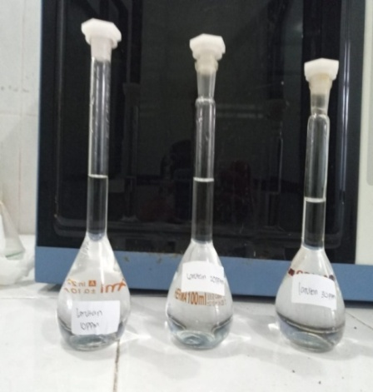
Figure 5. Fe standard solution
Based on Figure 5 quantitative analysis of the three standard solutions based on different plots of calibration curve methods. Further treatment for the sample, before the sample is injected into the ion chromatography system, the sample is allowed to reach room temperature.
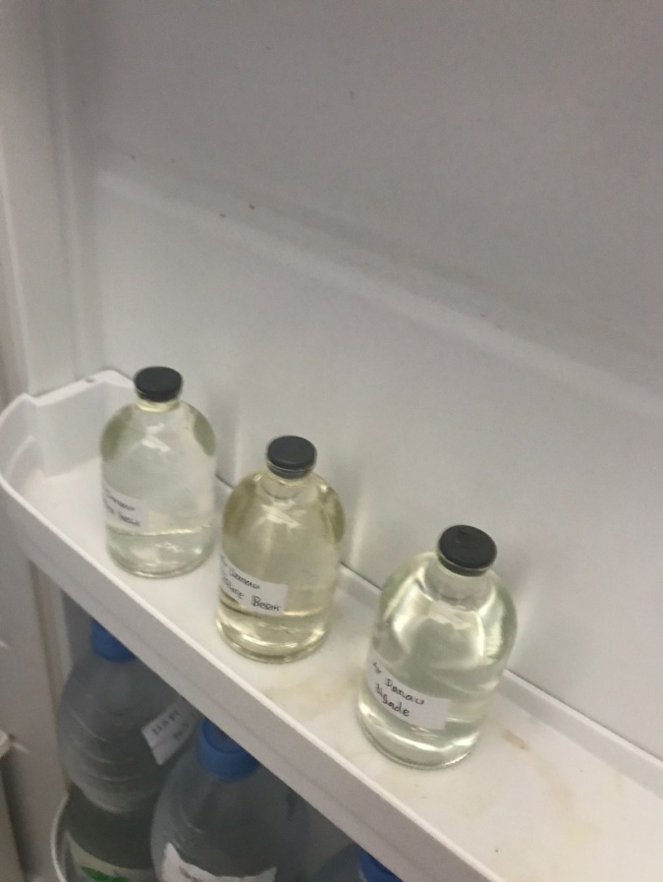
Figure 6. Samples (a) Lake Ngade Water (b) Big Tolire Lake Water and,
(c) Small Tolire Lake Water.
The sample is taken and then injected into an empty bottle, after which a hose is inserted so that it can mix with the eluent and go together to the separator column. The cations are then measured by a conductivity detector and the results of the sample analysis can be seen in Figure below.
(a)

(b)
(c)

Figure 7. Sample Chromatogram (a) Lake Ngade Water, (b) Big Tolire Lake Water,
and (c) Small Tolire Lake Water

Based on Figure 7, it is found that the types of samples that have high Ca²⁺ cations are the water of Small Tolire Lake, Big Tolire Lake and Lake Ngade. The results obtained from the analysis using ion chromatography for water samples were 18.6 s/cm (Small Tolire Lake), 13.2 s/cm (Big Tolire Lake), and 4.8 s/cm (Lake Ngade). As for the results of the sample chromatogram, namely y = 6.900x - 1.564 and R² = 0.984. Ca²⁺ ions were found in the Ngade lake samples because they contain many types of pollution such as domestic, agricultural and industrial wastes around the waters. As it is known that North Maluku is one of the provinces in Indonesia whose pollution levels are increasing because many people who live around the lake area build restaurant and residential industries (Amin, 2020).
Table 7. Results of recapitulation of Ca²⁺ ion concentration in samples based
on peak height and peak area data
Sample | Ca²⁺ Ion Concentration (ppm)
Ngade Lake | 1.259
Big Tolire Lake | 3.410
Small Tolire Lake | 6.154

Based on table 7 the concentration of Ca²⁺ ions in the sample has different concentration results from each sample, namely for Lake Ngade water the concentration value is 1.259 ppm, Big Tolire Lake water is 3,410 ppm and Small Tolire Lake is 6.154 ppm. There is a study conducted by (Pujiastuti, C. et al. 2019) that the more cation resins added with Ca²⁺ ions that are absorbed into the resin the greater the amount of resin, the greater the ability of the resin to absorb ions. The longer the contact time the Ca²⁺ ion absorbed is greater and exceeds the other ions. This is in accordance with the concept of ion selectivity, namely in ions that have the same valence ion, the greater the atomic weight of the ion, the higher will be absorbed into the resin.

Fe³⁺ Metal Ion Test with UV-Vis Spectrophotometry

The Fe³⁺ metal ion test was started by weighing 0.483 grams of FeCl₃.6H₂O crystals, 0.10 grams of 1,10-phenanthroline, 0.0235 grams of Na₂S₂O₃ using a watch glass. Each of these crystals was put into a 100 mL and 50 mL volumetric flask, added with distilled water up to the mark and homogenized. As for the acetate buffer crystal or 3.97 grams of sodium acetate trihydrate, put into a 50 mL volumetric flask, add 5 mL of glacial acetic acid and distilled water to the mark.
Next, a standard solution of 100 ppm was taken by making several concentrations such as 1, 3, 5, and 7 ppm. The standard solutions used in this study were primary and secondary standard solutions. Primary standard solutions are standard solutions made from standard substances with very high purity which are generally supplied by NIST, NIBSC which is used for calibration of standard solutions made, while secondary calibration is a solution whose concentration is determined by reliable analytical methods (Visschedijk et al., 2005). Then added Na₂S₂O₃, 1,10-phenanthroline reagent, acetate buffer, acetone and aquade. The existence of this reagent is in order to determine the solution used as an ingredient for a reaction to take place (Pretsch et al., 2020). For a blank solution, it is made by adding reagents and aquades to the limit mark, in the presence of a blank solution, the absorbance can be zeroed on the UV-Vis spectrophotometry tool.
For testing lake water samples, it is done by taking samples and putting them into a 10 mL volumetric flask and then adding the reagent to each volumetric flask containing the sample. Then the standard solution and sample were measured using UV-Vis spectrophotometry with a wavelength of 509 nm. The test results of each concentration can be seen in the figure below:

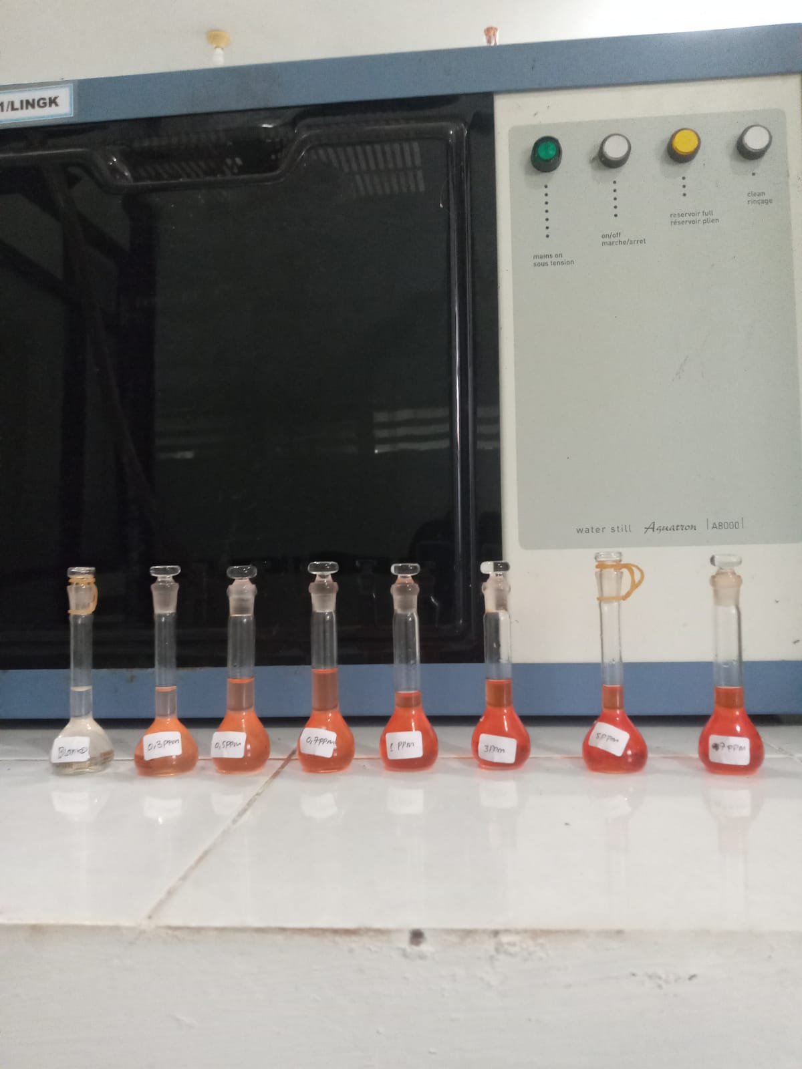
Figure 8. Test results of standard solutions with concentrations
of 1, 3, 5, and 7 ppm
From Figure 8, the results experience a color change from faded pink to dark pink which is different for each concentration because the higher the concentration, the more colorful or concentrated the solution is as stated (Abdel-lateef et al., 2022).

For the measurement of iron in water can be done using spectrophotometry to determine the absorbance value. The color change was due to the addition of phenanthroline reagent which made the standard test solution red orange or dark pink according to research (Siddiqui et al., 2022).

Figure 9. Calibration Curve Graph
Based on Figure 9 can show that the test results have a fairly good linearity. This is shown by the coefficient value (R²) of 0.994. In addition, there are researchers (Onyelowe et al., 2022) who conducted the same study having a coefficient value (R²) of 0.9606 for Fe metal. In other words, the greater the metal content, the greater the light absorbance value.
Furthermore, testing samples that only add a reagent solution, so you can see the test results as below:

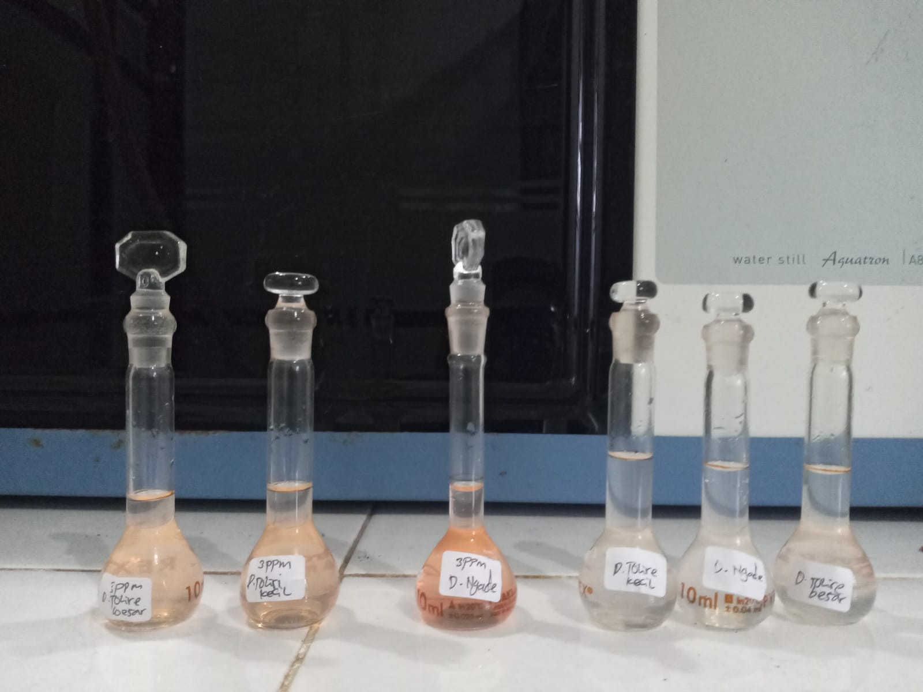
Figure 10. Sample test

From Figure 10, it can be seen that the color became cloudy for each sample the same due to the addition of reagents. Below is a table to determine the Fe content in the sample.

Table 8. Concentration of Fe ions in each sample (Lake Ngade Water,
Big Tolire Lake Water and Small Tolire Lake Water)
Sample | Absorbance | Fe³⁺ Ion Concentration (ppm)
Ngade Lake Water | 0.052 | 5.606
Big Tolire Lake Water | 0.066 | 5.500
Small Tolire Lake Water | 0.082 | 5.379

Based on table 8. above, it can be seen that the water containing more Fe is Small Tolire Lake, followed by Big Tolire Lake and the last one is Lake Ngade. Meanwhile, if calculated using the formula y = ax + b, then the largest value is Lake Ngade, then followed by Big Tolire Lake and the last is Small Tolire Lake.

CONCLUSION
Based on the results of research and discussion obtained from inorganic ions Ca²⁺ and heavy metal ions Fe³⁺, it can be concluded that: Analysis of Ca²⁺ ions has 2 data obtained using ion chromatography, the data in question are peak height and peak area. The data (peak height) obtained results from the three water samples, namely Lake Ngade water at 4.835 S/cm, Big Tolire Lake water water 13.239 S/cm, and Small Tolire Lake water water 18.636 S/cm. As for the data (peak area) the results from the three water samples are Lake Ngade water of 14.0004 S/cm, Big Tolire Lake water water is 28.0517 S/cm, and Small Tolire Lake water is 8.6701 S/cm. Then analysis of Fe³⁺ absorbance values ​​obtained through measurements using UV-Vis spectrophotometry from the three water samples, namely Lake Ngade water 0.052 nm, Big Tolire Lake water 0.066 nm and Small Tolire Lake water 0.082 nm. Furthermore, the results of the standard calibration curve of the sample obtained through data on the concentration of Ca²⁺ peak area in each sample of Lake Ngade water is 1.259 ppm, Big Tolire Lake water is 3.410 ppm and Small Tolire Lake water is 6.154 ppm. calculation of the concentration, the results of the three water samples are for Lake Ngade water of 5.606 ppm, Big Tolire Lake water for 5.500 ppm, and Small Tolire Lake water for water for 5.379 ppm. From the results obtained above, this indicates that the method used is correct, because the results obtained are close to the theoretical results and also the values ​​obtained from the analysis of inorganic ions Ca²⁺ and heavy metal ions Fe³⁺ some are larger and some are small depending on the measurement and calculation.

ACKNOWLEDGEMENTS
The author would like to thanks Mr. Muhammad Amin and Mrs. Saras Wati Banapon for their contribution to this work.

REFERENCES
Abdel-lateef, M. A., Almahri, A., Alzahrani, E., Pashameah, R. A., Abu-hassan, A. A., & Hamd, M. A. El. (2022). Sustainable PVP-Capped Silver Nanoparticles as a Free-Standing Nanozyme Sensor for Visual and Spectrophotometric Detection of Hg 2 + in Water Samples : A Green Analytical Method.
Amin, M. (2016). Analisis Unsur Minor Kation Dalam Sampel Air Alam Dengan Menggunakan Teknik Kromatografi Ion. Jurnal Techno, 05(1), 1–7.
Amin, M. (2020). Penentuan Secara Serempak Kadar Minor Anion (F-, Cl-, NO2-, Br-, NO3-, SO42– dan PO43-) dalam Sampel Air Botol Kemasan dengan Teknik Kromatografi Ion Kinerja Tinggi. Techno: Jurnal Penelitian, 9(1), 287. https://doi.org/10.33387/tjp.v9i1.1744
Biggs, J., von Fumetti, S., & Kelly-Quinn, M. (2017). The importance of small waterbodies for biodiversity and ecosystem services: implications for policy makers. Hydrobiologia, 793(1), 3–39. https://doi.org/10.1007/s10750-016-3007-0
Biruk, A. F. (2017). Waste management in the case of Bahir Dar City near Lake Tana shore in Northwestern Ethiopia: A review. African Journal of Environmental Science and Technology, 11(8), 393–412. https://doi.org/10.5897/ajest2017.2340
Dolph, C. L., Hansen, A. T., & Finlay, J. C. (2017). Flow-related dynamics in suspended algal biomass and its contribution to suspended particulate matter in an agricultural river network of the Minnesota River Basin, USA. Hydrobiologia, 785(1), 127–147. https://doi.org/10.1007/s10750-016-2911-7
Flanagan, K., Blecken, G. T., Osterlund, H., Nordqvist, K., & Viklander, M. (2021). Contamination of urban stormwater pond sediments: A study of 259 legacy and contemporary organic substances. Environmental Science and Technology, 55(5), 3009–3020. https://doi.org/10.1021/acs.est.0c07782
Githa, S., Sonia, R., Arief, B., & Palupi, B. (2022). Extraction of Antioxidant Compounds from Sargassum sp . Using Water as A Solvent and Ultrasound Assisted Extraction Method as A Derivation of Green Chemistry Principles. 2, 31–42.
Ma, M., Liu, S., Su, M., Wang, C., Ying, Z., Lin, Y., & Yang, W. (2022). Corrigendum to “Spatial distribution and potential sources of microplastics in the Songhua River flowing through urban centers in Northeast China” [Environ. Pollut. 292 (2022) 118384] (Environmental Pollution (2021) 268(PB), (S026974912036646X), (10.1016/. Environmental Pollution, 301(January), 118928. https://doi.org/10.1016/j.envpol.2022.118928
Onyelowe, K. C., Kontoni, D. P. N., Ebid, A. M., Dabbaghi, F., Soleymani, A., Jahangir, H., & Nehdi, M. L. (2022). Multi-Objective Optimization of Sustainable Concrete Containing Fly Ash Based on Environmental and Mechanical Considerations. Buildings, 12(7). https://doi.org/10.3390/buildings12070948
Pretsch, E., Bühlmann, P., & Badertscher, M. (2020). UV/Vis Spectroscopy. In Structure Determination of Organic Compounds. https://doi.org/10.1007/978-3-662-62439-5_9
Rohmah, S. A. A., Muadifah, A., & Martha, R. D. (2021). Validasi Metode Penetapan Kadar Pengawet Natrium Benzoat pada Sari Kedelai di Beberapa Kecamatan di Kabupaten Tulungagung Menggunakan Spektrofotometer Uv-Vis. Jurnal Sains Dan Kesehatan, 3(2), 120–127. https://doi.org/10.25026/jsk.v3i2.265
Setiawan, F., Wibowo, H., Santoso, A. B., Nomosatryo, S., & Yuniarti, I. (2014). Karakteristik Danau Asal Vulkanik Studi Kasus : Danau Tolire, Pulau Ternate. / Limnotek, 21(2), 103–114.
Siddiqui, J., Modupe, O., Vatandoust, A., & Diosady, L. L. (2022). Predicting the Stability of Double Fortified Salt by Determining the Coating Quality of the Encapsulated Iron Premix. Journal of Food Quality, 2022. https://doi.org/10.1155/2022/7812022
Simanjuntak, V. S. H. (2018). Pengaruh Laju Alir Dalam Proses Pengemasan Kolom Kromatografi Penukar Ion. Jurnal Kimia Mulawarman, 15(2), 82. https://doi.org/10.30872/jkm.v15i2.588
Visschedijk, M., Hendriks, R., & Nuyts, K. (2005). How to set up and manage quality control and quality assurance. Quality Assurance Journal, 9(2), 95–107. https://doi.org/10.1002/qaj.325

