
E-ISSN-2580-7129
Print- ISSN-1978-6107

TECHNO: JURNAL PENELITIAN
Journal homepage: http://ejournal.unkhair.ac.id/index.php/Techno
Issue 09 Number 01 May 2020 DOI: http://dx.doi.org/10.33387/tk.v9i1

STUDY OF CRYSTAL STRUCTURE AND MAGNETIC SUSEPTIBILITY OF IRON SAND PANGEO VILLAGE, MOROTAI JAYA SUBDISTRICT AS THE BASE MATERIAL FOR CATHODE MATERIAL IN THE MANUFACTURE OF LITHIUM ION BATTERIES

Rahim Achmad¹, Suryani Taib², Rohima Wahyu Ningrum³, Rusky Nuri Amelia⁴, Marwis Aswan⁵
¹ Department of Physics Education, Faculty of Teacher Training and Education Universitas Khairun. Email : diditernate71@gmmail.com
^{2, 3, 4} ¹ Department of Physics Education, Faculty of Teacher Training and Education Universitas Khairun. Email : diditernate71@gmmail.com
. Email: ryanitaib@gmail.com
⁵ Department of Environment Enginering, Faculty of Enginering Universitas Pasifik Morotai

Received:
Accepted:
Available online:

ABSTRACT
Morotai Island has a wealth of iron sand which is a natural resource in Morotai Jaya Subdistrict located in Pangeo Village. The use of iron sand is still a mixture of buildings for the local community and has not been explored further. The purpose of this study was to determine the Structural and Magnetic Suseptibility of Iron Sand as the base material for Cathode Material in the Manufacture of Lithium Ion Batteries. The research sample is taken at random qualitatively, then prepared in the laboratory to get dry phase iron sand. After being tested using the XRD tool, namely samples A, E, I. obtained fe3O4 content is widely contained in the iron sand pangeo village, Morotai Jaya. XRD. The peaks of the diffraction show Fe₃O₄ material with a spinel inverse structure. Sample A is most crystalline compared to sample I. Sample E has the lowest diffraction peak pattern due to the dominant mineral hematite (Fe₂O₃) of 70.31%. The value of the BSM test is obtained magnetic suspetiibility of 82867.54x10-8m3 /kg. The smallest is in the J sample with a value of 13186.98 54x10⁻⁸m³ /kg because when synthesis is slightly drawn magnets and the color is not too black that many mix with other materials. In addition, this relationship is directly proportional to the E sample which has a Fe₂O₃ magnetic material content of characterization of 70.31. The range of magnetic suceptibility values in samples A through L is at intervals (46-80000) x10⁻⁸m³ /kg, and (20,000-110,000) x x10⁻⁸m³ /kg. Based on these intervals, both the magnetic and mass suceptibility of each iron sand sample contain ilmenite particles (FeTiO₃) in the antiferomagnetic group, and magnetite (Fe₃O₄) is in the ferromagnetic group

Keywords: Iron sand, crystal structure, magnetic susceptibility

ABSTRAK

Pulau Morotai memiliki kekayaan pasir besi yang merupakan sumber daya alam di Kecamatan Morotai Jaya yang terletak di Desa Pangeo. Pemanfaatan pasir besi tersebut masih berupa campuran bangunan untuk masyarakat setempat dan belum dieksplorasi lebih lanjut. Tujuan penelitian ini adalah menentukan Struktrur Dan Suseptibilitas Magnetik Pasir Besi sebagai bahan dasar untuk Material Katoda Pada Pembuatan Baterei Lithium Ion. Sampel penelitian diambil secara random secara kualitatif, kemudian dilakukan preparasi di laboratorium untuk mendapatkan pasir besi fasa kering. Setelah diuji dengan mengunakan alat XRD yaitu sampel A, E, I. didapatkan kandungan Fe₃O₄ banyak terkdanung dalam pasir besi Desa Pangeo, Morotai Jaya. XRD. Puncak-puncak difraksi menunjukkan material Fe₃O₄ dengan struktur invers spinel. Sampel A paling kristalin dibandingkan dengan sampel I. Sampel E memilki pola puncak difraksi paling rendah karena dominannya mineral hematite (Fe₂O₃) 70,31%. Nilai dari uji BSM didapatkan suspetibilitas magnetik tebesar 82867,54x10⁻⁸m³ /kg. Paling terkecil ada di sampel J dengan nilai 13186,98 54x10⁻⁸m³ /kg karena saat sintesis sedikit ditarik magnet dan warnanya tidak terlalu hitam yang banyak bercampur dengan material lainnya.Selain itu, hubungan ini berbanding lurus dengan sampel E yang memilki kandungan material magnetik Fe₂O₃ dari karakterisasi sebesar 70,31. Rentang nilai suseptibilitas magnetik pada sampel A sampai L berada pada interval (46-80000) x 10⁻⁸ m³/kg, dan (20.000-110.000) x 10⁻⁸ m³/kg. Berdasarkan interval tersebut suseptibilitas baik magnetik maupun massa dari tiap sampel pasir besi mengandung partikel ilmenit (FeTiO₃) pada grup antiferomagnetik, serta magnetite (Fe₃O₄) berada di grup feromagnetik.
Kata Kunci: temperatur; mataair panas; tipe fluida

INTRODUCTION
North Maluku has a wealth of iron sand that is very abundant, one of them is in Morotai Island, Pangeo Village, Morotai Jaya Subdistrict. Besi sand is scattered along the beach but has not been explored and mostly only used to make buildings by local residents. Iron sand is a sand deposit containing iron particles (magnetite), which is found along the coast, formed due to the process of destruction by weather, surface water and waves against the original rocks containing iron minerals such as magnetism t, ilmenite, iron oxide, then accumulated and washed by waves of seawater. This iron sand is usually dark gray or blackish [1] Iron Oxide (α-Fe2O3) in iron sand is a mixture of LiFePO4 manufacturing materials for cathode base materials in Lithium Ion battery storage devices which is one of the most prominent and widely researched types of secondary batteries to maximize the efficiency of current energy use. Lithium Ion batteries have gravimetric properties and higher specific capacities, have a long life cycle, lower self-discharge rate and higher voltage output compared to other secondary batteries. It is also lightweight, economical and can be used repeatedly. The potential of this iron sand can be the potential of advanced materials in both mining products is iron oxide for the basic material of making cathodes in lithium ion batteries [2].
Therefore, research is needed to be done on the study of crystal structure and magnetic suseptibility of iron sand Pangeo Village, Morotai Jaya Subdistrict as the basic material for cathode material in the manufacture of Lithium Ion batteries. Microscopic observations of rocks will provide information to complement the initial data of iron sand exploration. Iron sand is characterized by XRF (X - Ray Fluorescence) to know the mineral content. After that, it is characterized by an XRD (X-Ray Difraktometer) to determine the strukutr and particle size and BMSM (Bartington Magnetic Susceptibility Meter) to measure the magnetic suspetibilability of the iron sand. The purpose of this study is to determine the mineral content, crystal structure and magnetic suseptibility of iron sand Pangeo Village, Morotai Jaya Subdistrict as the basic material for cathode material in the manufacture of Lithium Ion batteries.

MATERIALS AND METHOD

The research methods carried out are quantitative methods. Iron Sand is taken randomly sampling using sample bottles then labeled A through I according to sampling at different points purpossive sampling, for BMSM and sampe A, E, I for XRF, and XRD data.

RESULTS AND DISCUSSION
The lowest magnetism rate value is due to the location of the sample is close to residential areas that produce household waste that does not contain much magnetic minerals [3]. Table 1 shows the results of XRF characterization. The amount of mineral content contained in the sample is expressed in percent. Based on the table can be seen A sample of 70.31% dominated by the material hematite Fe2O3. This shows the content of Fe₃O₄ is contained in the iron sand of Pangeo Village, Morotai Jaya. In addition to these materials, the rest are other materials with smaller quantities such as SiO₂, CaO, TiO₂, and MnO.
Table 1. Material content with XRF
Sample Code | Fe₂O₃ | SiO₂ | CaO | TiO₂ | MnO
A | 50.94% | 29.29% | 13.10% | 5.10% | 1.29%
E | 70.31% | 15.47% | 6.10% | 5.19% | 1.44%
I | 54.58% | 18.40% | 5.45% | 5.26% | 1.18%

Further to that, the results of the XRD characterization of pangeo village iron sands, Morotai Jaya can show the spectrum expressed in the angle of diffraction and the intensity it produces. Sample A appears peaks of diffraction stating the miller index in fields (220), (311), (400), (511), and (440) which are the peaks of Fe₃O₄ material diffraction with a spinel inverse structure in accordance with JCPDS standard data (ICDD card No: 19-0629) [4]. As seen in Figure 1, the peaks are mainly 311 highest in sample A so it is more crystalline compared to sample I, but not in sample E has a different diffraction pattern d. This is due to the dominance of other hematite (Fe₂O₃) minerals so that when synthesis is more oxidized.
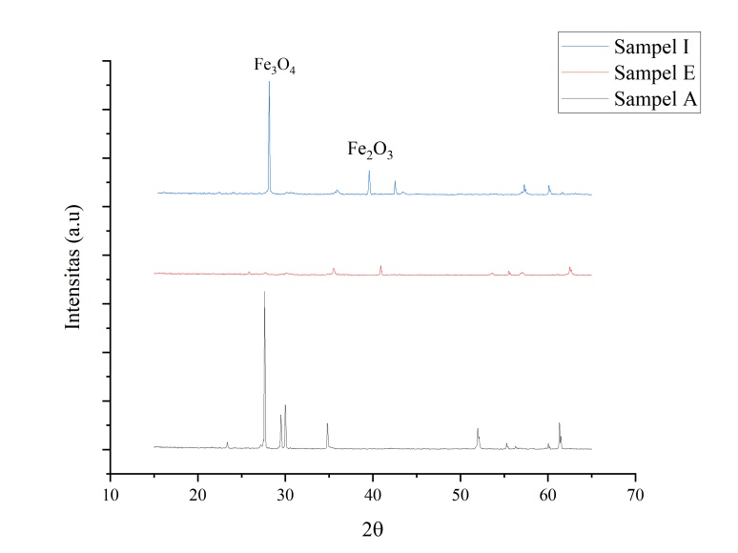
Figure 1. Spectrum of XRD characterization results of iron sand des Pangeo in samples A, E and I
The magnetic suceptibility and mass suceptibility values of each sample differ depending on the strength of the field of that sample. The difference in the value of magnetic suceptibility and mass suceptibility is due todifferences in the quantity of magnetic minerals in soil deposits [5]. Can be seen in Table 2, of the 12 sand samples taken in pangeo village, Morotai Jaya has a magnetic suspetibilbiltas value of the mass varies greatly.
Table 2. Magnetic Suseptibiltas value of Pangeo Village iron sand sample mass
Sample Code | Total Magnetic | Suceptibility Mass  (10-⁸m³/kg)
A | 12,63 | 13965,42
B | 12,63 | 32583,40
C | 12,63 | 19501,98
D | 12,62 | 42074,24
E | 12,64 | 82867,54
F | 12,64 | 54803,13
G | 12,63 | 51206,92
H | 12,62 | 64797,60
I | 12,61 | 41215,42
J | 12,63 | 13186,98
K | 12,67 | 67256,70
L | 12,63 | 81296,68

The largest magnetic suspetibility value in the E sample was 82867. x10⁻⁸m³/kg, while the smallest was in sample J with a value of 13186.98 x10⁻⁸m³/kg. This is because the J sample is at least magnetically drawn during synthesis, and the color is not too black because many mix with other non-magnetic materials. E samples are most easily attracted by magnets.
This relationship is directly proportional to the E sample which has Fe₂O₃ magnetic material content of characterization of 70.31% which is the largest compared to the I and A samples in sequence of 54.58%, 50.94%, while magnetic suseptibiltas values of 41215, x10⁻⁸m³/kg and 13965,42 x10⁻⁸m³/kg. The greater the value of magnetic suseptibiltas, the greater the magnetic mineral content of Fe₂O₃ which is the basis of cathode material in the manufacture of lithium ion batteries.
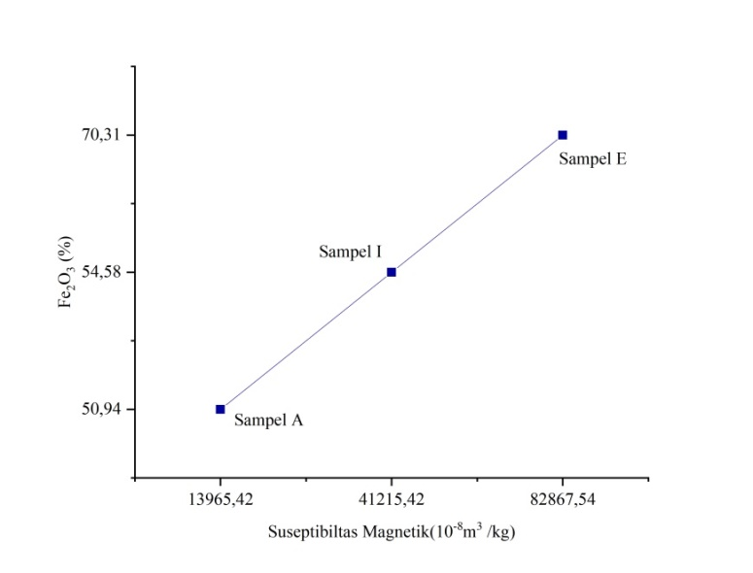
Figure 2. Suseptibiltas relationship with Fe₂O₃ magentic material content

The range of magnetic suceptibility values in samples A through L is at intervals of (46-80000) x10⁻⁸m³/kg, and (20,000-110,000) x10⁻⁸m³/kg. Based on these intervals, both magnetic and mass reliability of each iron sand sample contains ilmenite particles (FeTiO₃) in the antiferomagnetic group, and magnetite (Fe₃O₄) is in the ferromagnetic group [4].

CONCLUSION
The material content obtained from Pangeo Village Iron Sand is illuminated by magnetic materials Fe3O4 and Fe2O3. The crystal structure of the spiner inverse crystal with the greatest christanility is found in sample A. Based on the degree of magnetism of soil deposits found along the Sail river it is known that the spread of magnetic content is getting higher. (46-80000) x10⁻⁸m³/kg, and (20,000-110,000) x10⁻⁸m³/kg. Based on these intervals, both magnetic and mass reliability of each iron sand sample contains ilmenite particles (FeTiO₃) in the antiferomagnetic group, and magnetite (Fe₃O₄) is in the ferromagnetic group

REFERENCES

[1] Nengsi, Sisri W, dkk.. 2016. Karakterisasi Struktur Kristal dan Sifat Magnetik Maghemit (γ-Fe2O3) yang Dioksidasi dari Magnetit (Fe₃O₄ ) dari Pasir Besi Batang Sukam Kabupaten Sijunjung Sumatera Barat dengan Variasi Waktu Oksidasi.Jurnal Fisika Unand Vol. 5, No. 3 [2] Nurrohman, Devi T dan Pribadi, J.S. 2018. Kajian Struktur Kristal, Lattice Strain, Dan Komposisi Kimia Nano Partikel Pasir Besi Yang Disintesis Dengan MeTode Ball Milling. Jurnal Fisika Dan Pendidikan Fisika Volume 3, Nomor 2
[3]Purwariadi, Ibrahim. 2020. Potensi riset dan pengembangan FePO4 dari bahan baku lokal Fe₂O₃ di Indonesia. LIPI. Banten

[4] Rajab. 2017. Sintesis Nanopartikel Manganese Ferrite (MnFe2O4) Berbasis Pasir Besi Dan Mangan Alam Dengan Metode Reaksi Padatan. Skripsi. Universitas Halu Oleo

