A Practically Method to Modify Shallow Foundation for Supporting Multy-Storeyed Building with CPT Data Tests

Irnawaty¹⁾, Suyuti Suyuti²⁾, Arbain Tata³⁾, Maulana Ibrahim⁴⁾
^{1, 2, 3,4)} Universitas Khairun, Jalan Pertamina Kampus Gambesi, Ternate
email: irnawaty@unkhair.ac.id¹⁾, suyuti@unkhair.ac.id²⁾, arbain.tata@unkhair.ac.id³⁾, maulana@unkhair.ac.id⁴⁾

DOI: http://dx.doi.org/10.29103/tj.vxxix.xxx

(Received: xx xx 20xx / Revised: xx xx 20xx / Accepted: xx xx 20xx)

Abstract

A foundation aims to distribute upper structure loads as dead, live, and earthquake loads. A construction of medical building four stories called Mother and Children of RSUD Chasan Boisoirie as official hospital in Ternate city. Design of sub-structure results of the consulting were worked with shallow foundation with width B is the length (L) of 2,0 meters and depth (D_{f}) of 3,6m in field. However, condition was conducted by reinforcing and casting concrete for the foundation. There are some problems, i.e., ratio of foundation depth to the width B (λ) of 1,8 > 1,0. That can be collapsed of footing of foundation structure due to such shear punch due to an earthquake. Therefore, this research is followed National such as standard SNI, loading due to earthquake, learning CPT secondary data, checking soil layer data in the field, determining shear stress of foundation modification, checking soil stress beneath the foundation footing and calculation of the ground's flexural bar. Finally, the simulation results are given load as moment-x (M_{x}) of 23,97 tons, moment-y (M_{y}) of 23,86 tons and vertical load (P_{uv}) of 201,7 ton. Determining results of shear strength (ϕV_{np)} of 3.097,6 kN > 2017 kN (safe). Calculation is given a maximum stress of soil layer beneath foundation checked by σ_{max} of 863 kN/m² < q_{an} of 1.677,6 kN/m². Flexible bars for footing foundation due to vertical load and response of the subsoil layer were saved in controlled criteria.

Keywords: bearing capacity, modified foundation, earthquake load, shallow foundation, CPT data

- Introduction

In general, building construction design can be divided into 2 (two) parts: 1) the upper building structure, and 2) the lower building structure. Meanwhile, underfloor building structures usually use 2 (two) types of foundations: Shallow foundation and deep foundation. In which, a deep foundation can be designed with the type of well foundation, drill pile and pile. The field topography of the building construction area has a decreasing surface slope contour ranging from 8% to 20% west to east over a land elevation of more than 50 meters above the water sea level.

The foundation bearing capacity is considered the value of the mechanical parameters of the structure of the soil and rock layers. Field soil testing used to design the structure of the building under the construction of Mother and Children in the RSUD Chasan Boesoirie, which is located at Tanah Tinggi Ternate sub-district of Ternate city is using the Cone Penetration Test (CPT) data, it is referred SNI in 2008.

Field soil investigation data using the CPT method for 4 (four) points of TS1 to TS4 have provided a cone tip resistance (q_{c}) of 250 kg/cm² as described in Figure 1 below. Figure 1a. Shows the placement of the CPT test, where a diagonal line project was carried out to map the results of q_{c} values and land contours according to the field topography. While Figure 1b. shows the results of field data pieces by using the CPT method (Suyuti and Arbain, 2017).

Recently, the existing structural loads resulting from building planning can be written as shown in Figure 2 below.

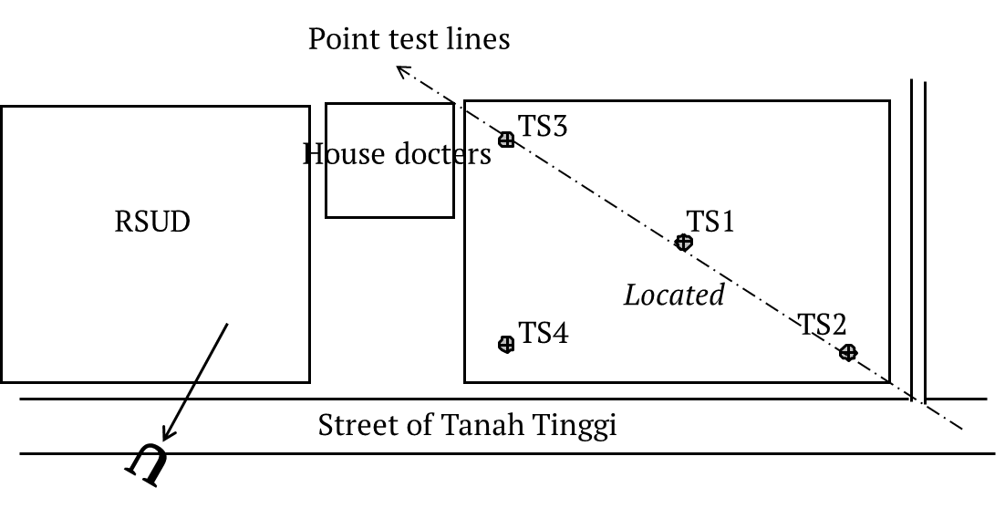 | 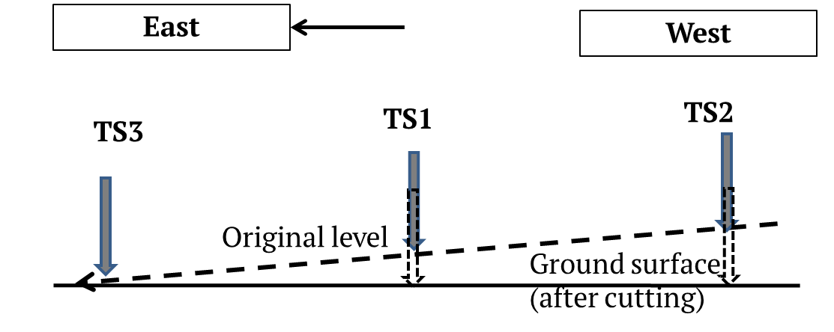
a) Layout placed points of CPT test | b) Long section of CPT test

Figure 1. Results of soil investigated by using CPT tests

A problem of the substructure's design data using a shallow foundation with a square footing type, it is a cross-section of width B of 2.0 m, length L of 2.0 m and depth D_{f} of 3.6 m.
A current shallow foundation planning criteria ratio is λ = D_{f}/ B of 1.8. The ratio λ should be λ ≤1.0, so the foundation should be designed with a deep foundation type. Meanwhile, when the research study was carried out at that time, the work on assembling the pedestal iron and shallow foundation foot plate had been carried out by the implementing contractor and was ready for installation and casting.
Because of that, there needs to be a solution on how to improve the results of the foundation design for the contractor so that they can still use the pieces of iron that have been completed. Furthermore, the function of the substructure can transmit loads (moment, shear and vertical) from the superstructure.
So, this study aim is to find out a solution for modifying shallow foundation structures in reducing the potential for shear failure of the footplate foundation due to static and dynamic loads due to earthquake as shown in Figure 2.

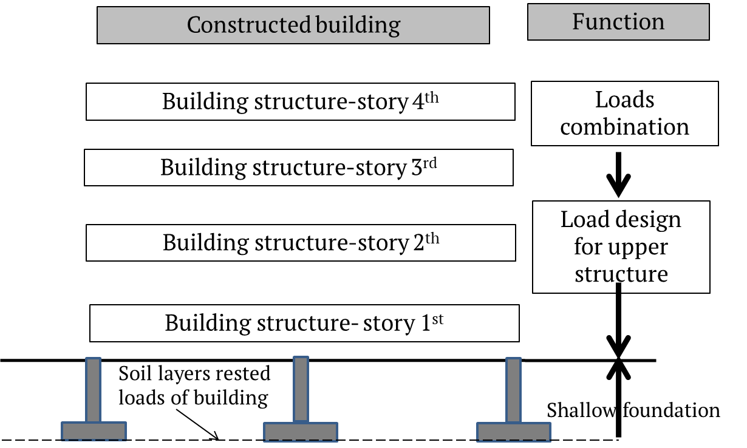
Figure 2. Illustration of procedure for designing construction with building functions
2. Research Methods
2.1 Used standard
To carry out scientific research, the method that the authors are used to make planning data on the superstructure loads of the hospital building made:
a) Following regulations such as Procedures for earthquake resistance (SNI, 2012), Requirements for structural concrete for buildings (SNI, 2013) concrete reinforcing steel (SNI, 2014), and the minimum load for planning buildings and other structures (SNI, 2013).
b) Input building planning data such as: The building consists of 4 (four) floors, located in Tanah Tinggi Sub-district, Ternate city, the building functions as a hospital, reinforced concrete building structure, floor height 4.0 m, concrete compressive strength (f'_{c}) of 20 MPa, yield stress of steel (f_{y})of 400 MPa, elastic modulus of concrete (E_{c}) of 21,01 MPa, and superstructure calculation using FEM auxiliary program,
c) Determination of dimensions for beams, columns and floor slabs
d) Dead loads such as floor slab loads, roof slab loads, column dead loads, and live loads that work for hospital facilities.
e) Dynamic earthquake load spectrum response, such as determining the risk of building structures and earthquake priority factors, as shown in Table 1 below.
Table 1. Category risk and earthquake load factors
Function | Risk category | Earthquake factor
Hospital | IV | 1,5

This study focused on the design of the substructure using: Data from the CPT test results (see Figure 1b). The resistance of the conical ends TS-2, TS-1 and TS-3 are given end resistance of conus (q_{c}) of 250 kg/cm², respectively at depth (D_{f}) of 2.0 m, 4.2 m and 4.6 m. In contractual, the results of shallow foundation planning were designed by using square pattern of footings with a cross-section of width (W) of 2.0 m, length (L) of 2.0 m and depth (D_{f}) of 3.60 m.

2.2. Literature
In order to make design is allowed internal stability of footing of foundation. The criteria of design must be followed as
The obtain shear stress of punch is defined as (Wijatmoko, 1999):

$t_{punch}=\frac{P_{uv}}{4h\left(h+B\right)}$ (1)
Where criteria shear stress (t_{punch}) of 10,4 kg/cm², this section is obtained t_{punch} of 0,40 kg/cm² (safe)
The allowable bearing capacity of foundation q_{all} may write (Isniati and Mochtar, 2023):

$q_{all}=\frac{q_{u}}{FS}$ (2)
Where: q_{u} is the ultimate bearing capacity of square footing, FS is the factor of safety (Suyuti et al., 2020)

The bearing capacity of the foundation limit (q_{u1}) as a shallow foundation using CPT data is (Suyuti, 2010):

$q_{u1}=\frac{q_{c}}{50}{\left(\frac{B+0,3}{B}\right)}^{2}$ (3)
Where: q_{c} is the cone tip resistance (data q_{c} test results of 150 to 200 kg/cm²) and B is the width of foundation.
The bearing capacity of deep foundation types with end enlargement (Coduto, 1994). So that the bearing capacity of the foundation limit (q_{u2}) is:

$q_{u2}=4,17\left(\frac{B_{col}}{B_{pk}}\right)\left(0,6σ_{r}N_{60}\right)$ (4)
Where: N₆₀ is the N-SPT value at the base of the footing, which is determined based on CPT test results (q_{c}) of 200kg/cm².

The calculation of the bearing capacity of the net foundation permit in q_{an} is written as (SNI, 2017):

$q_{an}=\frac{q_{u2}-p_{sc}}{FS}$ (5)

- Results and Discussions
3.1 Results
The results section should include the findings of the study. The findings include data presented in tables, charts, graphs, and other figures (maybe placed among research text or on a separate page). A contextual analysis of this data explaining its meaning in sentence form. The results section should simply state the findings, without bias or interpretation, and arranged in a logical sequence. Typically most of the sentences in the results section will be in the past tense, some will be in the present tense, and very few, if any, will be in the future tense.
The results of the CPT test for 4 (four) points are need to be checked for real conditions when excavation was completed in the field as shown in Figure 3 below (Suyuti and Arbain, 2017).
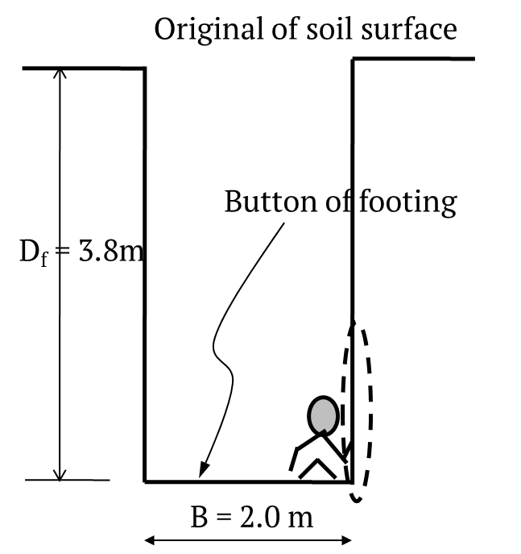 | 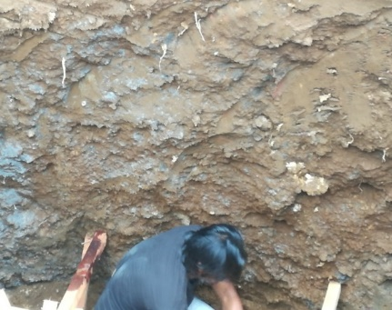
a) Illustrating shallow foundation | b) Documentation of soil sampling
Figure 3. Observed soil characteristics at the level button of foundation

Figure 3 shows the following several parameters of design data for foundation in the field :
- Width of foundation (B) of 2.0m, and length (L) of 2.0m, it is placed depth at 3.6 m.
- Direct partial observation of the results of foundation excavations in the field is that the dominant soil layer is clay to a depth of approximately 2.0 m, while granular soil is in the form of sand to clay gravel at a depth of 3.6m.
- The groundwater level is not found.
The results of the calculation of the water content and the volume weight of the subgrade soil layers are obtained sequentially water content (w) of 48% and soil bulk density (γ_{s}) of 1.9 kN/m³.
The selection of the foundation should take into account the following:
- Functions of the upper structure of the building
- The load volume and weight of the building superstructure
- Report data on the results of land investigations at the building site
- Earthquake loads of upper structures
- The cost to be involved.
Therefore, to determine the volume weight of the soil and the soil content of the base plan of the footing using the procedure as below:
Furthermore, the calculation of foundation stability is in the following sequence:
1) Use forces acting on the maximum foundation due to the earthquake load are obtained: Moment perpendicular and parallel to the image (M_{x}) of 23.97 kNm, and M_{y} of 23.86 kNm, with vertical load (P_{uv}) of 201.7 tons as shown in Figure 5 below:
2) Calculate shear stress of punch (t_{punch}) acting on the foundation structure needs to be checked is the equation (1) above.
3) Determine allowable bearing capacity of foundation q_{all}

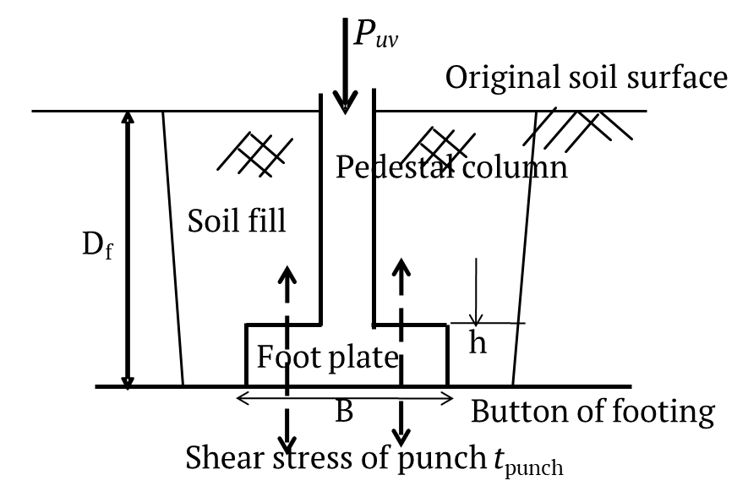 | 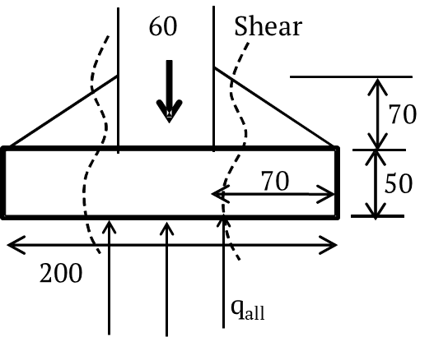
- Designed in the contractual | - Modified footing structure
Figure 4. A practical design of foundation in this study

4) Predict capacity of the foundation limit for shallow foundation using CPT data (q_{u1}) by using equation (3)
From q_{c} is the cone tip resistance (data q_{c} test results of 150 to 200 kg/cm²) and B is the foundation width (B) of 200 cm. So that the bearing capacity of the shallow foundation obtained (q_{u1}) of 300.9 tons/m².
Then, referring to the results of calculating the ratio (λ) of 1.8. The design needs to be compared with the method of calculating the limit bearing capacity of deep foundation types with end enlargement (Coduto, 1994). So that the bearing capacity of the foundation limit (q_{u2}) in equation (4).
By using N₆₀ is the N-SPT value at the base of the footing, which is determined based on CPT test results (q_{c}) of 200kg/cm²). From the CPT test data, the soil layer value in general can be categorized as hard density soil N-SPT of 60. B_{col} is the diameter of the conversion column (B_{col}) of √(4A₀₁/π), for A₀₁ of 3,600 cm², B_{col} of 0.68 m is obtained. C_{pk} is the diameter of the conversion foot plate (C_{pk}) of √(4A₀₂/π), for A₀₂ of 40,000 cm², obtained B_{pk} of 2.26 m.
σ_{r} is the standard effective stress, it is given σ_{r} of 100kN/m².
Then ultimate bearing capacity (q_{u2}) is obtained 375.3 ton/m².
5) Modification of the sole of the foundation with enlargement of the tip in equation (5). In calculation, it is found (q_{an}) of (450,4 – 30,96 to 2,5 = 168 ton/m². Check feasibility of vertical load Vertical load pressure acting on the soil under the footing (σ_{v}) of 201.7 tons/ 1.44 m² of 140 tons/m² < q_{an} of 168 tons/m² (fulfillment)

6) Check foundation shear strength
The results of the calculation and checking of the forces acting on the footing of the σmax foundation before and after being modified see Tables 2 and Table 3. Table 3 shows the shear strength of the foundation after being modified to obtain a safety factor of 1.5 times against the vertical load of the upper-structure.
7) Calculate soil stress under the foundation
The results of calculating and checking the soil stress acting on the base of the foundation are listed in Table 2 below.
Table 2. Calculation results for before and after modified shallow foundation
Description | Equation | Before | After | Unit
Column shear force with load factor | P_{uv} = | 2,017 | 2,017 | kN
Quality of concrete K-300 | f'_{c}= (0,83/9,81).300 = | 25.38 | 25.38 | MPa
Column point factor (center) | α_{s} = | 40 | 40
Width of column at direction of x and y | b_{x} = b_{y} = | 0.6 | 0.60 | m
Distance center bars against side of concrete | d' = | 0.0905 | 0.0905 | m
Thickness of plate | h = | 0.5 | 0.85 | m
Effective thickness of foot plate | d = h -d' = | 0.4095 | 0.7595 | m
Width shear of punch plane at x | c₁ = b_{x} + d = | 1.0095 | 1.3595 | m
Width shear of punch plane at y | c₂ = b_{y} + d = | 1.0095 | 1.3595 | m
Area of shear punch | A_{p}= 2(c₁+c₂)d = | 1.65356 | 4.130161 | m
Width of shear punch | b_{p} = 2(c₁ + c₂) = | 4.038 | 5.438 | m
Ratio of longer side to near side column | β_{c} = b_{x}/ b_{y} = | 1.0 | 1.0 | -
Stress of punch shear, taken minimum | f_{p}= [1+2/β_{c}] . (f'c^0,5/6)= | 2.519 | 2.519 | MPa
Quality of concrete K-300 | f_{p}= [α_{s}(d/b_{p})+2].(f'c^{0,5}/12) | 2.543 | 3.185 | MPa
Used shear stress of punch into account | f_{p} = | 2.519 | 2.519 | MPa
Reduction factor of punch shear | φ = | 0.75 | 0.75 | -
Used shear stress of punch | φ.V_{np} = φ.A_{p}.10³ ⁼ | 1240.17 | 3097.6 | kN
Checked strength criteria |  | No. safe | Safe

Table 3. Stress calculation results at the button foundation
Description | Equation | Result | Unit
Vertical total loads | P_{uv =} | 2,017.00 | kN
Moment at direction x | M_{x}= | 239.70 | kNm
Moment at direction y | M_{y} = | 238.60 | kNm
Width foot of foundation | B = | 2.00 | m
Length foot of foundation | L = | 2.00 | m
Moment inertia at direction x | I_{x} = 1/12.B.L³ = | 1.33 | m⁴
Moment inertia at direction y | I_{y} = 1/12.B³.L = | 1.33 | m⁴
Gravity center of foot foundation at direction x | x = B/2 | 1.00 | m
Gravity center of foot foundation at direction y | y = L/2 | 1.00 | m
Width of column at direction x | b_{x} = | 0.6 | m
Width of column at direction y | b_{y} = | 0.6 | m
Eccentricity at direction x | e_{x}= B/2 - (M_{y}/P_{uv}) = | 0.88 | m
Soil stress maximum | σ_{max} = (P_{uv}/A)+M_{x}.y/I_{x} + M_{y}.x/I_{y} = | 863.0 | kN/m²
Allowable net soil stress | q_{an}= | 1,677.6 | kN/m²
Checked soil stress: σ_{max} ≤ q_{an} | 863 < 1,677.6 (safe)

  - Discussions
The results of the evaluation of the foundation sole reinforcement can be seen in Figure 5 as below:

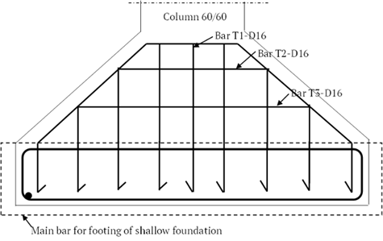 | 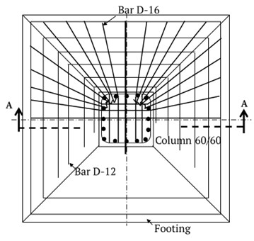
a) Top view of footing reinforcement | b) Bottom view of footing reinforcement

Figure 5. Detailed of shallow foundation reinforcement after modified in this study
After conducting research and recommendations to continue building construction work, work on the foundation structure was modified the footing as shown in Figure 6 as below.
The results of the implementation of the current mother and children building which has been used by the management of the Chasan Boisoirie Hospital Ternate are shown in Figure 7 below.
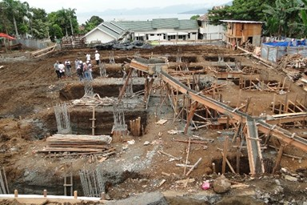 | 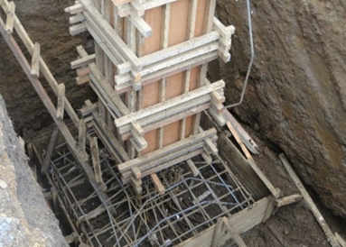
a) Planned in design foundation | b) Detailed reinforcement after modification

Figure 6. Foundation design structure after modification in this study

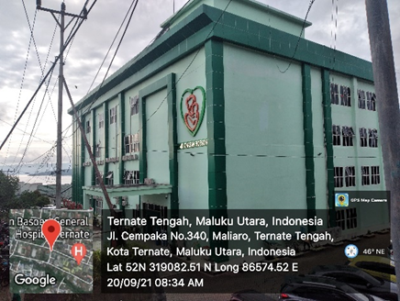

Figure 7. Documentation evidence of constructed building on using shallow foundation modification

- Conclusion and Suggestions
Based on cases study in this research, the conclusions that can be written as below:
- The amount of loading on the superstructure due to external influences on multy-storey buildings has met the requirements (SNI, 2012).
- The design of multy-storey building shear walls has been done accordingly (SNI, 2013).
- Field tests have been carried out using the CPT test method and have combined checking and sampling to determine the mechanical properties of the soil in the laboratory with a depth of hard soil up to (D_{f}) of 4.6 meters with a cone tip resistance (q_{c}) of 250 kg/cm².
- Research has found that the sub-foundation structure is designed to use a shallow foundation, this does not meet the criteria, namely (λ) of 1.8, it should be less than one point zero.
- This requires a review of the design, because it can pose a risk of failure in the shear strength of the footing. Therefore, in this research modification of the shallow foundation has been carried out into a deep foundation.
- The results of the calculation of the shear strength of the modified foundation soles show more than 1.5 times more than the shallow foundation soles, so it can be concluded that the modified Deep Foundation model can be used as a method for solving shallow foundation design problems for four-storey buildings.

This study can be suggested that to design shallow foundation, it must be satisfied to the criteria of external of footing capacity and internal stability of concrete quality. Moreover, in case foundation design of multy-stories building, then substructure should be used a deep foundation method.

5. Acknowledgements
Acknowledgments to the Manager of the physical activities of the RSUD Chasan Boisoirie, Ternate City. Thank you also to the PUPR Technical Director of North Maluku Province and the Faculty of Engineering, Universitas Khairun for their assistance and cooperation.

6. Rerefences
Badan Standarisasi Nasional. (2008). SNI 2827-2008. Cara uji penetrasi lapangan dengan alat sondir
Badan Standarisasi Nasional. (2012). SNI 1726-2012. Tata cara perencanaan ketahanan gempa untuk struktur bangunan Gedung dan non gedung
Badan Standarisasi Nasional. (2013). SNI 2847-2013. Persyaratan beton struktural untuk bangunan gedung
Badan Standarisasi Nasional. (2014). SNI 2025-2014. Baja tulangan beton
Badan Standarisasi Nasional. (2014). SNI 8460-2017. Persyaratan perancangan geoteknik
Coduto, D. P. (1994). Foundation design: Principles and practices. Pearson Education Limited, p.445-493
Mochtar, I. B. (2023). Increasing the bearing capacity of shallow foundations on soft soil after the installation of micro-piles. Journal of the Civil Engineering Forum, 9(3), 227–238. https://doi.org/10.22146/jcef.5925
Suyuti, (2010). Rekayasa Pondasi I. Ternate. Universitas Khairun Press
Suyuti dan Arbain (2017). Evaluasi pekerjaan sub-struktur (pondasi) Gedung ibu dan anak RSUD Hasan Boisoirie Ternate
Suyuti, Muhammad Rizal dan Yuni Damayanti (2020). Prediksi CBR lapangan pada pondasi matras di atas tanah lunak diperkuat tiang-tiang bambu menggunakan formula klasik Terzaghi, Teras Jurnal, Vol.10(1), p.59-70
Widjatmoko, 1999, Struktur beton, Universitas Semarang, p.347-358

