Comparative Performance Analysis of VANET Routing Protocols under Dynamic Node Mobility

Fahrizal Djohar^{1*}, Hafid Syaifuddin², Dharmawan³
¹Department of Electrical Engineering, Faculty of Engineering, Universitas Khairun
email : *fahrizaldjohar@unkhair.ac.id

Article history : Received Mar 12, 2024 | Revised Jul 11, 2024 | Accepted Jul 17, 2024

Vehicular Ad Hoc Networks (VANETs) are essential in supporting intelligent transportation systems, yet they face significant challenges due to frequent topology changes caused by high node mobility. This study evaluates the impact of node speed on routing performance using two representative protocols: Dynamic Source Routing (DSR) as a reactive protocol, and Destination-Sequenced Distance-Vector (DSDV) as a proactive protocol. Simulations are conducted using NS-3 and visualized with NetAnim under two mobility scenarios: 10 m/s and 20 m/s. Throughput, measured in kilobits per second (kbps), is the primary performance metric. The results show that DSR consistently outperforms DSDV across both speed levels, with average throughput decreasing at higher speeds for both protocols. However, DSR demonstrates greater adaptability in dynamic environments, maintaining relatively stable throughput despite increased mobility. These findings suggest that reactive protocols are better suited for high-mobility VANET scenarios, where rapid topology changes require efficient and responsive routing strategies.

Keywords: Vehicular, Networks, Mobility, Throughput, Protocols.
This is an open access article under the (CC BY-NC-SA 4.0)

- INTRODUCTION
Vehicular communication plays a significant role in supporting intelligent transportation systems, offering capabilities such as real-time traffic management, driver assistance, and road safety. However, frequent topology changes due to high vehicle mobility present critical challenges for routing data efficiently. The performance of a routing protocol in this context depends heavily on its ability to adapt to changing network conditions while maintaining acceptable throughput and low overhead [1].

One of the main issues addressed in this research is the decrease in routing performance as node speed increases. While existing protocols may perform well in static or low-mobility networks, they often fail to sustain high throughput in high-speed environments. Proactive protocols maintain updated routing tables through frequent broadcasts, which increases control overhead, whereas reactive protocols initiate route discovery only when needed, resulting in initial delays. Each approach presents trade-offs that must be evaluated across different mobility scenarios [2].

Recent studies have investigated these trade-offs by analyzing protocol performance under varying network conditions. Pratama et al. [3] evaluated routing protocols in urban environments using NS-3 and SUMO, showing that reactive protocols adapt better to dynamic topologies. Similarly, Toruan and Nurwarsito [1] emphasized that mobility and protocol selection significantly affect network performance. Al-Nasir and Mubarek [4] found that AODV, DSDV, and DSR behave differently depending on speed, with reactive protocols generally outperforming others in high-mobility scenarios. Supporting this, Safrianti et al. [5] concluded that DSR outperforms OLSR in terms of reliability under dynamic conditions.

Further, reactive routing protocols have been shown to reduce communication delays in VANETs, with autonomous vehicle scenarios demonstrating up to a 7.1% reduction in average trip time in high-density traffic environments [6]. Simulation results in an urban VANET context also reveal that DSR achieves the highest packet delivery ratio, followed sequentially by AODV, DSDV, and OLSR, indicating its suitability for dynamic networks [7].

In addition to routing behavior, the choice of propagation loss models significantly impacts performance. For instance, while OLSR performs best under the Friis model, AODV, DSDV, and DSR exhibit improved performance using the Two-Way and Nakagami-m models [8]. The influence of node density and speed has also been explored, showing that protocol efficiency is scenario-dependent, with each protocol excelling under specific conditions [9]. Moreover, realistic mobility models have been shown to affect protocol behavior, reinforcing the importance of accurate modeling in VANET simulation studies using NS-3 and SUMO [10].

From a protocol comparison standpoint, DSR consistently outperforms AODV across multiple performance metrics, offering higher stability and reliability in dynamic environments [11]. Likewise, when evaluated under both V2V and V2I communication scenarios, DSR demonstrates better throughput and reduced end-to-end delay compared to FSR [12].

Therefore, the contribution of this research lies in providing a focused analysis of node mobility's impact on routing throughput using recent tools and well-defined simulation environments. The findings are expected to support the selection of adaptive routing strategies for more reliable communication in dynamic vehicular networks.

- METHOD
This research utilizes the NS-3 simulator to assess the performance of routing protocols within a Vehicular Ad Hoc Network (VANET) framework. Two mobility scenarios are considered, with vehicle speeds set at 10 m/s and 20 m/s, representing standard urban traffic and high-speed mobility, respectively.
Start
Define Simulation Parameters
DSR Routing Protocols
DSDV Routing Protocols
Node Speeds 10m/s
Node Speeds 20m/s
Set Up Simulation Environment
Assign Node Speed
Select Routing Protocols
Analyze Results and Draw Conclusions
Finish
Figure 1. Flowchart of research method

The movement of nodes and packet transmission is illustrated using the NetAnim visualization tool. Two routing protocols are examined: Dynamic Source Routing (DSR), representing reactive protocols, and Destination-Sequenced Distance-Vector (DSDV), representing proactive approaches. Throughput, expressed in kilobits per second (kbps), serves as the primary performance metric.
DSR operates as a reactive routing protocol, initiating a route discovery process only when the source lacks a valid path to the destination. It functions through two main mechanisms: during Route Discovery, the source broadcasts a Route Request which is forwarded by intermediate nodes, appending their addresses until it reaches the destination. A Route Reply is then sent back along the discovered path. In the Route Maintenance phase, any link failure along an active route triggers a Route Error message to the source, which subsequently removes the faulty link from its route cache[13].

Conversely, DSDV is a proactive protocol grounded in the Bellman-Ford algorithm. Each node retains a routing table that records the shortest known paths to all reachable destinations. To maintain accuracy and prevent routing loops, each entry is associated with a sequence number generated by the destination node. These tables are refreshed periodically using full or incremental updates. Upon receiving an update, a node evaluates the sequence number and the path length; it updates its table if the new information is either more recent or offers a shorter route with the same sequence number[14].

- RESULTS AND DISCUSSION
This study evaluates the impact of node mobility on the performance of routing protocols in a VANET environment using two widely studied protocols: DSR and DSDV. The simulation environment is configured within a 750-meter x 750-meter area with 66 nodes which represent the number of vehicles in a region when the traffic density is quite high [15], and node mobility is tested at two different speeds: 10 m/s and 20 m/s. The primary performance metric observed is throughput (in kbps).

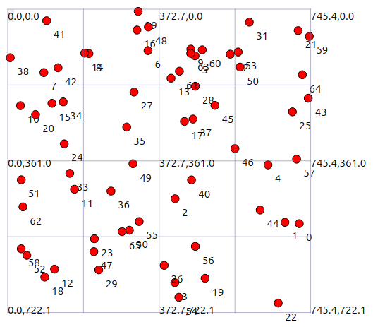
Figure 2. Node mobility representation shown in the area

The throughput performance of each evaluated routing protocol is presented in Figure 2. This figure highlights how changes in mobility affect the efficiency of data transmission, enabling a direct comparison of protocol responsiveness under dynamic network conditions.
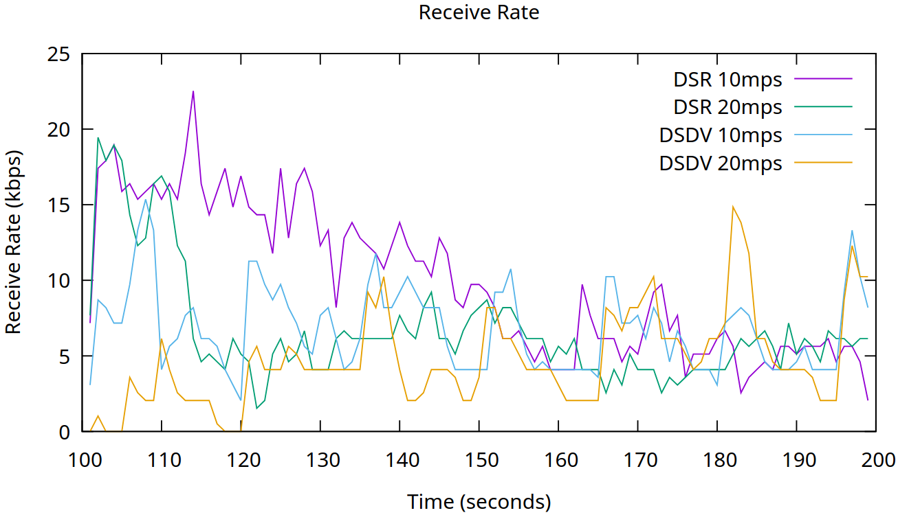
Figure 3. Throughput Performance of Routing Protocols Under Varying Node Speeds

From the performance curves shown in Figure 2, we derived the average throughput for each routing protocol under the specified mobility scenarios. Table 1 below lists these calculated values, enabling a direct comparison of protocol efficiency.

Table 1. Algorithms Performance at Different Speeds

Protocol | Speed (m/s) | Average Throughput (kbps)
DSR | 10 | 9.888
DSR | 20 | 6.692
DSDV | 10 | 6.785
DSDV | 20 | 4.706

The data shows that DSR outperforms DSDV in terms of throughput at both mobility levels. At 10 m/s, DSR achieves a significantly higher throughput (9,888 kbps) compared to DSDV (6,785 kbps). As the speed increases to 20 m/s, the throughput for both protocols decreases, but DSR maintains a higher performance (6,692 kbps) relative to DSDV (4,706 kbps).

This performance degradation at higher speeds is expected due to the increased rate of topology changes and more frequent route breaks. However, the degree of impact differs between the two protocols: DSR, being a reactive routing protocol, establishes routes on-demand. This approach proves to be more adaptable in dynamic environments, enabling DSR to maintain relatively stable throughput even at higher speeds. DSDV, a proactive routing protocol, maintains a consistent route table by periodically broadcasting updates. This method introduces more overhead in highly dynamic scenarios and struggles to adapt quickly to rapid topology changes, resulting in lower throughput as mobility increases.

The findings suggest that DSR is more suitable for high-mobility VANET environments where nodes move rapidly and route changes are frequent. In contrast, DSDV may be more effective in low-mobility scenarios where network topology remains relatively stable.

In practical VANET deployments, such as in urban traffic environments or highway scenarios, mobility is a critical factor. The superior adaptability of DSR in maintaining higher throughput makes it a better candidate for such conditions, especially when fast and reliable data transmission is essential for safety-related applications.

- CONCLUSION
This study has presented a performance evaluation of routing protocols in VANETs under varying mobility conditions. The results show that node speed significantly affects throughput. Higher speeds lead to reduced throughput due to frequent topology changes and route disruptions. Among the tested protocols, the reactive approach consistently maintained higher throughput compared to the proactive approach. This indicates that reactive routing is more effective in dynamic VANET environments where rapid changes in node positions occur. Overall, the findings suggest that the selection of routing protocols in VANETs should consider node mobility as a critical factor. Protocols that adapt quickly to topology changes are more suitable for high-mobility scenarios, which are common in vehicular networks.

REFERENCES
[1] S. A. O. Toruan and H. Nurwarsito, "Analisis Kinerja Protokol Routing DSDV, DSR, ZRP, dan AOMDV pada Jaringan VANET Menggunakan Simulator NS2," Jurnal Pengembangan Teknologi Informasi dan Ilmu Komputer, vol. 5, no. 5, pp. 2115–2122, May 2021.
[2] H. F. Mahdi, "Performance Evaluation for Vehicular Ad-Hoc Networks Based Routing Protocols," Bulletin of Electrical Engineering and Informatics, vol. 10, no. 1, pp. 104–112, Feb. 2021. doi: 10.11591/eei.v10i1.12345.
[3] R. A. Pratama, D. A. Sari, A. Mukhlis, and H. Pranowo, "Performance Evaluation on VANET Routing Protocols in the Way Road of Central Jakarta Using NS-3 and SUMO," in Proc. 4th Int. Conf. Informatics Comput. Sci. (ICICoS), 2020, pp. 1–6. doi: 10.1109/ICICoS51170.2020.9299004.
[4] A. W. K. Al-Nasir and F. S. Mubarek, "AODV, DSDV, and DSR Protocols of Routing for VANET: Performance Evaluation," Samarra Journal of Pure and Applied Science, vol. 6, no. 1, pp. 8–16, Mar. 2024. doi: 10.54153/sjpas.v6i1.1234.
[5] E. Safrianti, L. O. Sari, A. Romadan, and F. Feranita, "Comparative Analysis of OLSR and DSR Routing Protocol Performance on Vehicular Ad Hoc Network," SIMETRIS, vol. 14, no. 1, pp. 11–20, 2023.
[6] M. A. R. Abdeen, A. Beg, S. M. Mostafa, A. AbdulGhaffar, T. R. Sheltami, and A. Yasar, “Performance Evaluation of VANET Routing Protocols in Madinah City,” Electronics, vol. 11, no. 5, p. 777, Jan. 2022, doi: https://doi.org/10.3390/electronics11050777.
[7] F. Djohar, “Potensi Penerapan VANET Untuk Pengembangan Smart City di Kota Ternate,” MULTINETICS, vol. 10, no. 2, pp. 139–146, Dec. 2024, doi: https://doi.org/10.32722/multinetics.v10i2.6774.
[8] R. A. Pratama, L. Rosselina, Diah Sulistyowati, R. F. Sari, and Ruki Harwahyu, “Performance Evaluation on VANET Routing Protocols in The Way Road of Central Jakarta using NS-3 and SUMO,” 2020 International Seminar on Application for Technology of Information and Communication (iSemantic), pp. 280–285, Sep. 2020, doi: https://doi.org/10.1109/isemantic50169.2020.9234202.
[9] R. R. Ema, Md. F. Ahmed, Md. H. Ahmed, and T. Islam, “Effect of number of nodes and speed of nodes on performance of DSDV, AODV, AOMDV, DSR and GPSR routing protocols in VANET,” IEEE Xplore, Jul. 01, 2019. https://ieeexplore.ieee.org/document/8944844 (accessed June, 2025).
[10] K Sundari and A Senthil Thilak, “Impact of realistic mobility models on the performance of VANET routing protocols,” pp. 1–6, May 2023, doi: https://doi.org/10.1109/iconscept57958.2023.10170053.
[11] K. P. Sampoornam, S. Saranya, S. Vigneshwaran, P. Sofiarani, S. Sarmitha, and N. Sarumathi, “A Comparative Study on Reactive Routing Protocols in VANET,” IEEE Xplore, Nov. 01, 2020. https://ieeexplore.ieee.org/document/9297550 (accessed June, 2025).
[12] R. Z. Akbar, Istikmal, and Sussi, “Performance Analysis FSR and DSR Routing Protocol in VANET with V2V and V2I Models,” 2020 3rd International Seminar on Research of Information Technology and Intelligent Systems (ISRITI), pp. 158–163, Dec. 2020, doi: https://doi.org/10.1109/isriti51436.2020.9315367.
[13] D. B. Johnson, D. A. Maltz, and Y.-C. Hu, “The Dynamic Source Routing Protocol for Mobile Ad Hoc Networks (DSR),” IETF MANET Working Group, Internet-Draft, Apr. 2003.
[14] C. E. Perkins and P. Bhagwat, “Highly dynamic destination-sequenced distance-vector routing (DSDV) for mobile computers,” in *Proc. ACM SIGCOMM*, vol. 24, no. 4, pp. 234–244, Oct. 1994.
[15] M. T. Yudha Saputra and N. Marsaoly, “Model Matematis Hubungan Volume Lalu Lintas Dengan Tingkat Kebisingan Pada Simpang Tiga Ruas Jalan Raya Bastion,” Journal of Science and Engineering, vol. 3, no. 2, Nov. 2020, doi: https://doi.org/10.33387/josae.v3i2.2423.


BIOGRAPHIES OF AUTHORS

Fahrizal Djohar earned his Bachelor’s degree in Electrical Engineering from Universitas Ahmad Dahlan in 2017. He continued his academic journey by completing a Master’s degree in Electrical Engineering at Institut Teknologi Bandung, in 2021. Since 2022, he has been a lecturer at the Electrical Engineering Department, Universitas Khairun. His research interests include communication networks. He can be contacted via email at fahrizaldjohar@unkhair.ac.id.


Hafid Syaifuddin earned his Bachelor of Engineering from the Department of Electrical Engineering at Universitas Muslim Indonesia in 1999 and later completed his Master of Engineering at Universitas Hasanuddin in 2009. He has been a lecturer at the Faculty of Engineering, Universitas Khairun, since 2002. His research interests are in the field of telecommunications. He can be contacted at hafiz.zaifudin@gmail.com.


Dharmawan obtained his Master of Engineering degree from Universitas Brawijaya. Since 2024, he has been serving as a lecturer in the Department of Electrical Engineering, Universitas Khairun. His research focuses on the field of mechatronics. He can be reached at dharmawan@unkhair.ac.id.

