Harnessing the Power of Prototyping Method for Engaging Responsive Web Profiles

Ananto Tri Sasongko¹, Sunita Dasman²

¹Informatics Engineering, Faculty of Engineering, Universitas Pelita Bangsa
²Management, Faculty of Economics and Business, Universitas Pelita Bangsa

*Email: ¹ananto@pelitabangsa.ac.id , ²sunita.dasman@pelitabangsa.ac.id

(Received: dd mmm yyyy, Revised: dd mmm yyyy, Accepted: dd mmm yyyy)

Abstract

This research discusses the implementation of the prototyping method in enhancing institutional visibility through the development of responsive web profiles. Institutional visibility is key to achieving success and sustainable growth in today's digital era. Developing a responsive web profile effectively increases visibility as it provides optimal user experience across various devices and screen resolutions. The prototyping method was chosen as the primary approach in developing this responsive web profile. It allows developers to create initial models that can be tested and evaluated before the full development of the web profile. The research explains the steps in developing a responsive web profile using prototyping. The results show that this method offers an efficient and effective approach to creating a responsive web profile, ensuring user satisfaction, and meeting the increasing expectations of users. Therefore, institutions should consider applying this prototyping method to strengthen their visibility through innovative responsive web profiles. Responsive web profiles enable institutions to reach and engage their target audience through different devices, enhancing user engagement and providing consistent user experiences.

Keywords: Prototyping, Method, Institutional visibility, Responsive, Web profile

This is an open access article under the CC BY license.


*Corresponding Author: Author1

INTRODUCTION
The internet has become integral to human life in today's digital era. More people are searching the internet for information about specific institutions such as schools, colleges, or companies [1]. In this context, responsive web profiles have become one of the media to promote these institutions [2] However, many institutions have not fully maximized the potential of their responsive web profiles.
This research aims to enhance institutional visibility through the implementation of the prototyping method [3], [4] in responsive web profiles. This is considered important because the prototyping method can assist institutions in developing ideas and creating more efficient and effective designs before implementing them in responsive web profiles [5]. As a result, institutions can create more engaging, informative, and user-friendly responsive web profiles.
In the context of education, responsive web profiles can serve as a medium to introduce institutions to prospective students and parents. By providing comprehensive and accurate information, institutions can expand their reach and enhance their reputation in the public eye. Moreover, responsive and user-friendly profiles can influence prospective students' perceptions of institutions and increase their interest in joining [6].
Several articles serve as relevant references in exploring the application of prototyping techniques in developing responsive web profiles for institutions. Wahyudin and Rahayu[7] discuss web development and design techniques that enhance user experience and institutional visibility. Latuconsina et al. [8] also explore the use of the prototyping method in web design, which can improve the efficiency and effectiveness of developing web profiles.
Additionally, Fikriyya et al. [9] address the challenges of innovation in user experience design with new method, which is relevant as the prototyping method can enhance institutional visibility through responsive web profiles. Ramdani et al. [10] focus on the application of the prototyping method to improve the usability of e-notulen environments, which can inspire improvements in usability and user experience on institutional web profiles.
Sukamana [11] talks about developing web-based prototyping tools for user interface design relevant to prototyping methods in developing responsive institutional web profiles. Meanwhile, Syaukati Robbi [12] discusses method acceptance and user satisfaction towards e-learning prototype systems, providing insights on evaluating method acceptance and user satisfaction on institutional web profiles through prototyping.
Ariawan et al. [13] discuss the website design and development process, which can serve as a reference in the development phase of responsive institutional web profiles using the prototyping method. Aldisa [14] compare available website prototyping tools relevant to finding the right prototyping tools to enhance the efficiency and effectiveness of developing web profiles.
Furthermore, Agustian et al. [15] discuss website design and development technologies, which are relevant to the application of the prototyping method in responsive institutional web profiles. Finally, Dian Muzaki et a. [16] explore the use of the prototyping method in mobile application interface design, which is relevant to responsive institutional web profiles accessed through mobile devices.
In conclusion, these references will support the research on the implementation of prototyping methods in enhancing institutional visibility through efficient and effective responsive web profiles. This literature review shows that using the prototyping method in institutional responsive web profiles can improve institutional visibility and user experience. Various prototyping techniques and tools can be applied in the development of responsive institutional web profiles. The articles in this literature review can provide guidance and insights on using the prototyping method in developing responsive institutional web profiles more efficiently and effectively.
This research is expected to provide significant benefits to institutions in enhancing their visibility through the implementation of prototyping methods in responsive web profiles.

RESEARCH METHOD
The development of school website profiles involves subjective considerations such as design, content, and user experience, which are difficult to measure quantitatively. Qualitative methods are used by researchers to gain in-depth insights into user needs and expectations, as well as to understand users' feelings and perceptions about their website experience. Qualitative research in the development of school website profiles may involve interviews with relevant stakeholders such as teachers, students, and parents to gain their perspectives on website development. Additionally, direct observation of user interactions with the website can also provide insights into how users engage with the content and features presented.

2.1 Research Object
In this context, the object of research is the prototyping method in developing school profile websites. The research will focus on the process of using the prototyping method in developing a responsive web profile to increase institutional visibility, especially at TKIT Al Fajri Cahaya Umat in Cikarang, Bekasi Regency.

2.2 Research Type
This type of research is action research. Action research is carried out with the aim of improving and improving a particular condition or problem through actions that are carried out repeatedly in a continuous cycle [17]. In the context of this topic, action research can be carried out by applying the prototyping method in the iterative development of web profiles to increase the institution’s visibility. The action research process involves repeated observation, planning, action, and reflection to develop increasingly optimal interactive web profiles.

2.3 Data Collection Techniques
Data collection techniques in this topic include several methods to collect relevant information related to the application of the prototyping method in increasing the visibility of institutions through interactive web profiles. Following are some of the data collection techniques used in this study:
a) Survey: The survey was conducted to collect data from various related parties, such as teachers, school staff, parents of students, and the surrounding community. The survey was in the form of direct interviews to get their views and perceptions of the school profile website.
b) Observation: Observations are made to directly observe the process of developing and implementing a school profile website. Observations were also made to observe how the website is used by users, such as students, parents, or prospective students, to understand the effectiveness of using the website.
c) Literature Study: Conduct a literature study to obtain information about the theory and results of previous studies that are relevant to this topic. Literature study can help understand how the prototyping method has been applied in the development of websites or other institutional profiles.

2.4 Website Development Methods
The development method used is the prototyping method. The prototyping method is an approach to website development that involves creating an initial model (prototype) that can be tested and evaluated before developing the full version. This approach differs from traditional development methods, which require complete development before testing. The prototyping method provides flexibility and the opportunity to make improvements and adjustments prior to full implementation. This can help minimize the risk of errors and optimize the user experience of school profile websites. In addition, the prototyping method also allows institutions to be more responsive to changes in user needs and the latest method in the long term.

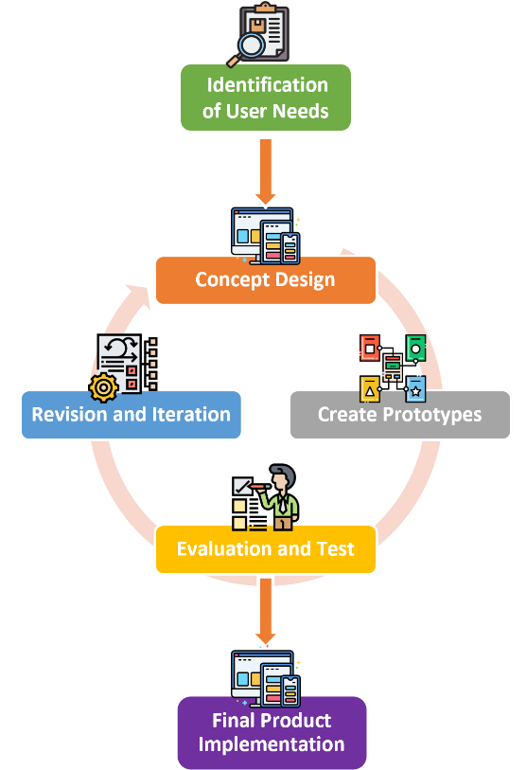

Figure 1. Prototyping Method

The following are the steps for the prototyping method and are described in Figure 1:
1. Identification of User Needs
First, identify the user's needs for the website to be made. This can be done through user interviews, business needs analysis, and user research.
2. Concept Design
Based on the identified user needs, create a conceptual design that includes the goals and features that will be implemented in the software or application. This helps in providing an initial picture of the product to be made.
3. Create Prototypes
Make a model or prototype of software or application using the prototyping method. At this stage, the focus is on creating prototypes that allow users to test the main features of the software or application.
4. Prototype Evaluation and Test
After the prototype is made, evaluate, and test the prototype by involving the user. This helps in knowing the extent to which the prototype meets the user's needs and fixes the prototype that is not good.
5. Revision and Iteration
After the evaluation and testing have been completed, make revisions and improvements to the prototype based on feedback from users. Then, repeat the evaluation and testing phase on the revised prototype. Do iterations until the prototype meets user needs and can be used properly.
6. Final Product Implementation
After the prototype has been developed and evaluated, the final product can be implemented using the prototyping method that has been mastered. The resulting final product will suit user requirements and meet the expected quality standards.
The prototyping method can help increase the institution's visibility and user experience in developing responsive web profiles. By using prototyping, developers can evaluate and improve responsive web profiles on an ongoing basis to achieve the desired goals.

RESULT AND DISCUSSION
This study aims to apply the prototyping method in developing online school profiles with the aim of increasing institutional visibility through responsive web profiles. The results of this study indicate that the application of the prototyping method has succeeded in producing a more responsive and user-friendly school profile website.
Through the prototyping method, the development team can more easily identify user needs and preferences in terms of website design, layout, and functionality. By involving the teachers and staff of TKIT Al-Fajri Cahaya Umat in the prototyping process, improvements and changes can be made directly based on their feedback, thus ensuring the suitability and satisfaction of the end user. The prototyping method also contributes to increasing the efficiency and speed of website development. Developers can preview and test website prototypes prior to full implementation, saving time and resources required for the development.
The online school profile created by the prototyping method has increased the visibility of the institution. Website users can easily access information about schools, academic programs, facilities, and extracurricular activities, thereby helping to improve the institution's image in the eyes of the public.
- Use Case
In the use case, there are two actors and some processes. The following is an explanation of the two actors and processes in the use case:
Actor:
- Visitors: Visitors are external actors who have access to the school profile website pages. They can access information about the school, view school profiles, academic programs, and extracurricular activities, and contact the school via the "Contact" page.
- Administrator: The administrator is an internal actor who has special access to the administration section of the school profile website. They are responsible for managing and updating content on website pages, such as uploading the latest news, managing class schedules, or changing contact information.
Process:
- Visitors access the "Home" page: Visitors open the website and access the "Home" page to get general information about the school and listen to the latest news or ongoing events.
- Visitors access the "About" page: Visitors can find out more about the school's profile, vision, mission, history, and values of the institution through the "About" page.
- Visitors access the "Academic" page: On the "Academic" page, visitors can find information about the curriculum, educational programs, and class schedules offered by the school.
- Visitors access the "Activities" page: Visitors can view ongoing or implemented school activities and events through the "Activities" page.
- Visitors access the "Contact" page: If visitors wish to contact the school or obtain further information, they can view the address, telephone number, and email address of the school on the "Contact" page.
- Administrators manage content: Administrators have special access to manage content across website pages. They can upload news updates, edit school profile information, or add new activities, which will be displayed on the "Activities" page.

- Website Screenshots
On this website’s “Home” page, Figure 2, users will be presented with an attractive and informative display. The main information about the institution will be displayed briefly, such as the school's profile, vision, mission, and advantages. Responsive design will provide an optimal user experience on various devices. In addition, users can also easily access additional information such as school programs, facilities, and extracurricular activities. This homepage serves as a starting point for exploring the entire website and encourages users to become more familiar with and engage with the institution.
On this "About" page, Figure 3, the user will get detailed information about the school's profile. This page contains inspiring stories about the history and development of the institution, the vision and mission that form the foundation, and the values that are upheld. By presenting this information, users can better understand the identity and philosophy of the institution. This "About Us" page will give users confidence that the institution is highly dedicated to providing quality and character education for its students.
The "Academic" page on this website, Figure 4, provides information regarding curriculum, educational programs, and relevant academic activities. Users will be able to access information about educational facilities that support the teaching and learning process. Users will gain a clear understanding of the academic system and curriculum implemented by the institution. This page aims to assist users in understanding and actively participating in the academic aspects offered by the school.
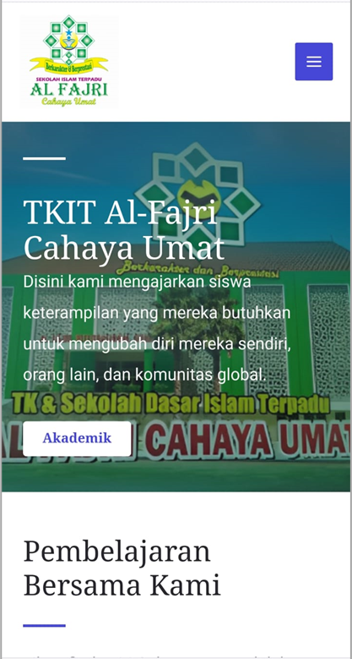
Figure 2. Home (Beranda) Page
The "Activities" page on this website, Figure 5, is a place to inform various activities and events held by the institution. Users can find information about extracurricular activities, social events, and other events involving students and teaching staff. Several photos and videos of activities are displayed to provide a clearer picture. This page aims to provide complete and interesting information about the activities taking place at the institution so that users can understand how active school life is and be involved in interesting and useful activities.

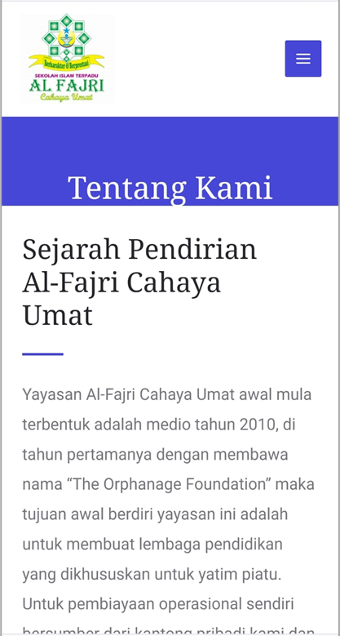
Figure 3. About Us (Tentang Kami) Page

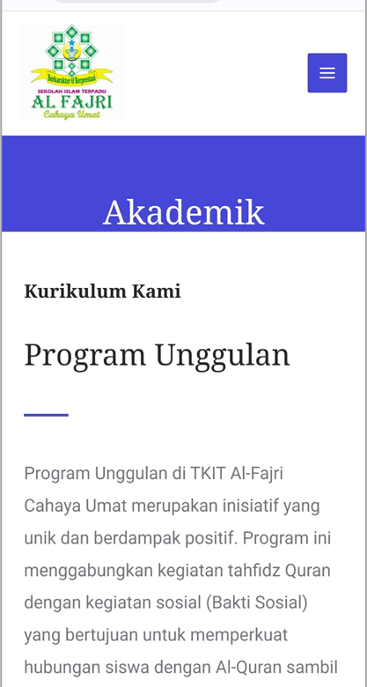
Figure 4. Academic (Akademik) Page

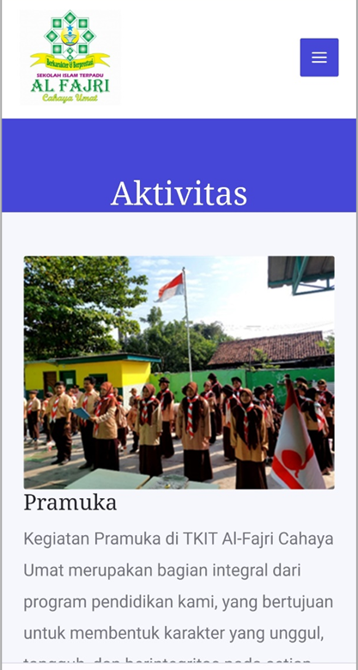
Figure 5. Activities (Aktivitas) Page

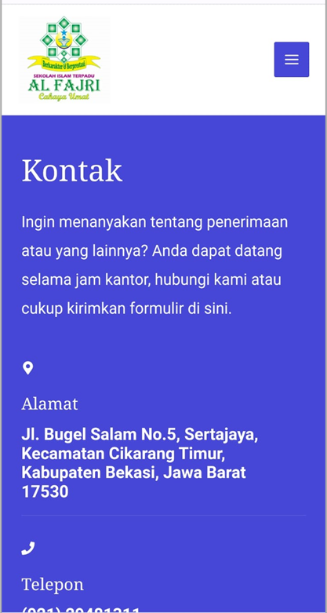
Figure 6. Contact (Kontak) Page
The "Contact" page on this website, Figure 6, provides detailed information on how to contact the institution. To contact schools, users can find addresses, telephone numbers, and email addresses. This page may also provide a contact form or message box that allows users to send questions or messages directly to the school. The purpose of this "Contact" page is to provide an easy means for users to communicate with the institution and get answers to any questions or needs they may have.

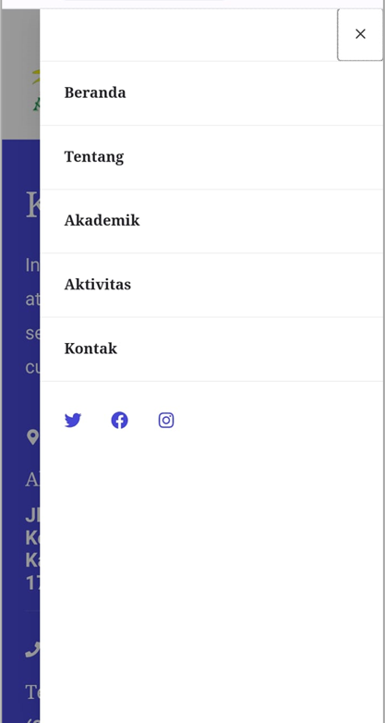
Figure 7. Menu Page

The "Menu" page on this website, Figure 7, serves as a clear guide to accessing the various pages and content on the website. Users will find a menu list with links that point to important pages such as Home, About Us, Academic, Activity, Contact, and other relevant menus. Intuitive layout and design settings help users easily find the information they want. This "Menu" page aims to provide a good user experience by providing efficient and effective navigation in exploring the entire contents of the website, increasing engagement, and facilitating interaction with institutions.

CONCLUSION
The implementation of the prototyping method in developing a school's website profile proves to be an effective approach for enhancing institutional visibility and improving user experience. Prototyping enables the creation of initial website models that can be tested and evaluated before full development, allowing for the identification of user needs, and obtaining valuable feedback for necessary improvements. The application of the prototyping method in developing the school's website profile at TKIT Al-Fajri Cahaya Umat Cikarang has shown positive outcomes. The responsive and interactive school profile website has increased the institution's visibility to the public, and the use of prototyping has streamlined the efficiency and speed of website development, resulting in time and resource savings. Notable benefits of the prototyping method in website development include early identification of user needs and preferences, optimizing user experience across various devices, and swiftly making improvements and adjustments. Consequently, this method enhances the school's website profile's overall quality and user satisfaction. However, despite its many advantages, the prototyping method may face challenges, such as ensuring active engagement from relevant stakeholders during the development process and securing adequate resources for website implementation.

Acknowledgment
We would like to extend our heartfelt gratitude and appreciation to TKIT Al-Fajri Cahaya Umat for their valuable contribution and support in the completion of this research article. Your cooperation and assistance have been instrumental in making this study possible. Thank you for being an essential part of this research journey.

REFERENCES

[1] C. Komariah et al., “PERAN ORANG TUA DALAM PEMBINAAN AKHLAK ANAK MELALUI MEDIA INTERNET,” 2021. [Online]. Available: http://ojs.iaisambas.ac.id/tarbiyah.islamic
[2] A. I. Rasidi and N. Ghaniaviyanto Ramadhan, “KLIK: Kajian Ilmiah Informatika dan Komputer Perancangan Website Company Profile Perusahaan CV. CUP10INDO Menggunakan Metode Design Thinking,” Media Online, vol. 3, no. 5, pp. 457–465, 2023, [Online]. Available: https://djournals.com/klik
[3] M. Irfan, E. W. Dwi, and D. Saputri, “PERANCANGAN PROTOTYPE INTERFACE SISTEM INFORMASI KEBERADAAN DOSEN,” vol. 14, no. 1, pp. 11–16, 2020.
[4] R. Fauziyyah and I. Ariyati, “Metode Prototype dalam Pengembangan Website Jasa Pengiriman Barang,” 2022. [Online]. Available: http://ejurnal.ubharajaya.ac.id/ index.php/jiforty
[5] J. Hendrawan and I. D. Perwitasari, “KAJIAN KONSEP DESAIN WEB RESPONSIVE DALAM PERANCANGAN WEBSITE INFORMASI DEKRANASDA KABUPATEN SAMOSIR,” Jurnal Mantik Penusa, vol. 3, no. 2, pp. 110–116, 2019.
[6] A. Cahya Wardhana, N. Anggraini, and N. F. Rozy, “PENGEMBANGAN APLIKASI WEB PERANCANGAN AGENDA PERJALANAN WISATA MENGGUNAKAN METODE USER EXPERIENCE LIFECYCLE,” vol. 8, no. 2, pp. 303–310, 2021, doi: 10.25126/jtiik.202182548.
[7] Y. Wahyudin and D. N. Rahayu, “Analisis Metode Pengembangan Sistem Informasi Berbasis Website: A Literatur Review,” Jurnal Interkom: Jurnal Publikasi Ilmiah Bidang Teknologi Informasi dan Komunikasi, vol. 15, no. 3, pp. 26–40, Oct. 2020, doi: 10.35969/interkom.v15i3.74.
[8] E. Latuconsina, B. Priyambadha, and H. Tolle, “Pengembangan Aplikasi Web Pengelolaan Alokasi Dana Desa Dengan Model Prototyping,” 2019. [Online]. Available: http://j-ptiik.ub.ac.id
[9] A. Fikriyya and R. T. Dirgahayu, “Implementasi Prototyping dalam Perancangan Sistem Informasi Sekolah Desa Pendar Foundation Yogyakarta.”
[10] C. Ramdani, D. Mustika Kusumawardani, F. I. Ali, and F. Informatika, “PERANCANGAN E-NOTULEN MENGADOPSI MODEL PENGEMBANGAN PROTOTYPING DAN JOINT APPLICATION DEVELOPMENT SYSTEM DESIGN OF E-NOTULEN BY ADOPTING PROTOTYPING DEVELOPMENT MODELS AND JOINT APPLICATION DEVELOPMENT.”
[11] H. T. Sukamana, “Prototyping ITSDI Journal Center Menggunakan Tools Invinsion Untuk Mewujudkan Creative Innovation Soft Skill Di Era Industri 4.0.”
[12] M. Syaukati Robbi, “Jurnal Teknologi Sistem Informasi dan Aplikasi Perancangan Aplikasi E-Learning Berbasis Web dengan Model Prototype pada SMPN 7 Kota Tangerang Selatan,” vol. 2, no. 4, 2019, [Online]. Available: http://openjournal.unpam.ac.id/ index.php/JTSI/index148
[13] M. D. Ariawan, A. Triayudi, and I. D. Sholihati, “Perancangan User Interface Design dan User Experience Mobile Responsive Pada Website Perusahaan,” JURNAL MEDIA INFORMATIKA BUDIDARMA, vol. 4, no. 1, p. 161, Jan. 2020, doi: 10.30865/mib.v4i1.1896.
[14] R. T. Aldisa, “Perancangan Sistem Informasi Untuk Pencarian Apotik Dengan Menerapkan Metode Prototyping Berbasis Android,” Journal of Information System Research (JOSH), vol. 3, no. 4, pp. 597–602, Jul. 2022, doi: 10.47065/josh.v3i4.1954.
[15] D. Agustian, E. Dwi Wahyuni, I. Nuryasin, and U. M. Malang, “Implementasi Metode Prototype dalam Perancangan Sistem Informasi Tracer Study pada Alumni Informatika UMM,” REPOSITOR, vol. 4, no. 2, pp. 147–158, 2022.
[16] A. Dian Muzaki et al., “Article history PERANCANGAN SISTEM INFORMASI RENTAL MOBIL DI ERA PANDEMI.”
[17] M. M. Al-Ababneh, “Linking Ontology, Epistemology and Research Methodology,” Science & Philosophy, vol. 8, no. 1, pp. 75–91, 2020, doi: 10.23756/sp.v8i1.500.

