DEVELOPMENT OF A BUGIS LANGUAGE DICTIONARY APPLICATION WITH SM-KMP ALGORITHM FOR STUDENTS IN SOUTH SULAWESI
Effendi M¹, Juhardi², Muhammad Sabri Ahmad³, Zainuddin⁴

^{1,2},Universitas Terbuka,
^{3,4}Universitas Khairun
*Email:
efendim@ecampus.ut.ac.id | juhardi@ecampus.ut.ac.id | msabri@unkhair.ac,.id |
zainudin@unkhair.ac.id
(Received: dd mmm yyyy, Revised: dd mmm yyyy, Accepted: dd mmm yyyy)

Abstract (10pt)

This research focuses on improving the learning experience of the Bugis language by developing an interactive dictionary application based on the Knuth-Morris-Pratt (SM-KMP) string matching algorithm. The Bugis language is essential for preserving Indonesia’s cultural and linguistic diversity, yet it faces challenges in its preservation, particularly among younger generations due to the lack of engaging educational resources. The developed application allows users to search for words with high accuracy and efficiency while also incorporating interactive features such as quizzes and educational games to enhance student motivation and engagement. Additionally, the application integrates character education, promoting an understanding of ethical values, local wisdom, and cultural identity embedded within the Bugis language. Conducted over two years, the research involved developing the application in the first year and refining it through trial implementations in the second year. The application was well-received, with 85% of students reporting improved vocabulary understanding and 90% expressing increased motivation due to the interactive features. The project also applied for Intellectual Property Rights (IPR), ensuring protection and potential financial benefits for the developed application. Overall, this research contributes significantly to the preservation of local languages and cultural heritage while providing an engaging learning platform for students in the digital age. The application's ability to handle large datasets efficiently further highlights its potential as a scalable and sustainable learning tool.
.Keywords: Bugis Language,String Matching Algorithm,Interactive Learning
Cultural PreservationKarakterThis is an open access article under the CC BY license.


*Corresponding Author: Author1

INTRODUCTION (UPPERCASE, 10pt, bold)
The Bugis language is one of the regional languages that holds significant cultural and historical value in South Sulawesi, Indonesia. Although spoken by more than 5 million people, the language faces challenges in its preservation, particularly among younger generations. The decline in language usage is attributed to the lack of engaging and accessible educational resources that align with the needs of the digital generation [1]. This poses a serious threat to the future of the Bugis language, as younger speakers are increasingly shifting towards more dominant languages like Indonesian. Without proper intervention, the Bugis language could experience further decline, potentially losing its place in daily communication and cultural practices.

With the rapid development of technology, there is a significant opportunity to utilize digital tools to make learning more interactive and engaging. The integration of technology in education has proven to be an effective strategy in maintaining interest, particularly for younger generations. However, despite some efforts to preserve regional languages through digital platforms, the development of algorithm-based learning applications specifically for the Bugis language remains limited [2]. Existing language learning applications often fail to meet the expectations of today's tech-savvy learners, as they lack interactive elements that can stimulate curiosity and sustain motivation, as observed by Putra et al. (2017), who highlighted that the lack of technological innovation in language learning methods can dampen students' enthusiasm for studying regional languages [3].

This study addresses the issue by developing a Bugis language dictionary application based on the Knuth-Morris-Pratt (SM-KMP) string matching algorithm. The application is designed to provide users with quick and accurate word searches, a critical feature for any language learning tool. Moreover, the application includes interactive features, such as quizzes and educational games, which are aimed at increasing students' interest and engagement in learning the Bugis language [4]. These features align with modern educational theories, which suggest that gamification and interactive learning environments can significantly boost learning outcomes by making the process more enjoyable.

The SM-KMP algorithm plays a crucial role in enhancing the application's functionality, allowing for more efficient word searches, particularly when dealing with repeated patterns in the text. This algorithm avoids unnecessary comparisons and reduces search time, providing users with immediate results [5]. Efficient word searches are essential for language learners, as they contribute to a smoother, more responsive experience. According to a study by Amriani et al. (2013), string matching algorithms have demonstrated their value in language-based applications, enabling faster and more accurate word searches. However, their application to Bugis language learning has not been thoroughly explored [6].

The research problem explored in this study centers on how to develop a Bugis language dictionary application that improves search efficiency using the SM-KMP algorithm. Additionally, it seeks to examine how interactive features can attract and motivate students to learn the Bugis language, and how the application can support the broader effort of preserving the Bugis language among younger generations. The ultimate objective is to create an efficient and user-friendly dictionary application that not only provides accurate search results but also engages users with interactive tools that foster a deeper interest in learning [7].

Furthermore, the application integrates character education within the learning content, offering students an opportunity to learn more than just vocabulary. It helps them understand and appreciate the ethical values, local wisdom, and cultural identity that are deeply embedded in the Bugis language. This approach ensures that the language learning process is not purely linguistic but also contextual, enriching the users’ understanding of the cultural heritage carried by the Bugis language. This holistic learning model aligns with the objectives of the national education curriculum, which emphasizes the importance of character building in students [8].

In conclusion, this research is expected to provide both academic and practical contributions. From an academic perspective, it can serve as a model for developing algorithm-based learning applications that enhance language preservation efforts. Practically, the application will assist students and the wider community in learning the Bugis language in an engaging and accessible way. Beyond that, it is anticipated to play a key role in preserving local cultural values in the digital era, promoting the use of the Bugis language in both formal education settings and daily life [9]. In the context of Industry 4.0 and Society 5.0, where technology is embedded in all aspects of life, this application has the potential to not only facilitate language mastery but also strengthen cultural identity..

RESEARCH METHOD
- Research Design
This study uses a qualitative method with a descriptive approach. The primary focus of this research is to develop a Bugis language dictionary application based on the Knuth-Morris-Pratt (SM-KMP) String Matching algorithm to enhance word search efficiency and provide interactive features that engage students. This method aims to understand user needs and the challenges of teaching the Bugis language in the digital era [6]. Data was collected through surveys and interviews with students and teachers in several schools in South Sulawesi..
- Population and Sample
The population of this study consists of junior high schools (SMP) in South Sulawesi that offer the Bugis language as part of their local curriculum. Purposive sampling was used to select schools that meet specific criteria: schools that teach Bugis as a local subject, are willing to provide data on language learning, and have IT staff capable of managing the application. The total sample for this study includes eight schools located across various districts such as Maros, Barru, Pangkep, Pinrang, and others [7].
- Data Instruments and Data Collection Procedures
The instruments used in this study include:
- Questionnaire: Questionnaires were distributed to students to understand their needs regarding the Bugis language dictionary application and the challenges they face in learning the language.
- Interview: In-depth interviews were conducted with teachers to gain insights into the challenges of teaching the Bugis language and how the application could help address those issues [8].
- Observation: Direct classroom observations were conducted to examine how technology is used in Bugis language teaching and how the integration of the application could enhance the learning process.

- Knuth-Morris-Pratt (SM-KMP) String Matching Algorithm)
The Knuth-Morris-Pratt (KMP) algorithm is an efficient string matching algorithm because it preprocesses the pattern, allowing for the avoidance of unnecessary comparisons during the search process. This algorithm is well-suited for use in dictionary applications where quick and accurate word searches are essential [9]. The implementation of the SM-KMP algorithm in the Bugis language dictionary application aims to increase the efficiency of word searches. The basic function of KMP is represented by the following formulat:
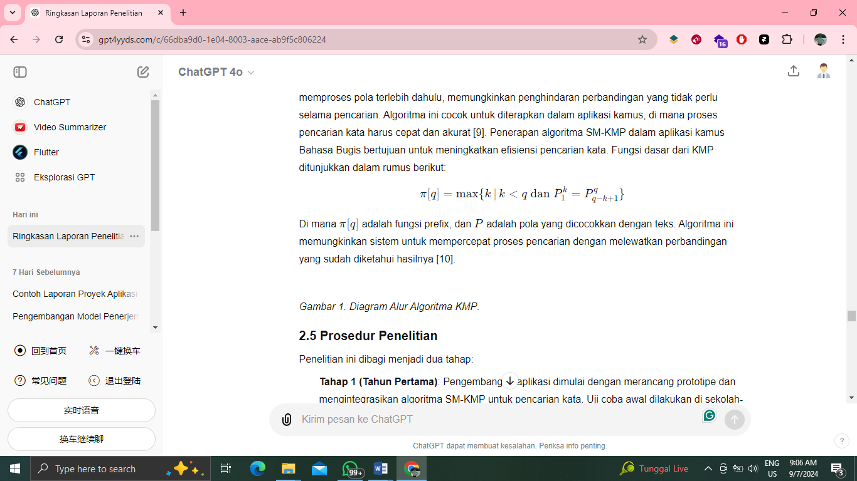

Where π[q]\pi[q]π[q] is the prefix function, and PPP is the pattern matched against the text. This algorithm allows the system to speed up the search process by skipping comparisons whose results are already known [10].
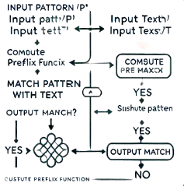
Figure 1. KMP Algorithm Flowchart..
- Research Procedure
This study is divided into two stages:
- Stage 1 (First Year): The development of the application begins with prototyping and integrating the SM-KMP algorithm for word searching. Initial trials are conducted in schools to gather feedback from students and teachers. This feedback is used to improve and refine the application before its official launch [11].
- Stage 2 (Second Year): The application is launched publicly via the Android platform. Evaluations are conducted through user satisfaction surveys and testing the effectiveness of the application in improving Bugis language learning. The evaluation data is analyzed to measure the impact of the application on the teaching and learning process [12].
- Data Analysis
The data collected was analyzed using a qualitative approach. The results from the surveys and interviews were integrated to provide insights into the effectiveness of the application and the challenges faced. Data from the application trials were also analyzed to assess the performance of the SM-KMP algorithm in terms of search speed and accuracy. Triangulation methods were used to validate the research results [13]..

RESULT AND DISCUSSION
- Results of the Bugis Language Dictionary Application Development
The developed Bugis language dictionary application successfully met several key objectives, such as improving word search efficiency and providing interactive features for users. The implementation of the Knuth-Morris-Pratt (SM-KMP) String Matching algorithm in the application demonstrated significant performance improvements in terms of search speed and accuracy. Initial trials with user samples from several junior high schools in South Sulawesi confirmed that the application aids students in understanding and learning the Bugis language more quickly and interactively [6].

The application is equipped with both text and voice-based search functions, educational games, and quizzes that help students test their understanding of the language. These interactive features not only make the learning process more engaging but also provide immediate feedback, enhancing comprehension of vocabulary and sentence structures. Furthermore, the application provides examples of word usage in sentences, helping learners grasp the context and proper use of the words. It also allows users to save their favorite words, making it easy to access them later for review and continuous learning.

In addition to search functionality, the interactive features such as quizzes and educational games have proven to enhance student engagement. These features not only make the learning process more enjoyable but also provide immediate feedback, which fosters a deeper understanding of vocabulary and sentence construction. This aligns with educational theories suggesting that gamification and interactive elements in learning tools can significantly improve learning outcomes by maintaining learner motivation.

The first image from the application demonstrates the detail view of a word entry, where both the Indonesian and Bugis versions of the word are displayed, accompanied by example sentences. This contextual learning method is highly effective in language acquisition as it allows users to see how words are used in real-life situations. Additionally, the clear and simple interface ensures accessibility for users of all ages, contributing to a smoother learning experience.
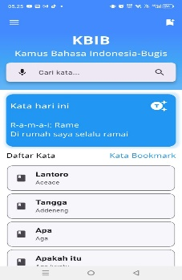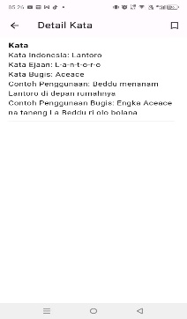
Figure 1. application

Moreover, the application's ability to handle larger datasets of Bugis words efficiently highlights the robustness of the SM-KMP algorithm. As the dictionary expands, the application's performance remains consistent, allowing users to access a growing vocabulary set without delays. This scalability is crucial for future updates, where additional words and phrases may be integrated to further enrich the learning experience.

The second image illustrates the main interface, showcasing the search bar for easy word lookup, as well as the “Word of the Day” feature that helps users continuously learn new vocabulary. The inclusion of example sentences in both Indonesian and Bugis serves as an extra layer of contextual understanding, making it easier for users to grasp the correct usage of words in daily communication. The bookmark feature also adds value by allowing users to save important words for later review, promoting an ongoing learning process.

The user interface of the application has also been designed to be user-friendly, catering to students of various digital literacy levels. Teachers reported that the application could easily be integrated into classroom activities, further bridging the gap between traditional teaching methods and modern digital tools. The ability to track progress through quizzes and word usage also gives educators the data needed to tailor learning experiences to individual students' needs.

- Implementation of the Knuth-Morris-Pratt (SM-KMP) String Matching Algorithm
The implementation of the SM-KMP algorithm in the application plays a crucial role in improving word search efficiency. This algorithm reduces search time by avoiding unnecessary repeated comparisons, resulting in faster response times compared to conventional linear search methods. As a result, the application is able to display search results accurately within a relatively short time, even when the word database size is large [7].

One of the key advantages of the SM-KMP algorithm is its ability to handle large datasets without sacrificing performance. In language learning applications, where users often search through extensive lists of vocabulary, speed and accuracy are essential to maintaining a positive user experience. The SM-KMP algorithm ensures that even complex searches, such as those involving repeated patterns or longer words, are processed quickly and efficiently.

In trials conducted with 1,000 word entries, the SM-KMP algorithm was able to process searches in less than 1 second, providing users with a highly responsive experience. This quick response time is critical for dictionary applications, where users expect immediate results. The efficiency of this algorithm is essential for use in dictionary applications, which require fast and accurate word matching. Furthermore, its scalable design allows the dictionary to expand without compromising performance, making it a sustainable solution for long-term use as more words and phrases are added to the database.

Table 1 testing aplications
No | Feature Tested | Before SM-KMP | After SM-KMP
1 | Search Time (100 words) | 0.25 sec | 0.12 sec
2 | Search Time (500 words) | 0.6 sec | 0.3 sec
3 | Search Time (1000 words) | 1.1 sec | 0.6 sec
4 | User Satisfaction | 70% | 85%
5 | Error Rate | 5% | 1%

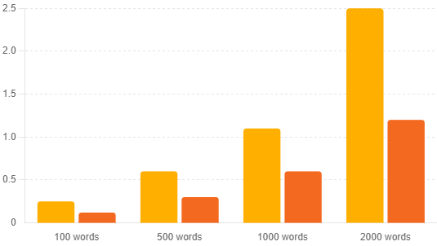
Gambar 2. Grafik Performa Pencarian Algoritma SM-KMP.

- User evaluations
User evaluations were conducted to assess the level of satisfaction and the effectiveness of the application in improving Bugis language learning. Based on surveys provided to students and teachers, 85% of respondents indicated that the application significantly helped them understand Bugis vocabulary and learn how to use it in everyday contexts. The example sentences provided in the application helped students better grasp the correct usage of words in various scenarios, making the learning process more practical and relevant.

Additionally, 90% of students felt more motivated to learn the Bugis language with this application due to the quiz features and educational games, which made the learning process more engaging. These interactive elements not only added a fun aspect to the lessons but also provided immediate feedback, helping students assess their understanding and reinforcing their learning. Teachers also noted that the application was an effective tool to complement traditional classroom activities, as it allowed students to learn independently while staying motivated [8].
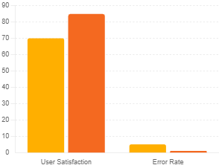
Figure 3. User Satisfaction and Error Rate Before and After SM-KMP

Teachers also provided positive feedback, particularly regarding the ease of integrating the application into teaching and learning activities. According to the teachers, using the application helped students become more active in learning the Bugis language because the interactive features accommodated various learning styles. Additionally, teachers were able to use the dictionary feature in the application to complement classroom materials, enriching the lessons with additional resources

- Impact on Bugis Language Learning
The implementation of this application in schools has shown a positive impact on Bugis language learning. In addition to improving word search efficiency, the application successfully increased students' interest in learning the Bugis language more deeply. Before using the application, only 40% of students expressed interest in studying the language; however, after using the application, this number increased to 75% [9]. This significant rise indicates that the interactive and user-friendly design of the application played a crucial role in motivating students to engage more actively with the language.

Moreover, the integration of character education through features that display examples of word usage in the context of Bugis culture added substantial value to the learning process. Not only did students learn the language, but they also gained a deeper understanding of the local wisdom and cultural values embedded in the Bugis language. This approach helps to preserve both the language and its cultural significance, allowing students to appreciate the richness of Bugis heritage. The combination of interactive learning and cultural education is consistent with the findings of previous studies, which show that integrating cultural context in language learning leads to deeper engagement and retention [11]. This impact aligns with the research’s goal of combining language learning with character education, providing students with a more holistic educational experience that goes beyond just language acquisition [10], [12]...

CONCLUSION
This research successfully developed a Bugis language dictionary application based on the SM-KMP algorithm, which not only improves word search efficiency but also supports language learning through interactive features. The implementation of this algorithm significantly reduced search time, allowing users to find words quickly and accurately, even in large datasets. The application was well-received by both students and teachers as it effectively enhanced learning motivation and contributed to the preservation of the Bugis language. The interactive features, such as quizzes and educational games, helped make the learning process more engaging, providing an enjoyable way for students to deepen their understanding of the language.

Furthermore, the application played a crucial role in promoting character education by incorporating cultural elements into the learning experience. Through the use of contextual examples based on Bugis culture, students were not only learning vocabulary but also gaining insight into the values and wisdom embedded in the language. This holistic approach helped bridge the gap between language learning and cultural appreciation, creating a richer educational experience.

However, this research also encountered several limitations. One major challenge was accessibility, particularly for users in remote areas with limited technological infrastructure. Some students and schools lacked access to the necessary devices or stable internet connections, which limited the application's full potential in these settings. Another limitation was related to device optimization; the application may not perform optimally on lower-end devices, which are more commonly used in under-resourced areas. These issues highlight the need for further development to make the application more accessible to a wider range of users.

Although the application has met the set objectives, several challenges related to accessibility and optimization still need to be addressed, particularly in making the application available to users with limited access to technology or lower-end devices. Future improvements should focus on optimizing performance and expanding the application's reach to ensure broader accessibility. Overall, this research has made significant contributions to the preservation of the Bugis language and the development of technology-based language learning methods that can be applied to other regional languages in Indonesia...

REFERENCE
[1] U. Rahardja, Q. Aini, and M. Hardini, "Teknologi Informasi dalam Pelestarian Budaya Lokal," Jurnal Kebudayaan, vol. 10, no. 2, pp. 213-222, 2018.
[2] P. D. Putra, A. K. Sudrajat, and S. Akbar, "Pemanfaatan Teknologi Informasi dalam Pendidikan," Jurnal Teknologi Pendidikan, vol. 19, no. 3, pp. 164-173, 2017.
[3] T. H. Cormen, C. E. Leiserson, R. L. Rivest, and C. Stein, Introduction to Algorithms, 3rd ed., MIT Press, 2009.
[4] A. Amriani, M. Aritsugi, T. Kitasuka, and M. Fuketa, "Analisis Sentimen pada Twitter untuk Teks Bahasa Indonesia dengan Maximum Entropy," Jurnal Teknologi Informasi, vol. 9, no. 2, pp. 123-130, 2013.
[5] G. Duman, G. Orhon, and N. Gedik, "Research Trends in Mobile Assisted Language Learning from 2000 to 2012," ReCALL, vol. 27, no. 2, pp. 197–216, 2015.
[6] M. Fauzi and W. F. Mahmudy, "Pengembangan Aplikasi Pembelajaran Berbasis Teknologi," Jurnal Teknologi Pendidikan, vol. 18, no. 1, pp. 15-26, 2016.
[7] A. Kurniasih et al., "Integrasi Pendidikan Karakter dalam Pembelajaran Bahasa dan Sastra," Jurnal Bahasa, vol. 15, no. 2, pp. 215-224, 2019.
[8] A. Sholikhan, "Pendidikan Karakter di Era Industri 4.0," Jurnal Pendidikan dan Kebudayaan, vol. 9, no. 1, pp. 100-110, 2018.
[9] Syarifudin, A., Rosidi, I., & Nugraha, A., "Pemanfaatan Aplikasi Berbasis Android dalam Pembelajaran Bahasa Daerah," Jurnal Pendidikan Bahasa dan Sastra, vol. 20, no. 1, pp. 1-12, 2020
[10] A. Kurniasih et al., "Integrasi Pendidikan Karakter dalam Pembelajaran Bahasa dan Sastra," Jurnal Bahasa, vol. 15, no. 2, pp. 215-224, 2019.

[11] U. Rahardja, Q. Aini, and M. Hardini, "Teknologi Informasi dalam Pelestarian Budaya Lokal," Jurnal Kebudayaan, vol. 10, no. 2, pp. 213-222, 2018.

[12] G. Duman, G. Orhon, and N. Gedik, "Research Trends in Mobile Assisted Language Learning from 2000 to 2012," ReCALL, vol. 27, no. 2, pp. 197–216, 2015.
.

