Journal of Science and Engineering |  |  |  | Full Paper
UTILIZATION OF CASHEW NUT SEEDS FOR LIQUID SMOKE PRODUCTION USING THE PYROLYSIS METHOD  Sudarmanto Jayanegara^{1*}, A. Imam Ramdhana Alqadri ², Mandasini ³, Chayping Mardi Sayudi ⁴, La Ifa ⁵  ¹Department of Mechanical Engineering, Faculty of Engineering, University Of Makasaar  ^{2,3,4,5}Department of Chemical Engineering, Faculty of Technology Industrial, muslim university of makassar indonesia |  |  | *Corresponding author  sudarmanto@unm.ac.id
Graphical Abstract |  | Abstract  Waste biomass is increasingly growingly and will be environmental pollution if not used wisely, this waste can be processed into fuel alternatives, in addition to the smoke from burning waste can be used as liquid smoke, as fertilizers and preservatives, both textile and food. This study aimed to determine the effect of time and temperature of the liquid smoke results from nut shells. Total sampel of research as 1500gr using pyrolysis method. Pyrolysis process is carried out at a temperature pyrolysis reactor 150-450oC. The production of liquid smoke from shell nut 1500gr by the method of pyrolysis produces liquid smoke grade 3 with the results of the best liquid at a temperature of 450oC and the optimum time of 2,5 hours at a yield of 32,66%. From the analysis using GC-MC spectrophotometer produces major chemical component of phenols(36,310%), acid(12,9475%) and carbonyl(16,715%).  Keywords: Liquid smoke, a nut shell, pyrolysis
 |  | This work is licensed under a Creative Commons Attribution-NonCommercial-ShareAlike 4.0 International License

1. INTRODUCTION (11 PT)
Indonesia is a tropical country with abundant natural resources. Various types of plants that can grow all year round make Indonesia have great potential for biomass sources. Natural resources that become biomass are in the form of agricultural waste, plantations such as rice husks, corn cobs, palm shells, cashew nut shells and others. Waste from plantations and agriculture is increasing day by day and will become environmental pollution if not used wisely. This biomass waste can be processed into alternative fuels besides the smoke from burning the waste can be used as liquid smoke as fertilizer and preservatives, both textiles and food.
Liquid smoke is the result of condensation from wood pyrolysis containing a large number of compounds formed due to the pyrolysis process of wood constituents such as cellulose, hemicellulose, and lignin (Darmadji, 1995). The results of pyrolysis of these compounds include organic acids, phenols, and carbonyls. (Anisah Kurnia, 2014). Previous research by Widiya et al. (2013), obtained the results of the acid, carbonyl, and phenol content components of 20.53%, 27.05% and 0% using durian skin as raw material.
Preservatives are widely used, almost all industries use them including the pharmaceutical, cosmetic, and food industries. In the health sector including pharmaceuticals, the use of preservatives is limited to the type and amount of use. Specifically for food preservatives, the regulations are in accordance with the Indonesian Minister of Health Regulation No. 722/ Menkes/Per/IX/88 (Hardman, 1988). However, there are also many irresponsible parties who use preservatives that are prohibited by BPOM for food such as formalin. (Ratnaningtyas, R.R, 2012).
Liquid smoke is a good solution as a substitute for synthetic food preservatives because it contains phenol compounds of 4.13%, carbonyl 11.3%, and acid as much as 10.2% so that microorganisms have difficulty growing and ultimately the food becomes durable. (Media BPP, ISSN No.1410–4210,2013). The study discusses the manufacture of liquid smoke from cashew nut shell waste raw materials using the pyrolysis method. Cashew plants are generally spread across eastern Indonesia. The main provinces producing cashew nuts are Southeast Sulawesi (47.5%), South Sulawesi (20.4%), East Java (10.3%), Central Java (7.4%), East Nusa Tenggara (5%), and Bali (3.5%) (Harianto, 2008).
Cashew plants are widely planted for their seeds, either for consumption or to be made into commercially valuable oil. The seeds have quite good nutritional content such as fat, protein, carbohydrates, vitamins and minerals. The oil comes from the skin cells of the seeds which are used as a medicine for food poisoning and by industry is also used as a preservative, synthetic resin, coated products and so on. In addition to the seeds, the fruit can also be consumed either eaten fresh or as a salad mix or made into a drink (Fitriandiny, 2012).
Cashew plants are classified as plants that have quite high economic value. Almost all parts of the plant can be utilized, starting from the fruit, seed skin and epidermis, roots, stems and leaves.
- Cashew seeds
Cashew seeds are very popular as snacks, especially on big days. In addition, cashew seeds are also widely used as flavorings for various types of foods such as ice cream, chocolate bars, and cakes.
- Fruit
Fruit can be processed into various foods and drinks including food vinegar, fruit juice, and cashew wine.
- Stem roots leaves
The stem produces blendok for book adhesive, roots as a stomach wash. Leaves as a medicine for burns and as a salad (Harianto, 2008).
- Seed skin and epidermis
Seed skin for making lacquer oil is used in various industries. Cashew epidermis is used as highly nutritious animal feed.

Cashew nut shell consists of three layers. The outermost layer is hard and tough called epicarp. The next layer is shaped like a wasp nest containing thick oil called laka oil or CNSL (Cashew Nut Shell Liquid) called mesocarp and the third layer is also hard called endocarp (Setyono, 2008). Cashew kernels consist of two white seeds. These cashew kernels are covered by a thin reddish-brown skin layer called the epidermis (testa). This epidermis contains 25% tannin. Cashew kernels are the edible part and have high nutritional value. Cashew kernels can be processed into various food products. Cashew kernels can be processed into various food products. Cashew kernels also contain oil that can be used as raw materials for the cosmetics industry. However, because the seeds are expensive and delicious to eat, efforts to squeeze cashew kernels are rarely done. One ton of cashew nuts (logs) can produce 220 kg of cashew kernels. Cashew kernels can provide energy of 6000 calories per kg compared to cereals which only provide 3600 calories, meat 1800 calories and fresh fruit 650 calories. (Mekka and Juddah, 2011).
The manufacture of liquid smoke uses the pyrolysis method, which is decomposition with the help of heat without oxygen or with a limited amount of oxygen. Usually there are three products in the pyrolysis process, namely: gas, pyrolysis oil, and charcoal, the proportions of which depend on the pyrolysis method, biomass characteristics and reaction parameters. The pyrolysis process involves various reaction processes, namely decomposition, oxidation, polymerization, and condensation. The reactions that occur during wood pyrolysis are: removal of water from wood at a temperature of 120-150 ° C, pyrolysis of hemicellulose at a temperature of 200-250 ° C, pyrolysis of cellulose at a temperature of 280-320 ° C and pyrolysis of lignin at a temperature of 400 ° C.
- Hemicellulose pyrolysis
Hemicellulose is the wood component that undergoes the earliest pyrolysis to produce furfural, furan, acetic acid and its homologues. Hemicellulose is a polymer of several monosaccharides such as pentosan (C5H8O4) and hexosan (C6H10O5). Pentosan pyrolysis produces furfural, furan and its derivatives along with a long series of carboxylic acids. Together with cellulose, hexosan pyrolysis forms acetic acid and its homologues. Hemicellulose will decompose at a temperature of 200-250 oC.
- Cellulose pyrolysis
Cellulose is a macromolecule produced from the linear condensation of the heterocyclic structure of glucose molecules. Cellulose consists of 100-1000 glucose units. Cellulose decomposes at a temperature of 280oC and ends at 300-350oC, cellulose pyrolysis takes place in two stages, namely:
A. The first stage is a hydrolysis reaction producing glucose.
B. The second stage is a reaction that produces acetic acid and its homologues, together with water and a small amount of furan and phenol.
- Lignin pyrolysis
Lignin is a complex polymer that has a high molecular weight and is composed of phenyl propane units. Compounds obtained from the pyrolysis of the basic structure of lignin play an important role in providing the aroma of smoked products. Lignin in pyrolysis produces phenol and phenolic ether compounds such as guaiacol (2-methoxyphenol) and its homologues and derivatives which play a role in the aroma of smoke from smoked products. Lignin begins to decompose at a temperature of 300-350oC and ends at 400-450oC. Phenol is produced from the decomposition of lignin which occurs at a temperature of 300 °C and ends at a temperature of 450 °C.
Pyrolysis at a temperature of 400 °C produces compounds that have high organoleptic quality and at higher temperatures there will be a condensation reaction to form new compounds and oxidation of condensation products followed by a linear increase in tar compounds and polycyclic aromatic hydrocarbons. Products preserved with smoke produced at a temperature of 400 °C have superior organoleptic quality compared to smoke treatments produced at higher temperatures. The effectiveness of the best antioxidants from phenol is from combustion at a temperature of 400 °C. (Luditama, 2006).
During the pyrolysis process, various compounds will be formed. The compounds contained in the smoke are grouped into several groups, namely, phenol, carbonyl (especially ketone and aldehyde), furan acid, alcohol and ester, lactone, aliphatic hydrocarbons, and polycyclic aromatic hydrocarbons. Smoke has the ability to preserve food because of the presence of acid, phenolic and carbonyl compounds.
Liquid smoke is a result of condensation or condensation of vapors from direct or indirect combustion of materials that contain a lot of lignin, cellulose, hemicellulose and other carbon compounds. The general definition of liquid smoke is a result of distillation or condensation of vapors from indirect or direct combustion of materials that contain a lot of carbon and other compounds. The raw materials that are widely used to make liquid smoke are wood, palm kernel shells, sawmill dregs, and others. Liquid smoke can also mean the result of cooling and liquefying smoke from coconut shells that are burned in a closed tube. Smoke that was originally solid particles cooled and then turned into liquid is called liquid smoke.
Liquid smoke consists of controlled combustion of wood pieces or sawdust so that it produces smoke that condenses into a liquid and traps smoke that has not melted in the solution or liquid. This form or substance can be formed through many methods to produce liquid smoke in a wide range.
From the three definitions above, it can be concluded that liquid smoke is the result of distillation or condensation of vapor from direct or indirect combustion of materials containing carbon. Liquid smoke is defined as a condensate liquid from wood smoke that has undergone storage and filtration to separate tar and certain materials. Liquid smoke is a mixture of solutions and colloidal dispersions of wood smoke vapor in water obtained from wood pyrolysis or made from a mixture of pure compounds. One way to make liquid smoke is by condensing smoke from imperfect combustion of wood. During combustion, the main components of wood, namely cellulose, hemicellulose and lignin, will undergo pyrolysis producing various compounds, namely phenol, carbonyl, acid, furan, alcohol, lactone, polycyclic aromatic hydrocarbons and so on.
Liquid smoke can be used as a food preservative due to the antimicrobial and antioxidant properties of compounds, such as aldehydes, carboxylic acids and phenols. The smoking technique using liquid smoke has several advantages compared to traditional smoking techniques. Smoking with liquid smoke is easy, fast, product uniformity, good food characteristics are obtained and there is no deposit of carcinogenic polycyclic aromatic hydrocarbon compounds in preserved food (Edinov et al., 2013).
The way to make liquid smoke is to put the coconut shell into a pyrolysis furnace (made of stainless steel) then close it tightly without any air coming out. After that, the heating process is carried out using a high-pressure stove model. After being heated for half an hour, smoke will come out of the furnace which is channeled through a pipe. In the first stage, the smoke will release a substance like tar, which is useful for wood preservatives. Smoke that does not drip in the form of tar is then channeled into the pipe flute and then enters the coil. Inside the coil, there is a second furnace in the form of a drum that has been filled with water. The flowing smoke vapor cools and becomes liquid, then is channeled into the third furnace. Because this liquid vapor is still not clear and also still contains hazardous substances, in this process the liquid vapor will be evaporated again (distillation). After going through two distillation processes, the liquid vapor will change color to clear (Atmaja, 2009).
Liquid smoke is divided into 3 types of grades, namely:
a. Grade 3 Liquid Smoke
Liquid smoke obtained from pyrolysis is grade 3 or distillation liquid smoke. The color is dark brown, the tar content (51.82%) is still high. Grade 3 liquid smoke cannot be used as a food preservative, because it still contains a lot of carcinogenic tar. Grade 3 liquid smoke is not used as a food preservative, but is used in rubber processing to remove odors and wood preservatives to make it resistant to termites. Other uses of grade 3 include: in rubber plantations, it can be used as a latex coagulant with the functional properties of liquid smoke/as a substitute for formic acid, antifungal, antibacterial. Wood industry, applications in coagulation of latex/raw rubber, applications in leather tanning. In addition, distillation liquid smoke can also be used in food preservation.
b. Grade 2 Liquid Smoke
Grade 2 liquid smoke has a clearer brown color, a much lower tar content of 16.6%, a phenol content of 9.55%, carbonyl of 1.67%, and the smoke aroma has been reduced.
This redistilled liquid smoke has great utility as a specific flavor and aroma giver as well as a preservative due to its antimicrobial and antioxidant properties. With the availability of liquid smoke, the traditional smoking process using smoke directly which has many weaknesses such as environmental pollution, uncontrolled processes, inconsistent quality and the emergence of fire hazards, all of which can be avoided (Himawati, 2010).
Grade 2 liquid smoke is used for food preservatives as a substitute for formalin with a smoke taste (smoked meat, smoked fish/smoked milkfish) that is transparent brownish in color, moderate sour taste, and weak smoke aroma.
c. Grade 1 Liquid Smoke
Grade 1 is a process with repeated distillation so as to eliminate the carbon content in the condensed smoke. Grade 1 liquid smoke is used as a preservative for ready-to-eat foods such as meatballs, noodles, tofu, barbecue spices. This grade 1 liquid smoke is clear in color, slightly sour in taste, neutral in aroma and is the best quality liquid smoke and does not contain any harmful compounds for application to food products.
Liquid smoke has many benefits and has been used in various industries, including:
a. Food Industry
This liquid smoke has a very large use as a specific flavor and aroma giver as well as a preservative due to its antimicrobial and antioxidant properties. With the availability of liquid smoke, the traditional smoking process using smoke directly which contains many weaknesses such as environmental pollution, uncontrolled processes, inconsistent quality and the emergence of fire hazards, all of which can be avoided.
b. Plantation Industry
Liquid smoke can be used as a latex coagulant with the functional properties of liquid smoke such as antifungal, antibacterial and antioxidants can improve the quality of the rubber products produced.
c. Wood Industry
Wood coated with liquid smoke is more resistant to termite attacks than wood that is not coated with liquid smoke.
The advantages of using liquid smoke include more intensive flavoring, easier control of flavor loss, can be applied to various types of food ingredients, more efficient in the use of wood as a smoke material, environmental pollution can be minimized and can be applied to ingredients in various ways such as spraying, dipping, or mixed directly into food. During combustion, the main components of wood, namely cellulose, hemicellulose and lignin, will undergo pyrolysis to produce various compounds, namely phenols, carbonyls, acids, furans, alcohols, actones, polycyclic aromatic hydrocarbons and so on. More than 300 compounds can be isolated from wood smoke from a total of more than 1000. Compounds that have been successfully detected in smoke can be grouped into several groups:
- Phenol, there are 85 types that have been identified in condensate and 20 types in smoke products.
- Carbonyl, ketone and aldehyde, 45 types that have been identified in condensate.
- Acid, 35 types that have been identified in condensate.
- Furan, 11 types that have been identified in condensate.
- Alcohol and ester, 15 types that have been identified in condensate.
- Lactone, 13 types that have been identified in condensate.
- Aliphatic hydrocarbon, 1 type that has been identified in condensate and 20 types in smoke products. Polycyclic aromatic hydrocarbons (PAH), 47 types that have been identified in condensate, 20 types in smoke products.
The three main components of smoke that play a role in the smoking process are phenol, carbonyl, and acid compounds. The composition of these compounds in liquid smoke is influenced by the raw materials and the manufacturing process. The three main compounds found in liquid smoke and their roles in the smoking process are as follows:
The composition of smoke is influenced by various factors, including the type of wood, the water content of the wood and the combustion temperature used. The type of wood that undergoes pyrolysis determines the composition of the smoke. Hardwoods generally have a different composition than softwoods. Hardwoods (eg oak and beech) are the most commonly used because pyrolysis of hardwoods will produce a superior aroma, richer in aromatic compounds and acid compounds than softwoods (wood containing resin). Water content also varies the composition of the smoke. Increasing water content causes low phenol levels and increases carbonyl compound levels. The combustion temperature of the wood also affects the composition of the smoke.

2. METHOD
The materials used in this research were cashew nut shells obtained from Southeast Sulawesi.

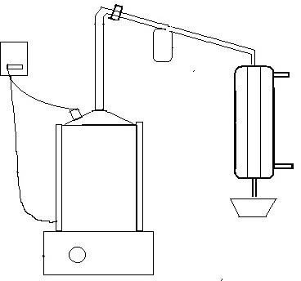

Liquid Smoke Container
Heating Stove
Inlet Water Pipe
Pyrolysis Reactor
Water Outlet Pipe
thermocouple
Tar Container

Figure 1. Pyrolysis Equipment Series
There are 4 methods used:
- Processing and weighing
The sample is dried for 5 days so that the water content of the cashew nut skin is reduced. Then weigh the cashew nut skin as much as 1.5 kg.
- Pyrolysis Process
The pyrolysis process is carried out in a pyrolysis reactor with a temperature of 150 ° C- 450 ° C. This process is stopped for a specified period of time.
- Condensation
The smoke from the pyrolysis results is condensed with a condenser to produce liquid smoke using cooling water at a temperature of ± 28oC continuously.
- GC-MS Analysis
Identification of pyrolysis results was carried out using GC-MS analysis. In the observation data collection, there were two variables:
1. The time variations used were 1, 1.5, 2, and 2.5 hours
2. The temperature variations used were 150oC, 250oC, 350oC and 450 o/C

Peanut Shells

Condensation
T= ± 28ºC

Pyrilysis
T = 150-450ºC
Uniformization of size and drying of peanut shells

Liquid Smoke
GC-MS analysis

Figure 2. Flow diagram of water smoke production

3. RESULTS AND DISCUSSION

The effect of total liquid volume based on sampling every 30 minutes
The effect of total liquid volume based on sampling every 30 minutes produced at a temperature of 450oC is presented in the Table and to clarify the discussion is presented in Graph 1.
Table 1 Effect of total liquid volume based on sampling every 30 minutes at a temperature of 450oC
Time | Total Liquid Volume
(minute) | (ml)
30 | 197
60 | 350
90 | 434
120 | 466
150 | 473
Table 4.1 shows that the longer the pyrolysis time, the more liquid is formed. This happens because the longer the pyrolysis time, the more compounds in the cashew nut shells are decomposed into liquid. The liquid formed consists of phases, namely the heavy phase called residue and the light phase called liquid smoke. Table 4.1 shows the total volume of liquid based on sampling every 30 minutes at a temperature of 450oC, the optimum pyrolysis time is 2.5 hours (150 minutes) which is used as the pyrolysis time for temperatures of 150oC, 250oC, and 350oC.
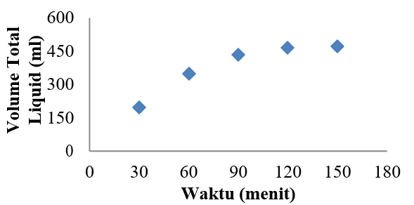
Graph 1. Effect of Total Liquid Volume based on sampling
every 30 minutes at a temperature of 450oC

Graph 1 shows that the longer the pyrolysis time, the more liquid smoke is formed. This happens because the longer the pyrolysis time, the more compounds in the cashew nut shells are decomposed into liquid smoke.

Effect of Pyrolysis Temperature on Liquid Volume
The effect of pyrolysis temperature on the volume of liquid produced is presented in Table 2 and to clarify the discussion is presented in Graph 2.
Table 2. Effect of pyrolysis temperature on liquid volume
Temp  (°C) | Time  (Jam) | Total Volume of Liquid Smoke  (ml)
150 | 2,5 | 76
250 | 2,5 | 164
350 | 2,5 | 341
450 | 2,5 | 473

Table 2 shows that the higher the pyrolysis temperature, the greater the amount of liquid formed in the same time span. This occurs because the decomposition of each compound in the cashew nut shell occurs at different temperatures, namely the decomposition of hemicellulose occurs at a temperature of 200-250oC, lignin at a temperature of 300 oC and ends at a temperature of 400 oC, so that at a temperature of 450 oC it shows an optimum increase with the same time span.

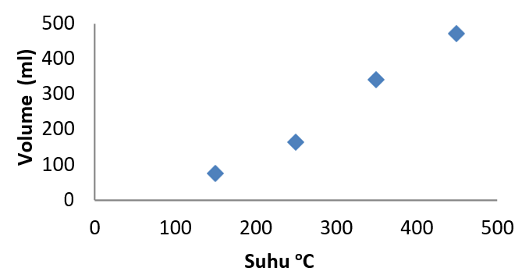

Graph 2. Effect of pyrolysis temperature on liquid volume

Graph 2 shows that the higher the pyrolysis temperature, the greater the amount of liquid smoke formed in the same time span. This happens because the decomposition of each compound in the cashew nut shell occurs at different temperatures.

Effect of pyrolysis temperature on the volume of liquid smoke and residue
The effect of pyrolysis temperature on the volume of liquid smoke and residue produced is presented in Table 3 and to clarify the discussion is presented in graph 3.
Table 3. Effect of temperature on the volume of liquid smoke and tar.
Temp  (°C) | Total Volume of Liquid Smoke  (ml) | Tar Volume  (ml)
150 | 72 | 4
250 | 145 | 19
350 | 215 | 126
450 | 283 | 190
Table 3 shows that the higher the pyrolysis temperature, the more liquid smoke is formed as well as the tar residue. The increase in tar volume occurs at temperatures of 350 oC to 450 oC. This is because tar is formed at a temperature of 400 oC. The total liquid from the pyrolysis results is separated in a separating funnel over a period of 1 week.
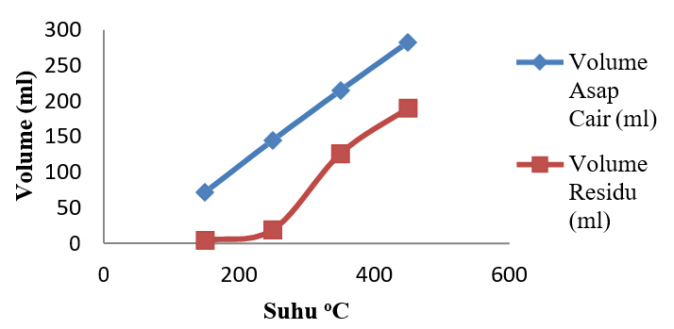
Figure 3 Effect of pyrolysis temperature on the volume of liquid smoke and residue

In Graph 4.3, it shows that the higher the pyrolysis temperature, the more liquid smoke is formed, as well as tar. The increase in tar volume occurs at temperatures of 350 oC to 450 oC. This is because tar is formed at a temperature of 400 oC.

Effect of pyrolysis temperature on liquid smoke density
The effect of pyrolysis temperature on liquid smoke density is presented in Table 4 and to clarify the discussion is presented in Graph 4.
Table 4. Effect of pyrolysis temperature on liquid smoke density
Temp | ρ Liquid Smoke
oC | (gr/ml)
150 | 1.0180
250 | 1.0184
350 | 1.0308
450 | 1.0312
Table 4 shows that the higher the pyrolysis temperature, the greater the density of liquid smoke. It can be seen that at temperatures of 350 oC and 450 oC there is an increase in the amount of density. This occurs because the temperature of the many compounds that are decomposed at a temperature of 300 oC - 400 oC and the amount of tar that is formed and bound to the liquid smoke.
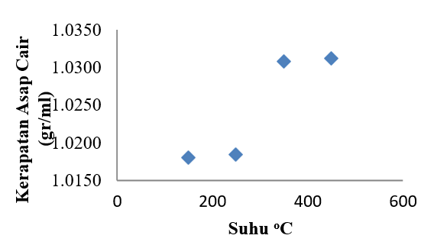

Figure 4 Effect of pyrolysis temperature on liquid smoke density

In Graph 4.4, it shows that the higher the pyrolysis temperature, the greater the density of the liquid smoke. It can be seen that at temperatures of 350 oC and 450 oC there is an increase in the amount of density. This occurs because the temperature of the many compounds that are decomposed at a temperature of 300 oC - 400 oC and the amount of tar that is formed and bound to the liquid smoke.

Effect of pyrolysis temperature on the charcoal formed
The effect of pyrolysis temperature on the charcoal formed is presented in Table 5 and to clarify the discussion is presented in Graph 5.
Table 5 Effect of pyrolysis temperature on the charcoal formed
Temp | Charcoal weight
C | (gr)
150 | 981,63
250 | 861,34
350 | 505,07
450 | 413,11

Table 5 shows that the higher the pyrolysis temperature, the lower the weight of the charcoal residue formed. This happens because the higher the pyrolysis temperature, the more components of the cashew nut shell are decomposed so that the weight of the charcoal residue is getting smaller. It can be seen that at a temperature of 150o C the weight of the charcoal is still very large, this happens because the pyrolysis of the cashew nut shell occurs imperfectly due to the very low pressure and temperature so that the smoke that is released returns to the pyrolysis reactor.

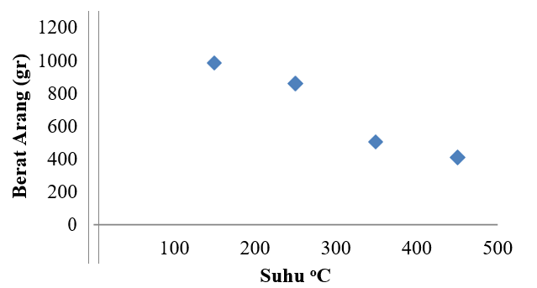

Graph 5. Effect of temperature on the charcoal formed

Graph 5 shows that the higher the pyrolysis temperature, the lower the weight of the charcoal residue formed. This happens because the higher the pyrolysis temperature, the more components of the cashew nut shell are decomposed so that the weight of the charcoal residue is getting smaller.

Pengaruh suhu terhadap komponen kimia asap cair Tabel 6

Tabel 6 Pengaruh suhu pirolisis terhadap Komponen
Kimia asap cair

 | Area (%)
Chemical Components | Temperature (oC)
 | 150 | 250 | 350 | 450
Phenol and it derivates | 35,964 | 30,069 | 35,897 | 36,31
Acid | 6,833 | 10.555 | 10,945 | 12,947
Carbonyl | 9,102 | 22,566 | 37,892 | 16,715
Furan | 5,592 | 19,604 | 0,961 | 5,153
Pyrin | 18,763 | 10,580 | 1,781 | 11,718

The results of GC-MS analysis of liquid smoke from cashew nut pyrolysis showed that the phenol compound formed at a temperature of 450oC was more dominant, namely 36.31%. From the interpretation of GC-MS data, it can be seen that the higher the pyrolysis temperature, the more phenol and other compound components are produced.

4. CONCLUSION (11 PT)
The production of liquid smoke from cashew nut shells as much as 1500 gr with the pyrolysis method produces grade 3 liquid smoke with the best liquid results at a temperature of 450 oC and an optimum time of 2.5 hours with a yield of 32.66% and chemical components contained in liquid smoke with the main components of phenol (36.310%), Acid (12.947%) and carbonyl (16.715%).
From the results of the study, we hope that further research is needed on the separation of liquid smoke by means other than distillation, the functionality of liquid smoke from cashew nut shells in preserving and a review of the pyrolysis tool needs to be carried out so that a more optimum amount of liquid smoke is obtained.

REFERENCES (10 PT)

[1] Anisah, K., 2014. Anilasa Komponen Kimia Dan Uji Antibakteri Asap Cair Tempurung Kelapa Sawit Pada Bakteri Staphylococcus aureus Dan Pseudomonas aeruginosa, Jakarta: UIN Syarif Hidayatullah.
[2] Atmaja, A. K., 2009. Aplikasi Asap Cair Redestilasi Pada Karakterisasi Kamaboko Ikan Tongkol (Euthynus Affinis) Ditinjau dari Tingkat Keawetan dan Kesukaan Konsumen, Surakarta: Universitas Sebelas Maret.
[3] Darmadji, E. P., 2009. Teknologi Asap Cair Dan Aplikasinya Pada Pangan Dan Hasil Pertanian, Yogyakarta: Universitas Gadjah Mada.
[4] Edinov, S., Yefrida, Indrawati & Refilda, 2013. Pemanfaatan Asap Cair Tempurung Kelapa Pada Pembuatan Ikan Kering Dan Penentuan Kadar Air, Air Serta Proteinnya. Jurnal Kimia Unand, Volume II, p. 2.
[5] Fitriandiny, I. N., 2012. Uji Efek Penghambatan Aktivitas Glukosidase Fraksi Dari Ekstrak Etil Asetat Daun Jambu Mete dan Penapisan Fitokimia dari Fraksi Teraktif, Depok: FMIPA UI.
[6] Harianto, D., 2008. Pengaruh Penggunaan Kulit Biji Ari Mete ( Anacardium Occidentale) Dalam Ransum Terhadap Penampilan Produksi Domba Lokal Jantan, Surakarta: FP Universitas Sebelas Maret.
[7] Himawati, E., 2010. Pengaruh Penambahan Asap Cair Tempurung Kelapa Destilasi dan Redestilasi Terhadap Sifat Kimia, Mikrobiologi, dan Sensoris Ikan Pindang Layang (Decapterus spp) Selama Penyimpanan, Surakarta: FP Universitas Sebelas Maret.
[8] Kemendagri, 2013. Bersama Meningkatkan Daya Saing Daerah Melalui Penguatan Sistem Inovasi Daerah. Media BPP, Volume 12, pp. 4- 5.
[9] Mekka, S. & Juddah, M. S., 2011. studi pemanfaatan limbah biiomassa sebagai bahan bakar tambahan pada preheater PT.Semen Tonasa IV, Makassar: Universitas Hasanuddin.
[10] Nurrassyidin, Idral & Zultiniar, 2013. Pengaruh Variasi Temperatur dan Waktu Terhadap Rendemen Pirolisis Limbah Kulit Durian Menjadi Asap Cair, Pekanbaru: Universitas Riau.
[11] Pardosi, R. A., Diba, F., Dirhamsyah, M. & Oramahi, H. A., 2012. Bioaktivitas Asap Cair Kulit Buah Durian Sebagai Bahan Pengawet Papan Partikel Acacia Mangium Wild, Pontianak: Universitas Tanjungpura.
[12] Ratnaningtyas, R. R., 2012. Pirolisis Pembuatan Asap Cair Dari Bonggol Jagung Sebagai Pengawet Alami Pengganti Formalin, Semarang: Universitas Diponegoro.
[13] Setyono, D. N., 2008. Pengaruh Penggunaan Kulit Ari Biji Mete (Anacardium Occidentale) dalam Ransum Terhadap Kecernaan Bahan Kering dan Bahan Organik Pada Domba Lokal Jantan, Surakarta: FP Universitas Sebelas Maret.
[14] Widiya, Idral & Zultiniar, 2013. Pengaruh Suhu Destilasi Terhadap Komposisi Kimia Asap Cair Dari Kulit Durian, Pekanbaru: Universitas Riau.

