Journal of Science and Engineering |  |  |  | Full Paper
Performance Optimization of Hydraulic Type Load Frequency Control in Hydropower Plants: Study of Controllers with dan Without Droop Characteristics

Heru Dibyo Laksono¹, Dhea Rahmadani Putri², Mumuh Muharam^{3,} Rizki Wahyu Pratama⁴
Department of Electrical Engineering, Faculty of Engineering, Andalas University, Indonesia
*Corresponding author
herudibyolaksono@.eng.unand.ac.id
Graphical Abstract  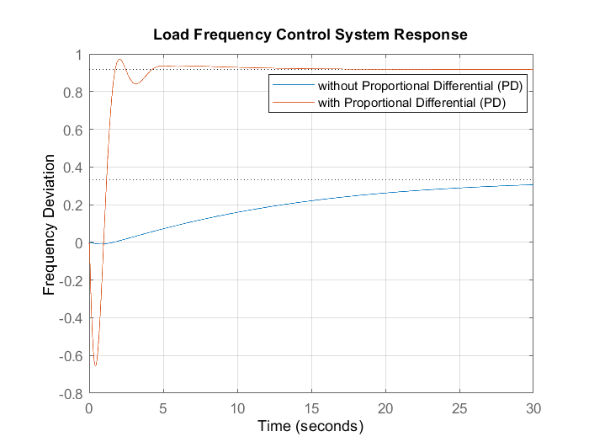 |  | Abstract  This research discusses the performance of the hydraulic type Load Frequency Control (LFC) system in hydropower plants using a single controller configuration equipped with a governor against power input. The Load Frequency Control (LFC) system is used to stabilizer the power frequency during load changes by considering the influence of droop characteristics on the governor. Analysis is performed using MATLAB simulation to measure transient parameters such as rise time, peak time, steady state time, and maximum skip. The results show that the use of droop on the governor is more effective in reducing overshoot, improving system stability, but slowing down the response time. Conversely, the configuration without droop accelerates the system response but risks overshoot. Controllers with derivative components such as PD and PDF, are superior in achieving rise time. Whereas, controllers that have integral components such as PI, PID, and PIDF are better at controlling overshoot when using droop characteristics. In conclusion, the combination of droop characteristics with derivative components in the governor provides optimal performance in maintaining the frequency stability of the hydraulic type Load Frequency Control (LFC) system.  Keywords: Load Frequency Control, Governor, Droop, PID Controller, Hydraulic
 |  | This work is licensed under a Creative Commons Attribution-NonCommercial-ShareAlike 4.0 International License

1. INTRODUCTION
Electrical energy is a major necessity in everyday life. The stable quality of electricity supply, especially in terms of frequency, is very important to maintain the optimal performance of equipment used by consumers. The power system consists of power plants that produce energy and loads that utilize that energy[1]. When present at load, the power system experiences frequency changes that can have a negative impact if not addressed immediately. Therefore, a control system is needed that can stabilize the frequency of electricity. One of the control systems used is Load Frequency Control (LFC)[2][3].
The variation of consumer and production loads in the electricity system leads to instability of active and reactive power requirements. This causes inappropriate frequency changes during system operation[4][5][6]. Larger frequency deviations can lead to poor system operation or lower performance. This can endanger consumers and can cause blackouts if the frequency is unstable or drops too low, which can cause damage to expensive production equipment[7]. The frequency must be set at 50Hz or at a tolerance limit of ±2% of the normal frequency to ensure good electricity quality. So in this case a Load Frequency Control (LFC) control system is needed to prevent frequency changes[8][9].
A frequency control system or Load Frequency Control (LFC) is excellent for controlling energy supply because it serves to store frequency changes and monitor frequency instability caused by load changes. Frequency and data flow in an area tend to change when there is a disturbance or load variation, so it must be controlled to remain stable[10]. By using Load Frequency Control (LFC), frequency fluctuations in the electrical system caused by load changes should not exceed the tolerance limit[11][12][13]. Load Frequency Control (LFC) control system is one of the most important parts in power systems and control systems. Load Frequency Control (LFC) balances the power output generated by power plants and the energy expected by consumers to provide a stable and high-quality power supply[14][15]. Studies on superconducting magnetic energy storage support Load Frequency Control (LFC) technology. These studies show that superconducting magnetic energy storage can improve overall system stability and response[4][5][14][18].
One of the methods used by Load Frequency Control (LFC) systems is the Proportional-Integral-Derivative (PID) control controller[12][19]. Due to its ease of use and outstanding performance, PID controllers are still the top choice in the power industry today[6][7][21]. Controller parameters such as proportional constant (Kp), integral constant (Ki), and derivative constant (Kd) are used to calculate the output value of the PID controller[22]. Mechanical valve action is provided by the PID controller based on the magnitude of the resulting error[23][24][25]. Often, PID controllers are used in Load Frequency Control (LFC) systems but these controllers have drawbacks in terms of dynamic work[8][16] and can cause instability if the gain values are not appropriate.
This research aims to analyze the performance of Load Frequency Control (LFC) system in hydroelectric power plant with single controller configuration using governor against power input. The use of governor in this system aims to maintain a stable frequency despite load changes and the analysis results can be seen through the performance of transient parameters such as rise time, peak time, steady state time, and maximum pass. In addition, the research aims to compare the performance of the system using a single controller with a governor against the power input with the design criteria as a reference.
This research has limitations to ensure the focus of the Load Frequency Control (LFC) system performance analysis on hydraulic type power systems using PID controllers and filters. These limitations are needed so that the research remains directed and in accordance with the objectives achieved. The problem limitations in this research are as follows:
- The research only focuses on analyzing the performance of hydraulic-type LFC systems using several types of PID controllers (P, PI, PD, PID, PDF, and PIDF).
- The study did not include other controller configurations, such as cascade or multi-control systems.
- The system response under review is limited to the power input to the hydraulic turbine with the analyses covering conditions with and without droop characteristics of the governor.
- The research only uses MATLAB simulation to evaluate the transient response of the system, such as rise time, peak time, steady state time, and maximum skip.
The analyzed system operates at a nominal frequency of 50Hz under non-transient conditions so it does not include frequency disturbances outside the standard tolerance limits.

2. METHOD
MATLAB simulation is used to analyze the performance of a single controller on a hydraulic LFC system against power input. The system block diagram was drawn to show the control flow, including details of the parameters tested, such as rise time, peak time, steady time, and maximum skip, as well as the settings for the governor and droop.
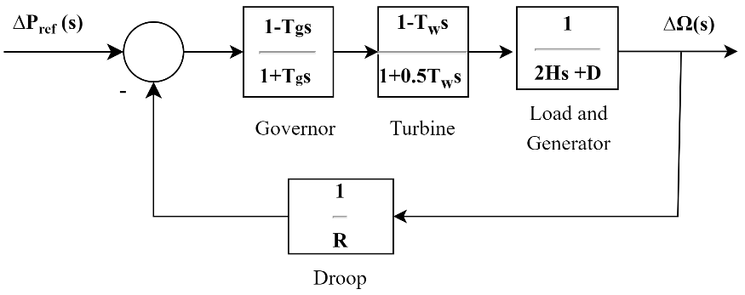
Figure 1. Block Diagram of Uncontrolled Hydraulic Type LFC against Power Input
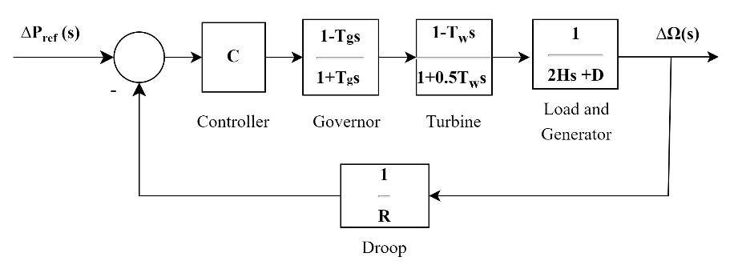
Figure 2. Block Diagram of Hydraulic Type LFC with Single Controller against Power Input
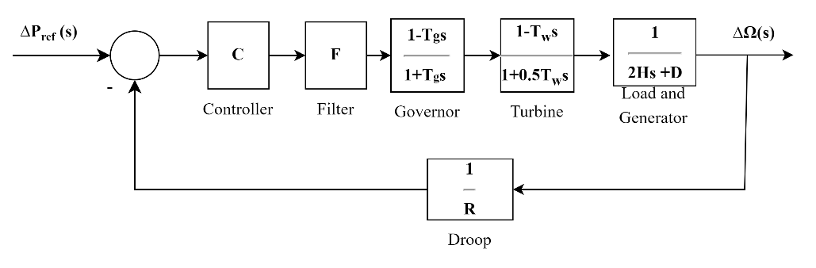
Figure 3. Block Diagram of Hydraulic Type LFC with Single Controller using Filter against Power Input

Based on Figure 1 - Figure 3, each of the block diagrams has a transfer function. The transfer function can be seen in the following equation. Figure 1 is a block diagram of a hydraulic type LFC without a controller, where the equation can be seen as follows.
$$\frac{∆Ω\left(s\right)}{∆P_{ref}\left(s\right)}=\frac{\left(\frac{1}{1+T_{G}s}\right)\left(\frac{1-T_{w}s}{1+\frac{1}{2}T_{w}s}\right)\left(\frac{1}{2Hs+D}\right)}{1+\left(\frac{1}{1+T_{G}s}\right)\left(\frac{1-T_{w}s}{1+{\frac{1}{2}T}_{w}s}\right)\left(\frac{1}{2Hs+D}\right)\left(\frac{1}{R}\right)}$$ | (1)

In Figure 2. is a block diagram of a hydraulic type LFC with a controller where the equation can be seen below.
$$\frac{∆Ω\left(s\right)}{∆P_{ref}\left(s\right)}=\frac{(C)\left(\frac{1}{1+T_{G}s}\right)\left(\frac{1-T_{w}s}{1+\frac{1}{2}T_{w}s}\right)\left(\frac{1}{2Hs+D}\right)}{1+(C)\left(\frac{1}{1+T_{G}s}\right)\left(\frac{1-T_{w}s}{1+{\frac{1}{2}T}_{w}s}\right)\left(\frac{1}{2Hs+D}\right)\left(\frac{1}{R}\right)}$$ | (2)
In Figure 3. is a block diagram of hydraulic type LFC with a controller using a filter, where the equation can be seen below.
$$\frac{∆Ω\left(s\right)}{∆P_{ref}\left(s\right)}=\frac{(C)(F)\left(\frac{1}{1+T_{G}s}\right)\left(\frac{1-T_{w}s}{1+\frac{1}{2}T_{w}s}\right)\left(\frac{1}{2Hs+D}\right)}{1+(C)(F)\left(\frac{1}{1+T_{G}s}\right)\left(\frac{1-T_{w}s}{1+{\frac{1}{2}T}_{w}s}\right)\left(\frac{1}{2Hs+D}\right)\left(\frac{1}{R}\right)}$$ | (3)

Table 1. Types of PIDTune Controllers Standard Model[12]
Controller Type | Mathematical Representation
Proportional (P) | $$K_{p}$$
Proportional-Integral (PI) | $$K_{p}+\frac{K_{p}}{T_{i}s}$$
Proportional-Differential (PD) | $$K_{p}+K_{p}T_{d}s$$
Proportional-Integral-Differential (PID) | $$K_{p}+\frac{K_{p}}{T_{i}s}+K_{p}T_{d}s$$
Proportional-Differential with a first-order filter in the Differential section (PDF) | $$K_{p}+\frac{K_{p}T_{d}s}{\frac{T_{d}}{N}s+1}$$
Proportional-Integral-Differential with a first-order filter in the Differential section (PIDF) | $$K_{p}+\frac{K_{p}}{T_{i}s}+\frac{K_{p}T_{d}s}{\frac{T_{d}}{N}s+1}$$

Table 2. Design Criteria for Analyzing the Switching of Hydraulic Type Load Frequency Control to Power Input
Design Criteria | Design Value
Rise Time ${(T}_{r})$ | <2.000 s
Peak Time ($T_{p}$) | <4.000 s
Settling Time ($T_{s}$) | <6.000 s
Peak Value ($y_{p}$) | <0.055
Maximum Pass Rate ($M_{p})$ | <20%

3. RESULTS AND DISCUSSION (11 PT)
In this section, it can be seen that the use of a governor in a hydraulic-type Load Frequency Control system has an important role in improving the transient performance of the system. The use of droop characteristics in the governor results in better stability as it can reduce overshoot, albeit with a little extra time at the peak time and steady state time. Without droop, the system tends to have a faster response time but risks overshoot that can affect long-term stability. The results of the analysis are obtained from the comparison of the criteria set.

Table 3. Information Analysis of Hydraulic Type Switching with Single Controller against Power Input without Droop Characteristics
Transition | P | PI | PD | PID | PDF | PIDF
Rise Time | 2.160 | 13.075 | 0.597 | 13.648 | 1.699 | 13.646
Peak Time | 6.344 | 30.312 | 6.938 | 31.367 | 5.209 | 31.279
Settling Time | 10.742 | 52.022 | 3.882 | 51.926 | 7.817 | 52.080
Peak Value | 0.989 | 1.111 | 0.935 | 1.074 | 1.009 | 1.077
Maximum Pass Rate | 12.697 | 11.087 | 1.949 | 7.399 | 14.361 | 7.648
Based on Table 3, it can be seen that all controllers meet the maximum skip value and only PD and PDF controllers meet the rise time parameter. This shows that PD and PDF controllers have derivative and Proportional components that make the system more responsive in overcoming load changes in the Load Frequency Control (LFC) system. The derivative component in the PD and PDF controllers provides a fast reaction to changes in the initial error so as to accelerate the system response and suppress the rise time. Meanwhile, controllers that use integral components such as PI, PID, and PIDF experience longer rise times due to the presence of integral components that work in reducing long-term errors rather than initial responses. However, the absence of droop characteristics in these configurations allows all controllers to fulfil maximum pass through as the system can produce sharp and controlled responses without any additional restrictions on the initial frequency rise.

Table 4. Information Analysis of Hydraulic Type Switching with Single Controller against Power Input with Droop Characteristics
Transition | P | PI | PD | PID | PDF | PIDF
Rise Time | Nan | 4.309 | 0.009 | 3.580 | 0.005 | 3.457
Peak Time | Inf | 32.213 | 1.291 | 8.235 | 1.338 | 8.592
Settling Time | NaN | 17.398 | 11.936 | 15.592 | NaN | 16.473
Peak Value | Inf | 0.999 | 1.238 | 1.010 | 1.235 | 1.062
Maximum Pass Rate | NaN | 0 | 3229.600 | 0.963 | 6420.800 | 6.238
Based on Table 4, it can be seen that only the PD and PDF controllers fulfil the parameters of rise time and peak time, while for maximum skip only the PI, PID, and PIDF controllers do. The existence of droop characteristics can slow down the initial response of the system to prevent excessive response that causes large overshoot. The derivative components in the PD and PDF controllers are able to overcome this slowdown resulting in appropriate rise times and peak times. On the other hand, for the maximum skip value parameter, the integral component in PI, PID, and PIDF controllers is able to work optimally with the droop characteristic. The integral component plays a role in reducing the final error and provides additional stability to the response so as to hold the overshoot within tolerable limits. Thus, the droop characteristic gives a significant advantage to controllers that have an integral component in keeping the maximum skip low, but can reduce the effectiveness of the rise time in controllers that do not have a derivative component.

Table 5. Information Analysis of Hydraulic Type Switching with Single Controller and Filter against Power Input without Droop Characteristics ($τ=0,025)$
Transition | P | PI | PD | PID | PDF | PIDF
Rise Time | 2.139 | 13.038 | 0.566 | 13.606 | 1.686 | 13.604
Peak Time | 6.346 | 30.247 | 2.021 | 31.325 | 5.189 | 31.226
Settling Time | 10.670 | 51.978 | 5.349 | 51.891 | 7.867 | 52.044
Peak Value | 0.996 | 1.112 | 0.972 | 1.075 | 1.019 | 1.077
Maximum Pass Rate | 13.482 | 11.158 | 5.965 | 7.452 | 15.469 | 7.703

Table 6. Information Analysis of Hydraulic Type Switching with Single Controller and Filter against Power Input without Droop Characteristics ($τ=0,05)$
Transition | P | PI | PD | PID | PDF | PIDF
Rise Time | 2.122 | 13.001 | 0.558 | 13.563 | 1.671 | 13.562
Peak Time | 6.346 | 30.254 | 2.172 | 31.239 | 5.261 | 31.189
Settling Time | 10.608 | 51.933 | 5.953 | 51.855 | 7.915 | 52.008
Peak Value | 1.003 | 1.112 | 1.012 | 1.075 | 1.029 | 1.078
Maximum Pass Rate | 14.289 | 11.230 | 10.317 | 7.507 | 16.598 | 7.758

Table 7. Information Analysis of Hydraulic Type Switching with Single Controller and Filter against Power Input without Droop Characteristics ($τ=0,075)$
Transition | P | PI | PD | PID | PDF | PIDF
Rise Time | 2.107 | 12.964 | 0.561 | 13.521 | 1.663 | 13.520
Peak Time | 6.343 | 30.219 | 2.254 | 31.169 | 5.308 | 31.169
Settling Time | 10.555 | 51.889 | 6.340 | 51.820 | 7.972 | 51.971
Peak Value | 1.010 | 1.113 | 1.046 | 1.076 | 1.038 | 1.078
Maximum Pass Rate | 15.111 | 11.303 | 14.018 | 7.562 | 17.712 | 7.814

Table 8. Information Analysis of Hydraulic Type Switching with Single Controller and Filter against Power Input without Droop Characteristics ($τ=0,1)$
Transition | P | PI | PD | PID | PDF | PIDF
Rise Time | 2.094 | 12.927 | 0.572 | 13.479 | 1.658 | 13.479
Peak Time | 6.344 | 30.141 | 2.363 | 31.117 | 5.349 | 31.089
Settling Time | 10.512 | 51.845 | 6.662 | 51.784 | 8.031 | 51.935
Peak Value | 1.017 | 1.114 | 1.074 | 1.076 | 1.048 | 1.079
Maximum Pass Rate | 15.944 | 11.377 | 17.111 | 7.618 | 18.814 | 7.871
Based on Table 5 - Table 8, it can be seen that all controllers fulfil the maximum pass value parameter at all τ values. At the value of τ = 0.025 - 0.05, the PD controller fulfils all the parameters of both rise time, peak time, steady state time, and maximum skip value. This is because at low values of τ, the filter does not slow down the response significantly which allows the derivative component to work optimally in achieving a fast and stable response. However, at higher values of τ, the filter effect slows down the system response so that the steady state time is not achieved according to the set criteria. Whereas, at rise time only the PDF controller fulfils at all values of τ. This is because the filter component at high τ degrades the Differential effect so that the overall performance at steady state time and maximum skip is affected.

Table 9. Information Analysis of Hydraulic Type Switching with Single Controller and Filter against Power Input with Droop Characteristics ($τ=0,025)$
Transition | P | PI | PD | PID | PDF | PIDF
Rise Time | NaN | 4.285 | 0.009 | 3.558 | 0.005 | 3.449
Peak Time | Inf | 31.859 | 1.410 | 8.158 | 1.349 | 8.704
Settling Time | NaN | 17.450 | NaN | 15.657 | NaN | 16.564
Peak Value | Inf | 0.999 | 1.280 | 1.015 | 1.267 | 1.068
Maximum Pass Rate | NaN | 0 | 3344.900 | 1.457 | 6588.100 | 6.753

Table 10. Information Analysis of Hydraulic Type Switching with Single Controller and Filter against Power Input with Droop Characteristics ($τ=0,05)$
Transition | P | PI | PD | PID | PDF | PIDF
Rise Time | NaN | 4.262 | 0.010 | 3.545 | 0.005 | 3.440
Peak Time | Inf | 31.495 | 1.489 | 8.324 | 1.498 | 8.808
Settling Time | NaN | 17.505 | NaN | 15.725 | NaN | 16.660
Peak Value | Inf | 0.999 | 1.294 | 1.019 | 1.288 | 1.072
Maximum Pass Rate | NaN | 0 | 3380.100 | 1.938 | 6702.200 | 7.237

Table 11. Information Analysis of Hydraulic Type Switching with Single Controller and Filter against Power Input with Droop Characteristics ($τ=0,075)$
Transition | P | PI | PD | PID | PDF | PIDF
Rise Time | NaN | 4.243 | 0.011 | 3.529 | 0.006 | 3.430
Peak Time | Inf | 31.120 | 1.573 | 8.241 | 1.579 | 8.904
Settling Time | NaN | 17.564 | NaN | 15.796 | NaN | 16.757
Peak Value | Inf | 0.999 | 1.286 | 1.024 | 1.279 | 1.077
Maximum Pass Rate | NaN | 0 | 3359.300 | 2.420 | 6653.400 | 7.201

Table 12. Information Analysis of Hydraulic Type Switching with Single Controller and Filter against Power Input with Droop Characteristics ($τ=0,1)$
Transition | P | PI | PD | PID | PDF | PIDF
Rise Time | NaN | 4.224 | 0.012 | 3.517 | 0.006 | 3.427
Peak Time | Inf | 30.735 | 1.649 | 8.396 | 1.654 | 8.782
Settling Time | NaN | 17.625 | 23.326 | 15.871 | 23.487 | 16.859
Peak Value | Inf | 0.999 | 1.266 | 1.029 | 1.259 | 1.082
Maximum Pass Rate | NaN | 0 | 3307.300 | 2.897 | 6546.500 | 8.174
Based on Table 9 - Table 12, it can be seen that the PD and PDF controllers fulfil the parameters of rise time and peak time. Meanwhile, the maximum skip value only PI, PID and PIDF controllers fulfil. The existence of droop characteristics and filters with various τ in this configuration is useful to withstand the initial response spike and maintain stability in the system response. The PD and PDF controllers fulfil the rise time and peak time, due to the presence of derivative components that help speed up the initial response while the droop and filter characteristics slow down the total response. In contrast, PI, PID, and PIDF controllers that have integral components are able to contain and control excessive overshoot. However, at high τ filters can extend the time it takes for the system to reach steady state so no controller is able to fulfil the steady state time criterion at all available values of τ.

4. CONCLUSION
This study shows that the use of a governor has an important role in stabilizing the frequency especially during load changes. The use of droop characteristics in the governor helps in reducing overshoot and improving stability although it lengthens the response time of the system. In contrast, a configuration without droop results in faster response, but with greater risk of overshoot.
The PD and PDF controllers proved to be optimal in accelerating the rise time. Whereas, PI, PID, and PIDF controllers control overshoot better when droop is applied. The use of filters with high τ values can slow down the time to reach steady state which affects the long-term stability. Overall, the combination of droop and derivative components in the governor provides optimal performance for Load Frequency Control (LFC) systems in hydraulic power systems.

ACKNOWLEDGEMENTS
The researcher would like to thank the colleagues who have helped complete this research. In particular, the authors would like to thank the Department of Electrical Engineering and the Faculty of Engineering, University of Andalas.

REFERENCES (10 PT)
[1] F. R. Ningsih, “Simulasi Dan Analisa Sistem Kendali Frekuensi Tenaga Listrik Dengan Pilot Servo Dan Kombinasi Pengendali PIDTune Model Standar (Model Hidraulik),” J. Ilmu Pendidik., vol. 7, no. 2, pp. 809–820, 2020.
[2] V. T. W. Vina, “Analisis Setting Speed Droop dan Deadband Governor Unit 1 PLTA Maninjau Sebagai Pengaturan Frekuensi pada Sistem 150 KV,” J. Tek. Energi, vol. 11, no. 2, pp. 25–29, 2023, doi: 10.35313/energi.v11i2.3912.
[3] I. P. Riasa, R. S. Hartati, I. B. G. Manuaba, and D. A. S. Santiari, “Pengaruh PLTB Sidrap Terhadap Sistem Kelistrikan Sulawesi Selatan,” Maj. Ilm. Teknol. Elektro, vol. 19, no. 1, p. 27, 2020, doi: 10.24843/mite.2020.v19i01.p04.
[4] Oladiran Kayode Olajiga, Emmanuel Chigozie Ani, Zamathula Queen Sikhakane, and Tosin Michael Olatunde, “Assessing the Potential of Energy Storage Solutions for Grid Efficiency: a Review,” Eng. Sci. Technol. J., vol. 5, no. 3, pp. 1112–1124, 2024, doi: 10.51594/estj.v5i3.974.
[5] G. Liu, J. H. Park, C. Hua, and Y. Li, “Hybrid Dynamic Event-Triggered Load Frequency Control for Power Systems With Unreliable Transmission Networks,” IEEE Trans. Cybern., vol. 53, no. 2, pp. 806–817, 2023, doi: 10.1109/TCYB.2022.3163271.
[6] S. Asgari, M. B. Menhaj, A. A. Suratgar, and M. G. Kazemi, “A disturbance observer based fuzzy feedforward proportional integral load frequency control of microgrids,” Int. J. Eng. Trans. A Basics, vol. 34, no. 7, pp. 1694–1702, 2021, doi: 10.5829/IJE.2021.34.07A.13.
[7] H. D. R. ’Aisya; W. H. bin M. S. Laksono, “Frequency Domain Analysis of Load Frequency Control Using PIDTune Model Standard.” Andalas Journal of Electrical and Electronic Engineering Technology, Padang, 2023. doi: 10.25077/ajeeet.v3i1.38.
[8] A. J. Pakpahan and Herlambang Setiadi, “Optimal Control Design for Frequency Regulation in Electric Power System With Low Inertia,” J. Adv. Technol. Multidiscip., vol. 3, no. 1, pp. 26–36, 2024, doi: 10.20473/jatm.v3i1.59984.
[9] D. Marsudi, “Operasi Sistem Tenaga Listrik,” Graha Ilmu, no. April, pp. 2–5, 2006.
[10] N. A. Orka, S. S. Muhaimin, M. N. S. Shahi, and A. Ahmed, An Enhanced Gradient Based Optimized Controller for Load Frequency Control of a Two Area Automatic Generation Control System, vol. 1069. 2023. doi: 10.1007/978-3-031-16832-1_5.
[11] T. Siswanto, D. Hendra Kusuma, and A. Raikhani, “Desain Optimal Load Frequency Control (Lfc) Pada Sistem Pembangkit Listrik Tenaga Mikrohidro (Pltmh) Menggunakan Metode Particle Swarm Optimization (Pso),” Pros. SENTIA – Politek. Negeri Malang , vol. 6, pp. 35–39, 2016.
[12] P. Kundur, “Power System Stability and Control,” Power System Stability and Control. 2007. doi: 10.1201/9781420009248.
[13] D. Wahyudi, “Analisis Kestabilan Transient dan Pelepasan Beban saat terjadi Gangguan pada Pembangkit di PTPN X (Persero) PG. Ngadiredjo Kediri,” J. Tek. Elektro, vol. 07, no. 2, pp. 113–120, 2018, [Online]. Available: https://jurnal-lp2m.umnaw.ac.id/index.php/JP2SH/article/view/339/295
[14] S. Y. Bhuran and S. P. Jadhav, “Design of PID, IMC and IMC based PID Controller for Hydro Turbine Power System of Non-minimum Phase Dynamics,” J. Robot. Control, vol. 5, no. 2, pp. 416–426, 2024, doi: 10.18196/jrc.v5i2.21342.
[15] A. K. Baliarsingh, S. K. Mohapatra, and P. M. Dash, “Fractional Order PD(1+ PI) Controller for Frequency Control of Power System with Renewable Sources and Electric Vehicle,” Electrica, vol. 24, no. 2, pp. 406–424, 2024, doi: 10.5152/electrica.2024.23143.
[16] D. P. K. dan I. J. Nagrath, Modern Power Systems Analysis. 2022. doi: 10.1201/9781003207429-6.
[17] E. D. Cahyono, “Simulasi Rancang Bangun Alat pH Balancer Berbasis Logika Fuzzy Menggunakan Arduino Uno,” SinarFe7, pp. 296–301, 2021, [Online]. Available: http://download.garuda.kemdikbud.go.id/article.php?article=2811419%5C&val=25026%5C&title=Simulasi Rancang Bangun Alat pH Balancer Berbasis Logika Fuzzy Menggunakan Arduino Uno
[18] H. Bevrani, “Robust Power System Frequency Control,” Robust Power Syst. Freq. Control, 2009, doi: 10.1007/978-0-387-84878-5.
[19] B. Maharmi, I. Cholid, Syafii, and E. H. Arya, “Optimization of speed droop governor operation at the gas turbine cogeneration unit,” Indones. J. Electr. Eng. Comput. Sci., vol. 33, no. 1, pp. 20–30, 2024, doi: 10.11591/ijeecs.v33.i1.pp20-30.
[20] N. G. Hingorani dan L. Gyugyi, Understanding FACTS: Concepts and Technology of Flexible AC Transmission System. Library of Congress Cataloging-in-Publication Data, 2000.
[21] A. A. Aloukili, T. M. Nasser, S. Abuzaid, and M. A. Mehanna, “Improved of Load Frequency Control in a Three-Area Non-Reheat System Using Hybrid Fuzzy-PI Controller and PIDF based on Mountain Gazelle Optimizer,” International Journal of Renewable Energy Research, vol. 13, no. 4. pp. 1632–1645, 2023. doi: 10.20508/ijrer.v13i4.14242.g8841.
[22] D. V. Doan, K. Nguyen, and Q. V. Thai, “Load-Frequency Control of Three-Area Interconnected Power Systems with Renewable Energy Sources Using Novel PSO~PID-Like Fuzzy Logic Controllers,” Engineering, Technology and Applied Science Research, vol. 12, no. 3. pp. 8597–8604, 2022. doi: 10.48084/etasr.4924.
[23] C. S. M. Da Silva, N. J. F. Da Silva, F. A. D. C. Ayres Junior, R. L. P. De Medeiros, L. E. S. E. Silva, and V. F. De Lucena, “Experimental Implementation of Hydraulic Turbine Dynamics and a Fractional Order Speed Governor Controller on a Small-Scale Power System,” IEEE Access, vol. 12, no. March, pp. 40480–40495, 2024, doi: 10.1109/ACCESS.2024.3375349.
[24] A. G. Wibisono, “Sistem pengendali robot bergerak lurus dengan kontrol Proporsional Integral Derivatif (PID) berbasis LabView,” Telekontran, vol. 3, no. 2, pp. 13–24, 2015.
[25] P. M. Dash, A. K. Baliarsingh, and S. K. Mohapatra, “Frequency control of power system with electric vehicles using hybrid african vultures optimization algorithm and pattern search tuned fuzzy PID controller,” EAI Endorsed Trans. Energy Web, vol. 10, pp. 1–14, 2023, doi: 10.4108/EW.135.
[26] T. Mustarin, “Desain Optimal Load Frequency Control (LFC) dengan Superconducting Magnetic Energy Storage (SMES) pada Sistem Pembangkit Listrik Tenaga Mikro Hidro Menggunakan Metode Firefly Algorithm,” p. 84, 2015, [Online]. Available: http://repository.its.ac.id/52255/
[27] S. Datta and D. Chakraborty, “An LMI based PID controller for load frequency control in power system,” Proc. IEEE Int. Conf. Control Appl., no. August 2013, pp. 655–660, 2013, doi: 10.1109/CCA.2013.6662824.

