A Survey on AI Models for Vehicular and UAV Networks Challenges in High Mobility and Dynamic Topology
Intesar Al-Asa'ad
Department of Computer Science
College of Computer and Mathematics
University of Mosul – Mosul- Iraq
intesar.25csp48@student.uomosul.edu.iq
Abstract
Artificial Intelligence (AI) has become a key enabler of intelligent vehicular (V2X) and Unmanned Aerial Vehicle (UAV) networks. These networks face extreme mobility and rapidly changing topologies, making stable communication and decision-making very difficult. Traditional AI models such as CNN and RNN fail to adapt quickly to these dynamic conditions. This survey reviews recent AI-based approaches designed to improve reliability, latency, and energy efficiency in V2X and UAV networks. The study compares Deep Reinforcement Learning (DRL), Graph Neural Networks (GNN), and Federated Learning (FL) methods, highlighting their benefits and limitations. Future research should focus on adaptive AI architectures that can operate under continuous topology changes and mobility uncertainty.
Keywords: V2X Communication, UAV Networks, Artificial Intelligence, Deep Reinforcement Learning, Graph Neural Networks, Federated Learning.
1. Introduction
Vehicular networks (V2X) provide an opportunity to exchange information with vehicles, road infrastructure, pedestrians, and cloud computing servers, which help to enhance the safety of traffic and the efficiency of the intelligent transportation system.
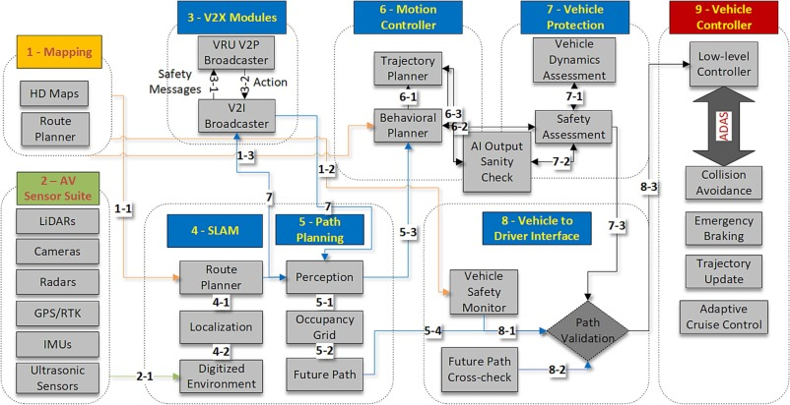
Equally,Unmanned Aerial Vehicle (UAV) communications can be used to support aerial nodes that work in collaboration with ground vehicles to enhance network coverage, aid in traffic monitoring, smart delivery, surveillance and reconnaissance missions[1]. Implementing Artificial Intelligence (AI) technologies into such networks will be a significant move in the creation of intelligent and self-sufficient communication systems. The application of AI algorithms is used to improve routing, resource allocation, collision avoidance, and energy management. Nonetheless, a network topology changes frequently due to the high mobility of network nodes (Dynamic Topology Updates) and the traditional AI models, including CNN and RNN, cannot respond to the changes in real time.
Therefore, there is an urgent need for more adaptive and dynamically responsive AI models that can efficiently handle rapidly changing communication environments in V2X and UAV networks[2].
Figure 1. Overview of V2X communication architecture

Figure (1) illustrates the structure of the V2X communication system, which consists of the following components[3]:
- On-board Unit (OBU): The communication module installed inside the vehicle, responsible for transmitting and receiving data.
- Road Side Unit (RSU): A communication unit located along the roadside that acts as a bridge between vehicles and the cloud infrastructure.
- Pedestrian Unit (PU): Smart devices carried by pedestrians that enable interaction with vehicles to prevent accidents.
- Cloud Server: A centralized cloud platform that processes data and provides collective intelligence to the network.
- UAV Nodes: Unmanned aerial vehicles functioning as signal relays or supporting nodes to expand coverage.
Such architecture shows how vehicles, pedestrians and both ground and air infrastructures are integrated to make V2X a holistic networking architecture that can be used in many other intelligent applications in the future like autonomous driving and cooperative transportation systems. [1].

2. Research Problem
The classical AI algorithms are unable to meet the high mobility and high changes in topology of vehicles and UAV networks, which leads to the appearance of link breakages, delay in data, and poor decision making. The study aims at coming up with adaptive AI tools that can be exploited effectively in unstable scenarios and have low latency and high precision..
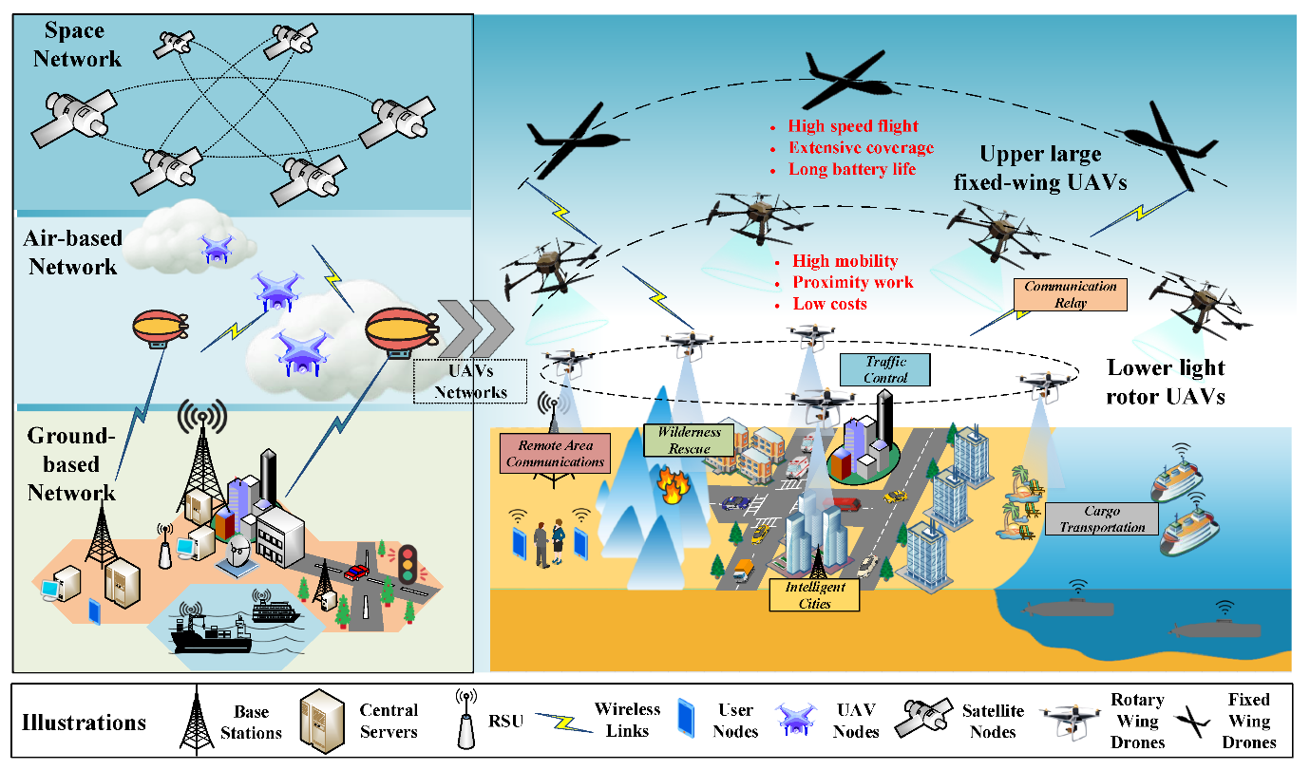
Figure 2. Dynamic UAV-V2X Network Topology

3. Objectives
- Review AI approaches applied to V2X and UAV networks.
- Identify challenges caused by mobility and topology dynamics.
- Compare AI techniques such as DRL, GNN, and FL in terms of accuracy, latency, and stability.
- Outline research gaps and future directions for adaptive intelligent communication systems.

4. Previous Studies
In 2023-2025, recent studies have investigated implementing Artificial Intelligence (AI) to the vehicular (V2X) and UAV networks to enhance the reliability, latency, and energy efficiency of communication. The majority of the works utilized the high-tech approaches that included Deep Reinforcement Learning (DRL), Graph Neural Networks (GNN), and Federated Learning (FL) to solve the problems of mobility and dynamic topology. Nevertheless, in spite of these developments, the available methods remain limited in real-time responsiveness in highly dynamic environments. The main contributions of these studies are summarized in Table 1.

Table 1. Summary of Previous Studies (2023–2025) on AI Models for V2X and UAV Networks

No. | Author(s) & Year | AI Technique / Method | Main Objective | Key Findings / Contributions | Source
1 | Wang et al. (2025) | AI & ML for 6G-V2X | Analyze AI applications for intelligent 6G-V2X systems | Deep Reinforcement Learning reduces latency and improves reliability in high-mobility environments | arXiv:2506.09512
2 | Wang et al. (2024) | FL + GNN + Multi-Agent DRL | Optimize Age of Information (AoI) in vehicular edge computing | Combined FL and GNN enhance data freshness while preserving privacy | arXiv:2407.02342
3 | Yacheur et al. (2024) | Deep Reinforcement Learning | Radio Access Technology (RAT) selection in hybrid vehicular networks | Improved packet delivery ratio by 30% and reduced resource usage | arXiv:2407.00828
4 | Marzuk et al. (2025) | DRL for Energy Efficiency | Resource management and energy optimization in 6G-V2X | Achieved high energy efficiency with low latency performance | MDPI Electronics 14(6), 1148
5 | Nawaz et al. (2024) | Federated Learning & Edge Knowledge Fusion | UAV knowledge sharing in 6G edge networks | Enhanced coverage and reduced communication overhead without raw data transfer | Univ. of Glasgow ePrints
6 | Li et al. (2024) | Dynamic Graph Neural Networks | Joint sensing & communication in THz vehicular networks | Increased service rate of vehicles by up to 28% using adaptive GNN models | arXiv:2403.11102

5. Comparative Analysis
In the recent past (2023 to 2025), the use of different Artificial Intelligence (AI) methods such as Deep Reinforcement Learning (DRL), Graph Neural Networks (GNN), and Federated Learning (FL) have been studied as a way of improving the reliability and efficiency of communication in vehicular (V2X) and UAV networks.
Despite the achievement of these approaches in the reduction of latencies, enhancement of routing, and reduction of the energy consumption, the majority of them do not reasonably adapt dynamically to the settings, which are highly mobile and dynamically topologized.
The given limitation indicates the necessity of an adaptable AI model that would be able to sustain low latency rates, high accuracy, and consistent connectivity in a fast-evolving network environment.
6. Proposed Framework
As shown in Figure 3, the suggested framework, created in this paper, combines Artificial Intelligence (AI) with Vehicular (V2X) and Unmanned Aerial Vehicle (UAV) communication to improve real-time decision-making, traffic optimization, and network stability in high mobility and dynamic topology conditions.
This framework is a design of the researcher, who is trying to develop an adaptive and smarter communication space that will allow vehicles and UAVs to work efficiently to provide the continuity, reliability, and low-latency communication.
Moreover, the framework is a series of three complementary elements that include UAV-based communication architecture, IoT-based data flow, and AI-driven control modules. The combination of these factors creates adaptive intelligent system that can optimize the communication and control the traffic situation dynamically in complex and highly changing network conditions.
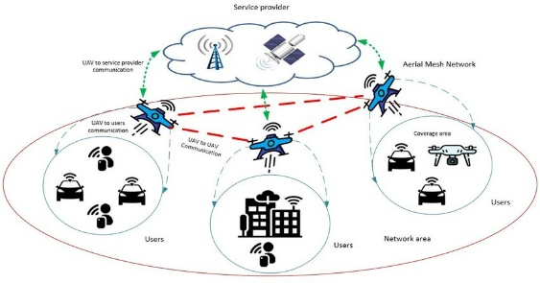
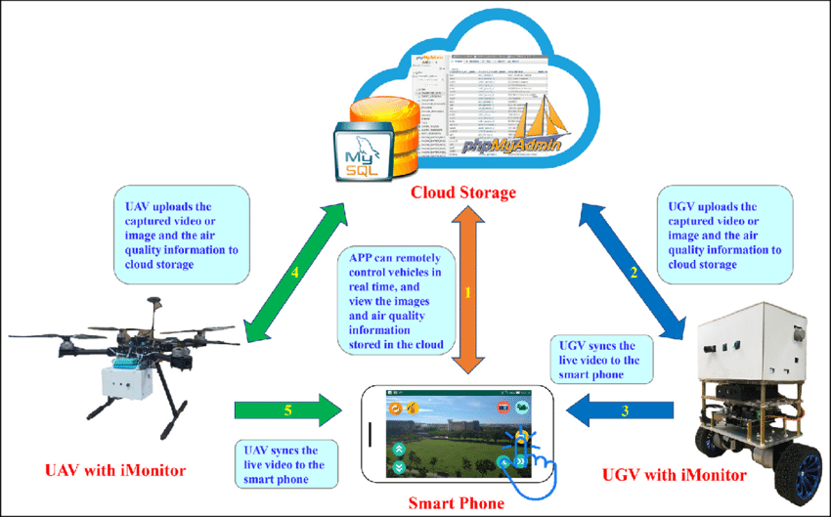
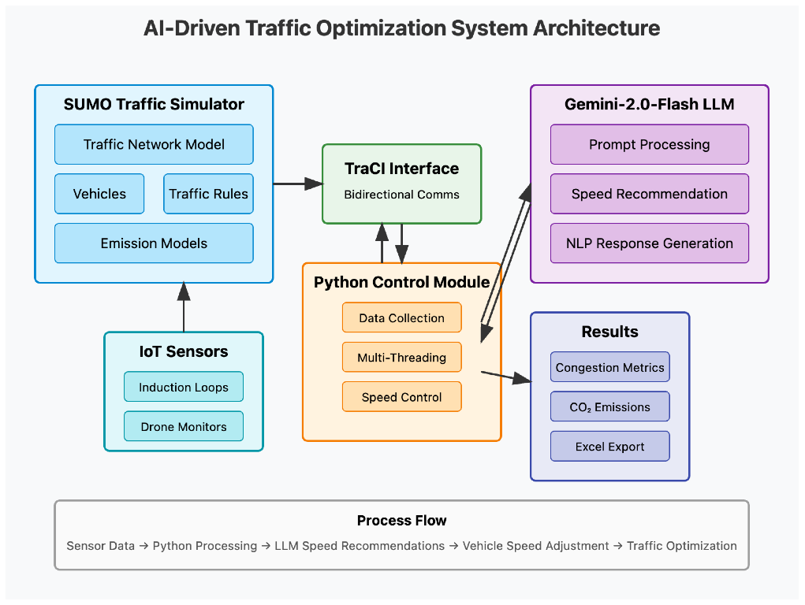
Figure 3. AI Modules for Vehicular and UAV Communication
(Developed by the author based on concepts extracted from previous studies, including Wang et al. (2025), Shah et al. (2024), and Tan et al. (2022)).

Figure Description
- UAV-Based Communication Architecture (top-left): This section shows the use of UAVs as flying relay stations between ground vehicles, users and service providers. The UAVs make a wireless mesh network that improves the coverage of signals and connectivity even in locations with low-quality terrestrial infrastructure..
- IoT-Based Data Flow (bottom-left): This layer entails integration of Internet of Things (IoT) devices, intelligent vehicles, and cloud storage. Sensor and user-device data are collected and sent to the cloud where they are analyzed to track the status of vehicles, the environmental conditions and road-safety conditions in real-time.
- AI-Driven Traffic Optimization Module (right-side): This component shows the intelligence core of the system. It includes:
  - SUMO Traffic Simulator for modeling the road network, vehicle behavior, and emission levels.
  - IoT Sensors and Python Control Module for data collection, multithreading, and vehicle-speed control.
  - Gemini-2.0-Flash LLM to provide AI-based speed recommendations and congestion analysis.
  - The output produces traffic measures, CO 2 emission reports, and optimization outcomes that are also sent to be used in additional decision-making.
The process flow (bottom arrow) illustrates how sensor data are collected, processed by AI modules, and translated into adaptive traffic-control actions—ensuring efficient and reliable communication between vehicles and UAVs in high-mobility environments.

7. Challenges
Despite the significant advancements in integrating Artificial Intelligence (AI) into vehicular and UAV networks, several challenges remain unresolved:
- Rapid Topology Variation: The speed mobility results in constant variations in the topology of the network, and hence, unstable links and frequent handoffs. [5].
- Heterogeneous Communication Standards: The combination of several standards, including V2V, V2I, and UAV-to-UAV communication, leads to the problem of interoperability and complicated coordination. [3].
- Energy Constraints: UAVs and edge devices contain limited energy and processing power and limit long-range and real-time AI operation.
- Scalability and Synchronization: Federated AI models face synchronization problems when scaling across many distributed nodes[6].
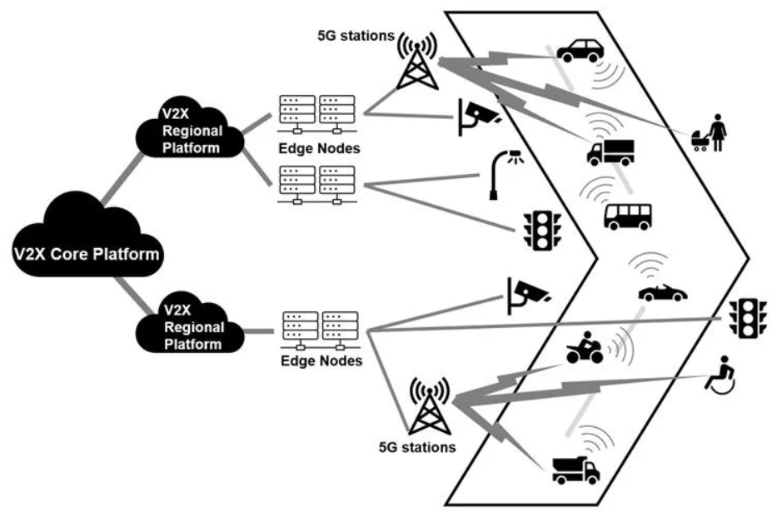
- Data Privacy and Security: Ensuring secure data exchange and maintaining privacy among intelligent nodes remain persistent challenges[7].
Figure 4. AI-Based Routing and Decision Loop in V2X Systems

Figure (4)[8] illustrates how AI models continuously analyze vehicle and UAV data to optimize routing and decision-making. The decision loop involves data sensing, AI prediction, path selection, and feedback control, enabling vehicles to dynamically adapt to changing network conditions.

8. Discussion and Future Directions
The integration of Artificial Intelligence (AI) into vehicles and UAV communication networks is a good direction of creating autonomous, low-energy, and low-latency networks.
The proposed structure shows how the combination of UAV-based coverage, data collection and IoT, and AI-based decision-making can be highly effective in enhancing the dependability of communication and decision-making in the dynamic environment.
However, several challenges remain open for future research.
First, real-time adaptability under unpredictable mobility still requires lighter and faster AI models[5].
Second, data privacy and security must be preserved during cloud and federated learning operations[8].
Third, energy constraints of UAVs limit continuous operation, requiring optimization in path planning and resource allocation[6].
Future research ought to expand upon hybrid AI systems made up of reinforcement learning, graph models, as well as federated strategies, to realize self-adaptive communication.
There are also edge computing and low-power AI accelerators that can be used to improve the speed of processing as well as energy efficiency in vehicles and UAVs.
This study is relevant to the expanding body of knowledge on intelligent vehicular networks because it highlights adaptive AI architectures that maintain performance at high mobility and dynamic topology.

8.1 Future Trends
The rapid evolution of AI and communication technologies opens new directions for intelligent vehicular and UAV systems:
- Graph Neural Networks (GNNs): for predicting and managing dynamic topology changes[2].
- Federated Learning (FL): for decentralized AI training without raw data sharing[8].
- Reinforcement Learning (RL): for autonomous resource allocation and decision-making[5].
- Hybrid Edge–Cloud Intelligence: for balancing latency, energy consumption, and accuracy[1].
- Explainable AI (XAI): for transparent and interpretable decision-making in autonomous vehicles[4].

9. Contributions and Recommendations
Contributions:
- This survey brings together the recent AI innovations, which solve mobility and topology issues in V2X and UAV networks.
- It categorizes AI methods into DRL, GNN and FL models and compares their performance.
- It points out the gaps in research in adaptability to real-time and cross-layer optimization..
Recommendations:
- Future studies should aim at creating hybrid AI systems that can acquire mobility patterns dynamically and change communication parameters.
- Integration V2X and UAV networks with 5G/6G edge computing will play a major role in the development of sustainable autonomous transportation networks..

10. Conclusion
The survey offered a survey of the Artificial Intelligence (AI) application in vehicular (V2X) and UAV communication networks, including the issue of high mobility and dynamic topology.
Based on the review of recent works and the suggested framework, AI, especially Deep Reinforcement Learning (DRL), Graph Neural Networks (GNN), and Federated Learning (FL), is critical in ensuring adaptive and smart communication.
The suggested system architecture incorporates UAV-based networking, IoT-based data collection, and AI optimization modules, and it is based on the foundation of real-time and reliable communication. Nevertheless, there is still the need to constantly conduct research to help solve mobility adaptation, energy efficiency, and data security issues.
Further developments in the 6G technologies, edge intelligence and hybrid AI systems will enable the vehicular and aerial networks in the future to further improve the capabilities to act autonomously, efficiently and sustainably in dynamic conditions.

11. References
  - Wang, D., Qiu, A., Zhou, Q., & Schotten, H. D. (2025). A Survey on the Role of Artificial Intelligence and Machine Learning in 6G-V2X Applications. arXiv preprint arXiv:2506.09512.‏
  - Wang, W., Wu, Q., Fan, P., Cheng, N., Chen, W., Wang, J., & Letaief, K. B. (2024). Optimizing age of information in vehicular edge computing with federated graph neural network multi-agent reinforcement learning. arXiv preprint arXiv:2407.02342.‏
  - Ali Shah, S. A., Fernando, X., & Kashef, R. (2024). A survey on artificial-intelligence-based internet of vehicles utilizing unmanned aerial vehicles. Drones, 8(8), 353.‏
  - Tan, K., Bremner, D., Le Kernec, J., Zhang, L., & Imran, M. (2022). Machine learning in vehicular networking: An overview. Digital Communications and Networks, 8(1), 18-24.‏
  - Zhou, L., Yin, H., Zhao, H., Wei, J., Hu, D., & Leung, V. C. (2024). A Comprehensive Survey of Artificial Intelligence Applications in UAV-Enabled Wireless Networks. Digital Communications and Networks.‏
  - Pal, O. K., Shovon, M. S. H., Mridha, M. F., & Shin, J. (2024). In-depth review of AI-enabled unmanned aerial vehicles: trends, vision, and challenges. Discover Artificial Intelligence, 4(1), 97.‏
  - Tlili, F., Ayed, S., & Fourati, L. C. (2024). Advancing UAV security with artificial intelligence: A comprehensive survey of techniques and future directions. Internet of Things, 27, 101281.‏
  - Chellapandi, V. P., Yuan, L., Brinton, C. G., Żak, S. H., & Wang, Z. (2023). Federated learning for connected and automated vehicles: A survey of existing approaches and challenges. IEEE Transactions on Intelligent Vehicles, 9(1), 119-137.‏

ملخّص البحث:
يتناول هذا البحث دور الذكاء الاصطناعي في تطوير شبكات اتصال المركبات (V2X) والطائرات بدون طيار (UAV)، وهي شبكات تواجه تحديات كبيرة بسبب السرعة العالية وتغيّر الطوبولوجيا المستمر.
تركّز الدراسة على تحليل أحدث النماذج الذكية، مثل التعلّم المعزّز العميق (DRL) والشبكات العصبية البيانية (GNN) والتعلّم الفيدرالي (FL)، ومقارنتها من حيث الدقة، وزمن الاستجابة، وكفاءة الطاقة.
يقترح البحث إطارًا تكامليًا جديدًا يجمع بين الذكاء الاصطناعي وإنترنت الأشياء والطائرات بدون طيار لتحقيق اتصال آمن ومتكيّف في الزمن الحقيقي.
ويسلّط الضوء على أبرز التحديات مثل محدودية الطاقة، وتعدد بروتوكولات الاتصال، وحماية البيانات، مع تقديم رؤية مستقبلية لتطوير أنظمة هجينة أكثر ذكاءً ومرونة في بيئات الاتصالات المتغيرة.

