Copyright Transfer Agreement Form
(Please sign and attach this form in the supplementary file when you make a new submission)

I, the undersigned,

Full Name* : MUSTOFA
Institution* : TADULAKO UNIVERSITY
Email* : mustofauntad@gmail.com OR mustofa@untad.ac.id
Address* : DEPARTMENT OF MECHANICAL ENGINEERING, UNTAD
Title of Submitted Article* : Kaji Eksperimen Jarak Optimal Panen Energi Foton Bohlam LED untuk PV Polycrystalline
List of Authors* : MUSTOFA

Declare that the article above is original, my own thoughts, not translated, and has not been published elsewhere or currently not in the process of other journal publications. I am willing to be responsible if there are parties who feel disadvantaged privately and/or based on a lawsuit in the future by the publication of this article.

I also declare that any and all rights in and to the article including, without limitation, all copyrights are transferred to PROtek: Jurnal Ilmiah Teknik Elektro and Universitas Khairun. Therefore, the copyright transfer hands it the power and authority to edit, reproduce, distribute copies, and to publish the article partly or fully.

*Fill out with corresponding author’s data
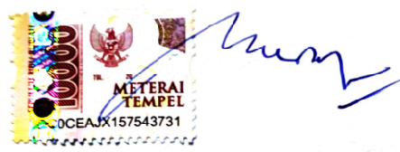

________MUSTOFA___________________________________________________
Corresponding Author’s Name & Signature Date 28/08/2022

