Copyright Transfer Agreement Form
(Please sign and attach this form in the supplementary file when you make a new submission)

I, the undersigned,

Full Name* : Irfan Mujahidin
Institution* : Politeknik Negeri Semarang
Email* : irfan.mujahidin@polines.ac.id
Address* : Jl. Prof. Sudarto, Tembalang, Kota Semarang 50275
Title of Submitted Article* : Scalability and Performance Analysis of LoRaWAN Networks for IoT Implementation: Comprehensive Review and Research Agenda
List of Authors* : Irfan Mujahidin and Rindang Reynaldi

Declare that the article above is original, my own thoughts, not translated, and has not been published elsewhere or currently not in the process of other journal publications. I am willing to be responsible if there are parties who feel disadvantaged privately and/or based on a lawsuit in the future by the publication of this article.

I also declare that any and all rights in and to the article including, without limitation, all copyrights are transferred to PROtek : Jurnal Ilmiah Teknik Elektro and Universitas Khairun. Therefore, the copyright transfer hands it the power and authority to edit, reproduce, distribute copies, and to publish the article partly or fully.

*Fill out with corresponding author’s data

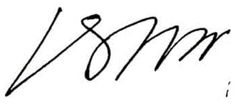
____________________________________________________________
Irfan Mujahidin July 17th 2023

