Analysis of DVB-T2 TV Broadcast Receiver with Comparison of Signal Reception Quality
Muhammad Dzikrillah
Jurusan Teknik Elektro
Program Studi Sarjana Terapan Teknik Telekomunikasi
Politeknik Negeri Sriwijaya
Palembang, Indonesia
mhmddzikrillah@gmail.com
Ade Silvia Handayani*
Jurusan Teknik Elektro
Program Studi Sarjana Terapan Teknik Telekomunikasi
Politeknik Negeri Sriwijaya
Palembang, Indonesia
Ade_silvia@polsri.ac.id*
Abdul Rakhman
Jurusan Teknik Elektro
Program Studi Sarjana Terapan Teknik Telekomunikasi
Politeknik Negeri Sriwijaya
Palembang, Indonesia
arahmanhamid.60@gmail.com

Abstract – Television is one of the most widely used media for receiving sound and image transmissions worldwide, particularly in Indonesia. Government regulations require all television broadcasters in Indonesia to cease analog broadcasts and transition to digital broadcasts. Consequently, a device known as the Set Top Box (STB), equipped with a low noise amplifier (LNA), converts DVB-T2 digital signals into images and audio suitable for analog televisions. Tests were conducted to evaluate its signal reception capabilities. These tests took place at four Palembang city locations, utilizing indoor and outdoor antennas. The results revealed that the device's signal strength ranged from -48.7 dBm, reaching 100% signal quality, to the weakest signal at -97 dBm. Moreover, an average difference of 6.9 dB was observed between indoor and outdoor testing for each frequency. Furthermore, analyzing the average signal strength based on distance showed that the highest strength of -56.2 dBm occurred at a distance of 1.5 km from the transmitter during outdoor testing. In comparison, the weakest strength of -91.6 dBm occurred at a distance of 1.8 km during indoor testing. Additionally, a signal strength comparison between test locations indicated that the most significant difference was between the Kamboja and Plaju locations. The LNA device achieved its highest gain value of 15.2 dB. Various factors, including antenna direction, obstructions such as buildings, antenna height, signal stability, and the distance between the transmitter and receiver, influence the signal quality.
Keywords: Low Noise Amplifier, DVB-T2, Set Top Box, Television.
Creative Commons Attribution-NonCommercial-ShareAlike 4.0 International License.

Introduction
Television is one of the most widely used media in the world, as humans, being social beings, need information about events or news from various parts of the world through various media, including television [1].
There are two types of television: digital television and analog television. Digital television or DTV uses digital modulation and digital compression systems to transmit image, sound, and data signals to television sets. On the other hand, analog television uses analog modulation to receive image and audio signals on television sets. Digital television (DTV) differs from analog television in many aspects, especially in its system and features.[2] Currently, the standard digital television technology used is Digital Video Broadcasting-Second Generation Terrestrial (DVB-T2), an advancement of the Digital Video Broadcasting-Terrestrial (DVB-T) technology. [3] DVB-T2 technology offers reduced spectrum requirements, better radio signal coverage, improved image quality, and interactive capabilities. [4]
Based on the recommendations of the International Telecommunication Union (ITU) in the Geneva 2006 (GE-06) Agreement, as well as the Government Regulation Number 46 of 2021 on Postal, Telecommunication, and Broadcasting Services, and the Minister of Communication and Informatics Regulation Number 11 of 2021 on broadcasting services, all broadcasting institutions are required to stop analog broadcasting and switch to digital broadcasting. This is aimed at improving the quality of television broadcasting with precise and advanced technology and achieving equitable distribution of quality television broadcasting throughout Indonesia. [5]
To receive digital television broadcasts, people need a Set Top Box (STB) device that can convert DVB-T2 digital signals into images and audio that can be displayed on analog TVs. a Low Noise Amplifier (LNA) is added To maximize the signal reception on this device. Based on a study conducted.[4] on the Realization of a two-stage LNA using λ/4 transformer impedance adjustment and Lumped Element for DVB-T2, the results showed a Gain of 12.96 dB and a Noise Figure (NF) of 4.05 dB. The higher the gain value, the better the signal strength improvement will be.
Good signal quality can be observed from the reception results of all digital television transmitter signals and good signal strength, as seen in the research on the design and testing of the Maximal Ratio Combining (MRC) technique on DVB-T2 TV receivers. The research showed that the DVB-T2 digital TV reception system can receive all DVB-T2 digital TV transmitters in Semarang with good quality, with a received power reaching -77.3 dBm, which increased to -71.2 dBm after using MRC [6].
In a study conducted by [7], image acquisition quality was measured using the SINPO method based on three main factors: acquired signal strength, interference from other signals, and atmospheric noise. Additionally, the research considered propagation conditions and overall reception quality (Overall merit).
This study aims to support the government's policy regarding Analog Switch Off (ASO) and encourage the public to use Set Top Box devices. To achieve this goal, the researchers plan to design a Set Top Box with the addition of an LNA (Low Noise Amplifier) to enhance signal reception sensitivity on the Set Top Box. Subsequently, a comparative analysis of signal reception quality will be conducted based on indoor and outdoor testing to evaluate the device's performance..

Basic of Theory
Digital Video Broadcasting Second Generation Terrestrial (DVB-T2) is a standard for terrestrial digital television broadcasting, which is an advancement of the DVB-T standard. This standard is issued by the DVB consortium and standardized by the European Telecommunication Standardization Institute (ETSI).[8] The technology transmits audio, video, and other compressed data in a "physical layer pipe" (PLP), using Orthogonal Frequency Division Multiplexing (OFDM) modulation with combined channel encoding and interleaving. With a higher bitrate than DVB-T, DVB-T2 enables the transmission of High Definition Television (HDTV) channels on terrestrial TV broadcasts. [9]
Table 1. Comparison of DVB-T with DVB-T2
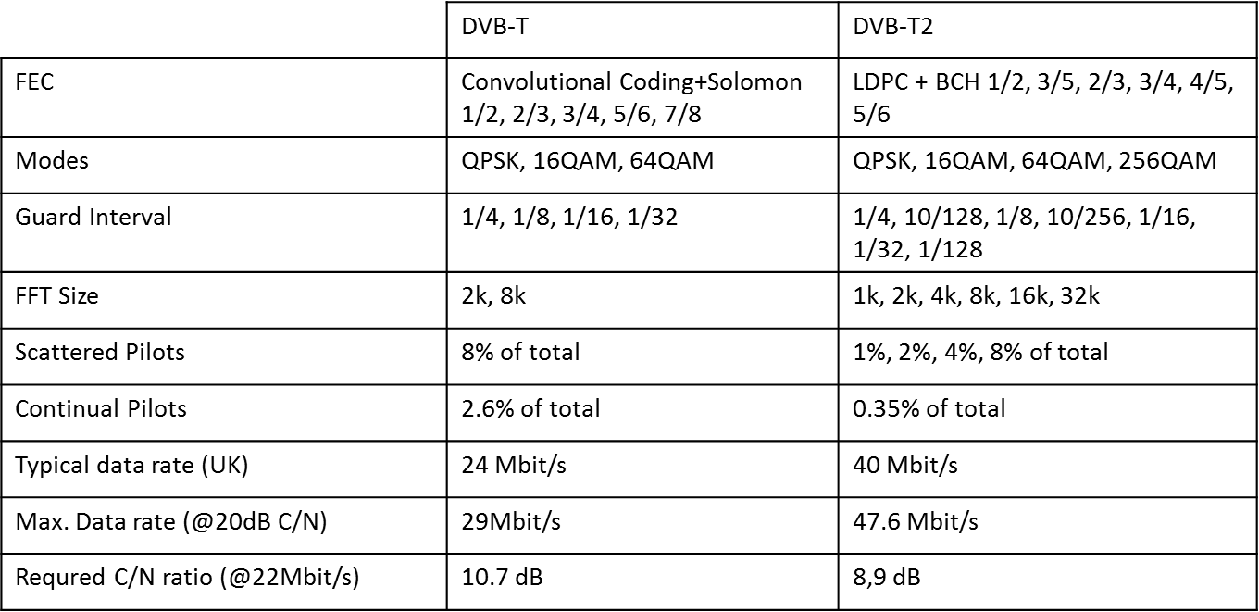
Inside the Set Top Box, there is a crucial component that acts as the central processing unit for the received signals, known as the TV tuner. The TV tuner is a device used to tune into radio frequencies and convert them into a new frequency called the Intermediate Frequency (IF). The IF frequency in digital television broadcasts carries the information/data multiplexed by the transmitter/radio frequency, which is then analyzed and separated into different pieces of information through the demultiplexing process. The outcome of the demultiplexer produces separate audio and video signals. [10]
Figure 1. TV tuner
A Low Noise Amplifier (LNA) is an electronic circuit that functions to amplify signals with very low power without reducing the signal-to-noise ratio.[11] LNA enhances both the signal strength and noise at its input but also introduces additional noise.[6] The purpose of LNA is to minimize the additional noise originating from the device's input, thus allowing signal amplification with low noise levels. [12] In this study, the LNA is connected to the signal input from the antenna to the set-top box to amplify the received signals.
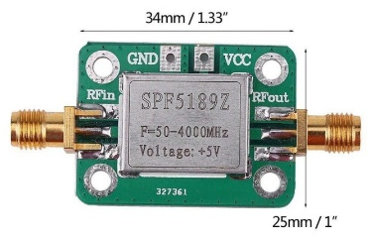
Figure 2. Low Noise Amplifier
The Low Noise Amplifier will increase the gain value. Gain represents the power signal amplification unit from the circuit's input to its output.[13] The gain value increased by LNA can be calculated using a spectrum analyzer at the input and output of the LNA device. Subsequently, the gain is determined using the following formula:
$Gain (dB)=Pout-Pin+cable loss$ (1)
To determine the signal reception quality of the device, researchers use the Received Signal Strength Indicator (RSSI) value. RSSI is the power of the signal received by the user in a specific frequency range, including noise and interference (Wideband Power). This parameter is often referred to as the Signal Level.[14]
An antenna functions as a signal receiver, capturing electromagnetic waves in the air transmitted by broadcasting transmitters.[13] It acts as an intermediary device that receives signals propagating through space and electric currents moving through metal conductors. [15] The type of antenna used in this study is a directional antenna with a Yagi model, which has an antenna gain ranging between 7 - 19 dBi.
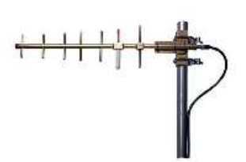
Figure 3. Yagi Antenna

Method and Design
The design and analysis of this study begin with constructing a research flowchart. Figure 3 illustrates the flowchart used in this research.:

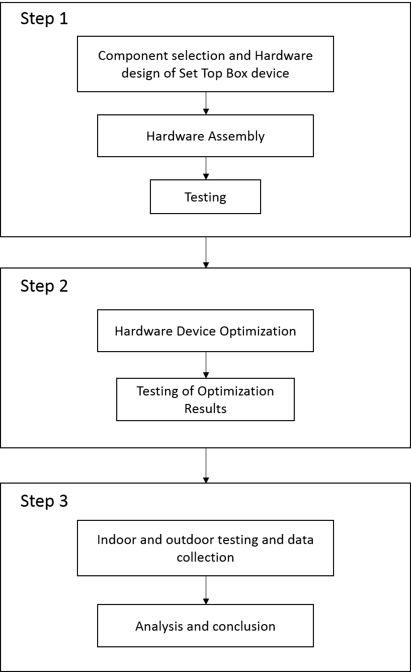
Figure 4. Flowchart

Based on the flowchart, the research commences with selecting device components and designing the device. The device components include a digital TV tuner, Low Noise Amplifier, power supply, transistors, capacitors, resistors, and infrared receiver. After the components are selected, the next step involves designing the schematic circuit of the power supply and Low Noise Amplifier using the Eagle application. Once the schematic circuit design is completed, the next phase entails creating the layout design on the PCB board.
Upon obtaining the layout design on the PCB board, the next step involves assembling the circuit components following the layout design on the PCB board. To connect the input signal from the antenna to the Low Noise Amplifier input and link the output to the tuner device, RG-315 cables with a speed factor of 0.75 are utilized. To ensure the cable length matches the frequency to be used, the cable length must be trimmed according to the wavelength at its operating frequency, known as Matching loss. The cable length is calculated based on the wavelength of 1/4λ and then cut into two parts for the LNA input and output cables. The cable length value can be calculated using the following equation :

$Cable Length= \frac{75}{F} ×VF$ $Cable Length= \frac{75}{566} ×0,75$
$Cable Length=$0,0993 m (2)

Subsequently, testing is conducted on the Set Top Box device by connecting the 12V adapter input to the circuit and linking the audio-video output to the analog TV device using RCA cables. An antenna cable is also connected to the Set Top Box antenna input.

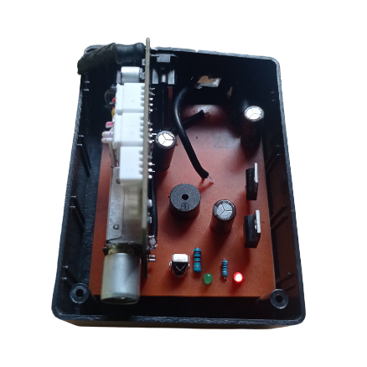
Figure 5. Set Top Box device

The results of these tests are utilized for optimizing the circuit by adding several components such as a current amplifier circuit, designing a toolbox, and incorporating a cooling blower to enhance device performance.
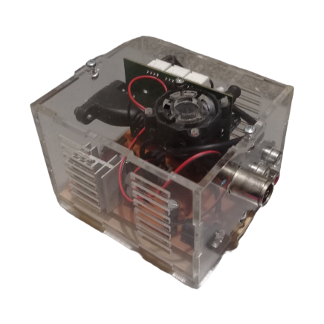
Figure 6. Device result after optimization

After successfully testing and optimizing the device, the next step involves conducting measurements using a Spectrum Analyzer. These measurements are performed indoors and outdoors at four locations in Palembang city. The objective of these tests is to ascertain the device's signal reception and the gain value of the utilized LNA. Yagi antennas are employed in the testing, positioned on a 2-meter high pole.
The measurement results will be analyzed based on the comparison between indoor and outdoor testing, the influence of distance on the received signal strength by the device, and the signal strength comparison among several testing locations.

Results and Discussion

Indoor and Outdoor Comparison Measurments
Based on the measurement and testing results conducted at various locations in Palembang city (namely Kamboja, Plaju, Kenten, and Bukit), the testing outcomes of the signal reception by the device were obtained. These results can be observed in the graph shown in Figure 7:
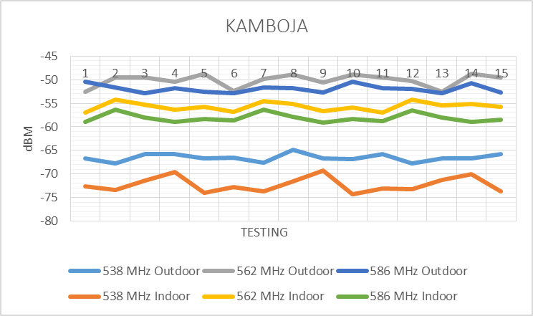
(a)
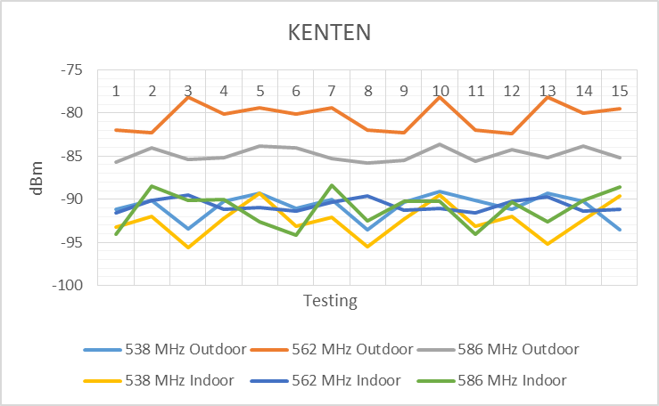
(b)

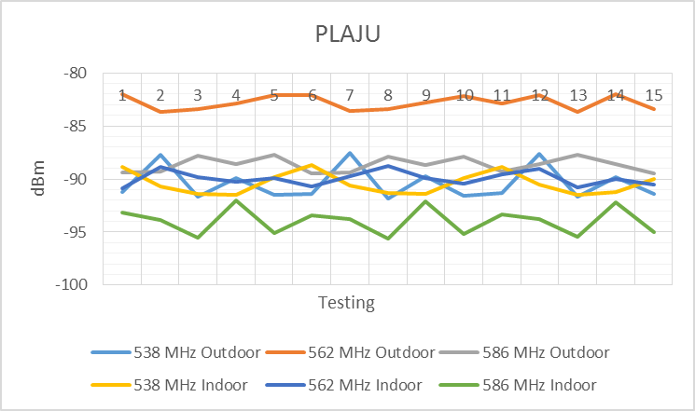
(c)
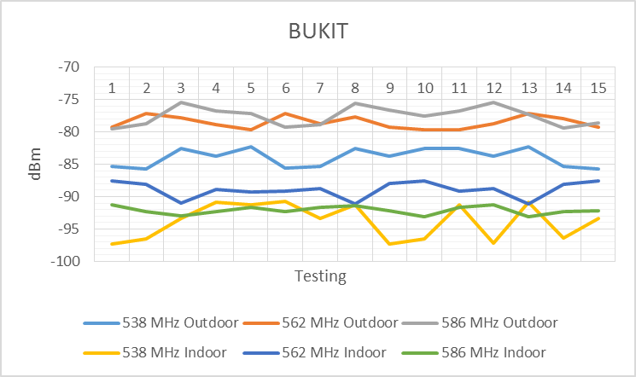
(d)
Figure 7. (a) measurement results in kamboja, (b) measurement results in Kenten, (c) measurement results in Plaju, (d) measurement results in Bukit
The researchers performed the signal measurement of the device to determine the signal reception quality in both indoor and outdoor conditions. These conditions were set based on the antenna placement at the testing locations. The Spectrum Analyzer was used to visualize and detect the power of the signals received by the device.
Based on the measurement results shown in Figure 7, it was found that the digital TV signal frequency in Palembang city consists of three broadcast muxes with centre frequencies of 538 MHz (channel 29), 562 MHz (channel 32), and 586 MHz (channel 35). In this measurement, the highest signal strength obtained was -48.7 dBm, while the lowest measured signal strength was -97.3 dBm. These measurements were taken for each frequency in indoor and outdoor conditions at each testing location.
Furthermore, the measurement results also revealed the difference in signal strength between indoor and outdoor testing. The highest average signal strength difference of 14.59 dB was observed at the Bukit location for frequency 586, and the lowest average difference of 0.04 dB was found at the Plaju location for frequency 538. The average difference in signal strength between indoor and outdoor testing was 6.9 dB for each testing location, as shown in the measurement results in Figure 8..
These measurements illustrate the impact of using indoor and outdoor antennas on the signal reception of the Set Top Box device, taking into account the testing environment to evaluate the performance of the Set Top Box device.
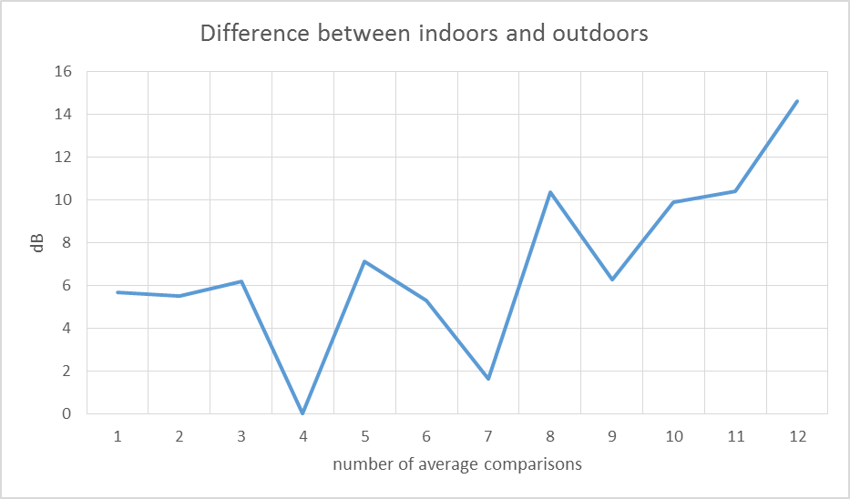
Figure 8. Indoor and outdoor testing differences

The Effect of Distance on Signal Strength
Researchers also analyzed the effect of distance on the signal strength received by Set Top Box (STB) devices. This signal strength was evaluated based on the test data in Figure 7, where each location had a different distance from the transmitter, and these distance variations could affect the signal strength received by the device.
The analysis conducted by the researchers showed that the distance significantly impacted the signal strength received by the STB devices. The input data indicated that as the distance between the STB device and the transmitter increased, the received signal strength decreased.
Testing in Figure 7 was conducted at various locations with different distances from the transmitter. The test results yielded the following findings: In the Kamboja location, which was 1.5 Km away from the transmitter, the average signal strength recorded was -56.2 dBm for outdoor and -62 dBm for indoor testing. In the Bukit location, which was 1.8 Km away from the transmitter, the average outdoor signal strength was -79.9 dBm and -91.6 dBm for indoor testing. Furthermore, at the Kenten location, which was 8.2 Km away from the transmitter, the average signal strength was -85.3 dBm for outdoor testing and -91.4 dBm for indoor testing. Finally, at the Plaju location, which was 8.6 Km away from the transmitter, the average signal strength was -87.2 dBm for outdoor testing and -91.4 dBm for indoor testing..
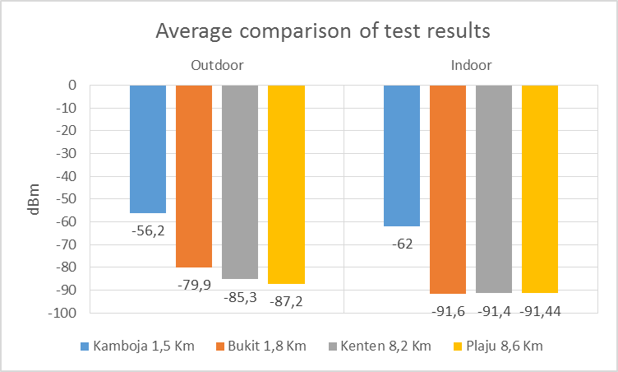
Figure 9. Average comparison of test results based on test location distance
There were apparent differences in signal strength from each location, especially in the farthest location during outdoor testing, where the signal tended to be very weak or unreachable. Additionally, outdoor testing data indicated that STB devices closer to the transmitter had better signal quality. This implies that users in areas far from the transmitter might experience issues such as disruptions or poor image quality on their television screens.
The researchers also noted that other factors, such as topography and physical obstacles, like tall buildings or vegetation, could influence the signal strength received by the STB devices, as observed in indoor testing. The comparison data in Figure 8 showed that some locations with different distances had the same signal strength, indicating the influence of physical obstacles during indoor testing. Therefore, strategic and unobstructed placement of the STB device's antenna could help improve the received signal quality.

Comparison of Signal Strength Between Test Locations
Based on the data in Figure 9, which contains the average signal strength comparison results at several locations, comparison data between the test locations can be seen in Figure 10. This data represents the average signal strength values from outdoor testing, as outdoor testing showed better values than indoor testing.
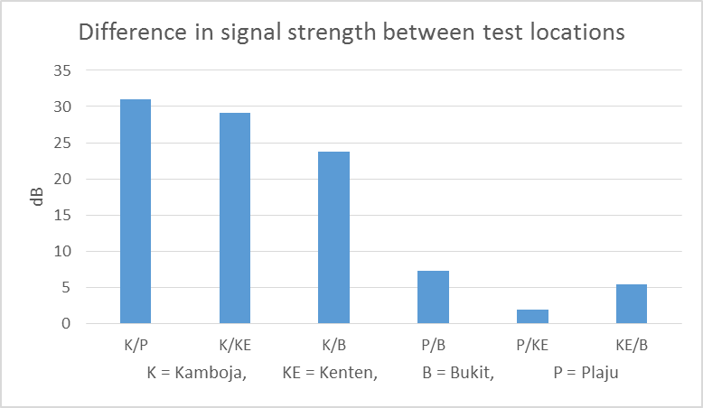
Figure 10. The difference in Signal Strength between test location
Figure 10 shows that the highest signal strength difference occurs in comparing the Kamboja and Plaju locations, with an average signal strength difference of 32 dB. On the other hand, the lowest signal strength difference occurs between the Plaju and Kenten locations, with a difference of 1.9 dB. These signal strength differences are influenced by various factors, such as the distance between the test location and the transmitter, the height of the antenna used by the STB device, the direction of the antenna used, and the presence of tall buildings obstructing the signal.
The signal strength differences are slightly lower for locations with the same distance, as seen in the Kenten and Plaju locations. However, we observe the signal strength difference between the Kamboja and Bukit locations. In that case, the signal strength values significantly differ, even though the distance from the transmitter is relatively close. This is due to tall buildings and structures obstructing the Line Of Sight (LoS) direction between the testing location on Bukit and the transmitter, making achieving a precise antenna alignment difficult.

Low Noise Amplifier Measurement and Signal Quality Measurement on Set Top Box Output Results
The Low Noise Amplifier (LNA) gain value was measured at a location in Kamboja using a Spectrum Analyzer to measure the incoming and outgoing signal power. The gain measurement was performed at the frequency of digital TV broadcast. The gain values obtained from the measurement and calculation based on the gain formula are shown in Figure 11.
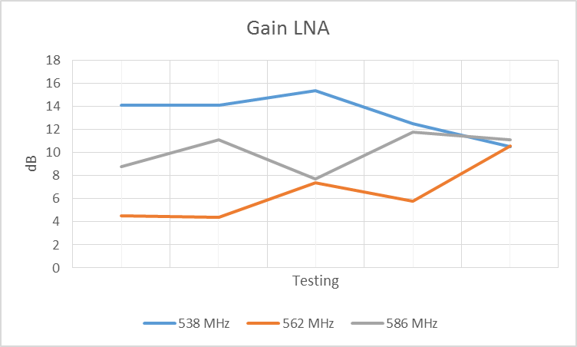
Figure 11. Value of Gain Measurement
Based on the measurement results from Figure 11, it was found that the highest gain value was obtained at a frequency of 538 MHz with a gain of 15.2 dB. Meanwhile, the lowest gain value was recorded at a frequency of 562 MHz with a gain of 4.4 dB. The data also indicates an average gain of 13.32 dB at a frequency of 538 MHz, an average gain of 6.54 dB at a frequency of 562 MHz, and an average gain of 10.1 dB at a frequency of 586 MHz.
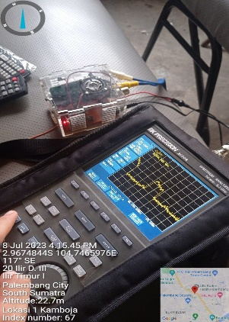
Figure 12. measurement using a Spectrum Analyzer
In addition to measuring the LNA gain value, the researchers also measured the signal strength on the display output of the Set Top Box device and determined the actual signal strength based on the percentage of signal strength displayed on the TV. Subsequently, the researchers determined the signal strength obtained based on the quality of the received broadcast image displayed by the STB device. The measurement results provide signal strength values based on percentages and the signal quality received by the Set Top Box device, as shown in Table 2.
Table 2. The signal quality of Set Top Box devices
Percentage | RSSI (dBm) | Signal Strength
90 – 100 % | > -65 | Excelent
80 – 90% | (-75) – (-65) | Good
60 – 80 % | (-85) – (-75) | Fair
50 – 60% | (-95) – (-85) | Poor
0 – 50% | < -95 | Loss
The measurement on the TV screen, which provides information for each broadcast, yielded signal quality values, as shown in Table 2. The percentage column represents the values displayed on the Set Top Box output on the TV, while the RSSI value is the average value obtained from measuring the signal strength based on the percentage displayed on the Set Top Box device.
The testing was conducted by connecting an adapter to the Set Top Box device, and then the output of the Set Top Box was connected to the analog AV input on the TV. After all connections are made, wait for the TV program to appear on the screen. To search for channels, press the "Setup" button on the remote, then select "Search channels" on the TV screen and wait for the process to finish. Once the channels are found, press the "Info" button on the remote to view the signal percentage information. The Set Top Box testing signal information, can be seen in Figure 13.

.
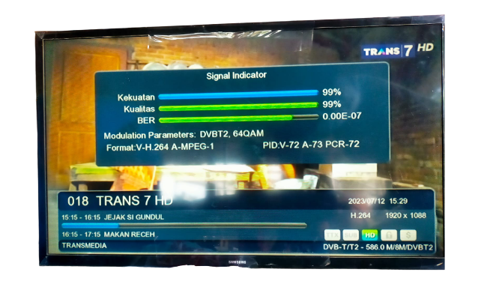
Figure 13. Display of Signal Information on the TV

Conclusion
The testing and analysis results indicate that the signal quality in indoor testing is worse compared to outdoor testing. The data shows that the signal strength in outdoor conditions is better because the antenna can reach the Line of Sight direction of the transmitter without obstruction from walls, unlike indoor testing. This study also identifies the influence of distance on the received signal strength and compares the testing data from various locations. The results demonstrate that the closer the receiver's distance to the transmitter, the stronger the signal will be. However, other factors such as building obstructions, antenna direction, antenna height, signal stability, and tall trees also affect the received signal strength at the Bukit location with a shorter distance, and the signal strength values approach those at a greater distance.
This research also yields the gain values of the Low Noise Amplifier device, with the highest gain occurring at a frequency of 538 MHz and the lowest at a frequency of 562 MHz, with an average gain almost reaching 10 dB. This aligns with the researchers' expectations to add a Low Noise Amplifier to the Set Top Box device. Furthermore, this research identifies the values of signal strength measurements based on the percentage of the signal displayed by the Set Top Box device, documented in Table 2. Based on these results, the research has successfully achieved the set objectives.

References
[1] H. Budiarto, B. Heru Tjahjono, A. Rufiyanto, A. A. N. Ananda Kusuma, G. Hendrantoro, and S. Dharmanto, TV Digital dan Prospeknya di Indonesia. 2007. [Online]. Available: http://www.argentina.ar/temas/medios/48-tv-digital
[2] N. Ya’acob et al., “Measurement of digital video broadcasting-second generation terestrial (DVB-T2) signal in Kuala Lumpur, Malaysia,” Indones. J. Electr. Eng. Comput. Sci., vol. 13, no. 3, pp. 1286–1293, 2019, doi: 10.11591/ijeecs.v13.i3.pp1286-1293.
[3] D. Fitriyani, K. Anwar, and D. Saputri, “Study on Radio Frequency Profile of Indonesia Digital Television DVB-T2 for Urban Areas,” no. 1, 2020, doi: 10.4108/eai.11-7-2019.2297441.
[4] A. Karyana, Y. S. Rohmah, and B. Prasetya, “Realisasi LNA Dua Tingkat dengan Teknik Penyesuai Impedansi Trafo λ/4 dan Lumped Element untuk DVB-T2,” ELKOMIKA J. Tek. Energi Elektr. Tek. Telekomun. Tek. Elektron., vol. 8, no. 1, p. 1, 2020, doi: 10.26760/elkomika.v8i1.1.
[5] P. P. RI, Peraturan Pemerintah Republik Indonesia Nomor 46 Tahun 2021 Tentang Pos, Telekomunikasi, dan Penyiaran, no. 08637. 2021.
[6] A. Charisma, D. Dwi Nugraha, A. S. Permana, and A. Yani, “Perancangan Low Noise Amplifier (LNA) Dua Tingkat dengan Lumped Element untuk Satelit Nano,” vol. 7, no. 2, pp. 170–178, 2021, [Online]. Available: https://doi.org/10.24036/jtev.v7i2.113092
[7] J. M. Martripagelardo, Dedy Suryadi, F Trias Pontia W, Fitri Imansyah, “Identifikasi Penerimaan Sinyal Antena Digital Untuk Televisi Menggunakan Metode Sinpo,” Jetc, vol. 14, no. 2, 2019.
[8] A. F. Mansor, D. Mohd Ali, and Y. Yusuf, “Performance Analysis of Digital Video Broadcasting - Second Generation Terrestrial (DVB-T2) Propagation for Fixed Reception in The Central Region of Malaysia,” Elektr. J. Electr. Eng., vol. 21, no. 1, pp. 54–60, 2022, doi: 10.11113/elektrika.v21n1.355.
[9] I. T. Union, DTTB Handbook Digital terrestrial television broadcasting in the VHF/UHF bands Version 1.02, 2002nd ed. 2002.
[10] S. Waluyanti, “Teknik Audio Video,” in Direktorat Pembinaan SMK, 2008, pp. 271–277.
[11] R. P. Sari, L. Lindawati, and S. Soim, “Monitoring Kapal Menggunakan Automatic Identification System(AIS) Dengan RTL-SDR dan Low Noise Amplifier (LNA),” PROtek J. Ilm. Tek. Elektro, vol. 9, no. 2, p. 119, 2022, doi: 10.33387/protk.v9i2.4691.
[12] V. M. Garcia, “Low Noise Amplifier Basics,” Ciprian, pp. 1–4, 2017.
[13] S. Reddy and R. Panicker, Antena And Wave Propagation, vol. 2. Malla Reddy Collage of Enginering and Technology, 2019.
[14] M. Ulfah and A. Sri Irtawaty, “Optimization of 4G Lte (Long Term Evolution) Network in Balikpapan City,” J. Ecotipe, vol. 5, no. 2, pp. 1–10, 2018.
[15] H. Ramza, Antena dan Propagasi Gelombang. Kemala Indonesia, 2020.

