Implementation of Fuzzy Logic in the Monitoring and Controlling System for Temperature and pH of Fry Aquarium Water Betta Fish Based on the Internet of Things

*Rico Wahyudi
Jurusan Teknik Elektro
Program Studi Elektronika dan Instrumentasi
Universitas Islam Negeri Sultan Syarif Kasim Riau
11950511622@students.uin-suska.ac.id

Hilman Zarory
Jurusan Teknik Elektro
Program Studi Elektronika dan Instrumentasi
Universitas Islam Negeri Sultan Syarif Kasim Riau
hilman.zarory@uin-suska.ac.id

Aulia Ullah
Jurusan Teknik Elektro
Program Studi Elektronika dan Instrumentasi
Universitas Islam Negeri Sultan Syarif Kasim Riau
auliaullah@yahoo.co.id

Ahmad Faizal
Jurusan Teknik Elektro
Program Studi Elektronika dan Instrumentasi
Universitas Islam Negeri Sultan Syarif Kasim Riau
ahmad.faizal@uin-suska.ac.id
Abstract – A problem faced by betta fish farmers is the difficulty in monitoring and controlling the temperature and pH of the water in betta fish fry ponds. This condition causes many deaths of Betta fish fry which results in a reduction in the supply of Betta fish seeds. To overcome this problem, a system based on the Internet of Things was developed(IoT) which can monitor in real time and control the temperature and pH of the water in the Betta fish fry pond. This system is implemented in an aquarium equipped with artificial intelligence in decision making which aims to keep the temperature and pH of the aquarium water stable. The components used in this system include ESP32, DS18B20 temperature sensor, water pH sensor, Thermo Electric Cooler (TEC), heater, DC pump, and fuzzy logic implementation. The results of system testing for 14 days showed that the system was able to monitor and control the temperature and pH of the aquarium water, maintaining ideal conditions for Betta fish fry with an average temperature of 28.79°C and an average water pH of 7.45. The system also succeeded in reducing the mortality rate of Betta fish fry, as proven in comparative tests between aquariums without system implementation and aquariums with system implementation. In this trial, each aquarium was filled with 30 betta fish fry. The results showed that the aquarium with system implementation was able to reduce the death rate of Betta fish fry by 5 or 16.67% from a total of 30 fish. Meanwhile, aquariums without system implementation had a death rate of 12 betta fish fry or 40% of the total of 30 betta fish fry.

Keywords: Fuzzy Logic, Temperature Control, pH Control, Betta Fish, IoT.
Creative Commons Attribution-NonCommercial-ShareAlike 4.0 International License.

Introduction
Betta fish or Betta Splendens is a species of freshwater fish originating from Indonesia. This fish is known for its beautiful, colorful body and long, ribbon-like fins. Since ancient times, Betta fish have undergone a breeding process focused on ornamental fish needs. This breeding is expected to improve the aesthetic appearance of Betta fish, producing various stunning varieties of Betta fish. The role of Betta fish as ornamental fish is increasingly prominent, the beauty and ease of care for Betta fish are the main reasons behind their popularity in the world of ornamental fish [1].
Betta fish are a tough type of fish and can be kept in small aquariums. Uniquely, Betta fish are often sold in retail stores in glasses or glass bottles without any filtration or aeration process. Even though the popularity of Betta fish continues to increase, a deep understanding of the environmental needs and welfare of Betta fish remains an important aspect in keeping them [2]. So it is very necessary to pay close attention to ensure optimal environmental conditions for the welfare of betta fish.
When it comes to spawning betta fish, there are a number of problems that can cause stress to betta fish, hindering their ability to mate. The breeding efforts of the Betta fish pair itself are vulnerable and need careful handling. This condition can lead to the risk of death in the early stages of development of Betta fish fry after breeding [3]. Several factors that influence the success of raising Betta fish fry involve aspects such as type of feed, water quality, presence of pests and potential for disease. Betta fish habitat characteristics such as water pH 6.5-8, water temperature 24-30°C, and the ability of Betta fish to survive in low oxygen levels caused by the presence of a labyrinth cavity similar to human lungs in fish. Siamese fighting fish [4]. Adjustments to these conditions need to be made according to the needs and behavior of Betta fish in their natural habitat. This has an important role in supporting optimal growth and survival of betta fish fry.
Currently, most betta fish farmers still carry out maintenance manually. The challenge in caring for fish manually is when the fish owner is busy or has other activities that make it difficult to monitor and maintain pond water quality consistently [5].
Caring for Betta fish fry can be more effective by using tools and systems that can control the water quality in the aquarium or Betta fish fry pond. In research conducted by Rahmat Salfitrah, he has succeeded in creating a system for monitoring and controlling the temperature and pH of Betta fish fry aquarium water using the KNN method [6]. The system created uses an Arduino as a microcontroller, and an LCD to display the sensor values ​​read in the aquarium water and will classify the sensor values ​​to determine the action of the actuator.
Based on existing problems and previous research, the author created a system that can control and monitor water quality in Betta fish fry aquariums using the fuzzy method. The fuzzy method is a controller that does not require an exact mathematical model of the system in question and shows excellent resistance to external disturbances [7]. The advantage of the fuzzy controller is its ability to respond quickly in transient situations and a fast response time so it is very suitable for controlling the temperature and pH of Betta fish fry aquarium water.

Basic Theory
Wateris a medium for fish farming activities, therefore understanding water quality is very important. Good water quality (according to cultivation standards) will be able to support optimal growth rates for fish cultivation. Based on knowledge and literature studies, the most important thing in managing water quality in the media for keeping Betta fish fry in a closed room is the temperature and pH parameters of the water which will greatly influence the survival of Betta fish fry [3].
ESP32 is a microcontroller equipped with high-speed Wi-Fi, making it very suitable for supporting the implementation of Internet of Things (IoT) systems and Bluetooth capabilities while using low power [8]. ESP32 is a development of the NodeMCU ESP8266 which has the disadvantage of not having a Bluetooth module but has the same function as an electronic circuit controller and also supports the development of Internet of Things (IoT) application systems.
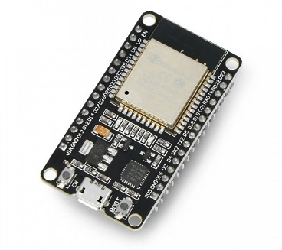
Figure 1. NodeMCU ESP32
DS18B20is the latest temperature sensor from Maxim with the ability to read temperatures in the range of 9 to 12 bits, covering -55°C to 125°C with an accuracy level of around 0.5°C [9].
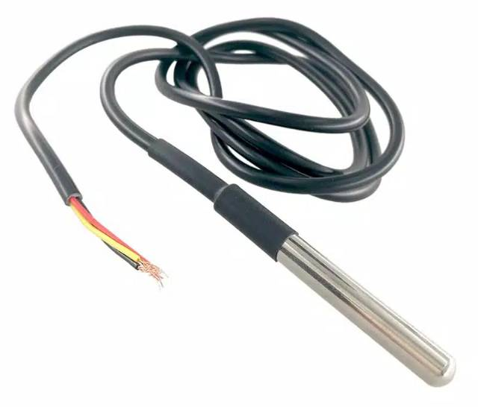
Figure 2. DS18B20 Temperature Sensor
pH sensorsis a glass electrode formed from glass bubbles that are sensitive to pH at the tip and contains a chloride solution that knows the pH as well as the reference electrode. To increase its functionality, this pH sensor is equipped with a data acquisition module. This module is responsible for converting the sensor output into a voltage on the analog pin, and at the same time has characteristics that cause the resulting voltage to become greater as the acid level in the pH of the water increases [10].
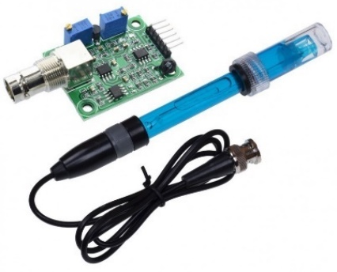
Figure 3 Water pH sensor
ThingSpeak is an internet of Things (IoT) platform that allows users to collect, manage and analyze data from various connected devices. ThingSpeak offers cloud services that make it easy for users to create and manage IoT projects. One of ThingSpeak's key features is its ability to integrate data from multiple sources, such as sensors, microcontrollers, and other IoT devices [11].
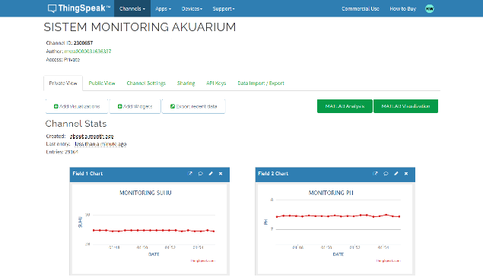
Figure 4. Display of ThingSpeak Software
Fuzzy Logic is a field of Artificial Intelligence (AI). Artificial Intelligence is computer science that studies machines (computers) that can act like humans or even better. Fuzzy Logic is a method for finding solutions to problems that are considered unclear [12]. In its solution, fuzzy logic uses linguistics such as in explaining water temperature, namely cold, normal, hot.
Fuzzy logic There are four stages in decision making, namely:
- Fuzzification
Fuzzification is a step of transforming input values from classic crisp sets into fuzzy values consisting of linguistic variables and membership functions.
- Inference
The process of inference involves reasoning on information or knowledge already existing in the environment, with the aim of generating information or new knowledge.
- Defuzzification
Defuzzification process changes the fuzzy output value to the original value (crisp set). The defuzzification method used in this study is the centeroid method [13], the defuzzification equation for the centeroid method is:
$$\overline{y}=\frac{\int_{Y-min}^{Y-max}{y.μY\left(y\right)dy}}{\int_{Y-min}^{Y-max}{μY\left(y\right)dy}}$$
- System Implementation
The final stage involves the application of models that have been made using the fuzzy logic method into the control system of temperature and pH levels in the aquarium used for the betta fish fry care.

Research Methods
- Software Design and Manufacture
In this step, the design and manufacture of a fuzzy logic system is carried out which is integrated with the ESP32 microcontroller.
Figure 5. System Flowchart
Design and manufacture of software using Arduino IDE software for the microcontroller module, and design of a fuzzy logic system to process the reading results of existing sensor parameters.
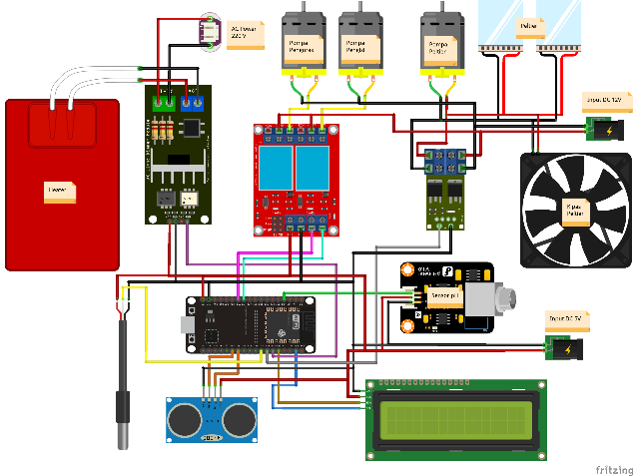
Figure 6. Overall system circuit
In Figure 6, the system for monitoring and controlling the temperature and pH of the Betta fish fry aquarium water is designed using an ESP32 microcontroller and is equipped with a DS18B20 temperature sensor and a pH sensor to read the parameters needed to determine the level of water quality, namely temperature and pH of the water. Each sensor will convert the sensor readings into voltage units which are then processed in an analog digital converter (ADC). The data obtained from the sensors will then be processed by the ESP32 microcontroller which has been combined with fuzzy logic.
Fuzzy logic will function as a data processor produced by sensors to determine what output will be carried out by the actuators used such as heaters, peltiers, and DC pumps by utilizing linguistic variables contained in fuzzy logic, so that results are obtained with levels off, medium, and strong for the output that the heater and peltier will provide. Meanwhile, the DC pump level results are dead, half and finished for the output that the DC pump will produce. Fuzzy programming is built using the C programming language.
Figure 7. Flowchart of Fuzzy Mamdani Method Process
To obtain the output determination to be carried out by the heater, peltier, and DC pump, process of forming fuzzy sets, also know as fuzzification, is required from the two input sensors. On the DS18B20 temperature sensor, five parameters are taken, namely cold, cool, normal, warm, hot. These five parameters are members of the set of degrees of membership. The different rules for the five parameters are as follows:
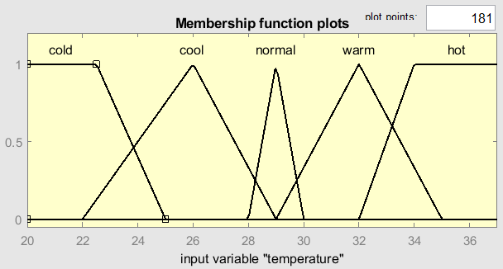
Figure 8. DS18B20 Temperature Sensor Rule Base
- Fuzzy set of temperature (°C) variables
$$μ_{Cold}\left[x\right]=\left\{\begin{matrix}1, & x≤20 \\ \begin{matrix}\frac{x-20}{22.5-20}, \\ \frac{25-x}{25-22.5},\end{matrix} & \begin{matrix}20≤x≤22.5 \\ 22.5≤x≤25\end{matrix} \\ 0, & x≥25\end{matrix}\right\}$$
$$μ_{Cool}\left[x\right]=\left\{\begin{matrix}\begin{matrix}0, \\ \begin{matrix}\frac{x-22}{26-22}, \\ 1, \\ \frac{29-x}{29-26},\end{matrix} \\ 0,\end{matrix} & \begin{matrix}x≤22 or x≥29 \\ \begin{matrix}22≤x≤26 \\ 26≤x≤29 \\ 29≤x≤29\end{matrix} \\ x≥29\end{matrix}\end{matrix}\right\}$$
$$μ_{Normal}\left[x\right]=\left\{\begin{matrix}0, & x≤28 atau x≥30 \\ \begin{matrix}\frac{x-28}{29-28}, \\ 1, \\ \frac{30-x}{30-29},\end{matrix} & \begin{matrix}28≤x≤29 \\ 29≤x≤30 \\ 30≤x≤30\end{matrix} \\ 0, & x≥30\end{matrix}\right\}$$
$$μ_{Warm}\left[x\right]=\left\{\begin{matrix}0, & x≤29 or x≥35 \\ \begin{matrix}\frac{x-29}{32-29}, \\ 1, \\ \frac{35-x}{35-32},\end{matrix} & \begin{matrix}29≤x≤32 \\ 32≤x≤35 \\ 35≤x≤35\end{matrix} \\ 0, & x≥35\end{matrix}\right\}$$
$$μ_{Hot}\left[x\right]=\left\{\begin{matrix}0, & x≤32 or x≥40 \\ \begin{matrix}\frac{x-32}{34-32}, \\ 1, \\ \frac{40-x}{40-34},\end{matrix} & \begin{matrix}32≤x≤34 \\ 34≤x≤40 \\ 40≥x≤40\end{matrix} \\ 0, & x≥40\end{matrix}\right\}$$
The pH sensor takes five parameters, namely very acidic, acidic, neutral, alkaline, highly alkaline. These five parameters are members of the set of degrees of membership. The different rules for the five parameters are as follows:
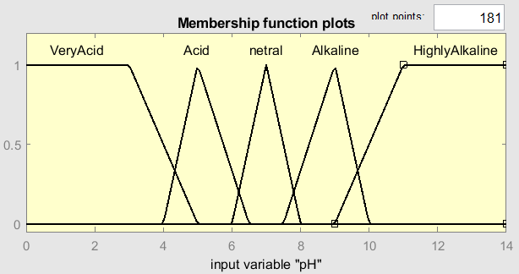
Figure 9. pH Sensor Rule Base
- Fuzzy set of pH variables
$$μ_{VeryAcid}\left[x\right]=\left\{\begin{matrix}1, & x≤0 \\ \frac{5-x}{5-3}, & 3≤x≤5 \\ 0, & x≥5\end{matrix}\right\}$$
$$μ_{Acid}\left[x\right]=\left\{\begin{matrix}0, & x≤4 or x≥6.5 \\ \begin{matrix}\frac{x-4}{5-4}, \\ 1, \\ \frac{6.5-x}{6.5-5}\end{matrix} & \begin{matrix}4≤x≤5 \\ 5≤x≤6.5 \\ 6.5≤x≤6.5\end{matrix} \\ 0, & x≥6.5\end{matrix}\right\}$$
$$μ_{Netral}\left[x\right]=\left\{\begin{matrix}0, & x≤6 or x≥8 \\ \begin{matrix}\frac{x-6}{7-6}, \\ 1, \\ \frac{8-x}{8-7},\end{matrix} & \begin{matrix}6≤x≤7 \\ 7≤x≤8 \\ 8≤x≤8\end{matrix} \\ 0, & x≥8\end{matrix}\right\}$$
$$μ_{Alkaline}\left[x\right]=\left\{\begin{matrix}0, & x≤7.5 or x≥10 \\ \begin{matrix}\frac{x-7.5}{9-7.5}, \\ 1, \\ \frac{10-x}{10-9},\end{matrix} & \begin{matrix}7.5≤x≤9 \\ 9≤x≤10 \\ 10≤x≤10\end{matrix} \\ 0, & x≥10\end{matrix}\right\}$$
$$μ_{HighlyAlkaline}\left[x\right]=\left\{\begin{matrix}0, & x≤9 or x≥14 \\ \begin{matrix}\frac{x-9}{11-9} \\ 1, \\ \frac{14-x}{14-11}\end{matrix} & \begin{matrix}9≤x≤11 \\ 11≤x≤14 \\ 14≤x≤14\end{matrix} \\ 0, & x≥14\end{matrix}\right\}$$
using Mamdani's fuzzy method. There are two fuzzy systems that are going to be in the process, namely, the fuzzy system for temperature input, and the fuzzy system for pH input. Each such system will have its own output such as temperature input that has heater and peltier output as in table 1.
Table 1. Temperature Fuzzy Rules
Rule | Input | Ouput
Rule | Temperature (°C) | Heater | Peltier
1 | Cold | Strong | Off
2 | Cool | Medium | Off
3 | Normal | Off | Off
4 | Warm | Off | Medium
5 | Hot | Off | Strong
Whereas for fuzzy systems the pH input will produce one output as a DC pump, where the DC pump will act as an automatic water replacement system when one of the rules on the fuzzy pH system is active as described in table 2.
Table 2. pH Fuzzy Rules
Rule | Input | Ouput
Rule | pH | DC Pump Drainage and Filling
1 | Very Acidic | Drain Out
2 | Acid | Drain Half
3 | Netral | Off
4 | Alkaline | Drain Half
5 | Highly Alkaline | Drain Out
The fuzzy temperature and pH input system has no correlation with each other, on tables 1 and 2 gives a detailed overview of how the system responds to each temperature condition and pH separately to maintain optimal aquarium water conditions. The author also describes several conditions where the temperature and pH input results experience several possibilities that occur at the same time producing different outputs also for each fuzzy system. Therefore, in table 1 the temperature input system will produce the heater and the peltier output, whereas in table 2 the pH input system would produce the output in the form of the action of a DC pump. Thus, the defusification process in this system produces two independent outputtes, namely heater-peltier and DC pump based on the temperature conditions and the pH of the water in the aquarium. These two separate sets of defusifification results provide precise control over each water condition parameter, adjusting the system response to the exact conditions.
One of the techniques used in the defusification process is the centeroid method, also known as the Center of Gravity method (COG). In this context, the center of gravity or centeroids can be regarded as a point along an axis that balances the gap between the areas on the left and right. The calculation of centeroids is done using the following equation:
$$\overline{y}=\frac{\int_{Y-min}^{Y-max}{y.μY\left(y\right)dy}}{\int_{Y-min}^{Y-max}{μY\left(y\right)dy}}$$

Results and Discussion
- Results
The temperature and pH control system for Betta fish fry aquarium water using the fuzzy logic method aims to control and maintain good and ideal aquarium water temperature and pH for Betta fish fry.
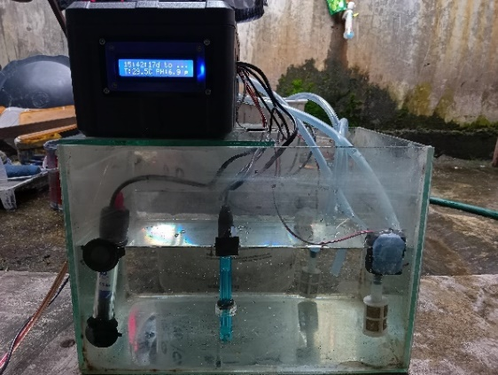
Figure 10. System Realization and Implementation
The image above shows the physical form of the tool which was built by combining three sensors, namely the DS18B20 temperature sensor, pH sensor and ultrasonic sensor. Where the results of the temperature sensor and pH sensor readings will be used in a fuzzy logic system, while the ultrasonic sensor is used as a water level limit trigger when draining and filling the aquarium water. The ideal water temperature for Betta fish fry is 28°C-30°C and the ideal water pH for Betta fish fry is in the range of 6.5-8 [4][6]. The fuzzy method used in this research is the Mamdani fuzzy method or commonly known as the Min-Max method [7].
- DS18B20 Temperature Sensor Testing
This test is carried out to evaluate the sensor's performance in measuring temperature accurately. The sensor testing process involves comparing the reading results from the DS18B20 sensor with data obtained from a digital thermometer as a reference. The purpose of this test is to assess the extent of error on the DS18B20 sensor by comparing the temperature reading values ​​between the DS18B20 sensor and a digital thermometer.
Table 3. DS18B20 Sensor Test Data
No. | DS18B20  Sensor (°C) | Thermometer (°C) | Error (%)
1 | 26,68 | 26,8 | 0,4
2 | 27,73 | 27,8 | 0,2
3 | 28,75 | 28,9 | 0,5
4 | 28,97 | 29 | 0,1

- pH Sensor Testing
This trial was carried out to evaluate the ability of the pH sensor to measure water pH accurately. The sensor testing process involves comparing the results of the pH sensor readings with data obtained from the pH meter as a reference. The purpose of this test is to assess how much error occurs in the pH sensor by comparing the water pH reading value between the pH sensor and the pH meter.

Table 4. pH Sensor Test Data
No. | Sensor pH | pH Meter | Error (%)
1 | 5,0 | 5,1 | 1,9
2 | 5,75 | 5,7 | 0,8
3 | 6,37 | 6,4 | 0,4
4 | 7,98 | 8,0 | 0,2

- Test Results for the pH and Water Temperature Control System
This test aims to determine the performance of the entire system, whether the system is able to maintain the pH and temperature of the aquarium water so that it can reduce the death rate of Betta fish fry. The testing method for this system is to compare the pH, water temperature and number of Betta fish fry in aquariums without a system and aquariums with a system. The experiment was carried out for 14 full days with the same treatment for feeding 3 times a day, namely morning, afternoon and evening. Each of the aquarium is filled with 30 three-week-old betta fish fry, which will then be compared between aquariums implementing the system and aquariums without implementing the system. Here’s a graph of the test results.
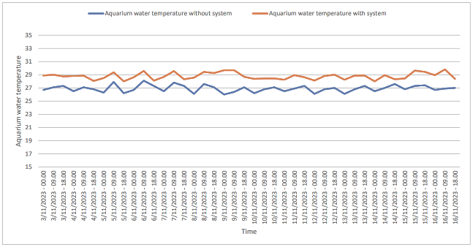
Figure 11. Aquarium Water Temperature Comparison Chart
From the test graph above, it can be seen that during the 14 days of testing, the system was able to maintain the ideal water temperature for betta fish fry, namely in the range of 28°C to 30°C [3]. It can be seen from the table above, the water temperature without implementing the system shows that the water temperature The aquarium is not at the ideal temperature for Betta fish fry with an average water temperature of 26.90°C. Meanwhile, the water temperature in the aquarium with the implementation of the system shows that the water temperature has been able to stabilize to the ideal water temperature for Betta fish fry with an average water temperature of 28.79°C, with the average water temperature produced from the aquarium with the implementation of the system being able to It was analyzed that even though the temperature was unstable and experienced ups and downs, the fuzzy system was able to maintain the ideal temperature for Betta fish fry according to the defuzzy results.
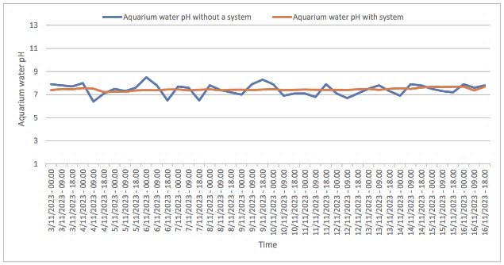
Figure 12. Comparison graph of aquarium water pH
From the pH test graph above, it can be seen that during the 14 days of testing, the average pH value of aquarium water without implementing the system shows that the average pH value of aquarium water is 7.44, it's just that the pH of aquarium water can be out of the ideal pH value limit for Betta fish fry, as per data on 06 November 2023 at 00:00 WIB the water pH value reached 8.5, likewise on 09 November 2023 at 18:00 WIB the water pH value reached 8.3. Meanwhile, the pH value of the water in the aquarium with the system implemented shows that the pH value of the aquarium water is stable with an average pH value of 7.45, although the comparison between the average pH value of the aquarium water without the system implementation and the aquarium where the system is implemented is not too far, however Aquariums that implement the system are much better at maintaining the stability of the pH of the water so that it does not leave the ideal pH limit for Betta fish fry, so that the fuzzy system has carried out its duties well according to the defuzzy results.
Based on the results of the overall system test which was filled with 30 betta fish fry and tested for 14 days, data on the water pH was stable in the range of 6.5 to 8 with an average water pH of 7.44, and the water temperature also stable in the value range of 28°C to 30°C with an average water temperature of 28.79°C. This shows that the implementation of fuzzy logic in the system for monitoring and controlling water temperature and pH in cultivating betta fish fry has succeeded in keeping the pH and temperature of the aquarium water stable, as evidenced by the death rate of betta fish fry in aquariums with the implementation of the system totaling 5 or 16.67 % of a total of 30 betta fish fry. Meanwhile, in aquariums without implementing the system, the death rate for Betta fish fry was 12 or 40% of the total of 30 Betta fish fry. A comparison of the mortality rate for Betta fish fry can be seen in the graph below.
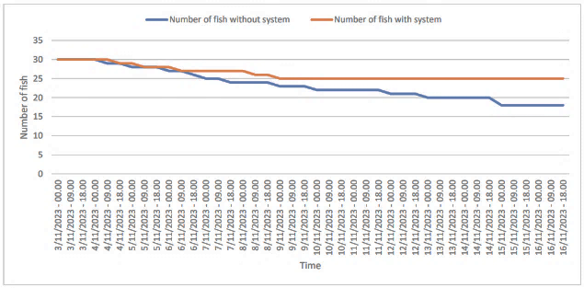
Figure 13. Comparison graph of mortality rates for Betta fish fry
Apart from influencing the mortality rate of betta fish fry, the research results of Agun Permata Sari and friends also stated that temperature also has a real influence on the growth rate and survival of betta fish fry. The optimal temperature for growth rate is found at ± 29.00°C [3]. This can be proven by comparing the size of the betta fish fry in the picture below.
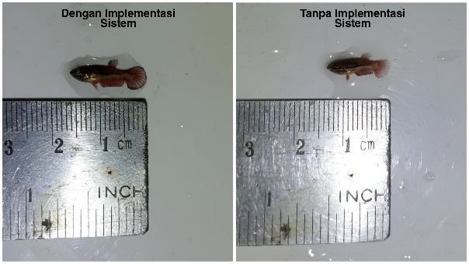
Figure 14. Comparison of Betta Fish Fry Sizes
The Betta fish fry samples in the picture above were taken from each aquarium that was 5 weeks old. From the picture above we can analyze that the growth rate of Betta fish fry in aquariums with system implementation is faster than Betta fish fry in aquariums without system implementation.

Conclusion
This aquarium water temperature and pH control system using the fuzzy logic method can help betta fish breeders in automatically controlling the temperature and pH of the aquarium water for betta fish fry. The fuzzy system is able to make decisions in maintaining optimal water temperature and pH for Betta fish fry with an average temperature of 28.79°C and an average water pH of 7.44. So the system is able to reduce the death rate of Betta fish fry with a death rate of 5 or 16.67% of the total of 30 Betta fish fry. Apart from that, the system is able to support the growth rate of Betta fish fry by influencing the temperature of the aquarium water. Betta fish breeders can also monitor the temperature and pH conditions of aquarium water in real time via the ThingSpeak website anywhere and at any time.

References
[1] M. Kajimura, K. Takimoto, dan A. Takimoto, “Acute toxicity of ammonia and nitrite to Siamese fighting fish (Betta splendens),” BMC Zoology, vol. 8, no. 1, hal. 3–9, 2023, doi: 10.1186/s40850-023-00188-3.
[2] A. Hendrizal, I. Lesmana, M. A. Wibowo, M. Fauzi, dan Budijono, “Betta Fish Farming Information System Based on Android Applications,” IOP Conference Series: Earth and Environmental Science, vol. 695, no. 1, 2021, doi: 10.1088/1755-1315/695/1/012019.
[3] A. Permata Sari, N. Cokrowati, dan M. Marzuki, “PENGARUH SUHU BERBEDA TERHADAP LAJU PERTUMBUHAN DAN KELANGSUNGAN HIDUP BURAYAK IKAN CUPANG (Betta splendens),” Indonesian Journal of Aquaculture Medium, vol. 2, no. 2, hal. 110–118, 2022, doi: 10.29303/mediaakuakultur.v2i2.1732.
[4] M. Mustaqim, K. Eriani, E. Erlangga, dan R. Rusyidi, “Pengaruh suhu terhadap perkembangan embrio ikan Cupang Betta splendens,” Depik, vol. 8, no. 3, hal. 235–242, 2019, doi: 10.13170/depik.8.3.13916.
[5] E. Marianis, L. Jasa, dan P. Rahardjo, “Sistem Pemantauan Kekeruhan dan Suhu Air Pada Akuarium Ikan Hias Air Tawar Berbasis IoT (Internet of Things),” Majalah Ilmiah Teknologi Elektro, vol. 21, no. 2, hal. 271, 2022, doi: 10.24843/mite.2022.v21i02.p15.
[6] D. Sebagai et al., “Rancang bangun alat monitoring dan pengendali ph serta suhu air pada budi daya ikan cupang tugas akhir,” 2023.
[7] M. I. Sesengi, J. Jumiyatun, Y. Arifin, dan S. Dewi, “Sistem Pendeteksi Kualitas Air Di Sekitar Pesisir Pantai Tondo Menggunakan Metode Fuzzy Logic,” PROtek : Jurnal Ilmiah Teknik Elektro, vol. 11, no. 1, hal. 15–21, 2021, doi: 10.54757/fs.v11i1.32.
[8] I. Salamah, S. Suzanzefi, dan S. S. Ningrum, “Implementation of Fuzzy Logic in Soil Moisture and Temperature Control System for Araceae Plants Based on LoRa,” PROtek : Jurnal Ilmiah Teknik Elektro, vol. 10, no. 3, hal. 184–192, 2023, doi: 10.33387/protk.v10i3.6390.
[9] T. Suryana, “Implementation DS18B20 1-Wire Digital Temperature Sensor with NodeMCU IDEAL TEMPERATURE FOR BREWING COFFEE,” 2021.
[10] D. Aztisyah, “Implementasi Logika Fuzzy Mamdani Pada pH Air dalam Sistem Otomatisasi Suhu dan pH Air Aquascape Ikan Guppy,” Journal of Informatics, Information System, Software Engineering and Applications (INISTA), vol. 4, no. 1, hal. 58–70, 2022, doi: 10.20895/inista.v4i1.345.
[11] S. Kumari, R. Raj, dan R. Komati, “a Thing Speak Iot Based Vibration Measurement and Monitoring System Using an Accelerometer Sensor,” International Journal of Engineering Applied Sciences and Technology, vol. 6, no. 3, hal. 307–313, 2021, doi: 10.33564/ijeast.2021.v06i03.047.
[12] S. Plowerita, A. S. Handayani, I. Hadi, dan N. L. Husni, “Sistem Monitoring Kesehatan Dalam Penentuan Kondisi Tubuh Dengan Metode Fuzzy Mamdani,” PROtek : Jurnal Ilmiah Teknik Elektro, vol. 8, no. 2, hal. 102, 2021, doi: 10.33387/protk.v8i2.3341.
[13] Asriyanik dan K. Tarwati, “Metode Fuzzy Logic Untuk Penentuan Kelayakan Penerima Beasiswa Mahasiswa Di Universitas Muhammadiyah Sukabumi,” JASISFO: Jurnal Sistem Informasi, vol. 1, no. 2, hal. 56, 2020.

