https://ejournal.unkhair.ac.id/index.php/protk/index e-ISSN 2527-9572 / p-ISSN 2354-8924

Design of Miniature Zebra Crossing Violator Detection at Traffic Lights Based on

Internet Of Things

Lukman Alwi
UIN Sultan Syarif Kaim Riau(Department of Electrical Engineering,)
Jl. HR Soebrantas Simpang Baru, Pekanbaru, 28293, Indonesia 11950511612@students.uin- suska.ac.id

Ahmad Faizal
UIN Sultan Syarif Kaim Riau(Department of Electrical Engineering,)
Jl. HR Soebrantas Simpang Baru, Pekanbaru, 28293,
Indonesia ahmad.faizal@uin-suska.ac.id

Hilman Zarory
UIN Sultan Syarif Kaim Riau(Department of Electrical Engineering,)
Jl. HR Soebrantas Simpang Baru, Pekanbaru, 28293,
Indonesia hilman.zarory@uin-suska.ac.id

Dian Mursyitah
UIN Sultan Syarif Kaim Riau(Department of Electrical Engineering,)
Jl. HR Soebrantas Simpang Baru, Pekanbaru, 28293, Indonesia DMursyitah@gmail.com

Abstract – A frequen problem in riau province is the problem of traffic lights at zebra crossing, where drivers often cross the stop line. Many drivers, especially at traffic lights, cross the stop line, potentially causing congestion and accidents. To overcome these problem, technology is needed that can detect and monitor the number of zebra crossing violation remotely. One of the technological solutions is the use of iot-based esp32 cam camera modue and pir sensor, sepaker. This research aim to create a device that can detect drivers eho exceed the stop line at the zebra crossing violation detecion system at iot-based traffic lights. Five violations were tested using a stopwatch to measure the desice’s response time. Sensor 1 nad 2 detected the fastest violation at 0.34 seconds and 0.55 second respectively. Buzzer has a response time of 0.34 seconds, esp32 cam has a response time of 0.55 seconds, and telegram has response time occurs at a distance of 19 cm. The results showed that the pir sensor can detect the vehicles that cross the stop line, and the esp32 cam can capture image of the telegram as evidence of the violation within a distance of 20 cm, outside this range the sensor connot detect the violation.

Keywords: Zebra cross;Traffic light;Esp32-cam;PIR Sensor;Speaker

Creative Commons Attribution-NonCommercial- ShareAlike 4.0 International License.
- INTRODUCTION
Indonesia is a country with a large population, and almost every inhabitant is a vehicle user [1]. According to police data, on average, 23% of Indonesians use cars and 87% use motorcycles [2]. The density of motorized vehicles and cars is not proportional to the number of road segments they traverse [3]. Riau province is among those with the highest usage rates of motorized vehicles and cars. In 2021, the Riau Regional Police recorded around 2 million motorbike users and approximately 316 thousand car users, and these road users are closely related to traffic lights [4]. Traffic lights are essential for regulating traffic flow on roads [5].

One recurring issue in Riau province is the problem of traffic lights at zebra crossings, where drivers often surpass the stop line [6],[7]. Zebra crossings are designed for pedestrians to cross the road safely. Many drivers, particularly at traffic lights, cross the stop line, causing potential congestion and accidents. Accidents at traffic lights, especially at zebra crossings, are attributed to pedestrians' lack of caution, insufficient traffic signs, and reckless driving [8],[9]. In 2022, there were cases of drivers surpassing the zebra crossing stop line, with approximately 2.6 million violations in Riau province, occurring during peak hours of community activities on the roads [10],[11].

Another issue is the inadequate detection of zebra crossing violations at traffic lights in Riau province, allowing road users the freedom to break traffic light rules [12],[13]. To address this problem, technology is needed to remotely detect and monitor the number of zebra crossing violations. One technological solution is the use of an ESP32 CAM camera module-based IoT and PIR Sensor. The ESP32 CAM module is a development board with dual WI-FI + Bluetooth mode that uses an antenna and is based on the ESP32 chip. This PCB board can be applied for various purposes, such as CCTV surveillance, image capture, and more. Thus, the ESP32 CAM module can capture images and also serve as a Wi-Fi module for data transfer. On the other hand, the PIR sensor is a passive infrared radiation detection device capable of identifying infrared radiation emitted by an object [14][15].

In related studies on zebra crossing violations, such as the research titled "Prototype Warning of Zebra Crossing Violations at Traffic Lights with Sirens Using Arduino" by [16], ultrasonic sensors were found to detect violations within a distance of less than 30 cm. If a violation is detected, the buzzer sounds, and the LCD displays the message "Violation has occurred."

Another study by [17], on the "Prototype System for Detecting Zebra Crossing Violations at Traffic Lights," recorded sensor, buzzer, and ESP32 CAM response times averaging 1.196, 1.236, and 1.252 seconds, respectively, based on 5 trials.

In the study by [18], "Design of Prototype Warning System for Zebra Crossing Violators Based on ESP-32 CAM Microcontroller," the system detected violations only for vehicles crossing the zebra crossing boundary line. The maximum undetected violation distance was 36.9 cm for motorcycles and 18.7 cm for cars.

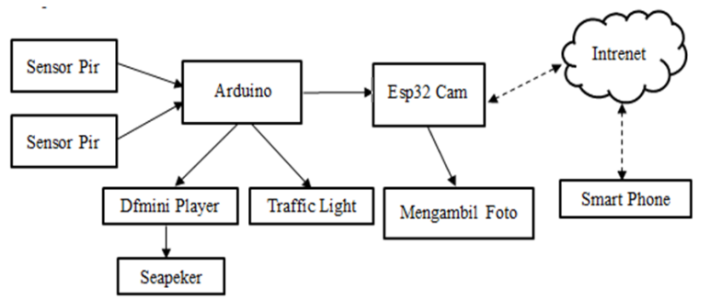
The study titled "Real-Time Zebra Crossing Violation Detection System Prototype at Traffic Lights Using Arduino" by [19], noted a program execution time of 66 seconds using the Millis function. After 10 loop tests, the average system time to complete one scheduling cycle was
66.004 seconds, with a time accuracy error percentage of 0.006%.

Furthermore, the research by [20], on the "Prototype Ban on Drivers Passing Zebra Crossings at Traffic Lights Based on ESP32 CAM,"
showed that when the sensor detects a vehicle, the speaker sounds, and the ESP32 captures an image.

Therefore, this study aims to create a device that can detect drivers exceeding the stop line at zebra crossings, designing a miniature IoT-based zebra crossing violation detection system at traffic lights. The miniature device consists of an Arduino as the control center, ESP32 CAM camera module for capturing videos and images of zebra crossing violations, PIR sensor for detecting drivers crossing the stop line, and DF Mini player for audio output. The programming language used is Arduino IDE. The system will utilize the ESP32 CAM module to detect violations and can be controlled remotely and in real- time, both automatically and manually.
- METHOD
The research method used in making miniature violations on drivers who cross the cebra crossing at traffic lights is the action research method. Action research is a research method in which the researcher enters the research subject's environment and intervenes in the research subject, observing and documenting what happens. The steps in this research are problem, design, action, evaluation and observation.
- The Role of Hardware
The hardware block diagram is shown in Figure 1, where this research will be divided into three parts namely; input, process and output. The input to the system is a pear sensor that functions to detect motorists who commit violations when the traffic light is red. In the process, the Arduino will have a function as a data processor received from the pear sensor and forwarded to the defmini player and esp32 cam will receive the data and will take photos of violations that occur. And output, defmini player will send input to the speaker to issue an appeal that a traffic violation has occurred and esp32 cam will send photos of violations that have occurred to a smart phone.

Figure 1. Hardware block diagrams.

- Wiring Diagram
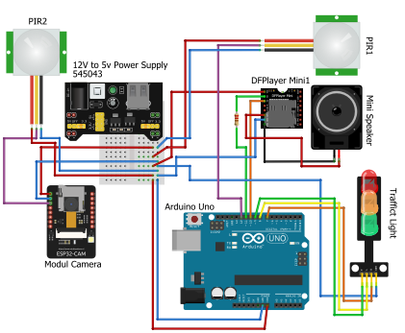

Figure 2. Wiring Diagram
In Figure 2 explains where in this wiring diagram all components are designed using an arduino microcontroller and equipped with an esp 32 cam and pear sensor, where when the traffic light is red the pear sensor functions as a detector of violations that occur, where if a violation occurs, the pear sensor will send the data to the arduino and the data will be processed and sent to the esp 32 cam and speaker where the esp 32 will take the violation that occurred and the speaker will issue a warning sound that a traffic violation has occurred.

- Tool components

Table 1. Tool components
No | Components
1 | Pear sensor
2 | Esp 32 Cam
3 | Arduino
4 | Df Mini player
5 | speaker
6 | Traffic light
7 | Power supplay
The table above shows the components used in making this alan, namely the pear sensor whict fungtions as a platfrom an object. Esp 32 cam function as a platfrom that can monitor in realtime by applying thhe camera and wifi module inside. While arduino function as an electronic controller and reads the onboar microcontroller input and converts it to output. Df miini player functions as a warning sound . traffic light as a traffic regulator. Power supplay to all components in acompute system or electronic device. .
- Telegram
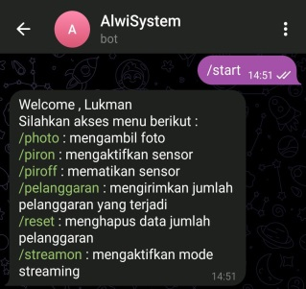
Telegram is a messaging application that has the advantages of being lightweight, fast, and ad-free. Within this platform, there is a bot system known as telegram bot, which enables communication with microcontrolled devices. In addition, Telegram is a cloud-based instant messaging service that can be accessed for free. Telegram clients are available for both mobile and desktop systems, allowing users to send messages as well as share photos, videos, stickers, audio, and various other file types.

Figure 3. Telegram bot.
Figure 3 shows the bot telegram after the device is turned on and connected to the smartphone where the user can directly access several features connected to the device manually. Where the first feature users can take photos manually and the second feature users can also turn on and turn off the sensor manually if there is an eroro on the sensor, and the third feature users can also see the number of violations that have occurred and users can also research the number of violations that have occurred, for the fourth feature, namely the streaming feature where users can see videos directly using this feature.

- Software Design
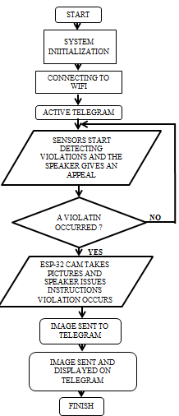
Figure 4. Folwchart Software
The software flowchart can be seen in Figure 4. When the device is powered on and starts analyzing the system, if the device is connected to Wi-Fi, Telegram becomes active, the traffic light and sensor become active, and the sensor will start detecting objects. If a violation is detected, the speaker will issue a warning, and the ESP32 CAM will capture an image. Subsequently, the image is sent to Telegram and displayed in the Telegram application.
- RESULTS AND DISCUSSION
  - Design
The results of the hardware and software design are implemented in a construction that depicts a simulation of an intersection with traffic lights. This construction utilizes a PIR sensor as a tool to detect vehicles crossing the pedestrian crossing boundary. The warning system will produce sound from the speaker if a driver crosses the stop line when the light is red, and the violation will be automatically recorded by the ESP32 CAM, then sent directly to Telegram. In the 5th illustration, the design of the traffic light intersection construction is depicted.

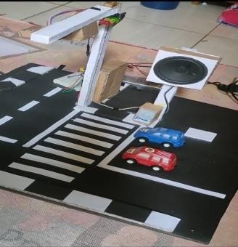
Figure 5. Design

  - Violation Detection System
The system will operate when the traffic light is red. If a vehicle crosses the stop line and enters the zebra crossing area, the PIR sensor installed at the initial line of the zebra crossing will detect this violation. Consequently, the speaker will immediately sound an alert, issuing a warning: "Please do not stop in the zebra crossing area; respect the rights of pedestrians.

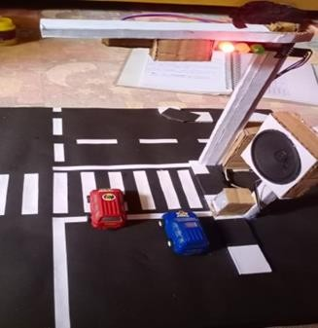
Figure 6. Violation Detection System
The installation of PIR sensors on the zebra crossing must be positioned accurately, specifically at the vehicle stop line, not on the zebra crossing itself. The purpose is to ensure that the sensor does not detect pedestrians using the zebra crossing but rather detects vehicles crossing the predetermined stop line when the traffic light is red.
  - Telegram Notification Testing
Whereas, the results of the sensor detection, when a violation occurs, will prompt the ESP32 CAM to capture an image. Subsequently, the captured image from the ESP32 CAM will be sent and displayed on the Telegram screen.

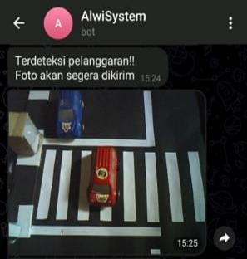
Figure 7. Notification of esp32 cam result to Telegram

  - System Testing

Table 2. Test the Buzzer System
No | Parameters | Pear Sensor 1 | Pear Sensor 2 | Buzzer
1 | Green Light | Off | Off | Off
2 | Yellow Light | Off | Off | On
3 | Red Light | On | On | On

In Table 2, the testing of the buzzer system is depicted. When the light is green, sensor 1 and sensor 2 will be off, and the buzzer will also be off. When the light turns yellow, sensor 1 and sensor 2 will be off, and the buzzer will be on, emitting a warning to prepare. When the light is red, sensor 1 and sensor 2 will be on, and the buzzer will be on. In case of a violation, the buzzer will emit a warning indicating a violation has occurred, and when there is no violation, the sensor will not emit a warning.
Tabel 3. System Breach Test
No | Parameters | Pear Sensor 1 | Pear Sensor 2 | Violation
1 | Green Light | Off | Off | There isn't any
2 | Yellow Light | Off | Off | There isn't any
3 | Red Light | On | On | There is

In Table 3, the testing is conducted to observe scenarios both without violations and with violations. When the light is green, sensor 1 and sensor 2 will be off, indicating no violations. When the light turns yellow, sensor 1 and sensor 2 will be off, also indicating no violations. When the light is red, sensor 1 and sensor 2 will be on, indicating a violation has occurred.
Tabel 4. Telegram System Test
No | Parameters | Pear Sensor 1 | Pear Sensor 2 | Telegram
1 | Green Light | Off | Off | There isn't any Photo
2 | Yellow Light | Off | Off | There isn't any Photo
3 | Red Light | On | On | There is Photo
In Table 4, the testing of the telegram system is presented. When the light is green, sensor 1 and sensor 2 will be off, and no violation photo will be sent via telegram. When the light turns yellow, sensor 1 and sensor 2 will be off, and no violation photo will be sent via telegram. When the light is red, sensor 1 and sensor 2 will be on, and upon a violation occurrence, the telegram will receive a photo of the violation. If there is no violation, the telegram will not receive any violation photo.
Table 5. Camera System Test
No | Parameters | Pear Sensor 1 | Pear Sensor 2 | Camera
1 | Green Light | Off | Off | Off
2 | Yellow Light | Off | Off | Off
3 | Red Light | On | On | On

In Table 5, the camera system testing is depicted. When the light is green, sensor 1 and sensor 2 will be off, and the camera will also be off. When the light turns yellow, sensor 1 and sensor 2 will be off, and the camera will remain off. When the light is red, sensor 1 and sensor 2 will be on, and the camera will be on. Upon a violation occurrence, the camera will capture a photo of the violation. If there is no violation, the camera will not capture any photo.
Table 6. Equipment Response Testing
No | A lot of tesing | Sensor Response 1 (seconds) | Sensor Response 2 (seconds) | Buzzer Response (seconds) | Esp32 Cam Response (seconds) | Telegram Response (seconds) | Vehicle Distance (Cm)
1 | Breach 1 | 00,34 seconds | 00,55 seconds | 00,34  seconds | 00,55  seconds | 01,00 seconds | 1 cm
2 | Breach 2 | 01,39 seconds | 01,35 seconds | 01,39  seconds | 01,35  seconds | 06,14 seconds | 6 cm
3 | Breach 3 | 01,92 seconds | 01,45 seconds | 01,92  seconds | 01,45  seconds | 03,05 seconds | 12 cm
4 | Breach 4 | 02,71 seconds | 02,93 seconds | 02,71  seconds | 02,93  seconds | 03,10 seconds | 16 cm
5 | Breach 5 | 03,11 seconds | 03,45 seconds | 03,11  seconds | 03,45  seconds | 06,81 seconds | 19 cm

The testing in Table 6 above was conducted using a stopwatch and involved 5 trial violations. From the calculations, the fastest response time for the device at a distance of 1 cm was found to be 00.34 seconds for sensor 1 and 00.55 seconds for sensor 2. Meanwhile, the lowest response times recorded were 00.34 seconds for the buzzer, 00.55 seconds for the ESP32 cam, and 01.00 seconds for data transmission via Telegram. The longest response time occurred at a distance of 19 cm, where sensor 1 and sensor 2 took 03.11 and 03.45 seconds respectively to detect the violation, the buzzer took 03.11 seconds, the ESP32 cam took 03.45 seconds, while Telegram took 06.81 seconds. The average response time was found to be 6.98 seconds for sensor 1 and 6.97 seconds for sensor 2. The average response time for the buzzer was 6.98 seconds, for the ESP32-CAM was 6.97 seconds, and for data transmission via Telegram was 14.65 seconds.
- CONCLUSION
Based on the results of the system design and analysis, it can be concluded that the device can operate as planned. The PIR sensor can detect vehicles crossing the stop line, and the ESP32 CAM can capture images of these violations, sending them to Telegram as evidence of the violation. The PIR sensor can detect violations within a distance of 20 cm, and beyond that range, the sensor cannot detect the violation. If a violation is detected, the speaker will sound, saying, "Please do not stop in the zebra crossing area; respect the rights of pedestrians."
For testing, five violations were conducted using a stopwatch to measure the response time of the device. Sensor 1 and 2 detected violations the fastest at 0.34 seconds and 0.55 seconds, respectively. The buzzer had a response time of 0.34 seconds, the ESP32 CAM had a response time of 0.55 seconds, and Telegram had a response time of 1.00 second. The longest response time occurred at a distance of 19 cm, with Sensor 1 and 2 detecting violations in 3.11 and 3.45 seconds, respectively. The buzzer had a response time of 3.11 seconds, the ESP32 CAM had a response time of 3.45 seconds, and Telegram had a response time of 6.81 seconds.
- REFERENCES
[1] U. Hasanah et al., “Rancang Bangun Prototype Sistem Pendeteksi,” J. Ilm. Forensik, vol. 11, no. 1, pp. 1–7, 2021, doi: 10.54757/fs.v11i1.31.
[2] Ruly Kurniawan, “Jumlah Kendaraan di Indonesia 147 Juta Unit,” Kompas, 2023. https://otomotif.kompas.com/read/2023/02/10/070200315/jumlah-kendaraan-di-indonesia-147-juta-unit-87-persen-motor (accessed Jul. 19, 2023).
[3] M. Yolanda, B. Rahmat, and S. N. Hertina, “Pendeteksi Pelanggaran Penyeberang Jalan Pada Zebra Cross Berbasis Internet Of Things,” eProceedings …, vol. 8, no. 5, pp. 5211–5220, 2021, [Online]. Available: https://openlibrarypublications.telkomuniversity.ac.id/index.php/engineering/article/view/15850%0Ahttps://openlibrarypublications.telkomuniversity.ac.id/index.php/engineering/article/view/15850/15563
[4] A. Riyadi, “Jumlah Kendaraan Bermotor,”
Badan Pusat Statistik Provinsi Riau, 2023. https://riau.bps.go.id/publication.html (accessed Oct. 01, 2023).
[5] M. H. Rifqo and H. Aprianti, “Sistem Respon Lampu Lalu Lintas Terhadap Pelanggaran Pengendara Menggunakan Ultrasonik,” JSAI (Journal Sci. Appl. Informatics), vol. 3, no. 1, pp. 57–64, 2020, doi: 10.36085/jsai.v3i1.946.
[6] A. Al Hafiz, Y. H. Syahputra, and D. Rahmadiansyah, “Simulasi Rising Kerbs Untuk Meminimalisasi Pelanggaran Lampu Lalu Lintas Menggunakan Teknik PWM Berbasis Mikrokontroler,” J. SAINTIKOM (Jurnal Sains Manaj. Inform. dan Komputer), vol. 21, no. 1, p. 25, 2022, doi: 10.53513/jis.v21i1.4810.
[7] N. Krishnan, “Implementation of Fatal Vehicle Collision Avoidance System for the Deterrence of Mishaps in Potential Zones,” Mediterr. J. Basic Appl. Sci., vol. 7, no. 3, pp. 113–119, 2023, doi: 1046382/MJBAS.2023.7310.
[8] R. Kurniawan, V. E. Kristianti, and A. Situmeang, “Alat Pendeteksi Pelanggaran Garis Henti Kendaraan Pada Persimpangan Lalu Lintas Satu Arah Menggunakan Sensor Laser Berbasis Arduino Mega 2560,” J. Ilm. Inform. Komput., vol. 24, no. 3, pp. 170–179, 2019, doi: 10.35760/ik.2019.v24i3.2359.
[9] W. A. Jabbar, “Design and Implementation of Portable Smart Wireless Pedestrian Crossing Control System,” Des. Implement. Portable Smart Wirel. Pedestr. Crossing Control Syst., vol. 8, no. 3, pp. 106109–106120, 2020, doi: 10.1109/ACCESS.2020.3000014.
[10] R. Heru, “Hasil Operaso Zepra Lancang Kuning 2022,” DITLANTAS POLDA Riau, 2022. https://mediacenter.riau.go.id/read/74298/hasil-ops-zebra-lancang-kuning-2022-pelanggar.html (accessed Oct. 01, 2023).
[11] S. Zhang, “Prediction of Pedestrians ’ Red Light Violations Using Deep Learning PREDICTION OF PEDESTRIANS ’ RED-LIGHT,” Civ. Eng. Commons, Transp. Eng. Commons, vol. 43, no. 1, pp. 1–43, 2020, [Online]. Available: https://stars.library.ucf.edu/etd2020 University
[12] Fathur Rahman, Indu Indah Purnomo, and Ihda Innar Ridho, “Rancang Bangun Sistem Pendeteksi Pelanggaran Pada Traffic Light Menggunakan Interface Delphi Berbasis Arduino Uno,” J. Tek. ELEKTRO ITP, pp. 1–6, 2021, [Online]. Available: http://eprints.uniska-bjm.ac.id/id/eprint/5427
[13] J. Zhou, M. Zhang, and H. Ding, “An ALNS-based approach for the traffic-police- routine-patrol-vehicle assignment problem in resource allocation analysis of traffic crashes,” Traffic Inj. Prev., vol. 0, no. 0, pp. 1–10, 2024, doi: 10.1080/15389588.2024.2335560.
[14] R. S. P. Siregar, K. Kurniabudi, and M. R. Pahlevi, “Rancang Bangun Pendeteksi Pelanggaran Lampu Lalu Lintas Berbasis Mikrokontroler Dan Sms Gateway,” J. Inform. Dan Rekayasa Komputer(JAKAKOM), vol. 1, no. 2, pp. 1–10, 2021, doi: 10.33998/jakakom.2021.1.2.2.
[15] J. A. Shanks and J. A. Shanks, “Probability in Action : The Red Traffic Light Probability in Action : the Red Traffic Light,” J. Stat. Educ. ISSN, vol. 1898, no. 2007, p. 12, 2017, doi: 10.1080/10691898.2007.11889457.
[16] E. K. Putra and O. Oktafiandi, “Prototipe Peringatan Pelanggaran Zebra Cross Pada Lampu Lalu Lintas Dengan Sirine Menggunakan Arduino,” J. Tek. ELEKTRO Inst. Teknol. PADANG, vol. 11, no. 2, pp. 52–56, 2022, doi: 10.21063/JTE.2022.31331108.
[17] I. Gunawan, A. Sudianto, and U. Hasanah, “Prototipe Sistem Pendekesi Pelangaran Zebra Cross Pada Traffic Light Berbasis Internet Of Things Pendahuluan karena peningkatan jumlah kendaraan bermotor tidak diiringi dengan peningkatan kesadaran dari masyarakat . Manajemen lalu lintas semakin didukung,” J. Inform. dan Teknol., vol. 6, no. 2, pp. 328–338, 2023, doi: 10.29408/jit.v6i2.14065.
[18] Y. Rahmawati, I. U. V. Simanjuntak, and R. B. Simorangkir, “Rancang Bangun Purwarupa Sistem Peringatan Pengendara Pelanggar Zebra Cross Berbasis Mikrokontroller ESP-32 CAM,” Jambura J. Electr. Electron. Eng., vol. 4, no. 2, pp. 189–195, 2022, doi: 10.37905/jjeee.v4i2.14499.
[19] R. R. Nugraha, S. R. Akbar, and G. E. Setyawan, “Rancang Bangun Prototype Sistem Real Time Pendeteksi Pelanggar Zebra Cross Pada Traffic Light Dengan Menggunakan Arduino,” J. Pengemb. Teknol. Inf. dan Ilmu Komput. Univ. Brawijaya, vol. 3, no. 1, pp. 708–715, 2019, [Online]. Available: http://j-ptiik.ub.ac.id
[20] A. M. Idham, A. Candra, and A. N. Faizah, “Prototype Larangan Pengendara Melewati Zebra Cross di Traffic Light Berbasis Esp32 CAM,” Lajagoe J. Informatics, Multimedia, Inf., vol. 1, no. 1, pp. 21–30, 2023.

