Battery Cell Charging Behavior Analysis Using Constant Current and Constant Voltage Methods

Anna Cyntia PDY
Electrical Engineering Department, Andalas University, Padang, Indonesia
email : annacyntia99@gmail.com

*Muhammad Imran Hamid
Electrical Engineering Department, Andalas University, Padang, Indonesia
email :
imran@eng.unand.ac.id

Ayu Elsa Afriyanti
Electrical Engineering Deparment, Andalas University, Padang, Indonesia
email : ayuelsa240494@gmail.com

Abstract – This study conducts a battery charging simulation using the Constant Current/Constant Voltage (CC/CV) method to analyze the behavior of lithium-ion batteries during the charging process. Using MATLAB and mathematical algorithms, the simulation results were analyzed in depth to evaluate the battery's charging efficiency, usable capacity, and internal impedance under various operating conditions. The simulation results show how the battery reaches its total capacity safely and efficiently in the initial stage, followed by safer and more controlled charging in the final stage, to avoid the risk of overcharging and ensure long battery life. The results from the simulation show that using the CCCV method can optimally manage battery charging by maintaining a balance between charging speed and operational safety, making it an ideal choice for charging lithium-Ion batteries in various applications.

Keywords: Battery charging, Constant Current/Constant Voltage, Efficiency, Overcharging, Lithium-Ion batteries, Operational safety
Creative Commons Attribution-NonCommercial-ShareAlike 4.0 International License.

Introduction
The need for efficient and environmentally friendly energy resources is increasingly urgent in the modern era characterized by rapid technological development. Batteries, especially lithium-ion, have become one of the main components in energy storage, and they are used in various applications ranging from electronic devices to electric vehicles[1][2]. One of the main challenges in battery use is understanding how the battery reacts during the charging and discharging process, especially in the Constant Current/Constant Voltage (CC/CV) charging mode. The CC-CV method is the most widely adopted charging method for developing chargers for Li-ion batteries, and it has several improvement methods. As listed in [3] and [4], Li-ion battery internal resistance compensation is used in CC-CV-based chargers in some studies. This is not only for low-power Li-ion chargers; the CC-CV method is also applied to high-power Li-ion battery chargers [5]. CC-CV-based chargers are also used in various charger topologies, including LLC resonant converters[6][7] and Sheppard Taylor PFC converters [8]. A deep understanding of battery behavior during these charging modes is critical to improving efficiency, safety, and lifespan.
Various studies have been conducted to model and simulate battery behavior during the charging process. Previous studies mainly focused on characterizing key parameters such as State of Charge (SOC)[9], terminal voltage, current, and power during the charging process[9]. Simulation using software such as MATLAB has been widely used for its ability to visualize results and provide deeper insight into the internal dynamics of a battery. However, although many studies have discussed battery charging simulation, there are variations in the approaches and results obtained, so a more comprehensive analysis is needed to obtain a more holistic understanding.
Although much research has focused on battery charging simulation, several aspects must be explored in depth. For example, many studies only focus on one or two parameters without considering the interactions between various parameters during the filling process. Additionally, existing simulations often do not involve in-depth analysis of how changes in parameters such as current and voltage affect SOC and overall battery performance. Therefore, studies need to model, simulate, and analyze multiple parameters simultaneously to provide a more comprehensive picture of battery behavior during the charging process.
This research uses MATLAB to simulate battery cell behavior during the charging process in CC/CV mode. This simulation analyzes changes in SOC, terminal voltage, current, and power during the charging process. Utilizing various graphs for visualization provides deeper insight into the interactions between these parameters and how they affect overall battery performance.
R_{p}
This research's main contribution is providing a comprehensive simulation model that can be used to analyze battery behavior during the charging process. This model is expected to help researchers and engineers better understand the internal dynamics of batteries and provide guidance for optimizing the charging process to increase efficiency and battery life. Apart from that, the results of this simulation can become a reference for future battery technology development, especially in the context of electric vehicle applications and more efficient energy storage.

Lithium-Ion Battery Models
Lithium-ion batteries, one of the most widely used types of batteries in portable electronic devices and electric vehicles, have unique characteristics[10][11]. To accurately understand and predict the performance of Lithium-ion batteries, researchers have developed the Equivalent Circuit Model (ECM)[12]. The ECM represents a Lithium-ion battery as a combination of ideal electrical components, such as resistors, capacitors, and voltage sources[13]. This model enables in-depth analysis of the behavior of Lithium-ion batteries under various operating conditions. Electrical models are generally described by equivalent circuits based on a combination of essential elements to approximate batteries' electrochemical processes and input-to-output dynamics. By combining these essential elements in various ways, electrical models can be divided into four classes: the Rint model, the radio control model, the Thevenin equivalent circuit model, and the Partnership for a New Generation of Vehicles model. Among these models, the Thevenin equivalent circuit model is widely used to model Lithium-ion batteries because it has a simple model structure and can capture the dynamic response of the battery well within an acceptable error limit. Therefore, we choose this model as the essential element of our proposed model.
The equivalent circuit model is shown in Figure 1 and consists of three parts: (1) an equivalent ohmic internal resistor Rs; (2) a parallel resistor-capacitor (RC) network Cp//Rp (where Rp is the equivalent polarization resistance and Cp is the equivalent polarization capacitance), which is used to simulate the transient response of the battery during the charge-discharge transient; and (3) the VOC (h(t)), which is a nonlinear nonlinear function of SoC h(t). This equivalent circuit model considers current as the model control input and terminal voltage as the measured output.

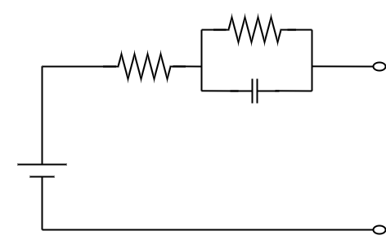
-

+

+

-

+

-

v_{c}(t)
v_{b}(t)
i_{b}(t)
v_{oc} (h(t))
C_{p}
R_{s}
Figure 1. Equivalent circuit model of a lithium-ion battery[14].
In theory, the equivalent circuit parameters $R_{s}$, $R_{p}$, and $C_{p}$ in this model are functions of temperature and SoC. However, since the changes in SoC and temperature over time are minimal, these parameters can be considered quasi-stationary; they do not change over time within a short observation window. In addition, for real-time applications, parameter identification can only be performed within a finite sliding time window or an exponentially decreasing time window based on the latest measurements. Therefore, with a certain error tolerance, these parameters can be considered constant during the identification process. In other words, online identification can capture these parameters faster than the changes in temperature or SoC.
Using Kirchhoff's laws, the dynamics of this circuit can be expressed as follows:

$v_{b}\left(t\right)=v_{oc}\left(h\left(t\right)\right)-R_{s}i_{b}\left(t\right)- v_{c}\left(t\right)$ (1)

$\frac{{dv}_{c}\left(t\right)}{dt}=-\frac{1}{C_{p}R_{p}}v_{c}\left(t\right)+{\frac{1}{C_{p}}i}_{b}\left(t\right)$ (2)

Where $v_{b}\left(t\right)$ and $i_{b}\left(t\right)$ are the terminal voltage and current, respectively, and $v_{b}\left(t\right)$ is the voltage across the RC network, which cannot be measured directly[14].

CC-CV Method
In the battery charging process, several methods can be used, including the constant voltage (CV) method, constant current (CC) method, and a combination of both, known as the constant current-constant voltage (CC-CV) method[15]. The CC-CV charging method is often used because it is considered safe and prevents overcharging. During the transition from CC to CV mode, the charging current in the battery will decrease, which also supports the safety of the charging process [10].
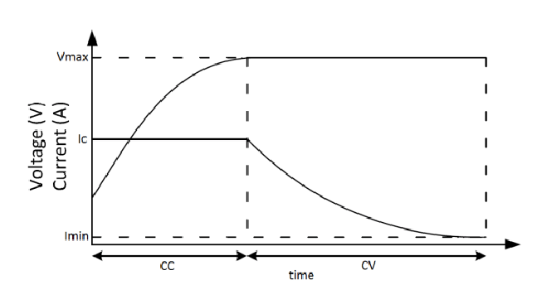

Figure 2. CC-CV method filling curve[16]

The figure above shows a charging graph using the CC-CV method. In the constant current (CC) stage, the current remains stable while the voltage increases as the battery's State of Charge (SoC) increases. When the battery, such as a lead-acid battery, is close to total capacity, the charging method switches to the constant voltage (CV) stage, where the voltage is maintained at a certain level, and the charging current begins to decrease. This graph illustrates the safe and efficient transition from constant current to constant voltage charging, designed to prevent overcharging and ensure the battery reaches its maximum capacity without damage.

Method
This study conducted numerical simulations using MATLAB and mathematical algorithms to solve a system of nonlinear nonlinear differential equations that describe the complex behavior of lithium-ion batteries. The equivalent circuit model used in this simulation includes ohmic resistance, concentration polarization, and charge transfer polarization to represent the electrochemical phenomena inside the battery cell. Model parameters, such as nominal capacity, internal resistance, and open voltage, were obtained from experimental data on NMC 18650-type battery cells. The charging simulation used the CCCV (Constant Current Constant Voltage) profile by setting the charging current at 1C in the constant current stage, followed by a constant voltage of 4.2V in the constant voltage stage. The upper limit of the operating temperature was set at 45°C to evaluate the effect of temperature on battery performance.
The simulation results were analyzed in depth to evaluate the battery's charging efficiency, usable capacity, and internal impedance under various operating conditions. These simulation results can make a significant contribution to the development of a more intelligent and efficient battery management system, as well as extending the cycle life of lithium-ion batteries.
This battery charging simulation models and analyzes the behavior of a battery cell during the charging process with a constant current until it reaches a specified maximum voltage, then continues with charging using a constant voltage. This program's initialization parameters include simulation time (max time = 10001 seconds), operating temperature (T = 25 degrees Celsius), and several battery parameters such as q, RC, r, m, g, and r0 obtained from the model. mat battery model using the “getParamESC” function. The maximum voltage allowed for a battery cell is 4.15 V. The variables stored, stores, story, and stores are used to store State of Charge (SOC) data, terminal voltage, current, and power during the simulation. SOC initialization starts at 50% with a value of z = 0.5, current on the RC resistor irc = 0, and hysteresis voltage h = -1. The CC charging mode uses a constant current of CC = 9 A. The for loop runs as many as maximum time iterations during the simulation. The battery terminal voltage (v) is calculated based on the SOC (z) and other factors, while the charging current (ik) is calculated to achieve the maximum voltage (maxV). The current is limited to the CC value (9A) during CC charging mode, and the SOC (z) is updated based on the charging current (ik). The program also updates the RC resistor current (irc) and hysteresis voltage (h), and stores the SOC, terminal voltage, current, and power values ​​for each iteration. After the simulation, the results are visualized by creating several subplots showing the relationship between SOC, terminal voltage, cell current, and cell power over time, additional plots showing current and power simultaneously, and a combined plot of SOC and terminal voltage.

Results and Discussion
The following are the results and analysis of a lithium-ion battery charging simulation using the Constant Current/Constant Voltage (CC/CV) method that illustrates how the battery's State of Charge (SOC) changes over time during the charging process. The simulation results contain the dynamics of battery charging in two main phases of constant current and constant voltage and show how the battery reaches its total capacity safely and efficiently. Further analysis of these results will help understand the influence of the parameters used in the model on battery charging performance.
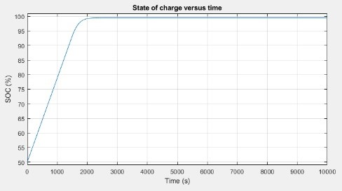
Figure 3. SoC versus time graph
In the initial charging phase, the battery's State of Charge (SOC) increases rapidly from 50% to nearly 100%, as shown in Figure 3, which shows that the battery is charged with a constant current (CC) of 9 A. Since the charging current remains constant in this phase, the SOC increases almost linearly with time. After about 2000 seconds, the rate of increase in SOC begins to slow down, indicating a transition to the constant voltage (CV) charging phase, where the battery terminal voltage has reached the maximum set voltage of 4.15 V, and the charging current begins to decrease to keep the voltage constant. For the remaining simulation time of up to 10000 seconds, the SOC remains stable at nearly 100%, indicating that the battery is fully charged and charging continues in constant voltage mode with a tiny current. This graph illustrates the typical CC/CV charging characteristics for lithium-ion batteries, where the constant current phase increases the SOC rapidly, followed by the constant voltage phase that charges the battery safely to total capacity without exceeding the specified voltage limit. Based on the results of the State of Charge (SOC) analysis against time, it can be seen that the SOC increases significantly in the early stages of charging with constant current (CC) before reaching a constant voltage condition (CV), next for the "Terminal voltage versus time" graph where the battery terminal voltage changes during the charging process.
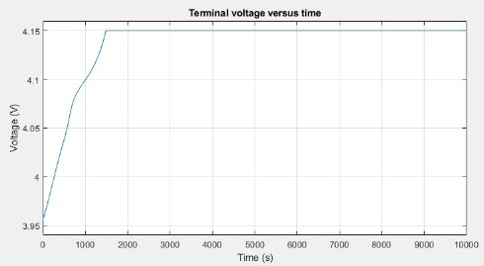
Figure 4. Terminal voltage versus time graph
In Figure 4, the Terminal voltage versus time graph shows that at the beginning of charging, the battery terminal voltage increases rapidly from about 3.95 V. This increase occurs during the constant current (CC) phase, where the current remains at 9 A. The terminal voltage increases as the battery absorbs energy and as it approaches 4.15 V (the maximum allowable voltage), the rate of voltage increase begins to slow down. This indicates the transition from the constant current (CC) charging phase to the constant voltage (CV) phase.
After about 1500 seconds, the terminal voltage reaches 4.15 V, the upper voltage limit for charging. At this point, the program decreases the charging current to keep the terminal voltage constant at 4.15 V. The graph shows that after this transition, the voltage remains stable at 4.15 V for the remainder of the charging duration, while the current decreases slowly until the charge is nearly complete.
This analysis shows typical CC/CV charging characteristics, where the battery terminal voltage increases rapidly during constant current charging until it reaches the maximum voltage limit. After that, the charging system switches to constant voltage mode, where the current is gradually reduced to maintain the voltage at a safe level, avoid overcharging, and protect the battery. These results are essential for understanding how battery voltage should be managed during charging to maintain the performance and safety of lithium-ion batteries.

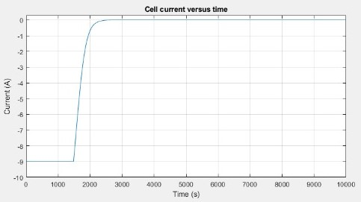
Figure 5. Cell current versus time graph
Next, in Figure 5, the Cell current versus time graph shows how the battery charging current changes during the CC/CV charging process. At the beginning of charging, the current is around -9 A, indicating the constant current (CC) phase, where the current is kept at a constant value to charge the battery quickly. The negative sign on the current indicates the direction of current flow into the battery during the charging process. The charging current remains constant at -9 A until around 1500 seconds, reflecting that the battery is being charged consistently at this stage.
When the terminal voltage reaches the maximum limit of 4.15 V (as analyzed in the voltage graph), the current graph shows that the current begins to decrease exponentially. This decrease marks the transition to the constant voltage (CV) phase, where the charging current is gradually reduced to maintain the voltage at a safe maximum level. The current decreases toward zero over time, indicating that the battery is almost fully charged and only requires a small current to maintain a constant voltage without the risk of overcharging.
This graph illustrates the CC/CV charging strategy, where a constant current is used to charge the battery quickly until the maximum voltage is reached. This is followed by a decrease in current to maintain a constant voltage and ensure safe and efficient charging. This analysis is essential to understand how the charging current is regulated during the lithium-ion battery charging process to maximize efficiency and extend the battery cycle life.

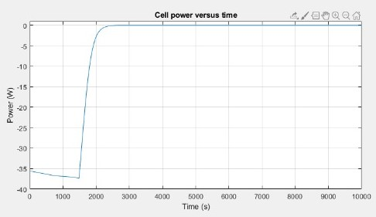
Figure 6. Cell power versus time graph
The last parameter is power, where the Cell Power versus Time graph shown in Figure 6 shows the battery charging behavior. At the beginning of charging, the power absorbed by the battery cell is negative, around -35 W, reflecting that energy is accumulated in the battery. During this stage, the terminal voltage increases as the State of Charge (SOC) increases, but the power remains negative because the charging current is still relatively large. Over time, around 1000 to 3000 seconds, the graph shows a rapid increase in power to near zero. This indicates that the terminal voltage is almost reaching the maximum allowable limit, so the charging current is reduced to keep the voltage within safe limits, which causes the power absorbed by the battery to decrease drastically. At the final stage of charging, after 3000 seconds, the power absorbed by the battery cell is almost zero, indicating that the battery is almost complete and the charging current is getting smaller to maintain the maximum voltage. At this point, the charge is in the Constant Voltage (CV) phase, where very little energy enters the battery, indicating that the battery is almost fully charged.
Based on the battery charging process test using the Constant Current/Constant Voltage (CC/CV) method depicted in the four States of Charge, Terminal Voltage, Current, and Power graphs shows typical charging dynamics for lithium-ion batteries. The SOC increases rapidly in the early charging stages, reflecting the constant current (CC) phase where the battery is charged with a stable current of 9 A. The terminal voltage at the same time increases from around 3.95 V to a maximum of 4.15 V. When this maximum voltage is reached, the charge switches to the constant voltage (CV) phase, where the voltage is maintained at 4.15 V, while the charging current gradually decreases. This decrease in current occurs because the battery is approaching total capacity, which is also reflected in the power absorbed by the battery. In the final stages of charging, the power absorbed by the battery approaches zero, indicating that the battery is almost complete and only requires a small current to maintain a constant voltage. Overall, this CC/CV method enables fast and efficient battery charging in the initial stage, followed by safer and more controlled charging in the final stage, to avoid the risk of overcharging and ensure long battery life.

Conclusion

In conclusion, the battery charging method using the Constant Current/Constant Voltage (CCCV) approach has proven effective in safely and efficiently charging lithium-ion batteries. The charging process begins with a constant current (CC), which allows rapid charging until the terminal voltage reaches a maximum limit. After reaching the maximum voltage, the charging switches to a constant voltage (CV) mode, where the current is gradually reduced to maintain a stable voltage. This approach not only maximizes charging efficiency but also protects the battery from the risk of overcharging and overheating, which can extend the battery life. Analysis from the simulation shows that using the CCCV method can optimally manage battery charging by maintaining a balance between charging speed and operational safety, making it an ideal choice for charging lithium-ion batteries in various applications.
In conclusion, you might elaborate on the importance of the work or suggest potential applications and extensions.

Acknowledgments
The authors, thanks to Electrical Engineering Department, Andalas University in most cases, sponsor and facilitations support.

References
[1] X. D. X. Dqj, E. D. Q. G. Lzhq, Q. Ri, Z. Lpsolhv, W. Lw, and L. V Kljko, “A Timely Review of Lithium-ion Batteries in Electic Vehicles: Progress, FutureOpportunities, and Challenges,” vol. 01015, 2021.
[2] D. N. T. How, M. A. Hannan, M. S. H. Lipu, K. S. M. Sahari, P. J. Ker, and K. M. Muttaqi, “State-of-Charge Estimation of Li-Ion Battery in Electric Vehicles: A Deep Neural Network Approach,” IEEE Trans. Ind. Appl., vol. 56, no. 5, pp. 5565–5574, 2020, doi: 10.1109/TIA.2020.3004294.
[3] L. Chen et al., “Estimation the internal resistance of lithium-ion-battery using a multi-factor dynamic internal resistance model with an error compensation strategy,” Energy Reports, vol. 7, pp. 3050–3059, 2021, doi: 10.1016/j.egyr.2021.05.027.
[4] P. Ningrum, N. A. Windarko, and S. Suhariningsih, “Estimation of State of Charge (SoC) Using Modified Coulomb Counting Method With Open Circuit Compensation For Battery Management System (BMS),” JAREE (Journal Adv. Res. Electr. Eng., vol. 5, no. 1, pp. 15–20, 2021, doi: 10.12962/jaree.v5i1.150.
[5] A. Amin, K. Ismail, and A. Hapid, “Implementation of a LiFePO4 battery charger for cell balancing application,” J. Mechatronics, Electr. Power, Veh. Technol., vol. 9, no. 2, pp. 81–88, 2018, doi: 10.14203/j.mev.2018.v9.81-88.

[6] B. Charging, “Wide-Load-Range Double-T Resonant Converter for CC / CV,” 2024.
[7] Y. Wei, Z. Wang, Q. Luo, and A. Mantooth, “A MATLAB GUI Program for LLC Resonant Converter,” 2020 IEEE Work. Wide Bandgap Power Devices Appl. Asia, WiPDA Asia 2020, vol. 1, pp. 2–6, 2020, doi: 10.1109/WiPDAAsia49671.2020.9360287.
[8] R. Kushwaha and B. Singh, “An EV battery charger based on PFC Sheppard Taylor Converter,” 2016 Natl. Power Syst. Conf. NPSC 2016, pp. 1–6, 2017, doi: 10.1109/NPSC.2016.7858944.
[9] A. Singh, K. Pal, and C. B. Vishwakarma, “State of charge estimation techniques of Li-ion battery of electric vehicles,” e-Prime - Adv. Electr. Eng. Electron. Energy, vol. 6, no. October, p. 100328, 2023, doi: 10.1016/j.prime.2023.100328.
[10] M. Senol, I. Safak Bayram, Y. NADERI, and S. Galloway, “Electric Vehicles under Low Temperatures: A Review on Battery Performance, Charging Needs, and Power Grid Impacts,” IEEE Access, vol. 11, no. March, pp. 39879–39912, 2023, doi: 10.1109/ACCESS.2023.3268615.
[11] M. Elmahallawy, T. Elfouly, A. Alouani, and A. M. Massoud, “A Comprehensive Review of Lithium-Ion Batteries Modeling, and State of Health and Remaining Useful Lifetime Prediction,” IEEE Access, vol. 10, no. September, pp. 119040–119070, 2022, doi: 10.1109/ACCESS.2022.3221137.
[12] T. Feng, L. Yang, X. Zhao, H. Zhang, and J. Qiang, “Online identification of lithium-ion battery parameters based on an improved equivalent-circuit model and its implementation on battery state-of-power prediction,” J. Power Sources, vol. 281, pp. 192–203, 2015, doi: 10.1016/j.jpowsour.2015.01.154.
[13] M. Auch, T. Kuthada, S. Giese, and A. Wagner, “Influence of Lithium-Ion-Battery Equivalent Circuit Model Parameter Dependencies and Architectures on the Predicted Heat Generation in Real-Life Drive Cycles,” Batteries, vol. 9, no. 5, 2023, doi: 10.3390/batteries9050274.
[14] D. Mu, J. Jiang, and C. Zhang, “Online semiparametric identification of lithium-ion batteries using the wavelet-based partially linear battery model,” Energies, vol. 6, no. 5, pp. 2583–2604, 2013, doi: 10.3390/en6052583.
[15] S. Muslimin, R. Maulidda, M. Nawawi, A. Rahman, and P. M. Kurnia, The Method of Constant Current - Constant Voltage (CC – CV) for SECA Electric Car Battery Charging with Fuzzy Logic Controller. Atlantis Press International BV, 2023. doi: 10.2991/978-94-6463-118-0_3.
[16] M. I. Akbar, M. Z. Efendi, and S. D. Nugraha, “SEPIC Converter for Lead Acid Battery Charger Using Fuzzy Logic type-2 Controller,” JAREE (Journal Adv. Res. Electr. Eng., vol. 6, no. 1, pp. 36–41, 2022, doi: 10.12962/jaree.v6i1.240.

