DEVELOPMENT OF TWO-WHEEL VEHICLE SECURITY SYSTEM BASED ON INTERNET OF THINK

Hery Setiawan
Univeristas BinaDarma,Sains Teknologi,Teknik Elektro
email : setiawanhery590@gmail.com

Tamsir Ariyadi
Univeristas BinaDarma,Sains Teknologi,Teknik Elektro
email : tamsirariyadi@binadarma.ac.id

Muhamad Ariandi
Univeristas BinaDarma,Sains Teknologi,Teknik Elektro
Email: muhamad_ariandi@binadarma.ac.id
Nina Paramitha
Univeristas BinaDarma,Sains Teknologi,Teknik Elektro
email : nina_paramitha@binadarma.ac.id

Abstract – Motorcycle theft and robbery have increased significantly during the pandemic, namely by 72.5%. The current motor vehicle security system only relies on keys for security, or uses additional electronic security devices such as alarms and security systems using touch sensors. However, this kind of security does not fully guarantee that the motorbike is safe. The problem of this research is how to design a security system based on RFID, GSM and GPS. The purpose of this research is to design a motorcycle security system based on RFID, GSM and GPS that is able to monitor and secure motorbikes and find out the difference in distance at GPS coordinate points to make it easier to find locations. The research method consists of hardware and software design and testing of the RFID system, GPS testing, GSM testing and overall current testing. The test results data show that the security system on a motorcycle using an RFID card is able to secure and detect without a plastic barrier as far as 3 cm while with a plastic barrier it is able to detect as far as 2.5, sending messages using SIM900A by sending commands to the Arduino with a delay or time gap of around 3 - 5 seconds, and the GPS used has good accuracy by taking 8 coordinate points or locations, then the average difference in distance is 4.5 m.

Keywords: Blynk cloud, gps gsm,rfid sensor, IoT

Creative Commons Attribution-NonCommercial-ShareAlike 4.0 International License.

INTRODUCTION
otorcycles are the most practical vehicles and can be obtained by all people. The reason why motorcycle users are often used is because the price of motorbikes is relatively cheap and fuel efficient. In Indonesia, the number of motorbike users is around 125.3 million units by the end of 2022. Motorbikes are considered the most efficient transportation. [1]
According to data from the South Sumatra Police, the increasing number of motorcycles will also be followed by a very high crime rate because motorcycles are very easy to break into. Especially automatic motorcycles such as Beat motorcycles, with a T-key, Beat motorcycles are easy to break into. Not only broken into in a place, it can also be like a motorcycle robbery or called a mugger. The South Sumatra Police stated that every year there is always an increase in crime in South Sumatra.
Various reasons are known why the robbers did this. One of the main reasons is the economic factor. They usually sell the stolen motorbikes to be used as daily living expenses because many of the robbers are unemployed. The emergence of new motorbike products every year is also suspected of being a trigger for robbery because they want to own the vehicle without having to spend money. The absence of motorbike security when the condition is robbed also makes the robbers free to take the victim's motorbike. In general, security on vehicles is still passive. Such as handlebar locks, key covers and so on.
One of the solutions to protect motorcycles from theft is the use of intelligent security system technology. Motorcycle security system technology that combines Internet of Things technology is classified as future security technology. This technology must continue to exist and continue to be developed to reach the industry so that the public can feel the benefits. The real benefit of IoT technology is more efficient and effective management in various fields.[2]

MetHOD
The operating principle of this device is based on the system structure in the form of a block diagram and the workflow in the form of a flowchart. This device utilizes Arduino Uno as the control center and an Android smartphone as input to send instructions to the system, with a connection bridged by the Wemos WiFi module.
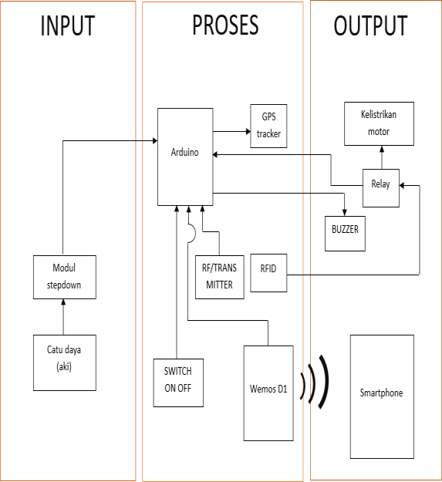
Gambar 2. 1 Tool working process
The Android application has two main options: Safe Mode and Normal Mode. When the smartphone is connected to the WiFi module in Safe Mode, the system automatically operates without the need for the ignition key. The system instructions are executed through the menu selected in the Android application, and the signal will be processed by the Arduino Uno. The Arduino Uno will disconnect the relay according to the option selected through the application.
In Normal Mode, the system is restored to factory configuration and the application cannot control it. Another advantage is that the ignition key can still be used when the smartphone battery is low. If the vehicle is stolen, the system will automatically turn off the vehicle and the engine will not be able to be started, even if using a T key or trying to crank, except in Safe Mode.
2.1 Flowchart
The goal is to arrange the position of the components so that they can be installed properly and neatly. Furthermore, in the process of designing this tool, a flowchart is needed. This flowchart is used to plan the sequence of steps in the operation of the tool, so as to produce results that are in accordance with the desired goals.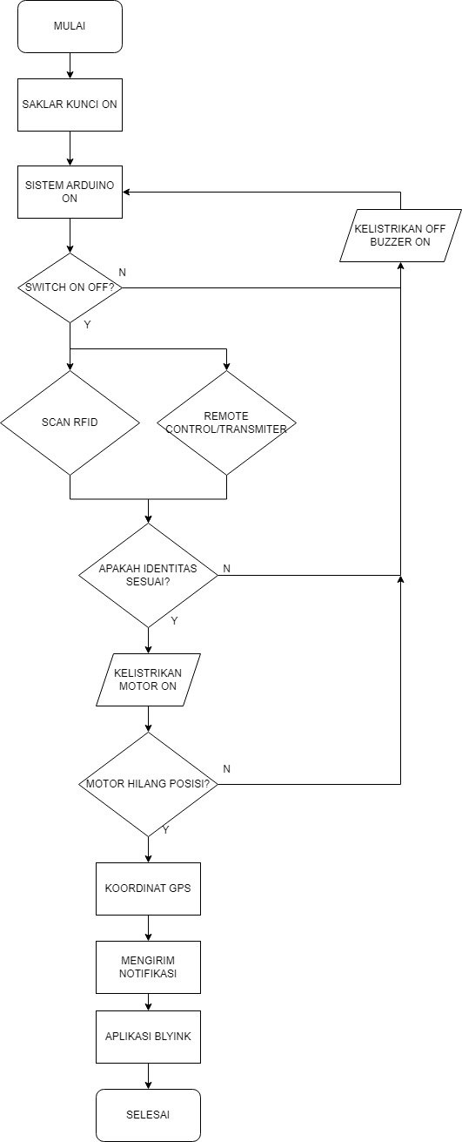
Picture 2. 2 Flowchart
2.2 Circuit Schematic
Circuit schematics are schematics of electronic components and equipment that are to be made. The purpose of making a circuit schematic is to find out what electronic components are needed to make a vehicle security system tool and by making the circuit schematic, it can estimate what components are needed. In addition, making a circuit schematic can help researchers in the process of making a vehicle security system tool.
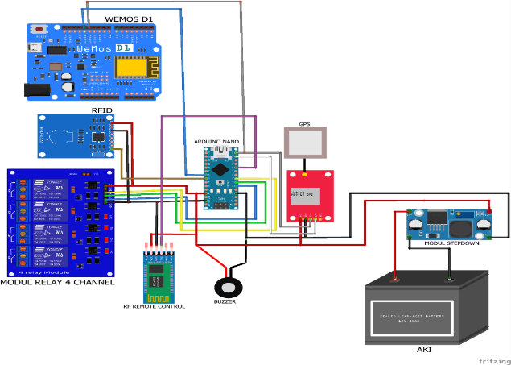 Picture 2. 3 Circuit Schematic
  - How the Tool Works
    - When turning on the motor key socket when the Arduino is on and other components will turn on. To turn on the motor engine, you must switch the output cable from the side stand, switching is done automatically via the remote control.
    - Switching has been activated, after that scan the RFID to read the identity of the personal motorbike. When the identity scan is detected correctly, the motorbike engine can be turned on.
    - Remote Control functions to turn on the motorbike engine, can be through the starter and can also turn off the motorbike engine. Among the keyless remote control buttons there are several functions, button 1 functions as a motorbike starter, button 2 functions as turning off the motorbike engine and button 3 functions as a switching to turn off the tool through the motorbike side stand
    - The GPS module functions to find out the position of the motorcycle. If the motorcycle is not known where it is, you can immediately ask for the GPS coordinates of the motorcycle's position and also the position of the motorcycle being mugged or stolen by force, you can immediately ask for the location point position in real time.

RESULT AND DISCUSSION
3.1 Measurement Objectives
This measurement aims to determine the level of success of the tool that has been created, where testing will be carried out with several measurement points.

3.2 Measurement Point
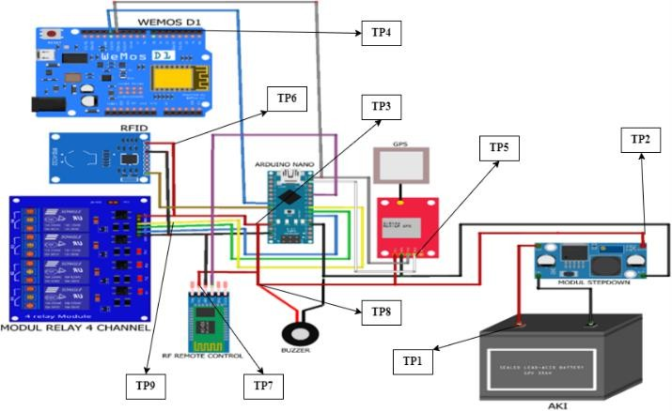
The measurement points can be seen in the image below. :
Picture 3. 1 Measurement Point
Description:
TP 1 = Voltage and current output measurement point from the battery.
TP 2 = Voltage and current output measurement point from the battery to the step down.
TP 3 = Voltage and current output measurement point step down to Arduino nano.
TP 4 = Voltage measurement point on the wemos. TP 5 = Voltage measurement point on the gps sensor. TP 6 = Voltage measurement point on the rfid module.
TP 7 = Voltage measurement point on the keyless module.
TP 8 = Voltage measurement point on the buzzer.
TP 9 = Voltage measurement point on the relay module.
3.3 Measurement results
This measurement was carried out 5 times at each measurement point that had been determined on the tool. After the measurement was carried out 5 times, the average measurement calculation was determined using the following formula 4.3 :
X = 𝑋1+𝑋2+𝑋3+𝑋4+𝑋5 =
𝑛
∑𝑋𝑖 (4.4)
Where :
∑𝑿𝒊 = is the total number of samples n = number of measurements
𝑋̅ = average price
The results of the measurements and average calculations can be seen in table 4.1. Example of the average calculation of the TP1 battery voltage: Average initial voltage value of TP1:

$$\text{X = }\frac{12.3+12.2+12.3+12.2+12.3}{5}= \frac{61.3}{5}$$
X = 12.26 V_{DC.}
Table 3. 1 Measurement
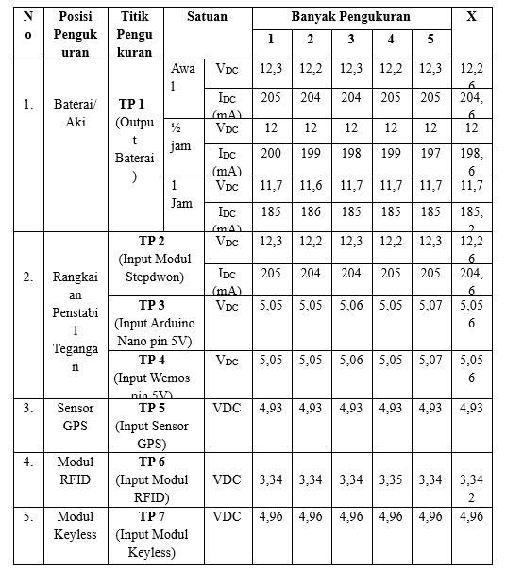
For measurements other than TP1, all measurements are carried out at the start of battery use.
3.4 Calculation Results
3.4.1 Calculation of Battery Energy Used
The battery capacity used is 1500 mAh with a measured current of 205 mAh. To find out the battery energy used, the battery life calculation is carried out using equation 2.2 in chapter II, namely :
Time (t) = $\frac{\text{"battery capacity}}{measured current}$
Time (t) = $\frac{\text{1500mAh}}{205}$
Time (t) = 7,31 h
The battery can last for ± 7.31 hours. After getting the results of the battery life calculation, the next calculation is the energy calculation which can use the energy formula.
W = V.I.t
This formula is used to calculate the energy consumed or produced by a device or electrical circuit in a certain period of time. Then the calculation is obtained :
Full battery capacity
t = 10.73 O'clock
W = V.I.t
W = 12.26 x 0.204 x 7.31 O'clock
W = 18.28 J
Use for ½ hour
W = V.I.t
W = 12 x 0.198 x 0.5 O'clock
W = 1.188 J
So the remaining battery energy for ½ hour is :
W beginning – W during _{½} O'clock as big as
Remaining battery energy = 18.28 J – 1.188 J = 17.092 J
Usage for 1 hour
W = V.I.t
W = 11.7 x 0.185 x 1 O’clock
W = 2.164 J
So the remaining battery energy for 1 hour is :
Remaining battery energy = W_{beginning} – W_{during 1 o’clock} as big as
Remaining battery energy = 18.28 J – 2.164 J = 16.116 J

3.4.2 Perhitungan Presentase Kesalahan
Untuk mengetahui besar presentase kesalahan pengukuran, dapat menggunakan persamaan 4.2.
% Kesalahan = $\left|\frac{\text{Data sheet }-pengukuran}{Data sheet}\right|\text{x 100\%}$........................................................(4.2)

Hasil dari pengukuran yang dilakukan didapat hasil rata – rata tegangan TP 3 yaitu 5.05 volt
% Kesalahan = $\left|\frac{\text{Pengukuran }-Data Sheet}{Data sheet}\right|\text{x 100\%}$
% Kesalahan = $\left|\frac{\text{5,056Vdc }-5Vdc}{5 Vdc}\right|\text{x 100\%}$
= 0,0112 % .

The error of the measurement is 0.41%. With the same formula as above, we can find the % error at each measurement point (TP) that has been determined.
Table 3. 2 Percentage of Errors
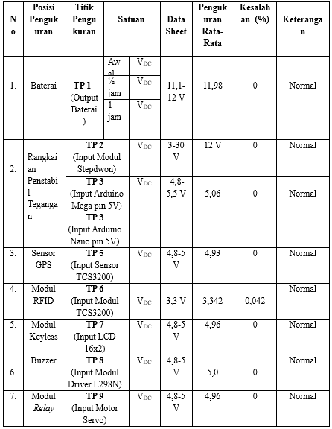
3.5. Tool Testing
3.5.1 RFID Tag Position Reading
Testing is done by reading RFID tags in vertical and horizontal positions. In the reading test, the card position is changed, to estimating the attachment of Tag cards to RFID readers that change positions.
The experiment will be conducted 10 times for the Horizontal position and 10 times for the Vertical position. The card is attached directly to the NFC reader and the response is seen on the serial data on the Arduino.
Table 3. 3 Reading Test with Horizontal and Vertical Position
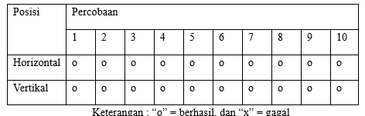
Table 3.3 is a table of RFID tag position reading tests with horizontal and vertical positions. In this experiment, 20 experiments were carried out with 10 experiments with a horizontal position and 10 with a vertical position. From a total of 20 experiments, the results obtained were that the RFID tag was read properly and successfully read, which means that from the 20 experiments, all experiments were successful. In table 4.3, from experiments 1 to 10 with 2 different positions, namely Horizontal and Vertical, it was successfully carried out, which is written with the symbol "o" which means successful and "x" which means failed.
So it can be concluded that from the position reading test, the results obtained are seen in table 3.3. The position of the Tag card does not affect the reader reading. Both horizontal and vertical card positions can be read well with a 100% success rate..
3.5.2 Tag Reading with Distance
This test is done by increasing the distance between the RFID reader and the Tag card. The distance will start from ±0cm to ±6cm. The position of the Tag card remains in a horizontal position. The following are the results of the Tag reading experiment with a distance.
Table 3. 4 Tag Reading Testing with Distance
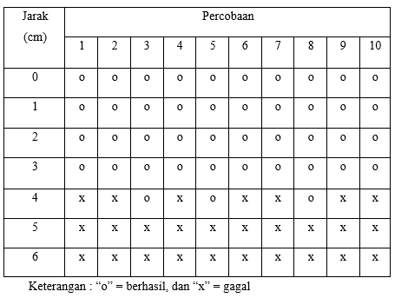
Table 3.4 is a test of RFID tag reading. The test was carried out starting from a distance of 0 cm to 6 cm with 10 trials. At a distance of 0 cm with 10 trials, the results obtained were that the RFID tag could be read properly. Then at a distance of 1 cm with 10 trials the tag can be read well too then the third trial at a distance of 2 cm the RFID tag can be read well too. Then at a distance of 3 cm from the first trial to the 10th trial the RFID tag can be read well in the fifth trial, namely with a distance of 4 cm the RFID tag is read but not all trials were successful where out of ten trials, seven trials were successful and three trials failed. In the sixth test, namely at a distance of 5 cm all RFID tags were not read and in the seventh trial with a distance of 6 cm all trials failed or were not read.
So it can be concluded and can be seen in table 3.4 card tag reading test with distance. The reader can read well from a distance of 0 cm to a distance of ±3cm well with the card position. While testing at a distance of ±4cm to a distance of ±6cm the reading is irregular. From this test it can be concluded that the RFID Tag can be read up to a distance of ±3cm with a success percentage of 100% and if the distance is increased again between the card Tag and the reader. Card Tag reading is not good at a distance of ±4 cm. Even at a distance of ±5 cm to ±16 cm the card is not read by the reader.
3.5.3 Testing the Effect of Time on Distance
This test aims to determine how long it takes to activate the motor power source. In this test, the distance between the remote and the motorcycle will be changed. This distance change is done to determine whether there is an influence between the distance and time to activate the motor power source. The test distance parameters that will be tested are based on testing the influence of distance on the success of data reception, because in this test the average time value of each distance will be sought..
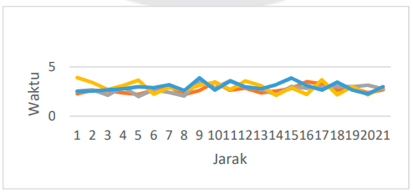
Picture 3. 2 Testing the Effect of Time on Distance to Activate the Motor Power Source
The test results of the time to activate the motorcycle are influenced by the distance between the motorcycle and the remote. The further the motorcycle is positioned, the longer it takes to turn on the motorcycle, but the change in the average time difference for each distance is only small. To turn on the motorcycle at a distance of 1 meter, the average time is 2.694 s, at a distance of 2 meters the average time is 2.7745 s, at a distance of 3 meters obtained an average time of 2.9425 s, at a distance of 4 meters obtained an average time of 2.986842 s. The distance of 4 meters is the optimal distance for the motorbike and remote to communicate with each other, beyond that distance the motorbike and remote cannot communicate optimally.
3.5.4 GPS Sensor Testing
From the testing and observation which aims to obtain data related to the security system and at the same time the control used in this study. Changing the input of the circuit block being tested and seeing the output of the circuit block being tested is how testing is done. The test results will be examined and used as a basis for generating conclusions. As a result, the characteristics of reliability and speed of execution and its weaknesses, of the tool made can be seen. As a result, it can be determined whether the device made is able to run the system reliably and in accordance with the criteria that have been set as in Table 3.5
Table 3.5 Motor position location detection test data
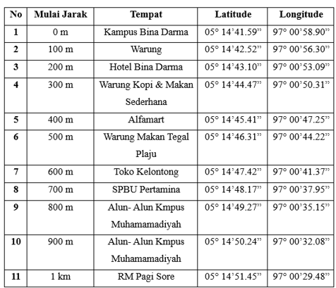
Based on the results of field testing, there are differences in the latitude and longitude coordinates, both in the first experimental GPS that was made and in the second experimental GPS, so they must be converted first. Then to find out the difference in distance between the two coordinate points, it can still be done by converting the latitude coordinates from the "Degrees decimal" format to "Degrees minutes seconds". This also applies to the longitude coordinates if there is a difference between the two and the results are subtracted so that the difference in minutes or seconds is obtained, and the difference is then converted back into a distance with meters..
For example, here the test coordinate data above can be converted. Based on the GPS tool that was made, the latitude coordinate is (5.2115527), when converted to "Degrees minutes seconds" the result is (5 ° 12'41" N) and for the longitude coordinate on the GPS tool, it is (97.016361), when converted to (97 ° 1'58" E). Difference in Latitude & Longitude coordinates :
5° 12’41” - 5° 12’42” = 1” x 30,9227 meters = 30,92 meters
97°1’58” - 97° 1’56” = 2” x 30,9227 meters = 61,85 meters
Distance Difference = $\sqrt{{30,92}^{2}+{61,85}^{2}}$
= $\sqrt{956,046+3.825,422}$
= $\sqrt{4.781,46}$
= 69,14 meters.
3.6 Analysis
From the results of the measurements and calculations that have been carried out, the following analysis can be carried out:
- In the measurements that have been carried out, the percentage of error is at a value of 0.042%. The percentage of errors of all components are all below 1%, which means that the tool is working well and according to what is expected.
- In the RFID position reading test, 20 trials were conducted with horizontal and vertical positions, and all trials were 100% successful. The card position did not affect the reading and in the RFID distance test, the tag was read perfectly up to a distance of ±3 cm with a 100% success rate. However, at a distance of ±4 cm and above, the reading was inconsistent, and above ±5 cm, the tag was not read at all.
- This test measures the time required to start the motor based on the distance between the remote and the motor. The results show that the further the distance, the longer the time required. However, this increase in time is not significant. At a distance of 1 meter, the average time is 2.694 seconds, at 2 meters it is 2.7745 seconds, at 3 meters it is 2.9425 seconds, and at 4 meters it is 2.986842 seconds. A distance of 4 meters is the optimal distance for communication between the remote and the motor. Above this distance, communication does not work well. It can be concluded that the effect of distance on time exists, but the change in average time at each distance is not too large until it reaches the optimal distance of 4 meters.
- GPS sensor testing was conducted to detect the location of a motorcycle based on latitude and longitude coordinates at several points. The results show the difference in coordinates that must be converted from "Degrees decimal" to "Degrees minutes seconds" format in order to calculate the distance difference. From this conversion, the difference between two points is calculated using the Euclidean distance formula, where the difference in latitude and longitude is converted into meters. For example, a difference in latitude of 1 second is equivalent to 30.92 meters, and a difference in longitude of 2 seconds is equivalent to 61.85 meters. With the calculation, a distance difference of 69.14 meters was obtained between the two points. This shows that the GPS sensor can detect position differences with a sufficient level of accuracy, even though there are slight difference that needs to be taken into account for detection accuracy.

CONCLUSION
Based on the results of measurements and testing on the security and control system using RFID and GPS, the following conclusions can be drawn:
- Instrument Accuracy: The percentage error in the measurements was 0.042%, with all components having errors below 1%, indicating that the instrument is functioning as expected.
- RFID Testing: RFID testing on 20 trials, both horizontally and vertically, showed 100% success. The position of the card did not affect the reading. However, in the distance test, the reading was consistent up to ±3 cm with a 100% success rate, but was unstable at a distance of ±4 cm and above, and at a distance of ±5 cm, the tag was not read.
- Motor Activation Time Test: The time required to activate the motor increases with increasing distance between the remote and the motor. However, the average time difference at each distance is not significant. A distance of 4 meters is the optimal distance for communication between the remote and the motor.
- GPS testing: GPS sensor testing shows that even though there is a slight difference in coordinates, the GPS is able to detect the position of the motorbike with fairly good accuracy after coordinate conversion is performed, resulting in an accurate distance difference.
SUGGESTION
    - RFID development: Further testing is needed on RFID to increase the reading distance above 4 cm to be more consistent and can be used in situations that require longer distances.
    - GPS Optimization: Adding more sophisticated algorithms can improve GPS accuracy, especially in minimizing coordinate differences, so that the system can be more reliable in tracking locations.
    - Component Integration: Improvements in synchronization between the remote and the motor, especially for distances above 4 meters, to keep communication smooth and time responsiveness consistent.

Acknowledgments
I would like to thank my supervisor, Mr. Tamsir Ariyadi, who has guide me in writing this journal. I would also like to thank my mother named Rodiah who has provided moral and material support during the process of writing this journal..

References

[1]H. I. Ramadhan¹, A. Bachri², and Z. Abidin³, “RANCANG BANGUN ALAT PENGAMAN SEPEDA MOTOR MENGGUNAKAN GPS BERBASIS IOT NodeMCU IoT Microcontroller GPS tracker Blynk,” 2020.
[2]T. Juwariyah, D. Widiyanto, and S. Sulasmingsih, “Purwa Rupa Sistem Pengaman Sepeda Motor Berbasis IoT (Internet of Things),” Ktrl.Inst (J.Auto.Ctrl.Inst), vol. 11, no. 1, p. 2019.
[3]“Sistem Pengaman Sepeda Motor Dengan Kombinasi Tombol Menggunakan Teknologi Android Berbasis Arduino Bluetooth.”
[4]H. Isyanto et al., “Perancangan dan Implementasi Security System pada Sepeda Motor Menggunakan RFID Sensor Berbasis Raspberry Pi,” vol. 2, no. 1.
[5]A. Sebastian, A. S. Lehman, and J. Sanjaya, “Perancangan Sistem Pengamanan Pada Sepeda Motor.”
[6]Y. Afriyan and M. Ridha Fauzi, “Rancang Bangun Pengaman Sepeda Motor Menggunakan RFID Berbasis Arduino,” Desember, vol. 7, no. 2, pp. 164–171.
[7]H. Cipta Di Lindungi Undang-Undang -----------------------------------------------------, “RANCANG BANGUN SISTEM KUNCI PENGAMAN SEPEDA MOTOR MENGGUNAKAN SENSOR INFRARED PROGRAM STUDI TEKNIK ELEKTRO FAKULTAS TEKNIK UNIVERSITAS MEDAN AREA MEDAN 2020 UNIVERSITAS MEDAN AREA.”
[8]D. Ely Kurniawan and M. Naharus Surur, “Perancangan Sistem Pengamanan Sepeda Motor Menggunakan Mikrokontroler Raspberry Pi dan Smartphone Android,” 2016. [Online]. Available: http://jurnal.pcr.ac.id
[9]D. Cakra, M. Wijaya, and H. Khariono, “JIP (Jurnal Informatika Polinema) PEMANTAUAN PH BERBASIS NODEMCU32 TERINTEGRASI BOT TELEGRAM MELALUI PLATFORM I-OT.NET”.
[10]E. * Ridwan, S. St, and I. Fahruzi, “Sistem Pengaman Motor Menggunakan Smartcard Politeknik Negeri Batam,” Jurnal Integrasi |, vol. 8, no. 1, p. 1, 2016.
[11]Modul GPS Neo6mv2. Diambil pada tanggal 22 Mei 2020 dari https://www.cytron.io/p-gy neo6mv2-flight-control-gps-module,2016.
[12]NodeMCU V3. Diambil pada tanggal 20 Mei 2020 dari http://Gado-Gadonya YOPI ARDINAL
[13] Rangkaian Regulator Dengan Rangkaian LM2596/Lm2576 Arus 3A. Diambil pada tanggal 22 Mei 2020 dari https://mikroavr.com/rangkaian-regulator-lm2596 lm2576.
[14] Teori HArversine Formula. Diambil pada tanggal 23 mei 2020 dari https://blogs.itb.ac.id/anugraha/2014/09/10/teori pengukuran-jarak.
[15] Teori Relay Elektro Mekanik. Diambil pada tanggal 22 mei 2020 dari http://elektronika dasar.web.id
[16] Musyafa, Fajar Fathul, Slamet Pamuji, and Hamid Nasrullah. 2021. Sistem Keamanan Sepeda Motor Mio GT Berbasis Arduino UNO Dan RFID. Auto Tech Jurnal Pendidikan Teknik Otomotif Universitas Muhammadiyah Purworejo 16(2):174–86. http://jurnal.umpwr.ac.id/index.php/autot ech/article/view/1253/895.
[17] Jakaria, Deni Ahmad, and Muhammad Rifki Fauzi. 2020. Aplikasi Smartphone Dengan Perintah Suara Untuk Mengendalikan Saklar Listrik Menggunakan Arduino. JUTEKIN (Jurnal Teknik Informatika) 8(1): 21–28. http://jurnal.stmikdci.ac.id/index.php/jurtekin/
[18] Tantowi, D., & Kurnia, K. (2020). Simulasi Sistem Keamanan Kendaraan Roda Dua Dengan Smartphone dan GPS Menggunakan Arduino. Universitas Buddhi Dharma.
[19] Mahesa, T. A., Rahmawan, H., Rinharsah, A., & Ariffin, S. (2019). Sistem Keamanan Brankas Berbasis Kartu E-KTP. Jurnal Teknologi & Manajemen Informatika, 5(1).
[20] Putra, A. (2021) “Sistem Keamanan Sepeda Motor berbasis Internet of Things dengan Smart Phone berbasis NodeMCU.

