DESIGN AND DESIGN OF MONITORING THE IDEAL BABY'S HEIGHT AND WEIGHT
Bagus Setiawan
Univeristas BinaDarma,Sains Teknologi,Teknik Elektro
email :
agus77015@gmail.com

Tamsir Ariyadi
Univeristas BinaDarma,Sains Teknologi,Teknik Elektro
email : tamsirariyadi@binadarma.ac.id

Endah Fitriani
Univeristas BinaDarma,Sains Teknologi,Teknik Elektro
Email:
endahfitriani@binadarma.ac.id

Nina Paramytha
Univeristas BinaDarma,Sains Teknologi,Teknik Elektro
email : nina_paramitha@binadarma.ac.id

Abstract- Growth and development of infants are crucial aspects that need to be regularly monitored, with height and weight serving as key indicators of nutritional status. This study aims to design and develop a technology-based system to automatically monitor the height and weight of infants using ultrasonic sensors and load cells. The system is designed to provide accurate, practical, and continuous real-time measurements, integrating technologies such as ESP32, LCD, and Blynk application. Test results demonstrate that the system achieves high accuracy with an error percentage below 1%, along with optimal performance of the ultrasonic sensor (distance up to 80 cm) and load cell (weight up to 10 kg). Among the 6 samples tested, 2 infants were categorized as undernourished, 4 as normal. This system is expected to simplify the monitoring of infant nutritional status, support early detection of health issues, and contribute to improved growth quality.
Keywords: Infant growth, infant development, nutritional status, ultrasonic sensor, load cell, ESP32, automatic monitoring, real-time, Blynk.

Creative Commons Attribution-NonCommercial-ShareAlike 4.0 International License.

INTRODUCTION

Infant growth and development are important aspects that must be continuously monitored by parents and health workers. Infant height and weight are the main indicators for assessing the nutritional status and health development of infants. Failure to monitor these two indicators can potentially lead to serious health problems, such as malnutrition or obesity, both of which can have a negative impact on infant growth and development. In the context of the modern world, with rapid technological developments, there is a need for a system that can monitor infant height and weight more accurately, practically, and continuously. Conventional monitoring systems that are still widely used require manual measurements that are often not carried out routinely, and are prone to human error. This requires a more innovative and efficient solution in monitoring infant growth.

The "Ideal Infant Height and Weight Monitoring Design and Construction" project aims to develop a technology-based system that can automatically measure and monitor infant height and weight in real-time. With the integration of the right sensors and the ability to store and analyze data, this system is expected to help parents and health workers in better monitoring infant growth. The data obtained from this system can be used to provide more accurate recommendations regarding the nutritional status of infants, as well as early detection if there is a deviation from the normal growth pattern.With this system, it is hoped that a solution can be created that not only facilitates monitoring, but also makes a significant contribution to efforts to maintain infant health in the early stages of life. Research conducted by Muhamad Reza Ardaffa Putra, Bekti Yulianti, Sumpena entitled "Design and Construction of an Ideal Weight and Height Measuring Tool Using the BMI (Body Mass Index) Method Based on IoT". The purpose of designing this tool is to create an automatic weight and height measurement system based on the Internet of Things (IoT) which is connected via the internet for measurement result information using the NodeMCU ESP8266 as a control, Ultrasonic Sensor HC-SR04 as a human height detector, LoadCell Sensor as a human weight detector, Light Emitting Diode (LED) as a marker or indicator of Body Mass Index (BMI) calculation results, Liquid Crystal Display (LCD) for direct monitoring, and Google Sheet as a measurement result database.

In addition, research conducted by Lu’Lu’ul Maknunah1, Miftachul Ulum1, Hanifudin Sukri entitled “Design and Construction of Nutrition Detection Sensor Based on Child Anthropometric Standards”. The working principle of this tool utilizes an ultrasonic sensor to determine the baby’s body length and a load cell sensor to determine the baby’s weight. Data detected by both sensors will be processed using the stm32 microcontroller. By using the z-score formula, nutrition can be classified into several statuses based on child anthropometric standards. The processed data will be displayed on the LCD and then stored in a MySQL database to facilitate reading the measurement results. So the author is interested in conducting research entitled “Design and Construction of Ideal Baby Height and Weight Monitoring”.

MetHOD

Tool Planning
In making a tool, the planning or design process of the tool is very important. With planning that has been prepared thoroughly beforehand, it is expected that the results can be in accordance with expectations and produce good tools that can work as expected. The planning process for making this tool includes all stages related to the circuit, namely Hardware and Software planning (programming language), for example the selection and preparation of each component, PCB manufacturing, installation on components and testing on the tool.

Desain Alat

The design of the tool that will be used in the prototype. The design of the ideal baby height and weight monitoring will be illustrated with a schematic series of the tool as shown in the image below:

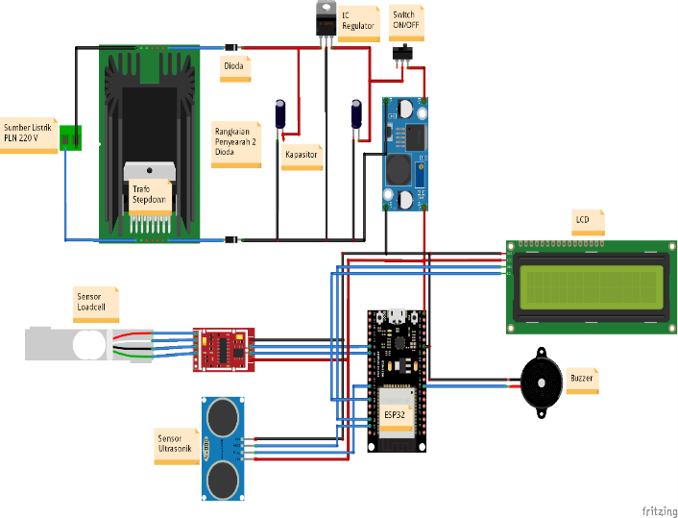

Figure 3.1 Circuit Schematic
(Source: Personal Document, 2024)
Figure 3.1 is a circuit schematic of the components used in this study. The following are the specifications and how the components used work:
- PLN is the main power source used with a voltage of 220V.
- The 5V DC power supply is the power supply used in this study with an output voltage of 5V DC and a maximum current of 1A. The power supply contains components such as transformers, diodes, capacitors and regulator ICs.
- Ultrasonic Sensor as a detector of human height.
- LoadCell Sensor as a detector of human weight.
- Buzzer as a marker or indicator of the results of the Body Mass Index (BMI) calculation.
- Liquid Crystal Display (LCD) to display the baby's weight and height.
- ESP32 as the brain of the components used.

Software Design
At this stage, the flowchart is made by designing a simple algorithm in the form of a flow diagram to facilitate the manufacture of the tool. In order for the manufacture of the tool to be carried out smoothly, the algorithm on the tool is described with a flow diagram first as in Figure 3.2.

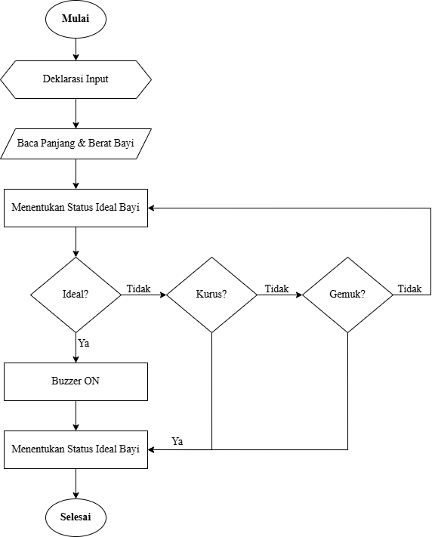

RESULT AND DISCUSSION
1) Measurement Objective
This measurement aims to determine the level of success of the tool that has been made, where testing will be carried out with several measurement points.

2) Measurement Points
The measurement points can be seen in the image below:
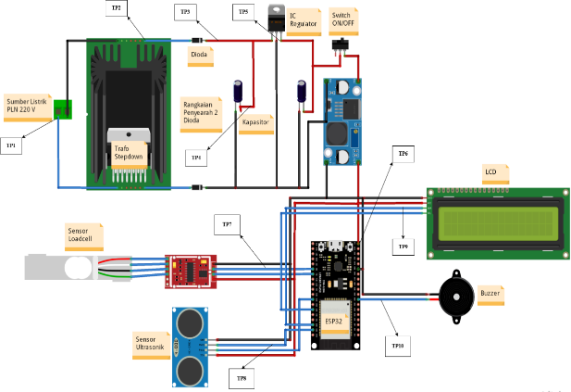

Picture 4. 1 Measurument Point

(Source: Personal Document, 2025)
Description:
TP 1: Measuring point at the PLN source which is the input voltage to the transformer.
TP 2: Transformer measuring point, calculating the voltage output by the center tap type transformer.
- TP 3: Voltage measurement point after the diode on the power supply.
- TP 4: Voltage measurement point after the capacitor on the power supply.
- TP 5: Measurement point on the output voltage of IC 7805.
- TP 6: Measurement point as a voltage source for ESP32
- TP 7: Output voltage measurement point on the Loadcell Sensor.
- TP 8: Output voltage measurement point on the Ultrasonic Sensor.
- TP 9: Output voltage measurement point on the 20x4 LCD.
- TP 10: Output voltage measurement point on the buzzer.
3) Measurement Result
Measurements were repeated 5 times to obtain accurate and optimal results. After the measurements were taken, the average results were obtained from the following formula:
x ̅=(x_1+x_2+x_3+〖x_4+x〗_5)/n = (∑▒x_i )/n……………..……………………………………… (4.1)
Information :
(∑▒X_i )/n = Total number of samples
Xi = Measurement
n = Number of measurements
x ̅ = Average price
To find out how big the percentage of differences and errors that occur in the measurement results using the formula. Therefore, to find out how big the percentage of the error is, it can be found out using the equation 4.2.
%Error=(calculationmeasurements)/Measurument| x 100% ………...………… (4.2)
Description:
%Error = Total Percentage of errors.
Measurement = Voltage Data from Measurement Results.
Calculation = Voltage Data from Calculation Results.

After measurements are made on the tool used, the value of each measurement result is obtained. During the measurement process, there is a possibility of errors or differences in the results obtained.
Tabel 4. 1 Measurument Result
No | Pengukuran | Titik  Pengukur-an | Satu-an | Hasil pengukuran (volt DC) |  |  |  |  | Rata-rata  (Volt DC) | Keteran-gan
 |  |  |  | 1 | 2 | 3 | 4 | 5 | Rata-rata  (Volt DC) | Keteran-gan
1 | Catu Daya | Masukkan Catu Daya  (TP1) | V_{ac} | 220,01 | 220,04 | 220,01 | 219,07 | 220,02 | 219,99 | Input ke trafo
1 | Catu Daya | Trafo  (TP2) | V_{ac} | 5,04 | 5,03 | 5,04 | 5,05 | 5,04 | 5,04 | Input ke diode
1 | Catu Daya | Dioda (TP3) | V_{dc} | 5,12 | 5,11 | 5,12 | 5,11 | 5,11 | 5,11 | Input ke Kapasitor
1 | Catu Daya | Dioda (TP3) | I_{dc}mA | 400 | 380 | 380 | 400 | 400 | 392 | Output Kapasitor
1 | Catu Daya | Kapasitor (TP4) | V_{dc} | 5,5 | 5,5 | 5,5 | 5,4 | 5,4 | 5,46 | Input ke IC 7812
1 | Catu Daya | IC 7805 (TP5) | V_{dc} | 5,2 | 5,2 | 5,21 | 5,21 | 5,2 | 5,204 | Input Stepdown
2 | ESP32 | TP6 | Vdc | 5,01 | 5,02 | 5,04 | 5,03 | 5,05 | 5,03 | Tegangan Input ESP32
3 | Sensor  Loadcell | TP7 | Vdc | 5,08 | 5,09 | 5,07 | 5,03 | 5,01 | 5,056 | Tegangan Input ESP32
4 | Sensor  Ultrasonik | TP8 | Vdc | 4,98 | 4,99 | 4,97 | 4,93 | 4,91 | 4,956 | Output to ESP32 When Active
 |  |  |  | 0.5 | 0.5 | 0.5 | 0.5 | 0.5 | 0.5 | Output to ESP32 When No Active
5 | LCD 16x2 | TP9 | Vdc | 4,98 | 4,99 | 4,97 | 4,93 | 4,91 | 4,956 | Output to ESP32 When Active
 |  |  |  | 0.4 | 0.4 | 0.4 | 0.4 | 0.4 | 0.4 | Output to ESP32 When No Active
6 | Buzzer | TP10 | Vdc | 4,98 | 4,99 | 4,97 | 4,93 | 4,91 | 4,956 | Output to ESP32 When Active

After getting the measurement result value, the next process is to calculate the part that can be calculated and then compare it with the measurement result to find out the percentage of error.
a) Transformer Voltage Calculation
The transformer voltage is calculated based on the existing specifications with the measured data using equation 2.1, the values ​​can be obtained as below:
$$a= \frac{N_{1}}{N_{2}}= \frac{V_{1}}{V_{2}}= \frac{220}{5}=44 V$$
Transformer voltage based on measurements as in table 4.1, the results are as below:
$$a= \frac{V_{measurument}}{V_{2}}$$
$$V_{2}= \frac{V_{measurument}}{a}= \frac{219,99}{44}$$
$$V_{2}=4,99 V$$

b) Infant Weight and Length Testing

This test is conducted to measure the weight and length of the infant using a combination of two types of sensors, namely an ultrasonic sensor to measure body length and a load cell sensor to measure body weight. This test aims to evaluate the accuracy of the measurement and categorize the nutritional status of the infant based on the weight and length obtained. The data tested involved infants with a maximum age of 7 months.

The following table is the result of testing involving 6 infant samples, which show variations in nutritional status based on growth standards. The following table illustrates the test results that include body weight, body length, and the category of nutritional status of the infants measured.

Table of Results of Infant Weight and Length Testing
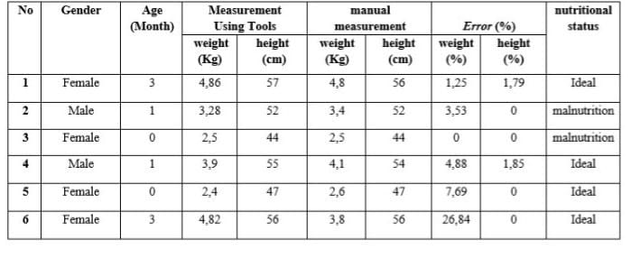

Based on the analysis of the table of results of the examination of the weight and length of the babies, it can be seen that there are two babies who are included in the category of malnutrition, namely babies No. 2 and 3. This shows that although their body length is according to the standard, their weight is lower than it should be for their age. For example, baby No. 3 at the age of 0 months has a body length of 44 cm and a weight of 2.5 kg which indicates the possibility of malnutrition. In contrast, four babies (No. 1, 4, 5, and 6) showed ideal nutritional status which means that their weight and length growth are balanced according to the standards for their age. For example, baby No. 1 at the age of 3 months weighs 4.86 kg and is 57 cm long which reflects optimal growth.

In terms of growth based on age, infants aged 0–1 months showed variations in nutritional status, with some infants having low body weight despite normal body length. Meanwhile, infants aged 3 months (No. 1 and 6) showed more stable growth with ideal nutritional status, although infant No. 6 had a weight error of 26.84%, indicating possible differences in measurement methods or certain conditions that affect the measurement results.

Overall, babies with malnutrition status require greater attention to diet and additional nutritional intake to increase body weight according to standards. Babies with ideal status need to be maintained with a balanced diet and regular monitoring so that their growth remains optimal. This analysis shows the importance of monitoring nutrition from an early age to ensure the baby's growth is in accordance with age standards and reduces the risk of health complications in the future.

CONCLUSION
Based on the results and discussion of the research "Ideal Baby Height and Weight Monitoring Design" the following conclusions can be drawn:
1) Percentage of Error: The device showed a percentage of error of 0.31%, with all components operating below 1% error, indicating that the device is working properly and as expected.
2) The ultrasonic sensor and load cell worked optimally with 100% success. The ultrasonic detects a distance of up to 80 cm, and the load cell reads weights up to 10 kg, according to its specifications.
3) This test measures the weight and length of babies using the ultrasonic sensor and load cell to assess accuracy and nutritional status. Of the five samples (age ≤7 months), two babies were classified as malnourished, while the other three were ideal. These results emphasize the importance of growth monitoring to prevent nutritional problems, with the data display on the LCD and Blynk showing the suitability of the measurements.
SUGGESTION
    - In further development, it is recommended to carry out periodic calibration to maintain the accuracy of the tool.
    - Based on the conclusion above, there are several suggestions that can be done to maximize the tool, namely the use of the HC SR04 ultrasonic sensor replaced by SRF04 which has a better level of accuracy, so that the measurement results will be better. In addition, when testing the Load Cell sensor there was an error, this was caused by the placement of the load not being directly above the Load Cell. In order for the weight reading to be more precise, it is necessary to add a Load Cell sensor.

Acknowledgments
I would like to thank my supervisor, Ma’am. Endah Fitriani, who has guide me in writing this journal. I would also like to thank my mother named Veronika who has provided moral and material support during the process of writing this journal.

VI. REFERENCES

- Wulandari, Luh Gede Putri, Hubungan Indeks Massa Tubuh Ibu Dengan Berat Badan Lahir Bayi Di Rumah Sakit Umum Pusat Sanglah Denpasar, Denpasar,
- M. D. Syahputra, U. Fatimah, S. Sitorus, and D. Suherdi, “Rancang Bangun Palang Otomatis Zebra Cross Menggunakan Metode Pulse Width Modulation Berbasis Arduino,” vol. 1, no. 0, pp. 50–56, 2022.
- Harismayanti, Retni, A., & Dunggio, S. N. (2023). Analisis perbedaan berat badan dan panjang badan pada bayi usia 6-7 bulan yang diberikan ASI eksklusif di wilayah kerja Puskesmas Kota Barat. Jambura Journal of Health Science and Research, 5(1), 152.
- Agus Wibowo Lawrence Adi Supriyono, Analisis Pemakaian Sensor Loadcell Dalam Perhitungan Berat Benda Padat Dan Cair Berbasis Microcontroller, Sekolah Tinggi Manajemen Informatika dan Komputer, Semarang. 2022.
- I. Gunawan and H. Ahmadi, “Sistem Monitoring Dan Pengkabutan Otomatis Berbasis Internet Of Things (IoT) Pada Budidaya Jamur Tiram Menggunakan NodeMCU dan Blynk,” Infotek J. Inform. dan Teknol., vol. 4, no. 1, pp. 79–86, 2021, doi: 10.29408/jit.v4i1.2997.
- M. Iman Wahyudi and Rifki Abdul Aziz, “Keran Air Wudhu Otomatis Menggunakan Sensor Infrared Sebagai Upaya Meminimalisasi Pemborosan Air,” J. Appl. Comput. Sci. Technol., vol. 3, no. 1, pp. 151–156, 2022, doi: 10.52158/jacost.v3i1.296.
- O'Connor, Sean, and Jonathan McCullagh. Design and Application of Load Cells. Journal of Instrumentation, Measurement, and Analysis, 2020.
- Carrara, P., et al. Innovative Load Cell Designs for Precision Weight Measurement in Industrial Applications. IEEE Transactions on Industrial Electronics, 2020.
- He, Zhenyu, et al. Recent Advances in Load Cell Technologies: Design and Application in Dynamic Force Measurement. IEEE Sensors Journal, 2023.
- Wang, Z., Zeng, Y., & Liu, X. (2021). Design of a Smart Baby Monitoring System Based on IoT. IEEE Access, 9, 164738-164747.
- Das, R., & Ali, S. M. (2019). Automatic Baby Monitoring System: A Review. International Journal of Advanced Research in Computer and Communication Engineering, 8(3), 45-50.
- Chowdhury, T., Rahman, M. M., & Rahman, M. (2020). IoT Based Health Monitoring & Automated Weight Measurement System for Newborn Babies. 2020 IEEE Region 10 Symposium (TENSYMP), 1238-1243.
- P. L. E. Aritonang, E. C. Bayu, S. D. K, and J. Prasetyo, “Rancang Bangun Alat Pemilah Sampah Cerdas Otomatis,” hal. 375–381, 2019.

