MONITORING OF PRESERVATIVE DETECTION DEVICES IN MARKET FOOD SNACKS

Anugrah Pratama
Univeristas BinaDarma,Sains Teknologi,Teknik Elektro
email :
anugrahpratama150700@gmail.com

Tamsir Ariyadi
Univeristas BinaDarma,Sains Teknologi,Teknik Elektro
email : tamsirariyadi@binadarma.ac.id

Endah Fitriani
Univeristas BinaDarma,Sains Teknologi,Teknik Elektro
Email:
endahfitriani@binadarma.ac.id

Nina Paramitha
Univeristas BinaDarma,Sains Teknologi,Teknik Elektro
email : nina_paramitha@binadarma.ac.id

Abstract – Food safety is a crucial issue in Indonesia, especially concerning the use of harmful preservatives such as formalin in market snacks. Manual monitoring of formalin usage is often ineffective, necessitating an automated system to detect formalin in real-time. This research aims to develop a formalin detection system based on the Internet of Things (IoT) using the ESP32 microcontroller equipped with an ultrasonic sensor for automatic object detection. The detection data is sent to a Telegram-based platform. The test results show that the system can accurately detect objects within a range of 0-20 cm and measure voltage effectively to ensure system stability. Testing on food samples revealed the presence of borax in several market snacks, demonstrating the system's effectiveness in detecting harmful preservatives and enhancing food safety.

Keywords: Food safety, formalin, Internet of Things (IoT), ESP32, ultrasonic sensor, borax, automatic detection, market snacks.
Creative Commons Attribution-NonCommercial-ShareAlike 4.0 International License.

INTRODUCTION
Food safety is a crucial aspect that must be considered, especially in developing countries like Indonesia, where traditional markets are still one of the main sources for people to obtain food and snacks. One serious problem that is often encountered is the use of hazardous chemicals such as formalin as a food preservative. Formalin, which should only be used for non-consumption purposes, is often misused by unscrupulous traders to extend the shelf life of food products, especially market snacks.
The use of formalin in food is very dangerous for human health. Short-term consumption of formalin can cause irritation to the digestive system, nausea, vomiting, and in more severe cases can cause damage to internal organs and even death. Therefore, early detection of the presence of formalin in food is very important to protect consumers. However, manual and periodic supervision of formalin use by relevant authorities is often ineffective due to limited resources and wide coverage areas. Therefore, an automatic system is needed that can detect the presence of formalin in real time and provide accurate information to authorities and consumers.
In this context, Internet of Things (IoT) technology offers a potential solution. One of the important components in the development of an IoT system is a microcontroller such as the ESP32, which is known for its strong performance, wireless connectivity support, and efficient power consumption. By utilizing the ESP32, a formalin detection system can be designed to continuously monitor food and send detection data to a web-based platform or mobile application for further analysis. Previous research conducted by Yashinta Hardiyani, Sapto Nisworo & Hery Teguh Setiawan (2023) entitled Planning a Formaldehyde Detection System in Food. This study discusses formalin detection using a push button to start formalin detection on the test object so that the reading is not automatic when there is a test object to be detected. In addition, in this study the data is only displayed on the LCD and has not been connected to the IoT system. Furthermore, research conducted by Dany Pratmanto, Evita Nur Khasanah & Rousyati (2021) entitled Formalin Detection Device in Fresh Fish Using an Arduino-Based Hcho Sensor. This study is only displayed on the LCD and buzzer as an indicator when there is formalin content. In addition, it has not been connected to the Android application either via IoT or other means. The development of this ESP32-based formalin detector is expected to be an important innovation in improving food safety in Indonesia. With this system that uses ultrasonic sensors to automatically detect objects and is connected to IoT, the public can be better protected from the dangers of consuming food containing formalin, and authorities can take more effective preventive measures. So the author is interested in conducting research entitled "Monitoring of Preservative Detection Devices in Market Food Snacks".

MetHOD
- 1. Tool Planning
In making a tool, the planning or designing process of the tool is very important. With planning that has been prepared thoroughly beforehand, it is expected that the results can be in accordance with expectations and produce good tools that can work as expected. The planning process for making this tool includes all stages related to the series, namely Hardware and Software planning (programming language), for example the selection and preparation of each component, manufacturing, installation on components and testing on the tool.
- Tool Design
The tool design that will be used in the monitoring tool for the formaldehyde detector in market food snacks based on ESP32 will be described with a schematic circuit of the tool as shown in the image below: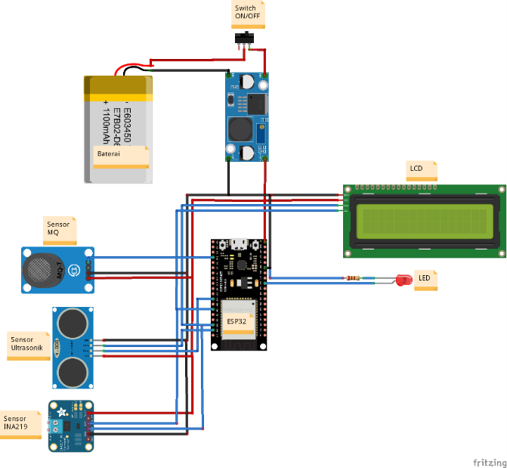
Figure 3 Circuit Schematic
(Source: Personal Document, 2024)
In Figure 3.1 is a schematic circuit of the components used in this study. The following are the specifications and how the components work:
- Lipo battery is a power source for this research tool.
- The LM2596 Stepdown Module is a voltage reducer from the lipo battery which was originally from 6-8VDC to 5VDC. This 5VDC voltage will be the source to the ultrasonic sensor, HCHO sensor, ESP32, LCD and LED.
- The mq-6 sensor functions to determine the concentration of formaldehyde gas in the detected object.
- The ultrasonic sensor functions to detect when there is an object to be measured for its formalin level.
- The ina219 sensor for voltage and percentage on the battery source used.
- ESP32 functions as a controller or brain of a program.
- The LCD functions to display values ​​or as information.
- LED as an indicator if there is formalin in the test object.
- Software Design
At this stage, the flowchart is made by designing a simple algorithm in the form of a flow diagram to facilitate the manufacture of the tool. In order for the manufacture of the tool to be carried out smoothly, the algorithm on the tool is described with a flow diagram first as in Figure 3
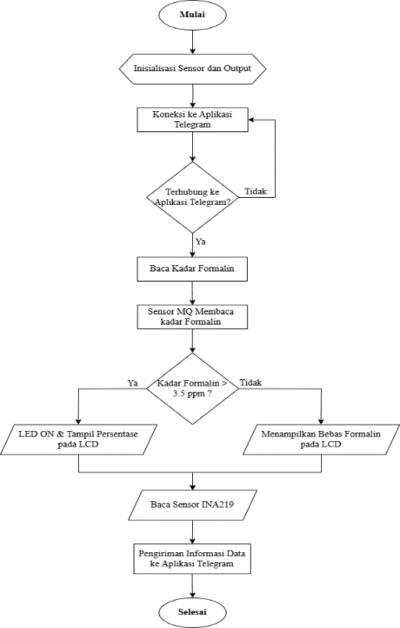

Figure 3 Flowchart
(Source: personal document, 2024)

RESULT AND DISCUSSION
- Measurement Objective
This measurement aims to determine the level of success of the tool that has been made, where testing will be carried out with several measurement points.

- Measurement Points
The measurement points can be seen in the image below:
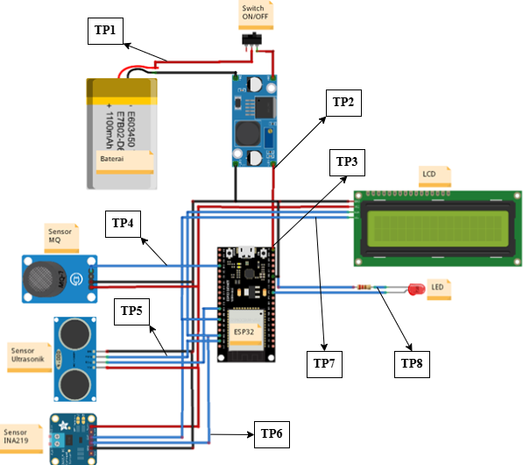

Figure 4 Measurement Points

(Source: Personal Document, 2025)
Description:
TP 1 = Voltage and current output measurement point from the battery.
TP 2 = Voltage and current output measurement point from the battery to the step down.
TP 3 = Voltage and current output measurement point from the step down to ESP32.
TP 4 = Voltage measurement point on the mq sensor.
TP 5 = Voltage measurement point on the ultrasonic sensor.
TP 6 = Voltage measurement point on the ina219 sensor.
TP 7 = Voltage measurement point on the 16x2 lcd.
TP 8 = Voltage measurement point on the led.
3) Measurement Results
This measurement was carried out 5 times at each measurement point that had been determined on the tool. After 5 measurements were taken, the average measurement calculation was determined using the following formula 4.1:
X = (X_1+X_2+X_3+X_4+X_5)/n= (∑X_i)/n.......................................................................(4.1)
Where:
∑X_i = is the total number of samples
n = number of measurements
X ̅ = average price

The results of the measurements and average calculations can be seen in table 4.1. Example of calculating the average battery voltage TP 1:

Average initial voltage value TP 1:
X = (7.5+7.6+7.5+7.4+7.5)/5= 37.5/5
X = 7.5 VDC.

For measurements other than TP 1, all measurements were taken at the beginning of battery use. Table 4 is the result of voltage and current measurements on the research equipment used.
No | Pengukuran | Titik  Pengukuran | Satuan | Hasil pengukuran (volt DC) |  |  |  |  | Rata-rata  (Volt DC) | Keterangan
 |  |  |  | 1 | 2 | 3 | 4 | 5 | Rata-rata  (Volt DC) | Keterangan
1 | Baterai | TP1 (Output Baterai) | V_{DC}  _{(Awal)} | 7,5 | 7,5 | 7,4 | 7,6 | 7,5 | 7,5 | Input ke stepdown
1 | Baterai | TP1 (Output Baterai) | I_{mA}  _{(Awal)} | 205 | 204 | 204 | 205 | 205 | 204,6 | Input ke stepdown
1 | Baterai | TP1 (Output Baterai) | V_{DC}  _{(1/2 Jam)} | 7 | 7 | 7 | 7 | 7 | 7 | Input ke stepdown
1 | Baterai | TP1 (Output Baterai) | I_{mA}  _{(1/2 Jam)} | 200 | 199 | 198 | 199 | 197 | 198,6 | Input ke stepdown
1 | Baterai | TP1 (Output Baterai) | V_{DC}  _{(1 Jam)} | 6,7 | 6,6 | 6,7 | 6,7 | 6,7 | 6,7 | Input ke stepdown
1 | Baterai | TP1 (Output Baterai) | I_{Ma}  _{(1 Jam)} | 185 | 186 | 185 | 185 | 185 | 185,2 | Input ke stepdown
2 | Modul Stepdown | TP2 | Vdc | 5,01 | 5,02 | 5,04 | 5,03 | 5,05 | 5,03 | Tegangan Input ESP32
3 | ESP32 | TP3 | Vdc | 5,01 | 5,02 | 5,04 | 5,03 | 5,05 | 5,03 | Tegangan Output  ESP32
4 | Sensor  MQ | TP4 | Vdc | 3,98 | 3,99 | 3,97 | 3,93 | 3,91 | 3,956 | Output ke ESP32 Saat Aktif
 |  |  |  | 0.5 | 0.5 | 0.5 | 0.5 | 0.5 | 0.5 | Output ke ESP32 Saat Tidak Aktif
5 | Sensor Ultrasonik | TP5 | Vdc | 4,98 | 4,99 | 4,97 | 4,93 | 4,91 | 4,956 | Output ke ESP32Saat Aktif
6 | Sensor INA219 | TP6 | Vdc | 3,98 | 3,99 | 3,97 | 3,93 | 3,91 | 3,956 | Output ke ESP32 Saat Aktif
 |  |  |  | 2,5 | 2,45 | 2,5 | 2,55 | 2,5 | 2,5 | Output ke ESP32 Saat Tidak Aktif
7 | LCD 16x2 | TP7 | Vdc | 4,98 | 4,99 | 4,97 | 4,93 | 4,91 | 4,956 | Output ke ESP32
8 | LED | TP8 | Vdc | 3,3 | 3,3 | 3,25 | 3,3 | 3,26 | 3,282 | Output ke ESP32

CONCLUSION
Based on the results and discussion of the research "Monitoring of Preservative Detection Devices in Market Food Snacks" can be concluded as follows:
1. All measurement results in Table 4.1 and Table 4.2 show stable and consistent voltage according to the datasheet specifications, with a measurement error of 0%, indicating that the system is working well and accurately.
2. The ultrasonic sensor detects objects accurately at a distance of 0-20 cm, while the INA219 sensor provides accurate and consistent voltage data, with a voltage below 6V indicating that the battery needs to be recharged, and a voltage above 6V indicating that the battery is in normal condition.
3. Testing of borax content in 8 food and beverage samples showed that three samples, namely meatballs (20%), seblak (80%), and chicken (40%), were detected positive for borax, while the other five samples were declared negative.

5.2 Suggestions
1. In further development, it is recommended to carry out periodic calibration to maintain the accuracy of the tool.
2. For the use of sensors to detect borax or preservatives in food/drinks, it is recommended to use an HCHO sensor because the MQ sensor needs to be calibrated before being tested.
V. SUGGESTION
[1]Syukri, M. and Mukhaiyar, R. (2021) “Alat Pendeteksi Formalin Pada Makanan Menggunakan IoT”, Ranah Research : Journal of Multidisciplinary Research and Development, 3(2), pp. 80-87. doi: 10.38035/rrj.v3i2.374.
[2] H. Aulia, R. Mukhaiyar, “A New Design of Hnadless Stirred Device”, Proceeding 4th International Conference on Technical and Vocational Education and Training (TVET), pp. 579-582, 2017.
[3] R.F. Ramadhan, R. Mukhaiyar, "Penggunaan Database Mysql dengan Interface PhpMyAdmin sebagai Pengontrolan Smarthome Berbasis Raspberry Pi", JTEIN: Jurnal Teknik Elektro Indonesia, vol. 1, no. 2, pp. 129-134, 2020.
[4] M.S. Yoski, R. Mukhaiyar, "Prototipe Robot Pembersih Lantai Berbasis Mikrokontroller dengan Sensor Ultrasonik", JTEIN: Jurnal Teknik Elektro Indonesia, vol. 1, no. 2, pp. 158-161, 2020.
[5] A.R. Marjan, R. Mukhaiyar, "Perancangan Konveyor Pengangkut Buah Semangka Berdasarkan Berat Berbasis Microkontroller", Ranah Research: Journal of Multidisciplinary Research and Development, vol. 3, iss. 1, pp. 219-225, 2020.
[6] R.C.J. Wydmann, R. Mukhaiyar, "Augmented Reality dalam Penggunaan Alat Rumah Tanggal Berbasis Internet Of Things", JTEIN: Jurnal Teknik Elektro Indonesia, vol. 1, no. 2, pp.84-91, 2020.
[7] D.A. Putra, R. Mukhaiyar, "Monitoring Daya Listrik Secara Real Time", VoteTEKNIKA: Jurnal Vocational Teknik Elektronika dan Informatika, vol. 8, no. 2, pp.26-34, 2020.
[8] S.M. Liusmar, R. Mukhaiyar, "Perancangan Sistem Otomasi Penggunaan Barcode Scanner Pada Trolley Berbasis Arduino Mega 2560", VoteTEKNIKA: Jurnal Vocational Teknik Elektronika dan Informatika, vol. 8, no. 2, pp. 43-49, 2020.
[9] R. Mukhaiyar, “Digital Image dan Remote Sensing Image as a Data for an Identification of a Quality of a Non-Point Source Pollutant in Ciliwung River, Indonesia”, International Journal of GEOMATE, vol. 12, iss. 32, pp. 142-151, 2017.
[10] R. Mukhaiyar, “Geographic Information System and Image Classification of Remote Sensing Synergy for Land-Use Identification”, International Journal of GEOMATE, vol. 16, iss. 53, pp. 245-251, 2019.
[11] R. Mukhaiyar, R. Safitri, “Implementation of Artificial Neural Network: Back Propagation Method on Face Recognition System”, Proceedings 2019 16thInternational Conference on Quality in Research (QIR): International Symposium on Electrical and Computer Engineering, November 14, 2019.
[12] D. Kho, “Pengertian LCD (Liquid Crystal Display) dan Prinsip Kerja LCD.” Retrieved fromhttps://teknikelektronika. com/pengertian-lcd-liquid-crystal..., 2019.
[13] S. Azzahra, “Rancang Bangun Alat Pendeteksi Formalin pada Makanan Berbasis Sensor HCHO,” 2019. Scientific Research & Development) Vol. 5, Issue 01, ISSN (online): 2321-0613, pp.873-875.

