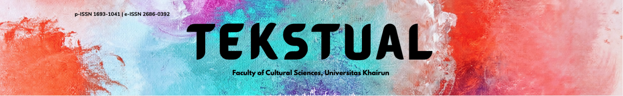
Volume 19, Nomor 2 (2021)
Homepage: http://ejournal.unkhair.ac.id/index.php/tekstual

Social Problems In Drama 13 Reasons Why: Peirce Semiotics Approach
Ratu Ainun Jariah¹, Fathu Rahman², M. Amir P^{3*}
^{1,2,3} English Department Faculty of Cultural Sciences, Hasanuddin University, Makassar, Indonesia
*Correspondence: ratu1349@yahoo.com

ABSTRACT

This study is entitled Social Problems In Drama 13 Reasons Why: Peirce Semiotics Approach, by analyzing the 13 episodes that aired in the first season of this series by Bryan Yorkey. This study aims to of this research is to analyze the social problems that happened to Hanna Baker based on the signs that appeared that made her commit suicide in the drama series. To describe Hanna's social problems, the researcher uses Charles Sanders Peirce's media text analysis method. The results of this study show that every scene and dialogue in the drama shows social problems including bullying, sexual assault, suicide, stalking, and judging. The results of the study that writer can conclude that the social problems experienced by Hanna in the drama series "13 reasons why" is a form of art that persuades the audience and conveys the social conditions of teenagers who are full of deviant behavior and conveys to all people to care about deviant actions that are present around us.

Keywords: Drama Series, Semiotics, 13 Reasons Why.

INTRODUCTION
Literary work has written by human that contains an aesthetic value, because literary works frequently use some consists of those writing which interpret the meanings of nature and life, in words of charm and power, touched with the personality of the author, in artistic forms of permanent interest, (Klarer, 2004) has stated that literature is a written form of an expression, this what makes literary works are different from any other written document. Literary works also divided into two separate categories, fiction (literary works that based on the author’s mind and imagination) and nonfiction (literary works that based on the real event that converted or adapted into written works) which again divided into poetry and prose. There also different types of form in literary works such as novel, poem, drama, and short story.
One part of a literary work is drama (Borchmeyer, 2003), which is divided into several acts and scenes, drama also contains characters, setting, roles and dialogue. There are many great drama maker, but the writer decided to analyze Brian Yorkey's drama. Brian was born in Nebraska, USA on October 23th 1970. He is one of the US drama maker who created famous works. His works often explore dark and controversial subject matter such as mental illness, grief, suburban underbelly, and ethics in both psychiatry and public education.(Next to normal 2010) was his first written work and was followed by another collection 4 years later.
He is also the Producer and Creator for the drama (13 Reasons Why 2017) which was nominated for (NAACP #Image Award for Outstanding Directing in a drama series 2018) and won for (EMMYS #television Academy Honors 2018). Among all of his popular works, writer decides to choose (13 Reasons Why 2017) as the object of the study. This drama is very popular among millennials because it raises the theme of high school children's lives, bullying at school which is sometimes not realized by teachers and parents, all types of school children are in this series and convey various kinds of moral messages (Rahman, 2017).
The American mystery drama series “13 Reasons Why” was released worldwide in March 2017 via Netflix, airs 13 episodes in season 1, has a duration of one hour each episode, and stars several well-known actors such as Dylan Minnette, Katherine Langford, Alisha Boe, Ross Butler and several other actors. This drama tells the story of a high school student named Clay Jensen (played by Dylan Minnete) who one day received a package containing 7 tapes with the numbers 1-13 written on each side. Clay, who was curious, finally played the cassette with side number 1. Clay was surprised, the voice he heard was the voice of Hannah Baker (played by Kathrine Langford) who had died a few months ago due to suicide.
LITERATURE REVIEW
Semiotic is the study of "signs" in human life. That is, everything that is present in our lives is seen as a sign, which is something that we must give meaning to (Hoed, 2008: 3). Peirce defines semiotics as the study of signs and what is associated with them, namely the way they function, relate to signs, send and receive them by those who use them. In terms of terminology. Semiotics is defined as the study of a broad range of objects, events, and all cultures as a sign (Peirce, 1991; Rahman, 2018). Semiotics come from the Greek word 'Semeion' which means a sign or 'Seme' which means sign (Zakaria, et al., 2021; Danesi, 2010). The sign at that time was interpreted to refer to the existence of something else.
For Peirce, a sign “is something that points someone to something in some respect or capacity.” Something that is used to make the sign work, by Pierce is called ground, consisting of a sign, object and an interpretant. Each element is related and formed with the following image.
Sign
Object
Interpretant
The Triangle of Meaning Charles Sanders Peirce
The reason this theory is called the triangle of meaning is that the shape of the sign is a word that has meaning. An object is something that is referred to by a sign and an interpretant is a sign that is in a person's mind that has a relationship with the object that a sign refers to (Anriadi, et al., 2021; Sukmawaty, et al., 2022). The continuity of the three elements is that they work together in one's mind, so that something is represented by the sign emerges. The essence of Charles Sander Peirce's theory is how a meaning emerges from a sign when the sign is used to communicate with humans (Chandler, 2007).
Charles Sander Peirce's theory is a grand theory in the world of semiotics. It is named a grand theory because its ideas are comprehensive and there is a structured description of all marking systems (Peirce, 1991; Goodman, 2015). He wanted to identify each elementary particle of a sign and recombine all the components in a single structure. By disassembling the language as a whole and then providing a theoretical model to show what if it is reunited in a structure (Bal and Bryson, 1991).
The three elements he uses, each element has another element that can help understand a message to be conveyed in a sign. Here are the additional elements:
- Sign (respentament)
It is something interpretable as saying or looking something.This sign if in a film will be in the form of visual and verbal display. Representament is defined as an object or object that functions as a sign. It can be said that this is the beginning to make observations in order to understand the meaning of the events of the film. This sign element is divided into 3 more elements, namely, Qualisign (for example, a person who speaks loudly means he is angry, and a person who laughs means happy, and red which shows courage or white which shows purity). Sinsign (for example, the word blurry or cloudly is in the word order cloudly river water which indicates that there is rain upstream of the river) and Legisign (namely the norms contained by signs. For example traffic signs that indicate things that humans may or may not do.
- Object
Is a subject matter of a sign and an interpretan. It can be anything discussable or thinkable, a thing, event, relationship, quality, law, argument, etc. In other words, it is to represent a sign. Elements of this object are divided into three parts, namely icons (a sign that is similiar to the object it represents. For example, the map of indonesia is an icon of the territory of the indonesia state, indexes (an index is a sign that has a casual relationship with what it represent or is also called a sign as evidance. For example, footprints on the ground are a sign if someone has crossed the ground), and symbols (a symbol is a sign based on a mutually agreed convention, rule, or agreement. For example, numbers, traffic lights, and country flags).
- Interpretant
Intrepetan can be interpreted as something else in terms or capacity which is a sign that is absorbed by our minds, as a result of our encounter with the sign. Intrepetant himself divides into three scopes, namely Rheme (is a sign that allows people to interpret based on choice. For example, a person with red eyes may indicate that the person has just cried, or has an eye disease, or has just woken up), Decisign (is sign of reality. For example, if there are frequent accidents on a road, then a traffic sign is installed on the side of the road stating that there are frequent accidents) and Argumen (is a sign that immediately gives a reason about something).
There are several studies that are used as references and references by this study, previous studies are: Arviani, et al., (2021) entitled Mental Healing in Korean Drama "It's Okay to Not Be Okay", This study aims to describe adult mental healing represented in the Korean drama series "It's Okay to Not Be Okay" through several characters. This romance drama wrapped in internal conflict and mental illness, has high ratings both domestically and internationally. Furthermore, it was aired through the Netflix network, the series broke viewership records and caused a lot of controversy. This study uses a qualitative approach using the theory of semiotic analysis and data analysis techniques from Charles Sanders Pierce. Meanwhile, Pierce categorizes the triangle theory of meaning, which consists of three main elements: sign, object, and interpreter. The researcher analyzed the selection of texts and images related to mental healing. The results showed that the characters in “It's Okay to Not Be Okay” experienced psychological disorders in the form of depression, antisocial behavior, autism, hallucinations, Manic Disorder, and Post-Traumatic Stress Disorder. This drama encourages Korean people who tend to be more aware of mental problems and the importance of healing them in the personal (non-medical) realm through the interpersonal approach of the characters. Healing techniques such as Butterfly Hug, Problem Solving Therapy, Interpersonal Therapy, and dealing with past traumas are some of the solutions for mental healing.
Zain, et al., (2021) entitled Representasi Sisi Kemiskinan Dalam Film Parasite (Analisis Semiotika Charles Sanders Peirce). Parasite or Gisaengchung in Korean, is a film from South Korea directed by Bong Joon-Ho. The films that are present in 2019 are films dark humor genre which is also filled with suspenseful scenes and drama, which raised the theme of social problems that occur in South Korean society, namely poverty. This study aims to analyze the poverty side of a film tense drama. The meaning of poverty can be seen from several scenes through the relationship between sign and meaning semiotic Charles Sanders Peirce model in the form of a concept triangle of meaning, namely sign, object, and interpreter. Qualitative research with analysis semiotics proposed by Charles Sanders Peirce is used as a method in this research. Of all the scenes, five scenes have been selected in the film that represents poverty. The five scenes are analyzed through the relationship of signs, objects, and interpretants depicted in each scene. See the sign and its meaning which depicts poverty in some of these scenes which turned out to be appropriate with the type of poverty, namely relative poverty. The results of this study conclude that there are several scenes that represent poverty which are categorized into relative poverty is seen from the aspect of social inequality. This is because there are some characters that can already meet the minimum basic needs but still much lower than the surrounding community.
Ramlan and Supratman, (2019) entitled Analisis Semiotika Charles Sanders Peirce Pada Sampul Majalah Tempo Edisi Satu Perkara Seribu Drama. The phenomenon that occurs on the cover of Tempo magazine's issue of one thousand dramas is a cover that describes the chaotic case of the former DPR RI Setya Novanto regarding the corruption case, the Setya Novanto case became hot news in the Indonesian media, his actions which caused controversy. The purpose of this study was to determine the meaning of the representamen, objects, and interpretants contained on the cover of the magazine. With that, the method used is the method of semiotic analysis of Charles Sanders Peirce. The results of the research show that the cover of Tempo magazine edition of One Perkara Seribu Drama represents the figure of Setya Novanto with the problem of his corruption case. The picture on the cover of the magazine shows the public opinion about Setya Novanto. The writing of One Case Seribu Drama is very appropriate to describe the case of Setya Novanto. Where the case is like a protracted drama and has many problems.

METHODOLOGY
In analyzing the data, the writer will use descriptive qualitative method. based on the description of qualitative method the writer wil collect and analyze data and draw conclusions. There are two types source of data in this study, Primary data is the data which will be derived from the drama 13 Reasons why season 1. Primary data includes dialogues, visual, and duration of drama. Supporting data will be taen from other books to substantiate the fact or information of the primary data.The writer will collect, read and find information of some related research from a variety of sources, journals, theses, Internet, and other relevant sources to complete the primary data. All the collected data, tthe writer would apply Pierce semiotics approach to analyze the social problems in the drama. Then finally the writer can draw the conclusion for this research.
FINDINGS AND DISCUSSION

Findings

This study aims to determine the results of observations about how the process of learning English through messenger applications. This research was conducted on 17 and 24 March 2021 at SMAN 1 Tinambung. Based on the observation sheet, the researcher found that there were several things that were not done by the teacher during the learning process through the messenger application. This can be seen when researcher visit schools and see how the learning process takes place.
- Profile of the Drama Series

Year of Releas | : | Maret 31, 2017
Genre | : | Mystery drama
Number of episodes | : | 13 episodes
Duration | : | 60 minutes each episode
Developer | : | Brian Yorkey
Production House | : | July Moon Productions
Producer | : | Joseph Incraprera
- Division of Roles and Characters
- Langford as Hannah Baker A teenager who commits suicide and records an audio cassette that triggers the events in the series.
- Dylan Minnette as Clay Jensen is Hannah's close friend who becomes obsessed with finding out what happened to Hannah.
- Alisha Boe as Jessica Davis A student who starts attending Liberty High at the same time as Hannah. She is in a relationship with Justin and Alex.
- Brandon Flynn as Justin Foley A student at Liberty High who comes from an abusive family and is in a relationship with Jessica.
- Justin Prentice as Bryce Walker A student from a wealthy family and the captain of the sports team at Liberty High.
- Miles Heizer as Alex Standall A student at Liberty High, Jessica's ex-boyfriend and Hannah's former friend.
- Ross Butler as Zach Dempsey He is Justin and Bryce's cowardly but kind friend at Liberty High.
- Devin Druid as Tyler Down A bullied student at Liberty High and a fan of photographers.
- Social Problems
- Bulliying
No | Sign | Object | Interpretan
1 | Bulliying
 | 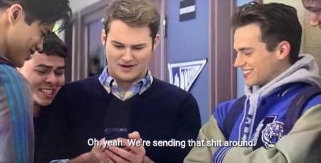  Tape 1 side a (00:44:48) - (00:44:53) Bryce: “Public space? That’s hot. We’re sending that shit around.” | A scene of Justin showing off Hanna’s photo and Bryce Walker sends Hannah’s picture that shows her underwear around the school. | From the scene it is interpreted that there has been cyberbullying by Bryce who humiliated others through social media, namely to Hanna by sending a photo showing Hanna's underwear which made all the students start talking about Hannah as a slut.
 | 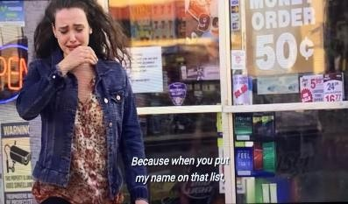  Tape 2 side a (00:43:12) - (00:43:24) Hannah on the tape: “it seems like nothing until the hurricane hits. Because when you put my name on that list, you put target on my…well it wasn’t just my ass.” | A scene of Hanna cries because Alex Standall makes a list “best and worst of ass”. He puts Hannah’s name as the best ass. | From the scene, it can be seen that Hanna is crying because Alex Standall puts Hanna's name as the best ass and makes All the boys around the school start looking at Hannah's butt while she is walking around.
 | 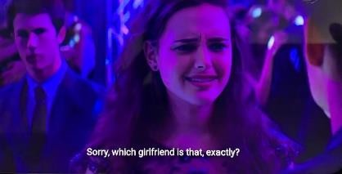  Tape 3 side a (00:34:34) - (00:34:55) Monty: “your girlfriend from the picture, Laura. I heard you two like a guy between you now and then. Courtney says you asked her for a three-way. I don’t blame you. She’s hot. She confirmed that not only did Justin finger you, but you went down on him” | A scene of Hanna is confused When Monty confronts Hannah in front of Clay about Hannah sexuality. | From the scene interpreted that Monty questions Hanna's sexuality in front of Clay and her friends, it can be seen from Hanna's expression that she doesn't and is confused about what Monty is talking about.
2 | Sexual Assault
 | 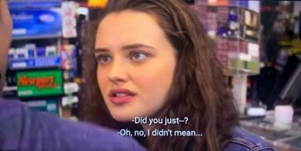  Tape 2 side a (00:42:46) - (00:43:02)  Hannah: “did you just?”  Bryce: “Oh, no. I didn’t mean… it’s just … it’s real tight… in the store. | A scene show Hannah shocked because Bryce Walker reaches over and grabs her ass. | From the scene it is interpreted that Bryce Walker decides to take things further after the list "best ass" spreading around the school. He is offering to buy Hannah a candy, and as he is handing it to herm, he reaches over and grabs her ass. Hannah also said that the list that everyone thought was a joke had made her the target of harassment by her friends at school.
 |   Tape 2 side a (00:42:46) - (00:43:02) Hannah: “did you just?”  Bryce: “Oh, no. I didn’t mean… it’s just … it’s real tight… in the store. | A scene of Hannah's got angry after harrassed by Marcus by groping her thigh without permission and insulting her in the cafe. | From the scene it is interpreted that Marcus is paired up with Hannah by a mutual friend for dollar valentine, a match-making charity event. They are planning for dinner in the restaurant.  Marcus shows up an hour late and with some of his friends on the football team. Marcus without Hannah's consent, he starts to feel thigh after sneakily glancing at his friends.The abuse experienced by Hannah made her depressed and low self-esteem.
 | 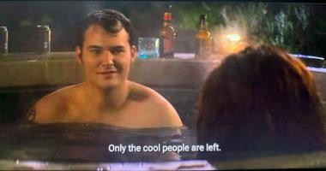  Tape 6 side b (00:42:53) – (00:45:52)  Hannah: “well, uh I’d better get going. My parents are probably super worried by now”  *He grabs her hands* Bryce “you just got here”  Hannah: “sorry, I gotta go” | A scene shows Bryce trying to get Hannah to have sex with him but Hanna refuses. and finally Hanna was raped by bryce. | Bryce comes into the tub then rapes Hannah in his hot tub, and when she comes to her senses, he asks her to stop and tries to run away from him but he can't do anything to stop Bryce. He left bruises on his arms and neck and didn't show any remorse about it. This is not only done by Bryce but also other male friends who often say that Hannah is cheap, a prostitute and so on. As well as the rumors that spread that Hannah was an easy woman and so on which caused her to receive a series of intimidation and sexual harassment and the culmination of which was the rape committed by Bryce.
3 | Judging
 |   Tape 1 side b (00:38:05) - (00:38:25) Jessica: “Enjoy it. Cause you will, won’t you?Cause that’s what sluts do’ | A picture shows Jessica says that Hannah is a slut and slaps her in front of many people. | Jessica angry and thinks that Hannah is the reason why she broke up with Alex. She talks with Hannah in Monet Café. And without asking the truth, she says that Hannah is a slut and slaps her in front of many people.
4 | Depression and Traumatic
 | 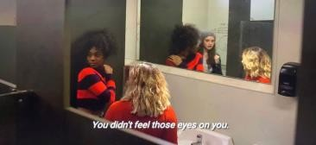  Tape 2 side a (00:22:49) –(00:22:53) Hannah:“you didn’t feel those eyes on you” | A scene shows Hannah is worried about it because people are staring at her. | From the scene it is interpreted that Hannah frustrated because While walking Hannah her friends followed behind her and took pictures of Hannah's ass with their cell phones.
 | 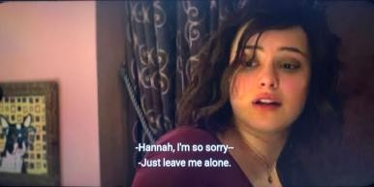  Tape 6 side a (00:37:52) – (00:38:13)  Hannah: “just leave me alone. Okay, just leave me alone, Clay. You should just go”  Clay: “you all right?”  Hannah: “I don’t want you here. Get out!” | A scene shows Hannah becomes lifeless and looks like she is no longer inside of her body. | From the scene it is , Hannah becomes lifeless and looks like she is no longer inside of her body after Bryce raped her. She begins to have flashbacks and cannot handle them. She pushes Clay away.
5 | Staking
 | 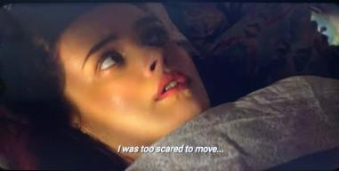  Tape 2 side a (00:07:41) - (00:08:42)  Hannah: “must have been the sound of a tree branch in the wind. But the sound followed me. I was too scared to move, even the shut the blinds” | A scene shows Hannah feels scared about staker. She cannot sleep, because she hears the click of the camera all the time. | From the scene it is interpreted that Hannah hears the click of the camera. she find out that is Tyler Down. Hannah tries to stop it by talking with Tyler. In the end, Tyler shares the picture around the school. It makes Hannah in trouble and Hannah feels paranoid after this.
6 | Suicide
 | Tape 2 side a (00:07:41) - (00:08:42)  Hannah: “must have been the sound of a tree branch in the wind. But the sound followed me. I was too scared to move, even the shut the blinds” | A scene shows Hannah feels scared about staker. She cannot sleep, because she hears the click of the camera all the time. | From the scene it is interpreted that Hannah hears the click of the camera. she find out that is Tyler Down. Hannah tries to stop it by talking with Tyler. In the end, Tyler shares the picture around the school. It makes Hannah in trouble and Hannah feels paranoid after this.
 | 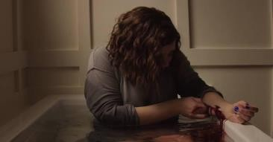  Tape 7 side a (00:33:25) - (00:34:00)  Hannah: “I think I’ve made myself very clear, but no one’s coming forward to stop me.  Some of you care. None of you cared enough. Neither did I and I’m sorry. | A picture shows Hannah killing herself by slicing her hand in the bathroom | From the picture it is interpreted that Hannah was slicing her own hand in a bathtub. Some time later his parents found she is dead.

CONCLUSION

Based on the analysis and the results of data analysis that has been carried out by researchers. that the writer concludes that the social problems experienced by Hannah Baker in the drama series ‘13 reasons why’ are obtained from the scenes that have been taken by the writer and analyzed using Charles Sanders Peirce's semiotics (sign, object and interpretan). In this study, the findings of bullying, depression and traumatic, judgment, sexual assault, stalking and making Hannah finally decided to commit suicide.

REFERENCES

Anriadi, Rahman, F., & Pattu, M. A. (2021). The Practice of Symbolic Violence in George Orwell’s Novel 1984. American Journal of Humanities and Social Sciences Research (AJHSSR), 5(11),144-153.
Arviani, H., Subardja, N. C., & Perdana, J. C. (2021). Mental Healing in Korean Drama “It's Okay to Not Be Okay. JOSAR (Journal of Students Academic Research), 7(1), 32-44.
Bal, M., & Bryson, N. (1991). Semiotics and art history. The art bulletin, 73(2), 174-208.
Borchmeyer, D. (2003). Drama and the world of Richard Wagner. Princeton University Press.
Chandler, D. (2007). Semiotics: the basics. Routledge.
Danesi, M. (2010). Pesan, Tanda, dan Makna: Buku Teks Dasar Mengenai Semiotika dan Teori Komunikasi . Yogyakarta: Jalasutra.
Goodman, L. (2015). Literature and Gender. Oxon: Routledge
Hoed, H. B. (2008). Semiotics and Socio-Cultural Dynamics. Jakarta: University of Indonesia.
Klarer, M. (2013). Introduction to Literary Studies. USA and Canada: Routledge
Peirce, C. S. (1991). Peirce on signs: Writings on semiotic. UNC Press Books.
Ramlan, W., & Supratman, L. P. (2019). Analisis Semiotika Charles Sanders Peirce Pada Sampul Majalah Tempo Edisi Satu Perkara Seribu Drama. eProceedings of Management, 6(2).
Rahman, F. (2017). Cyber literature: A reader–writer interactivity. International Journal of Social Sciences & Educational Studies, 3(4), 156.
Rahman, F. (2018). The Constraints of Foreign Learners in Reading English Literary Works: A Case Study at Hasanuddin University. Journal of Arts and Humanities, 7(2), 01-12.
Sukmawaty, Rahman, F.F., Andini, C. (2022). The Shift of Honorifics due to The Promotion As A Government Official: Comparative Study. ELS Journal on Interdisciplinary Studies in Humanities, 5(1), 166-176.
Zakaria, A. D., Rahman, F., & Armin, M. A. (2021). The Myths Of Symbol Of Singgi’tedong Speech In Ma’pandan Ritual In Mamasa Regency. NVEO-NATURAL VOLATILES & ESSENTIAL OILS Journal| NVEO, 2778-2786.
Zain, N. A., Valdiani, D., & Puspanidra, T. (2021). REPRESENTASI SISI KEMISKINAN DALAM FILM PARASITE (ANALISIS SEMIOTIKA CHARLES SANDERS PEIRCE). Jurnal Penelitian Sosial Ilmu Komunikasi, 5(2), 83-90.

