https://ejournal.unkhair.ac.id/index.php/tekstual https://doi.org/10.33387/tekstual.v21i1.6256
Open Access



P-ISSN: 1693-1041, E-ISSN: 2686-0392

Language Politeness on Instagram: A Case Study of Public Officer at Jakarta, Indonesia
Noval Nur Hidayat1, Fathu Rahman2, Asriani Abas3
^{1,2,3}Cultural Sciences Faculty, Hasanuddin University, Indonesia Correspondence: pelosstyle@gmail.com
Article History
Published
Copyright © 2023 Universitas Khairun: Under the license
CC BY-SA 4.0



Abstract
Advances in technology at this time not only to open mind but also changed the way humans communicate and interact. Forms of communication that are generally carried out face-to-face have now shifted a lot to virtual forms of communication on social media as intermediaries. Furthermore, communication on social media allows people to speak freely without thinking about language ethics and politeness. This virtual communication not only involves text alone but also uses emotions to represent a picture of their feelings. This research aims to find the use of official language on Instagram social media and to analyze the use of public officials' language when communicating on social media. The social media chosen as the subject of this study is Instagram which is widely used and accessed by internet users. This research used a descriptive qualitative method. The data source for this research prioritizes uploads by public officials only. The implementation of data collection in this study was a documentation method by collecting uploads of public officials on Instagram social media. The results of this study found that most public officials in private uploads had impolite comments seen in five factors, namely direct criticism with harsh words, encouragement of the speaker's emotional sense, protective of opinions, deliberately accusing the interlocutor, and deliberately cornered speech partners.

Keywords: Language Politeness, Instagram, Indonesia, Officer.

- BACKGROUND

Communication is important in interactions between social beings. Furthermore, language is a communication tool to convey expressions of something to others (Rahman, 2018; Sukmawaty et al., 2022). However, someone's expression has its own uniqueness, which can be seen from the conditions that are being experienced. An expression of one's personality that needs to be developed is an expression of a good, correct, and polite personality so that it reflects one's refined mind and noble character (Rahman et al., 2019; Andini et al., 2021). Every human being places a different social life as a result of language ethics also showing behavior or behavior in speaking (Nasution et al., 2021; Andini et al., 2022). In this case, the language system has a function as a means of ongoing human interaction in society (Chaer, 2010, p. 6; Siregar & Sosrohadi, 2021).
The use of polite language has not received much attention widely. This happens because language users do not know that in a language structure there is a politeness structure (Nakamura, 2014; Sukmawaty et al., 2022). Polite language structures are language structures composed by speakers/writers so as not to offend listeners or readers (Pranowo, 2012, p. 4).
Even though there are many ways for the parties to communicate using polite language, the fact is that communication that often occurs is not polite. There are several factors that cause the use of impolite language, namely direct criticism with harsh words, encouragement of the speaker's emotional sense, protective of opinions, deliberately accusing the interlocutor, and intentionally cornering speech partners (Pranowo, 2012, p. 68-71; Hamuddin et al., 2022).
Moreover, social media is online media is used to interact and share, limited by space and time. According to Prihatiningsih (2017, p. 54), social media is online content media created using publishing technology that is very accessible and scalable. One thing to note about technology is that there are disputes over how people know how to read, share stories, and seek information (Hamuddin et a., 2023; Chun et al., 2016; Junaid et al., 2023).
In today's internet era, the types of online social media are very diverse. One of them that is often used by netizens is Instagram. Instagram is a social networking site which was released on October 6, 2010 by Kevin Systrom, furthermore, as time goes by, it continues to grow(Mudrikah, 2020). At first, there were only a few users, but it has more than 8 million users from all over the world now. It was created to share moments in the form of photos and videos that allow users to take photos, take videos, apply digital filters, and share them with various social networking services, including Instagram's own (Rahman et al., 2019; Krismasakti, 2019).
The researcher's interest in examining the language politeness of public officer is based on several reasons. First, upload photos or videos that are uploaded very updated. Second, every uploaded information generally invites a lot of comments and various responses from its readers. Third, the diverse members who come from various educational backgrounds and ages cause the emergence of very varied forms of sentences and responses in language. Furthermore, the purpose of this research was formulated to describe the form of politeness in the language of public officials in uploads on Instagram.

- METHOD
This research used a descriptive qualitative method. At this stage, the researcher collects facts or data naturally in the form. The utterances in communication of comments uploaded by public officials are used as primary data. The research data is in the form of uploaded words or sentences and direct responses both in the form of discussion and vice versa in uploads on Instagram.
Researchers naturally observe and collect data in the form of written speech uploaded by public officers. So, researchers are not known to people in commenting on uploads of public officials, limited to observing and based on the data needed in this research.
The data source for this research includes private uploads of public officials only. Considering the contents of various uploads and the number of uploads every day is very large. Political news is the object of this study, seeing that news uploaded during political events is often discussed in public.
The data collection method used in this research is the documentation method, namely documenting the results of uploading information from public officials on Instagram social media. The procedures performed in data collection are as follows; 1) the researcher screenshots the uploads of public officials from Instagram social media, 2) the screenshot results are entered into the format that has been prepared. Validation of the collected data is inventoried, then analyzed by following the steps below; 1) classify data based on to the objectives or research questions, 2) analyze the data by developing a theory, 3) conclude the research results.

- FINDINGS AND DISCUSSIONS
The posted news from public officers in a month there are more than 10 news information. Furthermore, the news is not only in the form of verbal but many are accompanied by image information. Of course, the presentation of this image is accompanied by the intention that the information is visually presented so that the information becomes reliable.
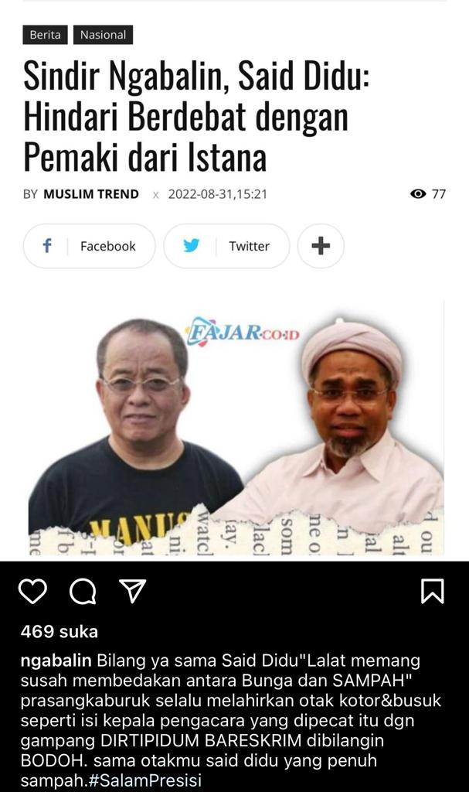
Figure 1. Data 1: satire
Data 1
NGABALIN’S SARCASM,
SAID DIDU: AVOID ARGUING WITH PALACE CUSTODIANS
Ngabalin Tell Said Didu "it's hard for flies to tell the difference between flowers and TRASH" bad prejudice always gives birth to dirty and rotten brains like the contents of the head of a fired lawyer who is called STUPID. Just like your brain Said Didu which is full of garbage.
It can be seen in Data 1 above that Ngabalin posted on his Instagram account and satirized a Secretary of the Ministry of State-Owned Enterprises (BUMN). Responding to Said Didu's satire, Ali Ngabalin immediately returned to writing a tweet that he addressed to Said Didu.
The post above is included in the impolite category, this public officer used harsh words such as dirty, trash, and rotten. Of course, sentences like this are very inappropriate to say to someone, especially on social media because many other social media users can see the post, because of this, this caused the public to be in an uproar and talk about this matter then made it go viral and this caused more complicated problems, such as attacking each other, so that they could be prosecuted in court.
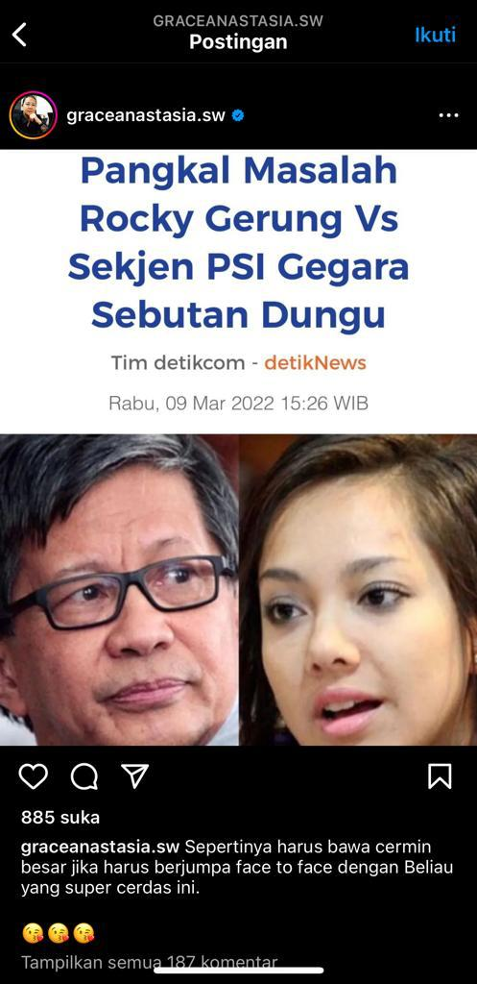
Figure 2. Data 2: satire
Data 2
THE ORIGIN OF THE PROBLEM, ROCKY GERUNG VS SECRETARY GENERAL OF PSI .. BECAUSE OF THE NICKNAME DUNGU (DUMB)
It seems like you have to bring a big mirror when you want to meet face to face with this super smart guy
As shown in Data 2 that the Secretary General of PSI (Indonesian Solidarity Party), Dea Tunggaesti 'attacked' each other with the Democracy Education Association (P2D) researcher named Rocky Gerung. The root of the problem for both was the discourse on postponing the 2024 elections. At first, the Secretary General of PSI, Dea Tunggaesti, was firm in rejecting the postponement of the 2024 elections. According to him, the reason for postponing the elections was due to the pandemic situation. Dea Tunggaesti posted a sentence that satirized Rocky Gerung, namely “it seems like you have to bring a big mirror if you have to meet face to face with this super intelligent person. This sentence expresses satire on the phrase "he is super smart".
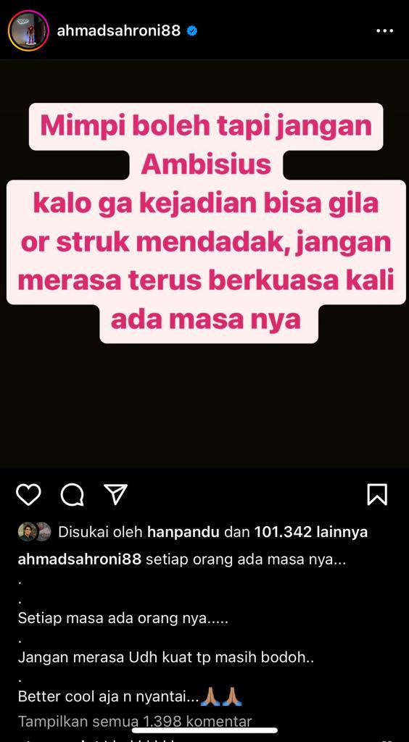
Figure 3. Data 3: harsh words
Data 3
DREAMS ARE OKAY BUT DON'T BE AMBITIOUS. IF NOT, YOU CAN GO CRAZY OR SUDDENLY HAVE A STROKE. DON'T STAY IN POWER BECAUSE THERE IS A TIME

Every time there are people
Don't feel strong but still stupid
Just cool off and relax
It can be seen in Data 3 that Ahmad Sahroni, a politician from the NasDem Party (One of the party names in Indonesia is the National Democrats), Ahmad Sahroni, he said that the dream of becoming president is not impossible. "If there is a way, allhamdulillah (all praise belongs), if not, allhamdulillah. As long as dreams are free, you don't pay," he said. Director of LSI (Indonesian Survey Institute), Denny JA, Ardian Sopa said that the dream of Ahmad Sahroni is a high level joke that is not impossible to achieve. According to him, this dream is not just an unnatural dream, but it is actually a positive thing and must be woken up soon for it to be realized, so he posted an article on his social media account "Dreams are allowed but don't be ambitious otherwise events can go crazy or sudden strokes, don't feel that there are times when you are in power.” It can be said that he utterance the harsh word to someone in his private account.
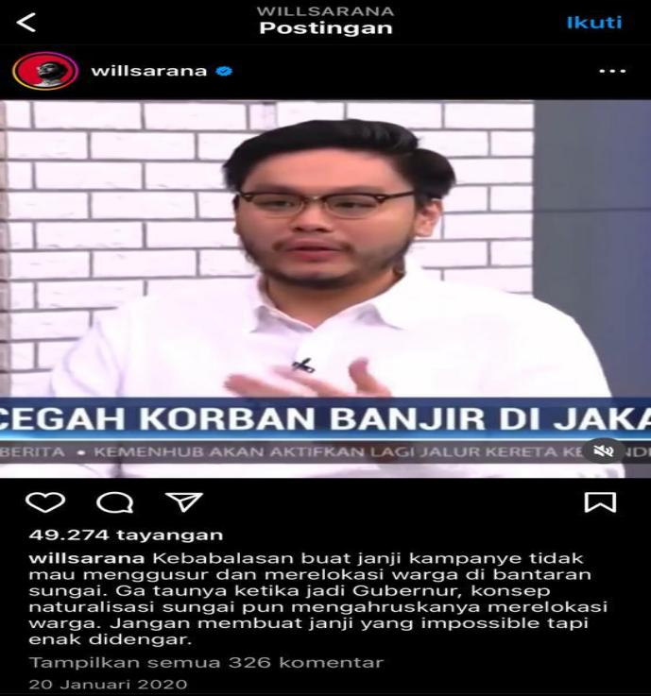
Figure 4. Data 4: harsh words
Data 4
PREVENTING FLOOD VICTIMS IN JAKARTA

It's too late to make campaign promises not to evict and relocate residents on the banks of the river. When it became governor, the concept of river naturalization also required it to relocate residents. Don't make promises that are impossible but pleasant to hear
Data 4 shows that Willsarana’s account posted on his private account that he satirized the government for promising to relocate residents living on the banks of the river in the campaign for the gubernatorial election, as written on his personal Instagram account "too much for campaign promises not to evict and relocate residents on the banks of the river. As a matter of fact, when he became governor, the concept of river naturalization forced him to relocate residents. Don't make promises that are impossible and pleasant to hear." The language he spoke was impolite, it marked by his unfamiliarity when he became governor, the concept of river naturalization forced him to relocate residents. As shown in this data, the utterance very rude to listen and it can hurt other people's feelings.These posts appear to give advice at first glance but contain harsh satire of the person it is intended for, which can trigger conflict.
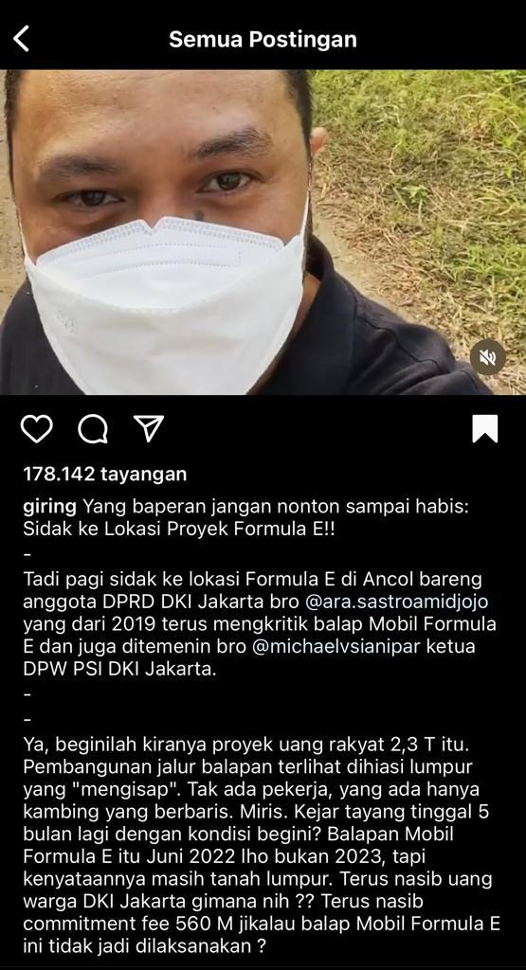
Figure 5. Data 5: satire
Data 5
SARCASM TOWARDS THE LOCATION OF FORMULA E IN ANCOL

Yes, this is the 2.3 trillion people's money project. The construction of the race track looks decorated with mud that "sucks in". There are no workers, there are only goats lined up. Pity, only 5 more months with this condition? The Formula E car race is June 2022 not 2023, but the reality is it's still mud. What about the fate of Jakarta residents' money? What will happen to the commitment fee of 560 billion if the Formula E car race doesn't take place?
As seen in Data 5, Giring said that the Formula E race track in Ancol was muddy, and it causing him to fall. Apart from that, according to him, there were only goats roaming the Formula E circuit construction site. Not only that, Giring also uploaded a video showing him mired in mud at the construction site of the Formula E circuit. According to him, PSI will also continue to oversee the openness of organizing Formula E in terms of the budget that has been issued. He ridiculed the government, especially the governor who was in office at that time because the funds used were very large but the development was so far from feasible that it raised suspicion, and he alluded to this by uploading a video where he was mired in mud and his language said "don't watch it until it's finished if you're upset", the government concerned.

- CONCLUSION

Language politeness is a good language activity and it contains awareness to respect other people when speaking, either directly or indirectly. Politeness through social media can be seen when answering questions, providing feedback and or commenting on a status. Polite language must be avoided from cruel comments, bullying, insulting and/or discrediting someone either obligatory or in harsh expressions. It is inappropriate to use dirty words, insult someone and contain racism.
The results of this research indicate that the interaction between speakers (politicians) speak dirty words, bullying, looking down on, discrediting and even insulting which actually doesn't need to happen because they are people who can be used as role models in communication, it's okay to have different opinions but by using polite language and not vice versa.

REFERENCES
Andini, C., Yassi, A. H., Sukmawaty. (2021). The Use of Honorifics in English and Buginese with special Reference to Bone Language: A Comparative Study. International Journal of Innovative Science and Research Technology, 6(7), 873-877.
Andini, C., Sosrohadi, S., Fairuz, F., Dalyan, M., Rahman, F. F., & Hasnia, H. (2022). The Study of Japanese Women in the Facial Treatment Advertisement: A Semiotics Perspective of Pierce’s Theory. ELS Journal on Interdisciplinary Studies in Humanities, 5(2), 337-347.
Chaer, A. (2010). Language politeness. Jakarta: Rineka Cipta.
Hamuddin, B., Syahdan, S., Rahman, F., Rianita, D., & Derin, T. (2022). Do They Truly Intend to Harm Their Friends?: The Motives Beyond Cyberbullying among University Students. In Research Anthology on Combating Cyber-Aggression and Online Negativity (pp. 775-788). IGI Global.
Hamuddin, B., Rahman, F., Pammu, A., Baso, Y. S., & Derin, T. (2023). Mitigating the effects of cyberbullying crime: A multi-faceted solution across disciplines. International Journal of Innovative Research and Scientific Studies, 6(1), 28-37.
Junaid, S., Ahmad, Nurhidayah, Mujizat, A., Andini, C. (2023). The Quality of Human and Non-Human Relation in Indonesia and England Portrayed in the Selected Picture Books. ELS Journal on Interdisciplinary Studies in Humanities, 6(2), 211-218.
Mudrikah, I. M. (2020). Political Branding Politisi Perempuan di Instagram: Kasus Pada Tsamara Amany Alatas. Jurnal Politikom Indonesiana, 5(2), 29-39.
Nakamura, K. (2014). The use of polite language by Japanese preschool children. In Social interaction, social context, and language (pp. 253-268). Psychology Press.
Nasution, M. M., Izar, J., & Afifah, I. H. (2021). An Analysis of Hate Speech Against K-Pop Idols and Their Fans on Instagram and Twitter from The Perspective of Pragmatics. Journal of English Teaching and Linguistics, 2(2), 91-99.
Pranowo. (2012). Berbahasa secara santun. Yogyakarta: Pustaka Pelajar.
Prihatiningsih, W. (2017). Motif penggunaan media sosial instagram di kalangan remaja. Communication, 8(1), 51-65.
Rahman, F. (2018). The Constraints of Foreign Learners in Reading English Literary Works: A Case Study at Hasanuddin University. Journal of Arts and Humanities, 7(2), 01-12.
Rahman, F., Abbas, A., Hasyim, M., Rahman, F., Abbas, A., & Hasyim, M. (2019). Facebook Group as Media of Learning Writing in ESP Context: A Case Study at Hasanuddin University. Asian EFL Journal Research Articles, 26(6.1), 153-167.
Rahman, F., & Amir, P., Tammasse. (2019). Trends in Reading Literary Fiction in Print and Cyber Media by Undergraduate Students of Hasanuddin University. International Journal of Education and Practice, 7(2), 66-77.
Siregar, I., & Sosrohadi, S. (2021). Analysis of Code Mixing in Jerome Polin Youtube Content “Nihongo Mantappu”. International Journal of Linguistics, Literature and Translation, 4(12), 01-08.
Sukmawaty, Rahman, F. F. & Andini, C. (2022). Covid-19 Pandemic and Axiology of Communication: A Study of Linguistic Phenomena. IJISRT, 7(4), 1079-1087.
Sukmawaty, S., Andini, C., & Rahman, F. F. (2022). The Shift of Honorifics due to The Promotion As A Government Official: Comparative Study. ELS Journal on Interdisciplinary Studies in Humanities, 5(1), 166-176.

