

Micro-Teaching Video as Assignment for Indonesian EFL University Students; Exploring Pre-Service Teachers’ Self-Efficacy
Dwi Budidarma Sutrisno^{1*}, Jasmal Martora², Megawati Basri³
^{1,2,3}Universitas Pasifik Morotai, Indonesia
*Correspondence: dwibudidarmasutrisno@gmail.com

 | Abstract  This qualitative research aims to explore perspectives from Indonesian EFL pre-service teachers about their self-efficacy through micro-teaching video assignment. The data were collected from observation, questionnaire, and written reflection taken from 19 participants of first, second, and third year university students in an English language education study program at one of the private universities in North Maluku. The results show that the students’ approaches to the instruction of creating micro-teaching are varied, while the students’ performance is influenced by limited vocabulary, grammar issues and subject matter comprehension, and finally students’ reflections include challenges and languages used in micro-teaching videos as well as their self-efficacy consisting their learnings, realizations, and beliefs.  Keywords: Pre-Service Teachers, Micro-Teaching, Self-Efficacy  Abstrak  Penelitian kualitatif ini mengeksplorasi sudut pandang dari calon guru konteks Bahasa Inggris sebagai bahasa asing di Indonesia tentang efikasi-diri melalui tugas vidio mikro mengajar. Data-data diambil dari observasi, survey, dan refleksi dari 19 koresponden dari mahasiswa tahun pertama, kedua, dan ketiga pada program studi pendidikan Bahasa Inggris di salah satu kampus swasta di Maluku Utara. Hasilnya menunjukkan bahwa pendekatan para siswa terhadap instruksi yang diberikan begitu variatif, sedangkan penampilan siswa dipengaruhi kosakata yang terbatas, masalah tata bahasa, dan pemahaman tentang materi terkait, refleksi para siswa termasuk tantangan, bahasa yang digunakan dan efikasi-diri terdiri dari pembelajaran, kesadaran dan juga kepercayaan.  Kata Kunci: Calon guru, Mengajar mikro, Efikasi-diri
  Article History
  Received 10/10/2022
  Accepted 10/11/2022
  Published 10/12/2022
  Copyright © 2021 The Author(s): This an open-access article distributed under the terms of the Creative Commons Attribution ShareAlike 4.0 International
  (CC BY-SA 4.0)
  

1. Introduction
The concept of micro-teaching was first introduced and developed by Dwight W. Allen from Stanford University in the 1960s, a practical approach aimed to support the development of educators in any type of field (Ping, 2013 in Kirsch & Sarmento, 2018). The process of microteaching usually involves lesson planning, teaching the materials, then followed by giving and receiving feedback (Brown, 1975 in Tulgar, 2019). In addition to that, microteaching will also likely require a video recording of the teaching as a detrimental part of the microteaching (Quinn, 2000, in Tulgar, 2019). Therefore, it can be argued that micro-teaching has been an integral part of the teacher training process to develop teaching skill.
Utami (2020) conducted a study with Indonesian EFL students who take a course called microteaching, the research focusing on the challenges that students may find during their time taking this course, especially when they do microteaching as part of the course. The research is a descriptive qualitative using questionnaires and interviews with 156 participants that later becomes 14 through random lottery. The research found that the majority of the participants have difficulties when it comes to managerial categories such as planning the materials, explaining the contents, controlling the microteaching in general. Moreover, some participants also experienced being nervous when delivering the microteaching while others are aware of their own mistakes and correcting themselves.
Ledger & Fischetti (2020) did mix-method research involving observation and questionnaire, they studied first-year students of pre-service teachers from two different universities, one in Australia and the other one in England. The study claimed that they did a combination of traditional microteaching with simulation technologies that allow the participants to teach using avatars. The study reveals that the benefits include good experience of microteaching using avatars that technically help improve confidence and the system is considered having great flexibility for teaching. As for the challenges, technical issues are found considering the use of VR technology, some find it as not real teaching, while others also expressing their opinions on their preference for doing it in the classroom.
Zulfikar et al (2020) carried out a qualitative study with semi-structured interviews and weekly written narratives from the participants consisting of 10 Indonesian EFL students during their senior year of college who have gone through micro teaching courses as well as required teaching internships. The study particularly looked at the students’ perspectives on the benefits from microteaching. It is found that the benefits gained by the students are related to improving their self-confidence, having their teaching strategies developed, and as a chance to build their communication skill within the context of students and teacher in class. In addition to that, some also reveal that microteaching did not help them to prepare themselves for the real situations such as how to manage classes with a big number of students as well as how to manage their time when things do not really go as they planned.
Zalarva & Makri (2022) performed qualitative research with 30 students from diverse majors including Greek language, mathematics, computer science, primary education and many more at a university from Greece. The 30 participants become 10 then group into four collaborative teams. The research focusing on microteaching delivered through online with technology-enhanced. The findings show that the participants having difficulties when it comes to choosing the digital tools for the online microteaching, time limitations also becomes an important issue considering time allocated for team negotiations, and then technical difficulties is also considered as one of the challenges. The study also emphasizes the importance of learning how to teach in the context of online teaching and learning.
While self-efficacy as a concept first discussed by Albert Bandura in 1977 centering around social cognitive theory about how beliefs and attitudes coming from those who learn and train to be a teacher will definitely be affecting their teaching, in other words, what pre-service teachers have gone through during their studies will be impactful when they finally become a teacher in their teaching roles (Bandura, 1997 in Egnili & Solhi, 2021). Therefore, studies related to self-efficacy of pre-service teachers has been fundamental within the realm of education to make sure the students are well equipped to teach after graduating. In addition to that, self-efficacy is not only about pre-service teachers’ knowledge when it comes to teaching, but more importantly about how they see themselves as teachers in the classroom.
Megawati & Astutik (2018) studied 27 seventh semester university students currently conducting teaching practicum in various schools. The study is considered a survey research using questionnaires consisting of 15 questions where the participants are required to choose five different responses including strongly agree, agree, I don’t know, disagree, and strongly disagree. The study found out that most of the participants agree that they have self-efficacy in terms of teaching English grammar and culture. Moreover, for the lesson planning competence, almost a quarter of the total participants indicate that they are still having difficulties structuring the lesson plan. In addition, for assessment, there are few participants showing their struggle to do assessment for their students’ English proficiency. Furthermore, even though classroom management self-efficacy shows positive response, a more in-depth analysis found that some participants who cannot respond positively have challenges because of the different types of difficulties such as the number of students in a classroom.
Tulgar (2019) looked at 45 pre-service EFL teachers within the context of Turkish in Turkey by collecting the data through open-ended questions, observation from instructor and observation from peers. The study found that most of the participants showed a positive response to micro-teaching, including improved confidence, more awareness of points of view on how to be a student compared to how to be a teacher during microteaching. However, others experienced difficulties in classroom management, and cannot really take feedback positively because they perceive comments on their microteaching negatively.
Sumarno (2019) investigated 39 pre-service teachers using a descriptive qualitative research method by having the participants do three microteaching followed by questionnaire and interview. The study reveals that after doing the microteaching most of the participants feel confident about students' engagement in their class, but only a small number of participants show their confidence in class management. Overall, the study concluded that even though participants’ self-efficacy is not that high after microteaching, it is observed to be higher before microteaching shows that micro teaching is helpful for the participants.
Lee at al (2023) researched students from a private university in South Korea consisting of 134 with surveys analyzed through ANOVA and t-test followed by 10 participants for interviews. This mixed-method approach research shows that survey reveals no significant difference of self-efficacy among participants from different semesters, while interviews found some prefer online microteaching while others like face-to-face microteaching.
A lot of previous research has been done about microteaching and self-efficacy; however, those studies often have been looking at these two topics separately and there is only a few research investigating the topics together. Therefore, this current research aims to carefully explore these issues collectively on how microteaching affects self-efficacy. The importance of looking at this topic is because of how connected and intertwined the issues of investigating university students as the pre-service teachers’ self-efficacy through micro teaching activities, it can be a natural environment where students who aspire to be teachers having teaching practices despite of their background of currently teaching or not currently teaching.

2. Method
This study is descriptive-qualitative research. The participants of this research include 19 students in total from first, second, and third year taking different courses at the same time. The microteaching video assignment is based on the courses they currently take, the microteaching can also function as the medium to showcase students’ comprehension of the materials they have been studying.
The data were gathered from observations, questionnaires, and reflection. The observation is about the microteaching video, the questionnaire was distributed after the students completed the video about their performance, and then the written reflections with guided open-ended questions about their self-efficacy.
The research questions for this particular study include (1) How are the students’ overall performance in a microteaching video assignment ? (2) How do the students perceive their microteaching video as an assignment? and then (3) How are students’ perspectives on their self-efficacy after doing microteaching?
The data collected from observations, questionnaires, and reflections will go through a thematic analysis method from Braun & Clarke (2006). It is expected that each of the data collection methods will be translated into analyzed data related to the topic of this research about the pre-service teachers’ self-efficacy. Moreover, it is also important to mention that considering this is a qualitative research, the research is interpreted through commonality and pattern that can be found during and throughout data collection and data analysis (Cresswell, 2018)

3. Findings

3.1 Observation Result
Based on the microteaching videos that students uploaded on social media, the videos are varied in terms of length even though the instruction for the duration is 10 minutes long minimum. Some students meet the requirement while others come with less than 10 minutes of videos, in other words, less than the instructed details about the video. These decisions of creating such length of micro-teaching videos are later answered when the participants respond to questionnaire and the reflection, this will be explained and elaborated more in each of the sections together with the patterns being found from the research.
Some students record a microteaching video in a class with white board, while others only record themselves in their bedroom. It is interesting to see how students respond to the microteaching video assignment differently considering the researcher who is also the instructor of the courses lets the students experiment and be creative with the video making process by not giving any specific requirement in terms of the video content. For those who do the microteaching video using whiteboard in the classroom shows a classroom context by having imagined interactions with imagined students. While those who prefer to make a microteaching video that recorded in their bedroom add their creativity using multimodality including images, texts, and audio playing in the background. The choice to record the video vertically or horizontally is important to note, some are comfortable to have the video recorded vertically while others choose horizontal might have something to do with how they usually record or upload a video to social media. It is also interesting to see variations in presenting the video.
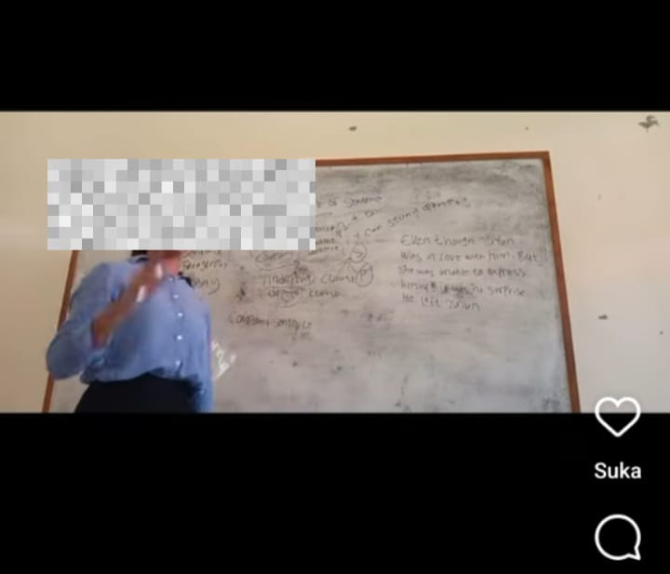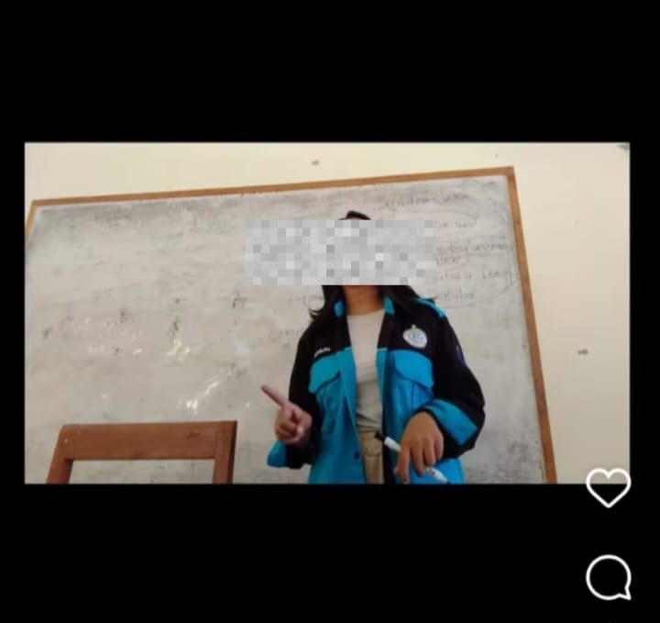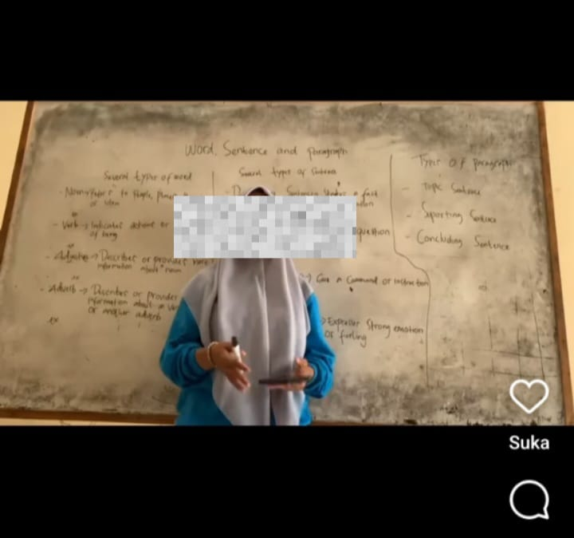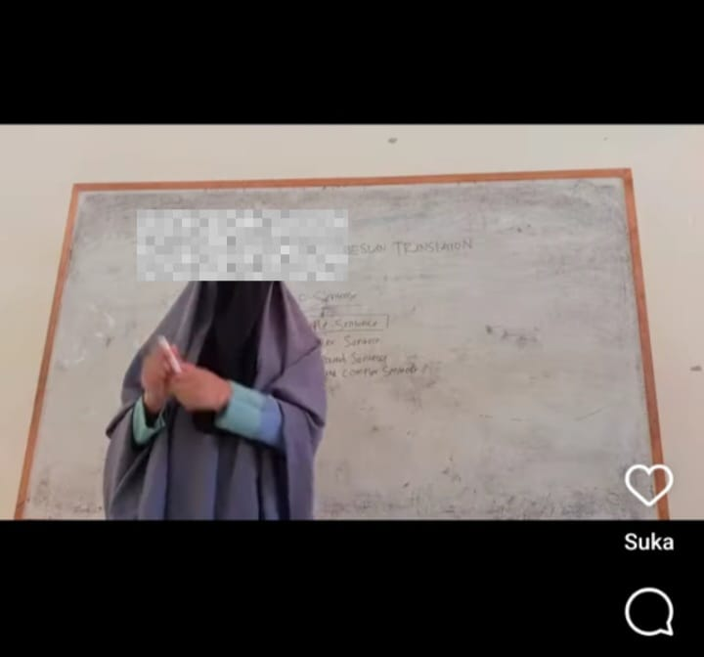
Image: Micro-teaching videos

3.2 Questionnaires Result

Limited Vocabulary

It is found that more than half of the participants admit that they have limited vocabulary and influencing their performance on micro-teaching video assignments. That is why only a few participants use 100 percent English when delivering their materials for micro-teaching video. It is interesting to note that the participants only give their response through options neutral, agree, and very agree. None of them show the answers by clicking options disagree or very disagree. This means the participants who are the university students as well as pre-service teachers clearly being mindful about their English vocabulary.
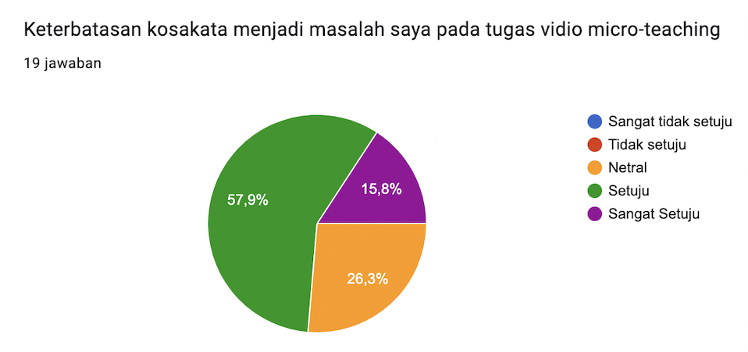
Image: Questionnaire from question on limited vocabulary

Grammar Issues
Information taken from the questionnaires also indicated that three-quarter of students participating in this research showed problems with grammar mastery. The issues with grammar is used as the reason for not being completely confident and therefore they use less English during their micro-teaching. The researcher expects to receive answers other than grammar issues when asking the reason behind their choice of language allocations during their micro-teaching.
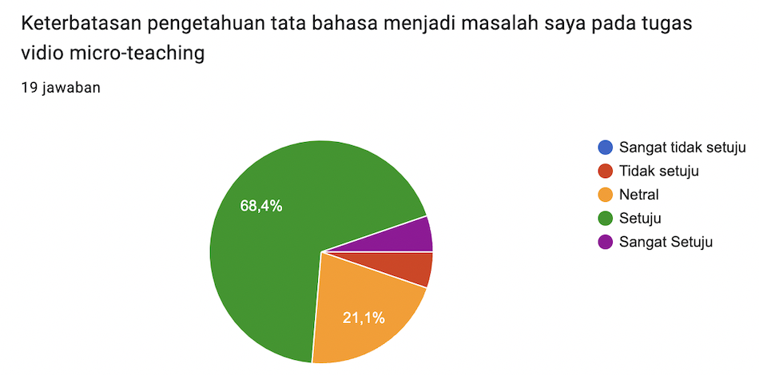
Image: Questionnaire from question on grammar issues
Subject Matter
There is only a small number of participants who admit that they have difficulties understanding the subject matter that they teach in microteaching videos. In other words, almost everyone in this study has a good understanding of the teaching materials being taught in their videos. It can be said that the participants have adequate comprehension on what they want to teach in a video.
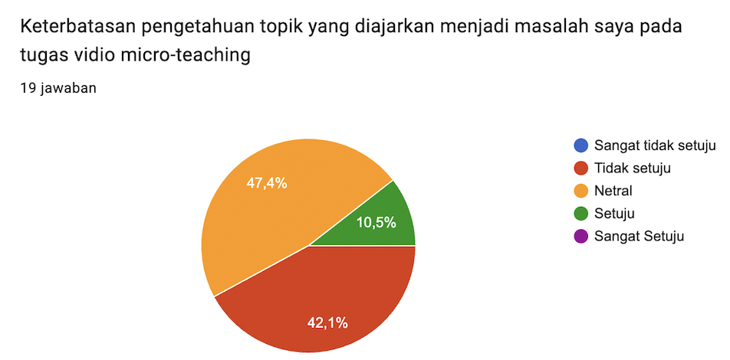
Image: Questionnaire from question on subject matter

3.3 Reflections Result

Challenges in Micro-Teaching

Most of the participants mention vocabulary to be their major difficulties in presenting their material in micro-teaching video that can be seen through the result of questionnaires, however, it is also important to emphasize that other issues exist as well considering the use of video as the medium of micro-teaching.
“My environment was a bit noisy, and it disrupted the process of creating the micro-teaching video”
“Repeatedly retake video”
One of many technical issues faced by the participant is how they deal with their surroundings when they plan to record the video. They need to make sure they have quiet space in order to take the video properly considering they talk a lot in a video for a certain length of time and duration presenting their teaching.
“The challenges when I make the teaching video is I must study hard before about the material, but I love the assignment”
Other than technical issues related to video making, there are also some participants highlighting the preparation stage to be taken into consideration as one of the challenges. The preparation centers around fully comprehending the teaching materials before delivering what they want to say in the video format.
Languages in Micro-Teaching

Almost everyone stated that they do not completely use English as a medium of instruction, however, the reason behind that is mostly based on their lack of vocabulary. There are only a few participants considering mixing the language between English and Bahasa Indonesia for learning objectives purposes.
“Jika menggunakan 50% bahasa dalam micro teaching akan membantu memberikan penjelasan yang lebih jelas pada audiens terkait topik yang dibahas, di mana bahasa inggris adalah the foreign language walaupun bahasa inggris menjadi bahsa internasional, terkadang banyak orang susah menangkap maksud dari speaker it’s not clear, audiens kurang puas dengan penjelasan yang hanya menggunakan bahasa inggris, keterbatasan kosakata dan pemahaman audiens menjadi pertimbangan penggunaan bahasa inggris ketika process teaching”
The English translation : The use of 50% Bahasa Indonesia in micro teaching will help in giving clearer explanations to the audience related to the topic being discussed, English is considered as foreign language, even though English is seen as international language but there are many people who cannot understand when someone speaks in English, the audience might not relate with a English-only explanation, therefore the lack of vocabulary and understanding becomes the consideration for the use of English as medium of instruction in English class.

This particular reflection highlights an important discussion on the issue of multilingualism. It is interesting to find out that the participants are already mindful about the context of being a pre-service teacher in Indonesia as a multilingual country. This shows that the use of mixing and switching languages between English and Bahasa Indonesia is not only about the lack of vocabulary.
“Selain kurangnya kosakata saya, saya menggunakan bahasa campuran Indonesia dan Inggris agar orang lebih mudah paham kalau ada beberapa kata atau frasa dalam inggris or Indonesia”
The English translation : The reason I mix English and Bahasa Indonesia is not only because I have limited English vocabulary. The other reason is because I want other people to understand what I say so that is why there are combinations of words or phrases in English and in Bahasa Indonesia.
Another similar reflection shows their intention of wanting to be understood by other people for the teaching objectives purposes. These reflections illustrate that participants already see and try to put themselves as a teacher.
Pre-Service Teachers’ Self-Efficacy

The participants show thorough reflections after completing the micro-teaching video assignment. In other words, the combination of micro-teaching and video format is proven to be beneficial for the participants to look at themselves and consider what they have done and objectively assess their own performance within the videos.

“Ternyata percaya diri itu sangat penting untuk seorang calon guru dan pengucapan serta harus perbanyak lagi vocabulary saya karena dalam kegiatan pembelajaran kita menggunakan kata yang itu itu saja sangat lah membosankan”
English translation: I have realized that confidence is important for a pre-service teacher. It is also crucial to expand vocabulary so that the class will not be boring.
“Yang saya pelajari dari vidio micro teaching adalah bagaimana saya dapat menjelaskan materi layaknya seorang guru”
English translation: What I have learned from micro-teaching video assignment is that how I can explain the teaching teaching materials as a teacher
Some of them point out confidence as one of the major factors in becoming a teacher. It means they started to carefully look for specific elements that make someone a teacher after reflecting on their own teaching performance. Moreover, others also note that they start thinking of how they will look as a teacher. It is important for pre-service teacher to see and imagine themselves as the profession.
“Dari tugas video micro teaching kemarin saya dapat mengenali kekuatan atau mengetahui kemampuan saya dalam pengajaran seperti penggunaan media pembelajaran yang efektif, area yang perlu ditingkatkan, menejemen waktu, memperluas wawasan tentang materi yang akan diberikan dan juga memperkuat keyakinan saya dalam memilih profesi sebagai seorang guru atau pendidik”
English translation: From micro-teaching assignments I have recognized my strength in teaching such as how to use media effectively. The areas I need improvement include time management and better understanding of the teaching materials as well as strengthen my belief in choosing teacher or educator as a profession”
“From the process of creating the video assignment, it was very helpful in improving my speaking skills and also training me to reduce nervousness. Additionally, when I practiced the material, I found that I understood it better”
Furthermore, some of the participants realize their own weakness which is a good start before starting to work on the efforts on the areas that need improvement. While others also raise the issues of being nervous but also recognize that practice helps to overcome such issues.

4. CONCLUSION
The result of the current study resonates with what has been found by Sumarno (2019) and Zulfikar et al (2020) in terms of how micro-teaching helps build confidence. Therefore, this current study can be considered as additional representation of such findings that micro-teaching is beneficial for not only improving but also building pre-service teachers’ confidence in teaching.
Ledger & Fischetti (2020) who did their study using advanced technology such as virtual reality for micro-teaching videos found that the participants experienced some degree of technical issues. This is also somewhat the case with the current study, even though the level of difficulties due to the difference in technology being involved. The instruction of current study is as simple as creating a micro-teaching video, however, for some participants who are not really familiar with editing video this might bring some challenges. In addition to that, technical being found in this current study is not only about the editing process, it also includes the process of recording the video, some said that they need to take multiple recordings before finally starting the editing stage.
Lastly, it is important to mention study from Lee at al (2023) who found that their participants prefer online microteaching compared to offline microteaching, however, considering that this current study only asking the participant to do the microteaching online through an edited video that uploaded to social media, this study cannot be completely compared to Lee at al’s. However, it is important to be taken into consideration for any further discussions and attempts of research with similar topics to do the comparison to find out the preference from the pre-service teachers.

References

Demirel, E.E. (2017). Investigating pre-service EFL teachers’ self-efficacy beliefs. Selçuk Üniversitesi Sosyal Bilimler Enstitüsü Dergisi, (38), 221-232
Hoag, T., & Wyatt, M. (2021). Exploring the self-efficacy beliefs of Vietnamese pre-service teachers of English as a foreign language. System, 96, 102422
Kirsch, W., & Sarmento, S. (2018). Workshops as an avenue of teacher development in a Language without Borders community in Southern Brazil. BELT: Brazilian English Language Teaching Journal. Porto Alegre, RS. Vol. 9, n. 2 (July/Dec. 2018), p.[395]-408
Kokkinos, T. (2022). Student Teachers and Online Microteaching: Overcoming Challenges in the Age of the Pandemic. European Journal of Educational Research, 11(3), 1897-1909.
Ledger, S., & Fischetti, J. (2020). Micro-teaching 2.0: Technology as the classroom. Australasian Journal of Educational Technology, 36(1), 37-54.
Lee, Y. J., Davis, R., & Li, Y. (2023). Korean Pre-service Teachers' Self-efficacy with Online Micro-Teaching Activities in a Teacher Education Program. International Journal of Instruction, 16(4).
Megawati, F., & Astutik, Y. (2018). TEACHING PRACTICUM: INVESTIGATING EFL PRE-SERVICE TEACHERS’SELF-EFFICACY. English Review: Journal of English Education, 7(1), 125-136.
Siregar, A. (2019). The Perceived Influence of Part-Time Teaching toward Students’ Performance in Micro-Teaching Class (Doctoral dissertation, UIN Ar-Raniry Banda Aceh).
Sumarno, W. K. (2019). INVESTIGATING THE IMPACT OF MICROTEACHING LESSON STUDY TO THE PROSPECTIVE ENGLISH TEACHERSâ€™ SELF-EFFICACY. Jurnal Smart, 5(1), 1-12.
TAKKAÇ TULGAR, A. (2019). The Effects of Microteaching Practices on Pre-service EFL Teachers' Professional Self-efficacy Development. Erzincan University Journal of Education Faculty/Erzincan Üniversitesi Egitim Fakültesi Dergisi, 21(2).
Utami, R. A. (2020). An Analysis Of Students' Challenges In Micro Teaching Class: Phenomena At English Language Education Of FKIP UIR (Doctoral dissertation, Universitas Islam Riau).
Widyawati, Y., & Fitriah, F. (2023). Reading Self-Efficacy of EFL Students on Pre-Service Teaching Program and Practice in the EFL Classrooms. Pedagogy: Journal of English Language Teaching, 11(1), 99-108.
Zalavra, E., & Makri, K. (2022). Relocating online a technology-enhanced microteaching practice in teacher education: Challenges and implications. Electronic Journal of e-Learning, 20(3), 270-283.
Zuhra, S. (2017). Micro Teaching: An Investigation into the Benefits and Challenges (Doctoral dissertation, UIN Ar-Raniry Banda Aceh).
Zulfikar, T., Nidawati, N., Khasinah, S., & Mayangsari, I. (2020). Indonesian students’ perceived benefits of the micro-teaching course to their teaching internship. Indonesian Journal of Applied Linguistics, 10(1), 242-250.

